SOLABS QM10

Change Control Process P0052 User Guide

Introduction 2

Change Control Process Flowcharts 3

Change Control Process – Process Roles 4

Starting a Change Control Process 5

Step 1 - Change Control Request 6

Completing the Process Task Form: 7

Change Type Options 7

General Information Fields 10

Creating Secondary Tasks 11

Initiating a Related Process 12

Initiating a Document Control Process 13

Submit and Confirm 13

Step 2 - Agreement of Change 14

Viewing an Agreement of Change Task 15

Acting on the Agreement of Change Task 16

Completing the Process Task Form 17

Reviewing Secondary Tasks and Related Processes 17

Submit and Confirm the Agreement of Change Decision 18

Step 3 - Change Control Coordinator Review 19

Acting on the Change Control Coordinator Review Task 19

Step 4 - Change Control Interdepartmental Review 21

Acting on the Change Control Interdepartmental Review Task 22

Step 5 - QA Approval to Change 23

Acting on the QA Approval to Change Task 24

Step 6 – Waiting Phase Change Implementation 26

Viewing a Secondary Task 26

Acting on the Secondary Task 27

Step 7 - Change Control Final Approval 29

Acting on the Change Control Final Approval Task 29

Step 8 – QA Completion Approval 31

Acting on the QA Completion Approval Task 32

Viewing Details for a Completed Change Control Process 33

Using the Process Values Table 33

Using the Related Items Table 33

Creating a Summary Report 33

Using the Audit Trail 34

Change Control Process Notifications 35

Included Notifications 35

Additional Notifications available as Options 36

# Introduction

This document provides instructions on the use of the **SOLABS QM10** **Change Control Process APP P0052** – by guiding you through each step in the process and providing information on the activities, settings and options associated with each step.

Refer to the following documents available in the SOLABS Knowledge Base for general information, navigation and functionality common to any **SOLABS QM Process APP** in the **SOLABS QM10 PROCESS Section**.

* **SOLABS QM10: Introduction to PROCESS Section**
* **SOLABS QM10: Notifications Guide**
* **SOLABS QM10 PROCESS Section: Parent/Child Process Relationships**

Different steps in a process are assigned to different roles and/or users in the system. You take action on the step assigned to you. For example, you may be assigned a **Change Control Final Approval** step in a **Change Control** process. A manager can monitor the status of process tasks assigned to their employees by using the Process Section search capabilities or the Process Reports to query process status by user.

Detailed information on this process, including any available options that can be chosen by the client, are available in the User Functional Design Specification (UFDS) document that comes with deployment of the Process in your instance of SOLABS QM10.

# Change Control Process Flowcharts

The entire **Change Control** **Process Flowcharts** are displayed on this page for informational purposes only - to show that it is a complex multi-step process with many related decision paths.

This document is organized into sections for each of the Steps in the Change Control Process. The flowchart section for each of those steps will be displayed in larger, more readable format within those sections.

The Flowchart below is available within the Process APP. As the process moves along, the active step in that Flowchart is highlighted.

The Flowchart to the right is available as part the User Functional Design Specification (UFDS) document that is provided with the Process APP.



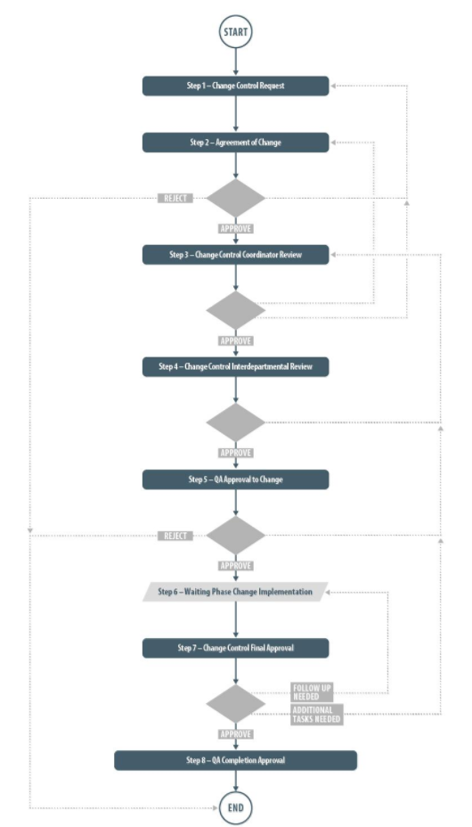

# Change Control Process – Process Roles

Decisions made by those involved in the process act to progress the workflow to the next Step or return it to a prior Step. The following **Change Control Process Roles** are associated with **Change Control Process P0052** and must be assigned to the Users in **SOLABS QM10** who will make the related decisions and need to receive email Notifications related to the ongoing process.

When SOLABS QM10 Users are assigned a Process Role, their names are then available on drop-down lists to be selected for their assigned steps in the process. The process will automatically notify them to Act On that Step/Primary Task. They will see the step in the Process Section of their SOLABS QM10 HOME Page and will also receive an email Notification.

Contact your SOLABS System Administrator if any of these Change Control Process Roles need to be assigned to additional Users. If these Process Roles are not assigned to any Users, the related process tasks will instead go to Users who have the System Role assignment of SOLABS Documentation Administrator. If that role is not assigned, the process tasks would go to the SOLABS System Administrator.

**PR_CCR_CCC:**

This Process Role must be assigned to those Users who will need to Act on the following Primary Tasks:

* Step 3 – Change Control Coordinator Review
* Step 7 – Change Control Final Approval *

Users with this role assignment will receive email Notifications for the following events:

* Step 1 is confirmed
* An *Approve* decision is confirmed at Step 2
* Step 8 is confirmed
* The process is cancelled
* All Secondary Tasks are completed (if available Option 5 is enabled)

**PR_CCR_QAM:**

This Process Role must be assigned to those Users who will need to Act on the following Primary Tasks:

* Step 5 – QA Approval to Change
* Step 8 – QA Completion Approval *

Users with this role assignment will receive email Notifications for the following events:

* The process is cancelled
* All Secondary Tasks are completed (if available Option 5 is enabled)

* Refer to the UFDS for available Options to switch the assignees for Steps 7 and 8.

* Option 2 allows Step 7 to instead be assigned to all Users with the Role PR_CCR-QAM.
* Option 3 allows Step 8 to instead be assigned to all Users with the Role PR_CCR_CCC.

# Starting a Change Control Process

From the **PROCESS** Section in SOLABS QM10, choose Start Process from the Quick Access **Process Menu**.



At the next screen, locate the listing for the Change Control Process and click the blue **START** button.

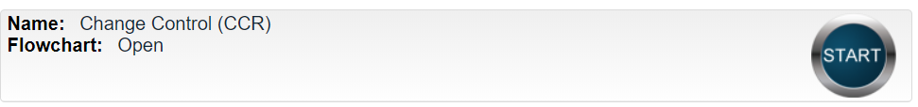

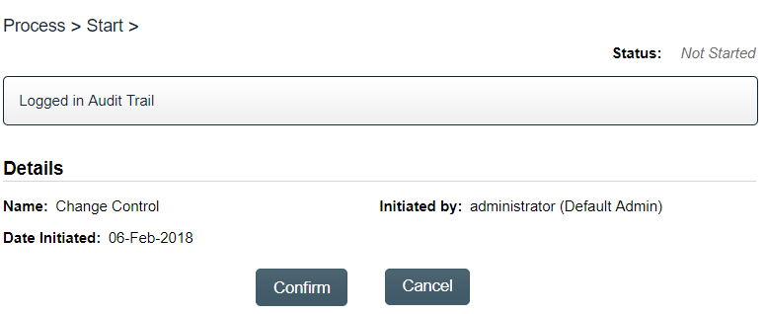

You will then be asked to Confirm this action, to move **Status** from *Not Started* to *In Process*. At this point a Unique ID will be assigned to the Change Control Process.

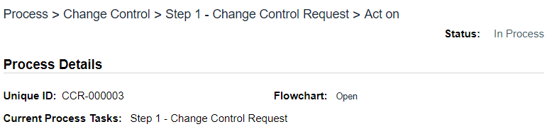

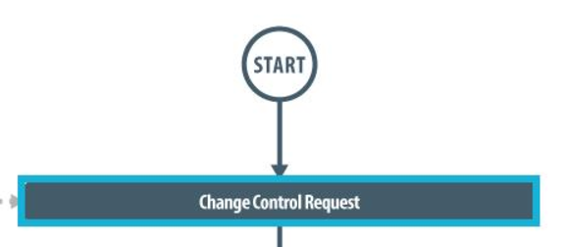The first Primary Task box on the **Process Flowchart** will now be highlighted when it is opened: Change Control Request.

# Step 1 - Change Control Request

At Step 1 the user initiating the Change Control enters all the required information and metadata into the **Process Task Form**.

As seen on the screen shot to the right, there are many fields to be completed by the initiator at this step. This page provides some general information on the various types of fields.

Some of the fields on the **Process Task Form** are editable text fields or text areas. Others are single-item selection fields or multi-item selection fields. Fields with an asterisk (*) are mandatory.

**Each of the fields in the Process Task Form will be more clearly displayed and described starting on the next page.**

The right-hand **Related Items** menu allows the initiator to **Link Documents** or **Link Processes**, if applicable. There are also sections to initiate **Secondary Tasks** and initiate new **Related Processes**, including a **Document Control Process**.

Refer to the separate document **SOLABS QM10: Introduction to PROCESS Section** for information on use of the **right-hand menus** and Related Processes, since they are common to all SOLABS QM Process APPs.

At the very bottom of the screen there is a **Save Draft** option if you cannot complete all the required fields at one time or if you need to use the right-hand menus to Link Documents or to Link Processes.

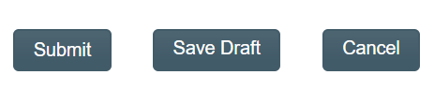

**CAUTION:** If you navigate away from this page without clicking on either **Submit** or **Save Draft**, all entries will be lost. To complete the information after the **Save Draft** option, you can either choose the **Act On** option from the Process section of your HOME Page, or search for the In-Process Change control and then use the right-hand **Act on Menu** to open the Process Task Form fields.

## Completing the Process Task Form:

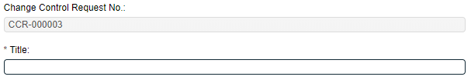This sub-section covers the information required for each field in the **Process Task Form** at **Change Control Process Step 1 - Change Control Request**.

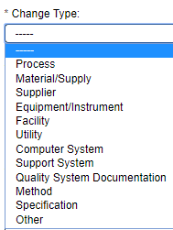The **Change Control Request No.** field will be automatically populated with the next available Change Control process number. The **Title** field is mandatory. Choose a clear, concise and intuitive title for the Change Control that will quickly communicate the subject. Titles will appear in Change Control Process Reports.

### Change Type Options



The **Change Type** field is a mandatory field. It is set up as a Single-item selection field of eleven high level Change Types plus a choice of “Other”.

After selecting a Change Type, additional mandatory fields will be displayed for the chosen Change Type for entry of the related details. Where those additional fields are Single-item selection fields or Multi-item selection fields, the values are populated from editable Custom Lists configured and maintained by your SOLABS System Administrator for your specific needs.

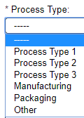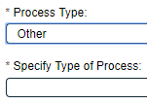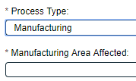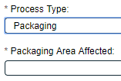Depending on choices at that next level, there may be even more fields displayed.

Values for Process Type 1, 2 and 3 are editable from a Custom List and will bring up no additional next-level fields.

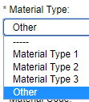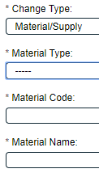

If the Material Type is selected as **Other**, a field will appear to enter the **Material Type Description**.

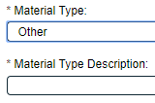

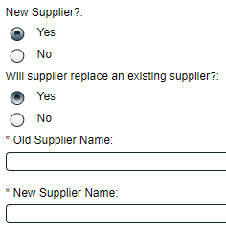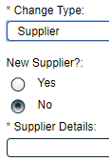

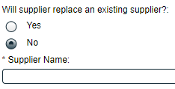

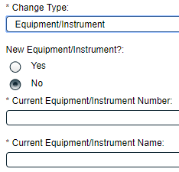

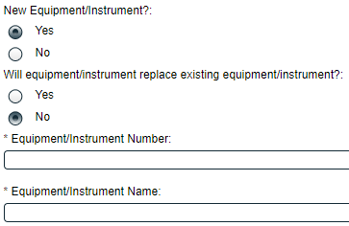

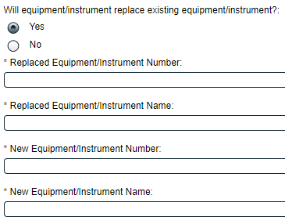

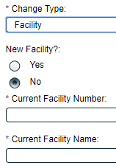

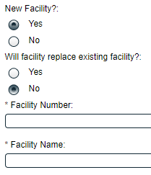

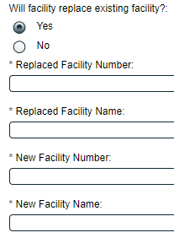

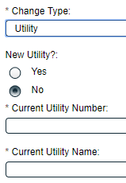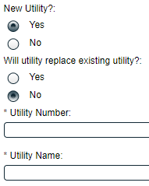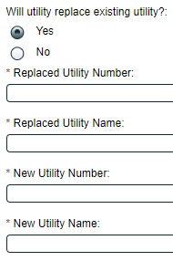

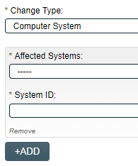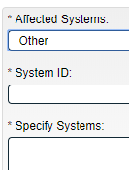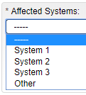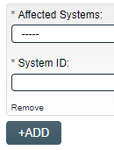When the Change Type is **Computer System**, multiple **Affected Systems** can be included in the change, by using the +ADD button to bring up another group of fields. A choice of **Other** brings up a field to **Specify Systems**.



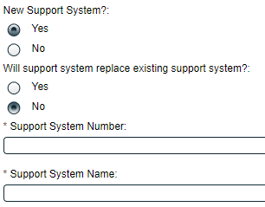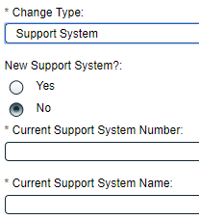

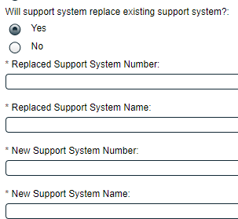



There are no additional fields for these Change Types. If either **Quality System Documentation** or **Method** is selected as the Change Type, you could initiate a related Document Control Process to provide that detail. Refer to Page 13 for initiating a Document Control Process as a child process of the Change Control.

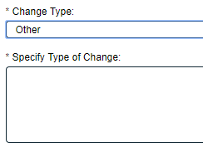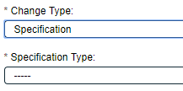

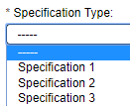

### General Information Fields

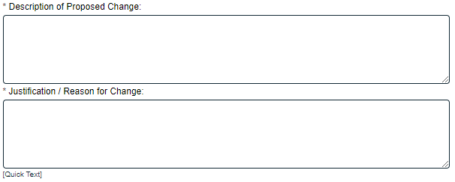For any Change Type selected, the next fields on the Process Task Form are mandatory free-text fields to enter the **Description of Proposed Change** and the **Justification/Reason for Change**. The Justification/Reason for Change field has the option to be populated by Quick Text. **Quick Text** is an **editable Custom List** of standardized phrases/terms that can be created as values for this field.

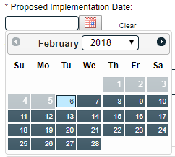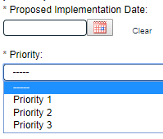The mandatory **Proposed Implementation Date** field can be populated from a Calendar.

The mandatory Priority field is a Single-item selection field populated by values from an **editable Custom List** maintained by your SOLABS System Administrator, with terminology unique to your organization.



The mandatory **Agreement of Change Assigned to** field is a Single-item selection field fed by the Active User list for your organization. There is no default value for this field, but you can set any other users, such as the manager of the Initiator. During configuration, an option is available to make it impossible to select the initiator of a Change Control Request to be the Agreement of Change Assignee. The person chosen in this field will be the person who will be assigned the next step in the Change Control Process: **Step 2 – Agreement of Change**.

## Creating Secondary Tasks

The initiator of the Change Control Process can create **Secondary Tasks** that will be associated with the Change Control. These Secondary Tasks can be assigned to appropriate Users for activities required to support completion of the Change Control but that are not part of the Primary Tasks.

The **Secondary Task** section is under the Process Task Form, but still on the Change Control Request screen. This section is available at various Primary Task Steps of the Change Control Process, allowing others involved in the review, implementation and approval of the Change Control to assign additional Secondary Tasks.

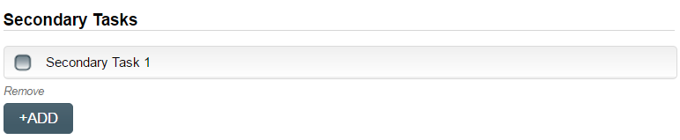After selecting **Secondary Task 1**, additional fields will be displayed to define and assign that task.

Replace the text “Secondary Task 1” with an appropriate Title for the task.

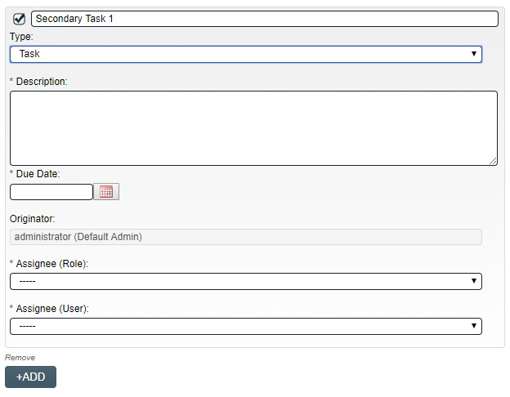The task **Type** can then be chosen from a drop-down list of task types. Choose one that is associated with this Change Control Process.

Enter a **Description** and a **Due Date** for the Task. Choose due dates appropriate to ensure tasks are completed in a time frame that supports on time Change Control completion.

The **Originator** field will default to the User initiating the Change Control Process and completing Step 1.

The **+ADD** button can be used to create additional Secondary Tasks.

The **Assignee** **(Role)** and the **Assignee (User)** fields must be selected for the chosen person. The drop-down lists will bring up the Active Roles list and the Active Users list. It is a good practice to let the assignee know that a Secondary Task is being assigned to them and ensure they will be able to complete it a timeframe that supports on time closure of the Change Control process.

To assign by **Role**, choose the appropriate Function Role from the list. All Users with that Role will then appear in the **Assignee (User)** drop-down list so that the appropriate person can be selected. To assign by **User**, choose the appropriate User from the list. Their Function Role will then appear in the **Assignee (Role)** drop-down list and must be selected.

The Assignees will receive email Notifications and see the View/Act On options for their Secondary Tasks only **after QA Approval to Change is completed at Step 5**. Until then the Task status is ***Not Started***. The **Secondary Tasks** are listed under **Related Items** at the bottom of the screen for any Change Control Step.

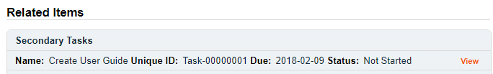

## Initiating a Related Process

To initiate a new **SOLABS QM10 Process** from within this Process, check the Available Processes box.

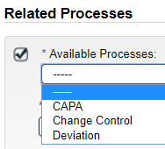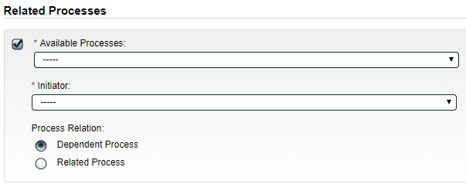The **Available Processes** field is a Single-item selection field of any Process APPs deployed for your organization.

Choose the Process Relation as either a **Dependent Process** (must be completed before the Change Control is closed), or a **Related Process.**

When the **Process Relation** is selected as **Dependent Process**, the process from which it was initiated is considered the **Parent Process**.

The mandatory **Initiator** field is a Single-item selection field fed by the Active User list for your organization. The person chosen in this field will be the person who will be assigned Step 1 of the process you are choosing to initiate. There is also an option to choose **myself**, if you would like to initiate the Related Process yourself.

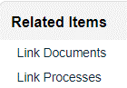If a Related Process was already initiated, separately from this Change Control, it can be linked as a Related Item using the right-hand menu option under **Related Items**. In this case, do not select the Available Processes box and instead use the **Link Processes** option.

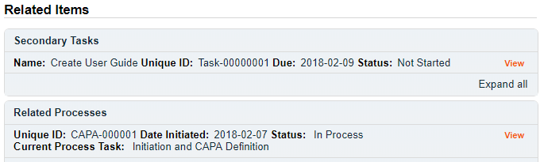Whether linking an existing process or initiating a new one, the Related Process will be listed in the **Related Items** section when CCR Step 1 is Submitted/Confirmed.

## Initiating a Document Control Process

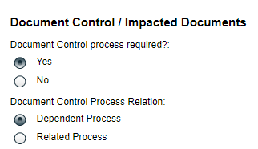To initiate a new **SOLABS QM10 Document Control Process** to manage any document updates required for this Change Control, select **Yes**. One or more documents can be included in a Document Control Process.

When the **Yes** option is selected, also choose whether it will be a **Dependent Process** (must be completed before the Change Control is closed), or a **Related Process**.

When the **Process Relation** is selected as **Dependent Process**, the process from which it was initiated is considered the **Parent Process**.

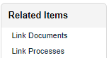If the Change Type was selected as Quality System Documentation, the **Yes** option and a Process Relation of **Dependent Process** will be pre-selected and will not be editable.

If a Document Control Process was already initiated, separately from this Change Control, it can be linked as a Related Item using the right-hand menu option under **Related Items**. In this case, leave the above setting at the default of **No**.

When the **Yes** option is selected, Step 1 of the Document Control Process will be launched immediately upon submission of Step 1 – Change Control Request, so that the person initiating the Change Control Process can also concurrently initiate the Document Control Process. The Change Control Process will be considered the **Parent Process**.

* the information from the Change Control **Description of Proposed Change** field will auto-populate the Document Control Process **Description of Change** field, which will remain editable
* the information from the Change Control **Justification / Reason for Change** field will auto-populate the Document Control Process **Purpose of Change** field, which will remain editable
* the information from the Change Control **Proposed Implementation Date** field will auto-populate the Document Control Process **Target Completion Date** field, which will remain editable

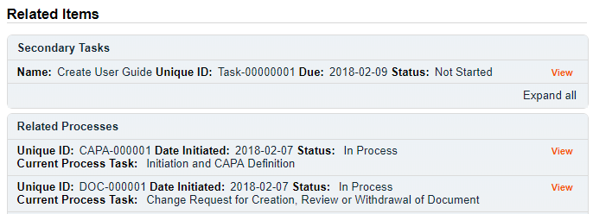Whether linking an existing Doc Control Process or initiating a new one, it will be listed in the **Related Items** section when CCR Step 1 is Submitted/Confirmed.

## Submit and Confirm

When all information has been entered in the **Process Task Form**, and any **Secondary Tasks**, **Linked Documents,** **Linked Processes, Related Processes or Document Control Processes** have been added, click **Submit** and then **Confirm.** This will progress the process to **Step 2 – Agreement of Change**. The Process Flowchart will highlight the next step of the process and the person chosen in Step 1 in the **Agreement of Change Assigned to** field will be listed. This person will also receive an email Notification and will see the **Step 2 – Agreement of Change** task listed on their SOLABS QM10 HOME Page. Additionally, all users with PR_CCR_CCC role assignment will receive an email Notification that a Change Control has been submitted and confirmed.

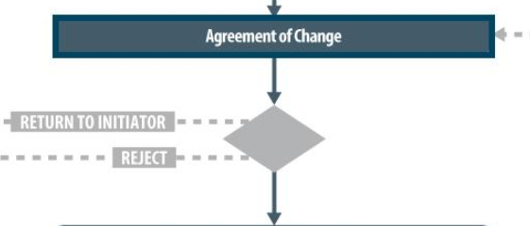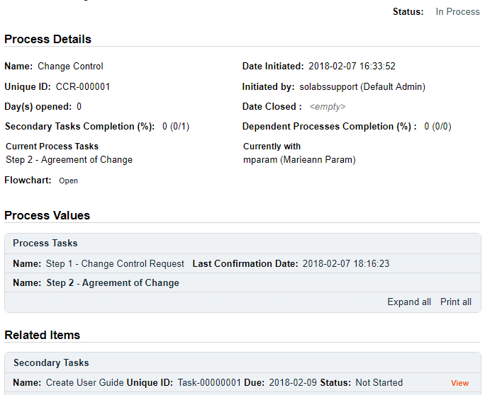

# Step 2 - Agreement of Change

At this step in the Change Control Process, the person chosen at Step 1 will receive an email Notification and will see the **Step 2 – Agreement of Change** task listed in the Process section of their SOLABS QM10 HOME Page.

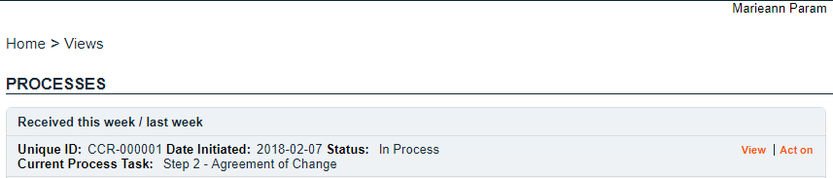

## Viewing an Agreement of Change Task

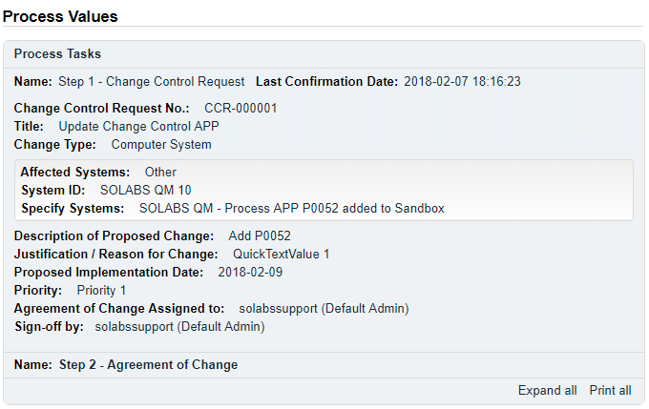**If the User clicks on the View option** to the right of the Process Task on their HOME Page, they will get the same screen shown on the previous page.

From that View screen, there are **Expand all** options under the **Process Values** table and the **Related Items** table, that can be used to see more detail on the information entered by the initiator at Step 1.

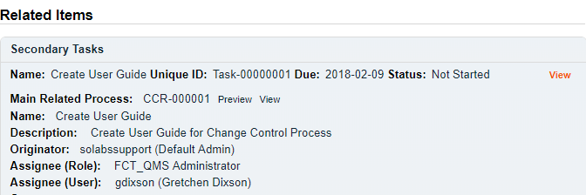They can also click on the **View** option to the right of any individual **Related Items** (Secondary Tasks, Linked Documents, Linked Processes) to go to those **Task Details**, **Document Details** or **Process Details** screens.

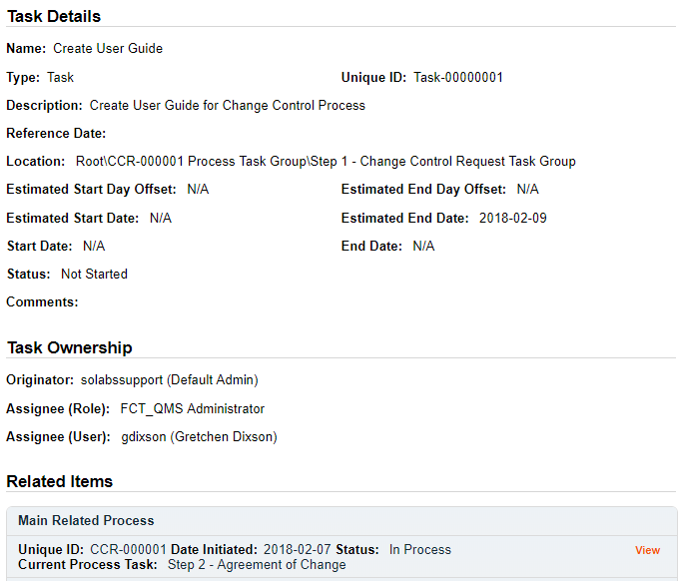

From any of those screens they can quickly return to the Process since it will be listed as a **Related Item** on all of those screens.

In this example, clicking on View for the Secondary Task listed in CCR-000001 brings up the **Task Details** screen for that assigned Task.

CCR-000001 is listed as a **Related Item** for that Task. To get back to CCR-000001, the User can click on the **View** option. This makes it easy to toggle between the Process and any Related Items.

## Acting on the Agreement of Change Task

****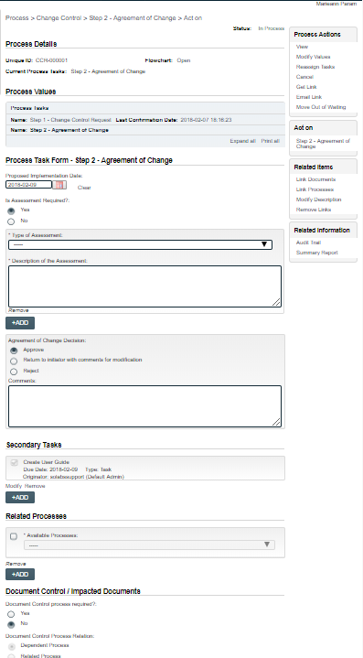**When the assigned User clicks on the Act on option** to the right of the Process Task, they will go immediately to the **Act on** screen for their **Agreement of Change** task.

As described on the last page, they can then use the **Expand all** option under the **Process Values** table to see all information entered by the Initiator at Step 1.

As seen on the screen shot to the right, there are a number of fields to be completed by the assigned User at this step.

As with Step 1, there are different field types on the **Process Task Form**, including date fields, Single-item selection fields and free text fields/areas. Fields with an asterisk (*) are mandatory.

The right-hand **Related Items** menu allows the initiator to **Link Documents** or **Link Processes**, if applicable. There are also sections to initiate **Secondary Tasks** and initiate new **Related Processes**, including a **Document Control Process**.

**Each of the fields in the Process Task Form will be displayed and described in more detail starting on the next page.**

Refer to the separate document **SOLABS QM10: Introduction to PROCESS Section** for information on use of the **right-hand menus** and Related Processes, since they are common to all SOLABS QM Process APPs.

Use the Save Draft option at the bottom if you cannot complete all the required fields at one time.

CAUTION: If you navigate away from this page without clicking on either Submit or Save Draft, all entries will be lost. To complete the information after the Save Draft option, choose either the Act On option from the Process section of your HOME Page, or search for the Change Control and use the right-hand Act on Menu to open the Process Task Form fields.

### Completing the Process Task Form

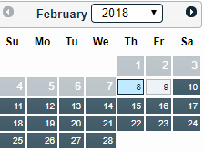This sub-section covers the information required for each field in the **Process Task Form** at Change Control Process **Step 2: Agreement of Change.**

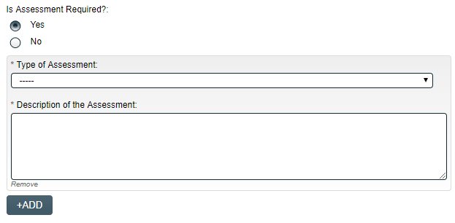The **Proposed Implementation Date** field will be pre-populated with the date proposed by the Initiator at Step 1, but can be edited.

Is Assessment Required? is a Yes/No option.

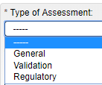If **Yes** is selected, a field group including mandtory **Type of Assessment** and **Description of the Assessment** fields are displayed. The **+ADD** button will bring up another field group, so that information for more than one Type of Assessment can be entered.

EXAMPLE

The **Type of Assessment** field is a Single-item selection field that can be populated from an editable shared Custom List of Assessment Types used by your organization.

### Reviewing Secondary Tasks and Related Processes

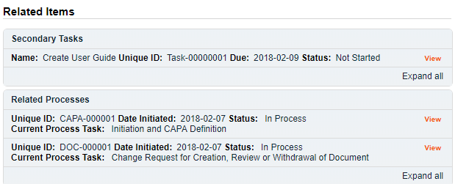Before making the final **Agreement of Change Decision**, the assigned User should also review the Related Items, by using the available **Expand all** and **View** options.

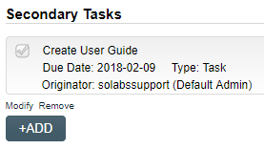There are **Modify** or **Remove** options for the existing Secondary Tasks. Additional Secondary Tasks can be created using the **+ADD** option.

The User acting on Step 2 can also **Link Documents** or **Link Processes** using the right-hand Related Items menu. The options to initiate a new **Related Process** or initiate a new **Document Control Process** are also enabled at Step 2.

### Submit and Confirm the Agreement of Change Decision

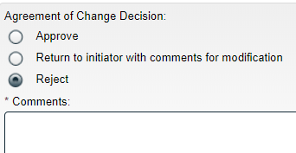After reviewing all information from Step 1, completing all required fields in the **Process Task Form**, reviewing any **Secondary Tasks** and reviewing any **Related Processes** or **Doc Control Process**, the assigned User for Step 2 will make the **Agreement of Change Decision**. There are three available options: **Approve**, **Return to initiator** **with comments for modification** or **Reject**.

The Comments field will be mandatory for a choice of either **Return to initiator with comments for modification** or **Reject**.

* A choice of **Return to initiator with comments for modification** will send the Change Control process back to **Step 1** – **Change Control Request** so that the Initiator can address the comments.
* A choice of **Reject** will **END** the Change Control process.
* A choice of **Approve** will progress the process to **Step 3 – Change Control Coordinator Review**. It will be assigned to all Users who have the Process Role **PR_CCR_CCC** assigned. (Note: if PR_CCR_CCC is not assigned to any users, the Step will be assigned to anyone who has the SOLABS Documentation Administrator role assignment).

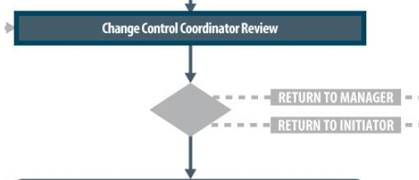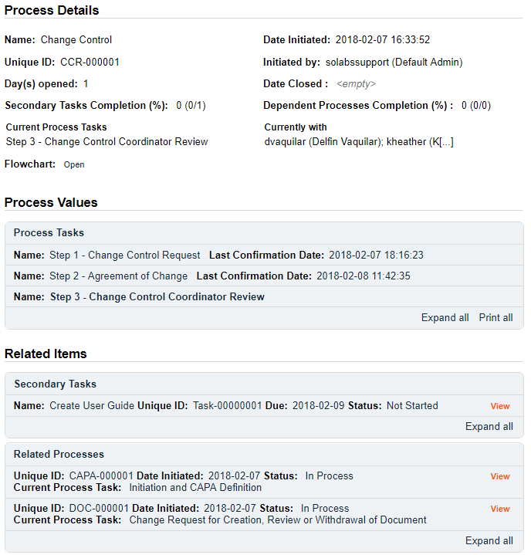The **Process Flowchart** will highlight the next step of the process. The **Process Details** screen will display the **Current Process Task** and who it is **Currently with.**

# Step 3 - Change Control Coordinator Review

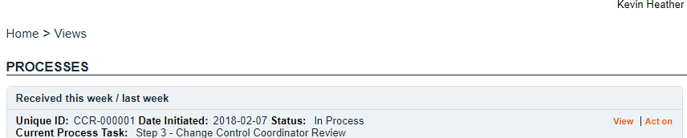At this step in the Change Control Process, all users with the process role PR_CCR_CCC assigned to them, will receive an email Notification.

They will see the **Step 3 – Change Control Coordinator Review** task listed in the Process section of their SOLABS QM10 HOME Page. Any one of them can act on the task.

As the **Change Control Process** progresses from Step to Step, the information from each step is added to the **Process Values** table so that it is available for those acting on later steps to review. If the process goes back to a previous step at any point, and then progresses again, all that detail will be captured as well. If **Secondary Tasks**, **Related Documents** or **Related Processes** are added along the way, they will be added to the **Related Items** section**.**

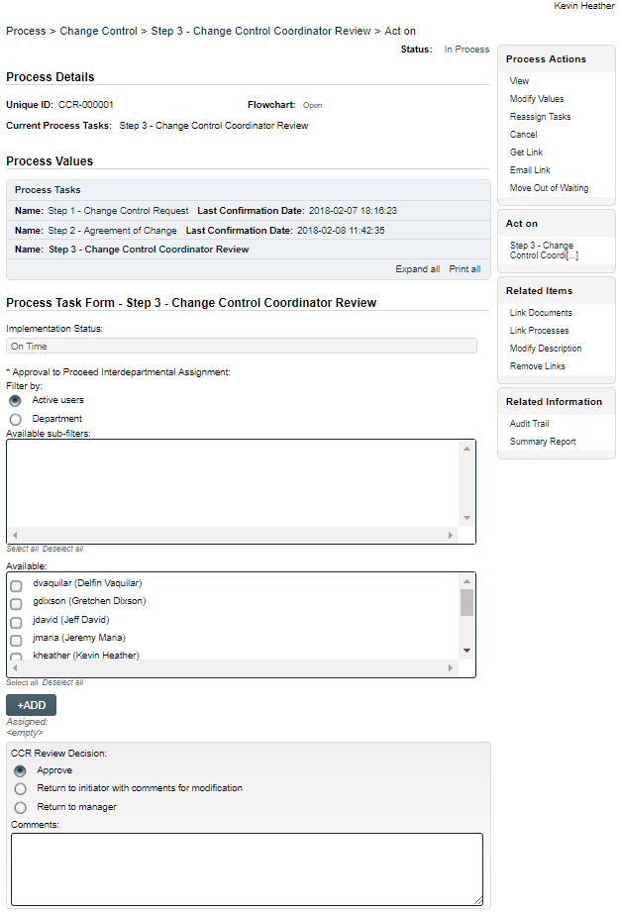As mentioned previously, with each Primary Task assignment, Users can use the **View** option from their HOME Page to see the **Process Details** screen, to Expand the Process Values table for additional details and to toggle back and forth between the Process and any Related Items.

## Acting on the Change Control Coordinator Review Task

When a **Change Control Coordinator Review** assigneeclicks on the **Act on** option to the right of the Process Task, they will go immediately to the **Act on** screen for **Step 3 – Change Control Coordinator Review.**

As described previously, the person can use the **Expand all** option under the **Process Values** table to see all information entered at Steps 1 and 2 of the process. They can also review all **Related Items**.

The options to Link Documents, Link Processes, Review/Modify/Remove/Add Secondary Tasks and initiate additional Related Processes or Document Control Processes are enabled at Step 3 as well.

**These fields will be displayed more clearly displayed and described starting on the next page.**

The **Implementation Status** field is not editable. It will display **On Time** if today’s date is on or before the **Proposed Implementation Date** and **Overdue** if that date has passed. In that case a field to enter a Follow-Up Date is enabled.



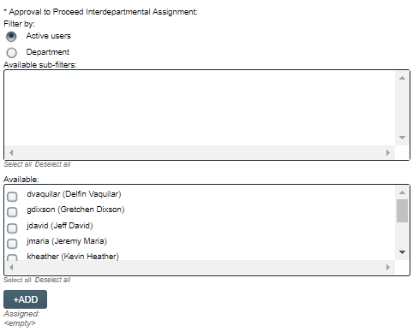The Change Control Coordinator will use the Approval to Proceed Interdepartmental Assignment section to assign appropriate interdepartmental approvals for the change being proposed. At least one person must be selected.

* If the **Filter by** is selected as Active users, the **Available** section will display a list of all **Active Users**.
* 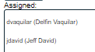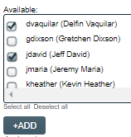If the **Filter by** is selected as **Department**, the **Available sub-filters** section will display a list of all **Active Departments**. When one or more departments are selected, the Available section will display only the Users who are assigned the Security Roles for those departments.

Select the appropriate people and then click on the **+ADD** button to add those Users to the **Assigned** section. When a CCR Review Decision of Approved is Submitted and Confirmed for Step 3, this will be the list of Users who will receive a Notification to Act on **Step 4 – Change Control Interdepartmental Review**.

As with previous steps, the User acting on Step 3 can **Link Documents** or **Link Processes** using the right-hand Related Items menu. The options to initiate new **Secondary Tasks**, **Related Processes** or a **Document Control Process** are also enabled at Step 3.

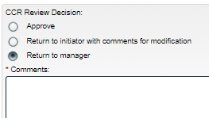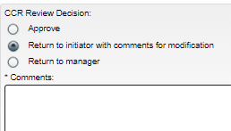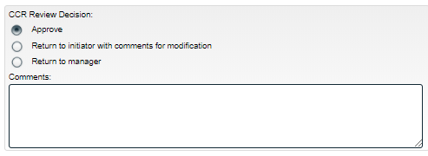When the Change Control Coordinator is ready, the CCR Review Decision is made. There are three available options.

The **Comments** field will be mandatory for choices of **Return to initiator with comments for modification** or **Return to manager**.

* A choice of **Return to initiator with comments for modification** will send the Change Control process back to **Step 1** – **Change Control Request** so that the Initiator can address the comments.
* A choice of **Return to manager** will send the Change Control process back to Step 2.
* A choice of **Approve** will progress the process to **Step 4 – Change Control Interdepartmental Review**. It will be assigned to the Users selected at Step 3.

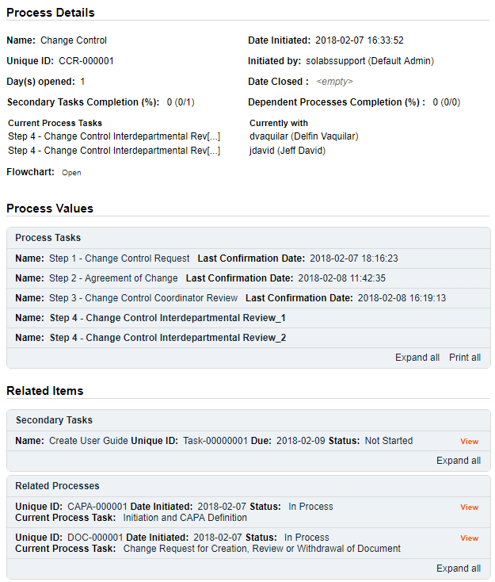The **Process Flowchart** will highlight the next step of the process. The **Process Details** screen will display the **Current Process Task** and who it is **Currently with.**

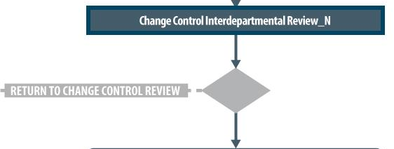

# Step 4 - Change Control Interdepartmental Review

At this step in the Change Control Process, the person(s) selected at Step 3 for Interdepartmental Review, will receive an email Notification and will see the **Step 4 – Change Control Interdepartmental Review** task listed in the Process section of their SOLABS QM10 HOME Page. Each person selected will need to Act on that task. In this example there were two people assigned the task, so the numbers **_1** and **_2** will appear after the task name to differentiate those tasks.

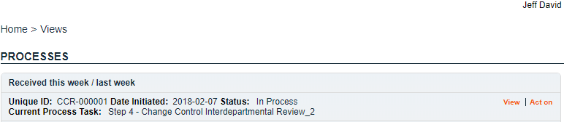

Again, as the **Change Control Process** progresses from Step to Step, each step is added to the **Process Values** table so that it is available for those acting on later steps to review. If **Secondary Tasks**, **Related Documents** or **Related Processes** are added along the way, they will be added to the **Related Items** section**.**

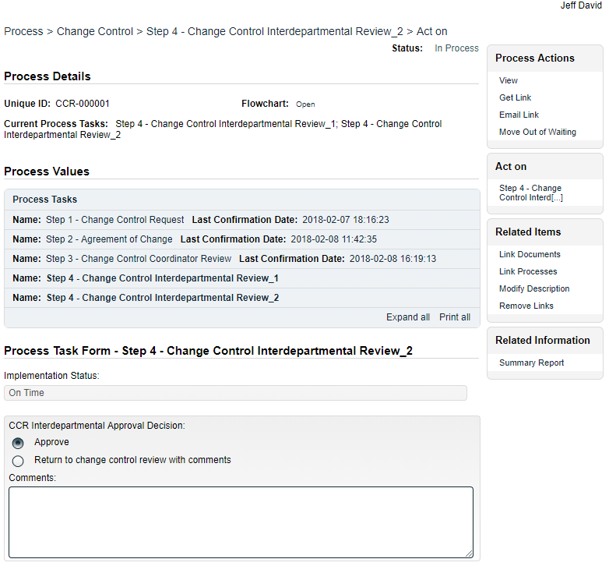As mentioned previously, with each Primary Task assignment, Users can use the **View** option from their HOME Page to see the **Process Details** screen, to Expand the Process Values table for additional details and to toggle back and forth between the Process and any Related Items.

## Acting on the Change Control Interdepartmental Review Task

When a **Change Control Interdepartmental Review** assignee clicks on the **Act on** option to the right of the Process Task, they will go immediately to the **Act on** screen for **Step 4 – Change Control Interdepartmental Review**.

As described previously, the person can use the **Expand all** option under the **Process Values** table to see all information entered at Steps 1 - 3 of the process. They can also review all **Related Items**.

The options to Link Documents, Link Processes, Review/Modify/Remove/Add Secondary Tasks and initiate additional Related Processes or Document Control Processes are enabled at Step 4 as well.

The **Implementation Status** field is not editable. It will display **On Time** if today’s date is on or before the **Proposed Implementation Date** and **Overdue** if that date has passed. In that case a field to enter a Follow-Up Date is enabled.

At this step in the Change Control process, the Interdepartmental Reviewers will review all the information that has been entered so far, add any additional Secondary Tasks, Related Documents, Related Processes or Document Control Processes, and then make their **CCR Interdepartmental Approval Decision**.

There are just two choices for that decision:

* A choice of **Return to change control review with comments** will require mandatory **Comments**. After all assigned people have acted on this step, the process will then go back to **Step 3** – **Change Control Coordinator Review** so that the Change Control Coordinator can address the comments.
* A **CCR Interdepartmental Approval Decision** of **Approve** will progress the process to **Step 5 – QA Approval to Change**. It will be assigned to any Users who have the Process Role **PR_CCR_QAM** assigned. (Note: if PR_CCR_QAM is not assigned to any users, the Step will be assigned to anyone who has the SOLABS Documentation Administrator role assignment).

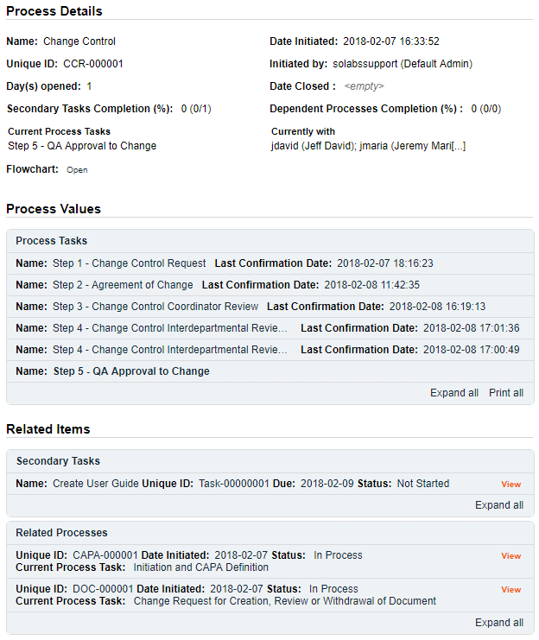The **Process Flowchart** will highlight the next step of the process. The **Process Details** screen will display the **Current Process Task** and who it is **Currently with**.

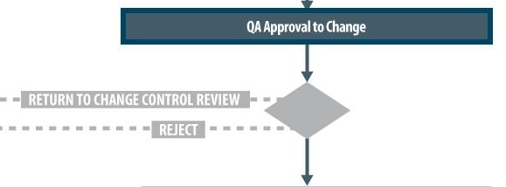

# Step 5 - QA Approval to Change

At this step in the Change Control Process, the person(s) with the process role PR_CCR_QAM assigned to them, will receive an email Notification and will see the **Step 5 – QA Approval to Change** task listed in the Process section of their SOLABS QM10 HOME Page. Any one of them can act on the task.

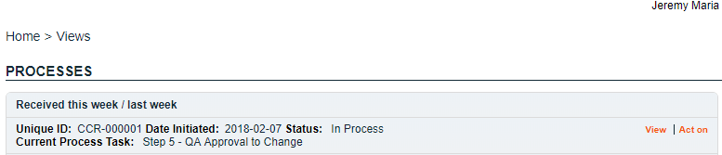

As mentioned previously, with each Primary Task assignment, Users can use the **View** option from their HOME Page to see the **Process Details** screen, to Expand the Process Values table for additional details and to toggle back and forth between the Process and any Related Items.

## Acting on the QA Approval to Change Task

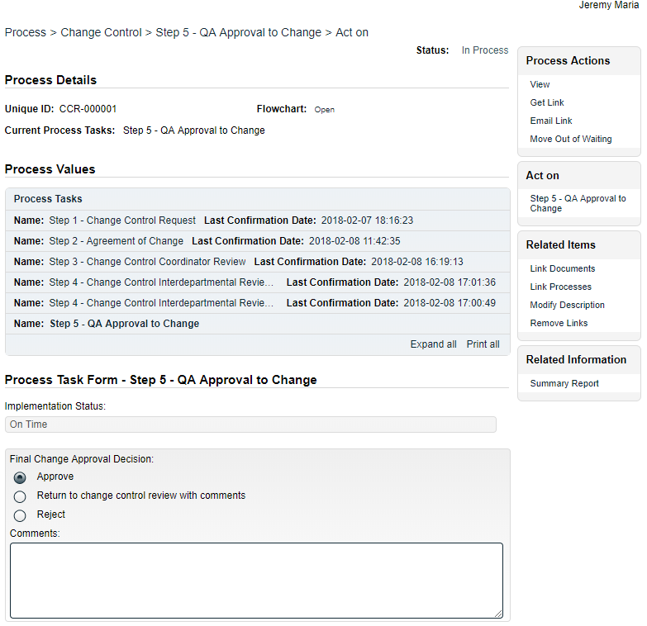When a **QA Approver** clicks on the **Act on** option to the right of the Process Task, they will go immediately to the **Act on** screen for their **Step 5 -** **QA Approval to Change** task.

As described previously, the person can use the **Expand all** option under the **Process Values** table to see all information entered at Steps 1 - 4 of the process. They can also review all **Related Items**.

The options to Link Documents, Link Processes, Review/Modify/Remove or Add Secondary Tasks and initiate additional Related Processes or Document Control Processes are enabled at Step 5 as well.

The **Implementation Status** field is not editable. It will display **On Time** if today’s date is on or before the **Proposed Implementation Date** and **Overdue** if that date has passed. In that case a field to enter a Follow-Up Date is enabled.

At this step in the Change Control process, the **QA Approver** will review all the information that has been entered so far, add any additional Secondary Tasks, Related Documents, Related Processes or Document Control Processes, and then make their **Final Change Approval Decision**.

There are three choices for that decision:

* A choice of **Return to change control review with comments** will require mandatory **Comments**. After this decision is submitted, the process will then go back to **Step 3** – **Change Control Coordinator Review** so that the Change Control Coordinator can address the comments.
* A choice of **Reject** will require mandatory **Comments**. The **Document Control / Impacted Documents** section will become disabled so that no additional Document Control Process can be added. Any in-process Document Control Processes that are in a Waiting phase will move out of Waiting. After this decision is submitted, the Change Control process will close.
* A **Final Change Approval Decision** of **Approve** will progress the process to **Step 6 – Waiting Phase Change Implementation**. At this point all **Secondary Tasks** will be released for assignees to **Act on**.

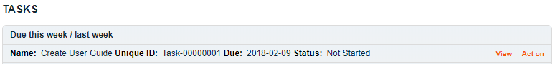All assignees of **Secondary Tasks** will receive email Notifications and see those activities listed in the **TASKS** section of their SOLABS QM10 HOME Page. They will be able to Act on those tasks to progress the status from *Not Started*.

The **Process Flowchart** will highlight the next step of the process. The **Process Details** screen will display the **Current Process Task** and who it is **Currently with** – **N/A** since the process is now in a Waiting Phase while Users complete their assigned Secondary Tasks.

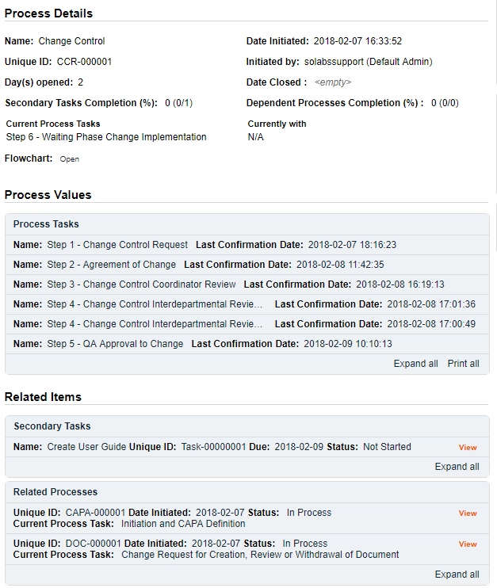

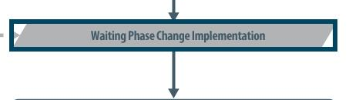

# Step 6 – Waiting Phase Change Implementation

Any **Secondary Tasks** are now released to **Act on** since the Change Control Process has been approved by QA. Step 1 of any Related Processes initiated from within the Change Control were assigned to the selected User at the time of assignment and can be progressed concurrently. Any that were set with Process Relation of Dependent, will need to be completed during this Waiting Phase.

## Viewing a Secondary Task

When the Assignee for a **Secondary Task** chooses the **View** option from their HOME Page, they are brought to the **Task > View** screen for that Task. They can now review what has been assigned to them and can also toggle to the **Change Control Process** that triggered the Task, since it is listed at the bottom of the screen as a **Related Item**.



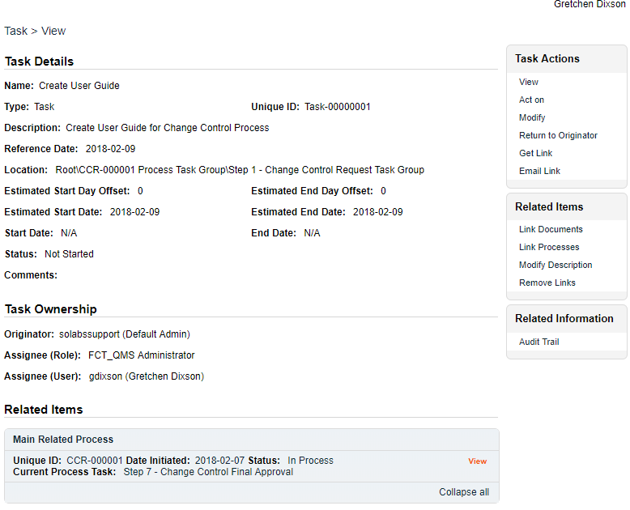

## Acting on the Secondary Task

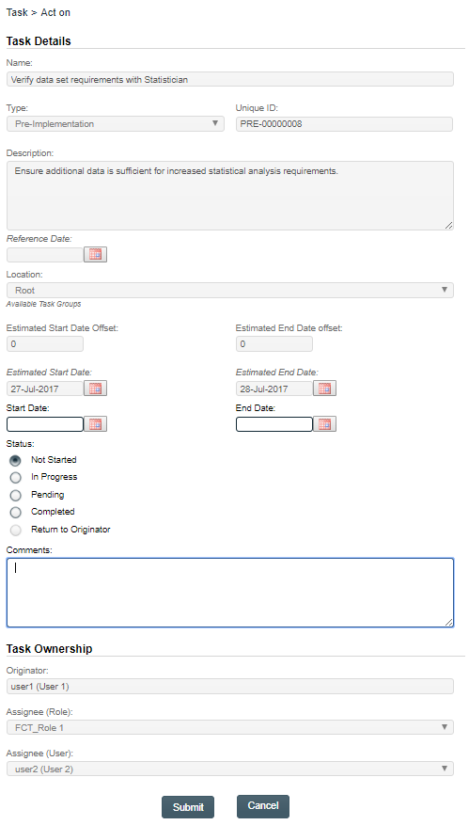When the Assignee for a Secondary Task chooses the **Act on** option from their HOME Page, they are brought to the **Task > Act on** screen for that Task.

From this screen, the Assignee can also review the **Task Details**.

The fields they have available to them are to select a **Start Date**, enter an **End Date** when they are finished with the task and to change the **Status** as they progress it.

They can also enter free-text **Comments** at any point.

The task will default to a status of **Not Started**. If a status of **In Progress** is selected, the **Start Date** field will be populated with the current date. If a **Start Date** is entered, the Status will automatically move to **In Progress.** For longer term tasks, it is best practice to periodically log in and provide status updates in the **Comments** field.

If a status of **Pending** is selected, the **Start Date** field will be grayed out.

If a status of **Completed** is selected, the **End Date** field will be populated with the current date. If an **End Date** is entered, the Status will automatically move to **Completed**.

The **Return to Originator** option is grayed out since it is currently not available.

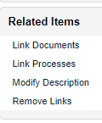If the Assignee would like to add evidence / documentation to support completion of the task, the **Link Documents** option is available on the right-hand menu.

The Change Control Process will move to **Step 7 – Change Control Final Approval** when one of the following conditions are met:

* The **Proposed Implementation Date** is reached.
* Any **Next Follow-Up Date** is reached
  + Setting a Next Follow-Up Date is an option at Step 7 where the Proposed Implementation Date is showing a status of Overdue.
* All **Secondary Tasks** and **Dependent Processes** reach a status of **Completed** or are **Cancelled.**

The **Process Flowchart** will highlight the next step of the process. The **Process Details** screen will display the **Current Process Task** and who it is **Currently with** – any Users who are assigned the Process Role of **PR_CCR_CCC.**

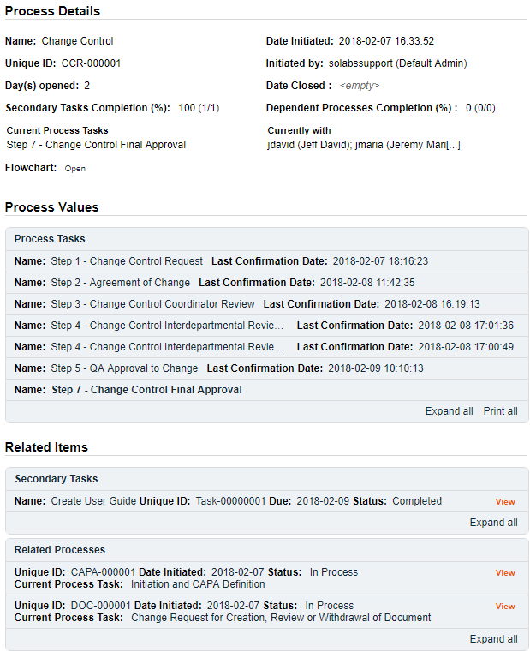NOTE: If **UFDS Option 2** is enabled, this step instead goes to Users who are assigned the Process Role of **PR_CCR_QAM**.

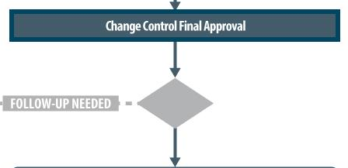

# Step 7 - Change Control Final Approval

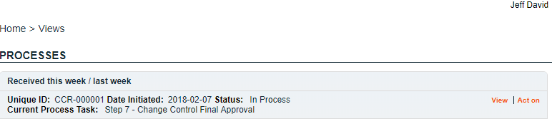At this step in the Change Control Process, the person(s) with the process role **PR_CCR_CCC** assigned to them, will receive an email Notification and will see the **Step 7 – Change Control Final Approval** task listed in the Process section of their SOLABS QM10 HOME Page. Any one of them can act on the task.

As mentioned previously, with each Primary Task assignment, Users can use the **View** option from their HOME Page to see the **Process Details** screen, to Expand the Process Values table for additional details and to toggle back and forth between the Process and any Related Items.

## Acting on the Change Control Final Approval Task

When an approver clicks on the **Act on** option to the right of the Process Task, they will go immediately to the **Act on** screen for their **Step 7 – Change Control Final Approval** task.

They have fields on the **Process Task Form** that they need to complete regarding the Implementation of the Change Control. See next page for details on these fields.

At this point the options to initiate more **Secondary Tasks** or **Document Control Processes** are disabled. A new **Related Process** can still be initiated, and the **Link Documents** and **Link Processes** options on the Related Items menu are still possible.

**Each of the fields in the Process Task Form will be displayed and described in more detail starting on the next page.**

The **Save Draft** option can be used if the required fields cannot all be completed at the same time, or if some Tasks are not yet complete (due to the process moving to this step because the Proposed Implementation Date or a Follow-Up Date were reached).



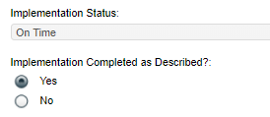As with other steps, the **Implementation Status** field is not enabled and will reflect a status of **On Time** or **Overdue**.

The **Implementation Completed as Described?** field is a **Yes** or **No** selection.

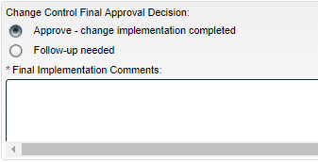The **Change Control Final Approval Decision** section of the Process Task Form includes a mandatory Final Implementation Comments field for either decision.

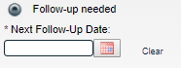If a decision of **Follow-up needed** is selected, there is also a requirement to enter a Next Follow-Up Date.

* A decision of **Follow-up needed** will send the Change Control process back to **Step 6 – Waiting Phase Change Implementation** when it is submitted.
* Entry of the **Next Follow-Up Date** is required and the following message will be displayed, since usually follow-up at this stage is due to Secondary Tasks not being complete yet:

*Please put Secondary Task to in Progress Status before confirming this step.*

* In this scenario, when the **Secondary Tasks** are complete, or when the **Next Follow-Up Date** is reached, the process will again progress to **Step 7 – Change Control Final Approval**.
* A decision of **Approve – change implementation completed** will progress the Change Control process to **Step 8 – QA Completion Approval.** If there are still Secondary Tasks that are not complete, the following non-blocking message will be displayed:

*There are secondary Tasks that are not completed. If you confirm, these secondary tasks will not be monitored anymore. If required, you can send the process back for monitoring these secondary tasks by selecting decision ‘Follow-up needed’.*

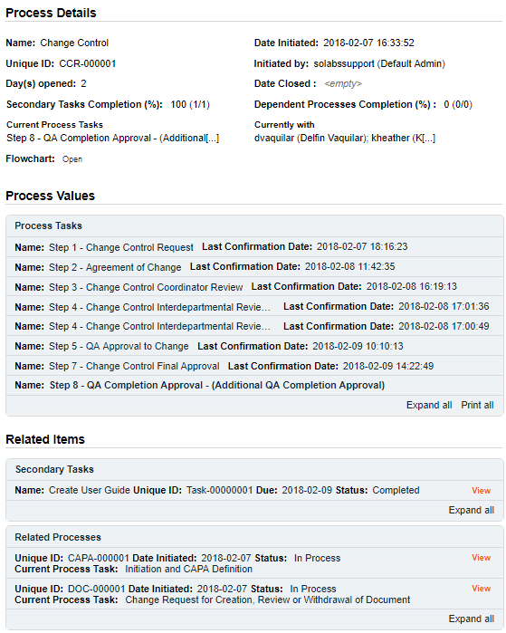The **Process Flowchart** will highlight the next step of the process. The **Process Details** screen will display the **Current Process Task** and who it is **Currently with** – any Users who are assigned the Process Role of **PR_CCR_QAM.**

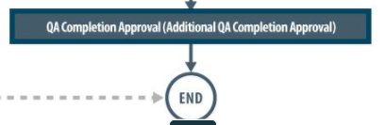

# Step 8 – QA Completion Approval

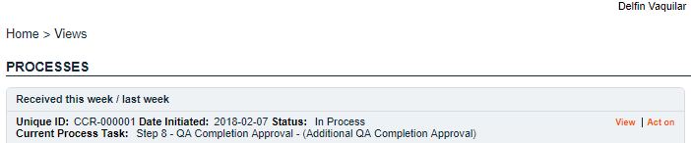At this step in the Change Control Process, the person(s) with the process role **PR_CCR_CCC** assigned to them, will receive an email Notification and will see the **Step 8 – QA Completion Approval – (Additional QA Completion Approval)** task listed in the Process section of their SOLABS QM10 HOME Page. Any one of them can act on the task.

As mentioned previously, with each Primary Task assignment, Users can use the **View** option from their HOME Page to see the **Process Details** screen, to Expand the Process Values table for additional details and to toggle back and forth between the Process and any Related Items.

## Acting on the QA Completion Approval Task

When a User clicks on the **Act on** option to the right of the Process Task, they will go immediately to the **Act on** screen for their **Step 8 – QA Completion Approval** task.

At this point the options to initiate more **Secondary Tasks** or **Document Control Processes** are disabled. A new **Related Process** can still be initiated, and the **Link Documents** and **Link Processes** options on the Related Items menu are still possible.

The only field at this stage is an optional field for **QA Review Comments**.

When this Step is Submitted and Confirmed, the Change Control Process will **END**, and be at a status of **Completed**.

All users with the PR_CCR_CCC role assignment will receive an email Notification.

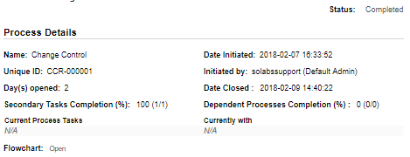

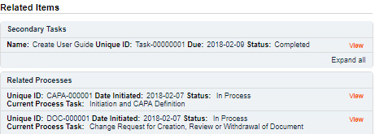If any Related Processes were not set as Dependent, they may still be In Process, and will be reflected as such under Related Items.

# Viewing Details for a Completed Change Control Process

Users are able to search for and view processes at any stage, using the Navigation tab in the **PROCESS Section** of SOLABS QM10.

## Using the Process Values Table

Process Tasks can be viewed by using the **Expand all** or **Print all** options at the bottom of the **Process Values** table. An individual Process Task can be expanded by clicking on it within the **Process Values** table.

## Using the Related Items Table

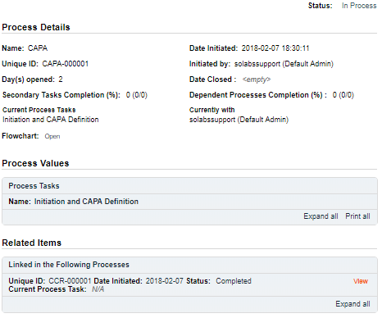Information on any **Secondary Tasks**, **Related Processes** or **Related Documents** can be accessed by clicking on the **View** option beside the listing in the **Related Items** section of the screen. From any of those **Details** screens, the Process will be listed under Related Items – you can quickly toggle back to the Main Process by clicking **View** next to it.

## Creating a Summary Report

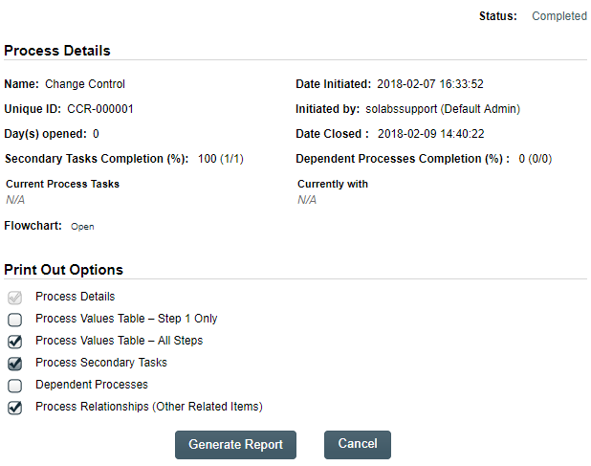Under the right-hand **Related Information** menu, click on the **Summary Report** option. Select the desired **Print Out Options** and then click on **Generate Report**.

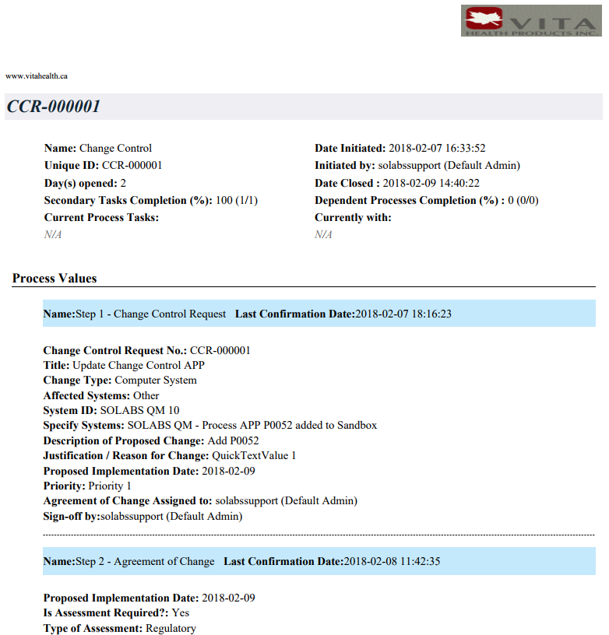A multi-page PDF Report will be generated, with any company header information set in System Configurations, and will include details on each step requested for the report.

LOGO

## Using the Audit Trail

Users with the **SOLABS System Administrator** role assignment, will also see the **Audit Trail** option on the right-hand **Related Information** menu.

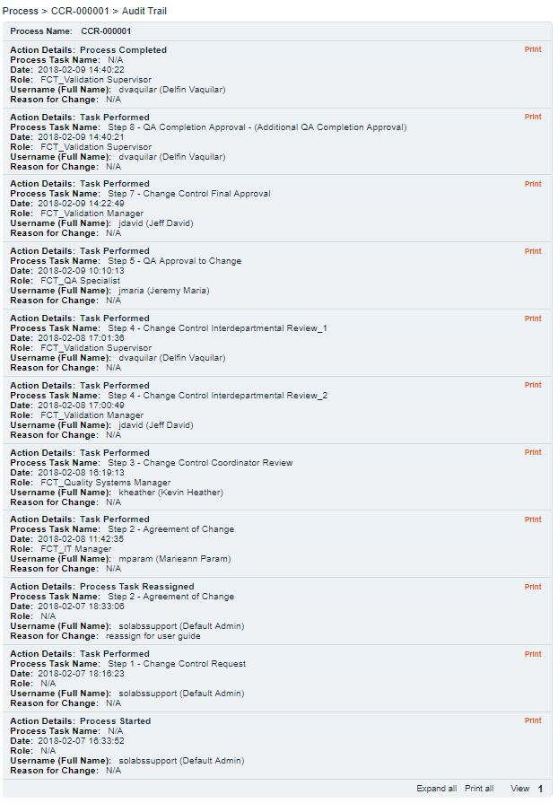There you will find all the details for every step of the Change Control Process, from **Process Completed** all the way down to **Process Started**, with options to expand or print the entire process or any individual steps.

# Change Control Process Notifications

The Notifications available with the Off-the-Shelf Change Control Process APP P0052 are identified in the Process Roles section of this User Guide and at the related Process Steps. The content of these email Notifications is described below.

General information on SOLABS QM10 Notifications are available in the SOLABS Knowledge Base in a document titled **SOLABS QM10: Notifications Guide.**

## Included Notifications

* When Step 1 is confirmed**,** the following email notification is sent.

**TO:** All users with PR_CCR_CCC role assignment

**SUBJECT**: SOLABS QM / Process / For Information: Process No. [UniqueID] was initiated.

**BODY**: Please note that a Change Control Process was initiated.

CCR #: [Unique ID]

Change Type: [Step 1 Change Type]

Description of Proposed Change: [Step 1 Description of Proposed Change]

Justification / Reason for Change: [Step 1 Justification / Reason for Change]

Proposed Implementation Date: [Step 1 Proposed Implementation Date]

* If ***Approve* is selected for Agreement of Change Decision at Step 2** the following email notification is sent on confirmation of Step 2.

**TO:** All users with PR_CCR_CCC role assignment

**SUBJECT**: SOLABS QM / Process / For Information: [username] has approved Process No. [UniqueID]

**BODY:** Please note that [username] has approved the following Change Control Process.

CCR #: [Unique ID]

Change Type: [Step 1 Change Type]

Description of Proposed Change: [Step 1 Description of Proposed Change]

Justification / Reason for Change: [Step 1 Justification / Reason for Change]

Proposed Implementation Date: [Step 2 Proposed Implementation Date]

* If ***Return to initiator with comments for modification*** is selected for **CCR Review Decision** at Step 3**,** the following email notification is sent on confirmation of Step 3.

**TO:** User that was chosen at Step 1 for Step 2: Agreement of Change and then confirmed that step.

**SUBJECT**: SOLABS QM / Process / For Information: Change Control Coordinator has returned Process No. [UniqueID] to initiator.

**BODY:** Please note that Change Control Coordinator has evaluated the following CCR Process and returned the process to initiator for modification.

CCR #: [Unique ID]

Change Type: [Step 1 Change Type]

Description of Proposed Change: [Step 1 Description of Proposed Change]

Justification / Reason for Change: [Step 1 Justification / Reason for Change]

Proposed Implementation Date: [Step 2 Proposed Implementation Date]

* If ***Approve*** is selected for **Final Change Approval Decision** at Step 5, the following email notification is sent on confirmation of Step 5.

**TO:** Initiator of Step 1

**SUBJECT**: SOLABS QM / Process / For Information: QA has approved Process No. [UniqueID].

**BODY**: Please note that QA has approved the following Change Control Process.

CCR #: [Unique ID]

Change Type: [Step 1 Change Type]

Description of Proposed Change: [Step 1 Description of Proposed Change]

Justification / Reason for Change: [Step 1 Justification / Reason for Change]

Proposed Implementation Date: [Step 2 Proposed Implementation Date]

* On confirmation of Step 8 the following email notification is sent.

**TO:** Initiator of Step 1, all users with PR_CR_CCC role assignment and Step 4 (Interdepartmental Review) approvers

**SUBJECT**: SOLABS QM / Process / For Information: QA has approved Process No. [UniqueID] and the process is now CLOSED.

**BODY**: Please note that QA has approved the following Change Control Process and the process is now CLOSED.

CCR #: [Unique ID]

Change Type: [Step 1 Change Type]

Description of Proposed Change: [Step 1 Description of Proposed Change]

Justification / Reason for Change: [Step 1 Justification / Reason for Change]

Proposed Implementation Date: [Step 2 Proposed Implementation Date]

* If the process is Cancelled**,** the following email notification is sent.

**TO**: Step 2 Assignee; all users with PR_CCR_CCC and PR_CCR_QAM role assignments and all Step 4 approvers (in the event the process is cancelled after confirmation of that step)

**SUBJECT**: SOLABS QM / Process / For Information: [UniqueID] has been CANCELLED and is now CLOSED.

**BODY**: Please note this Change Control Process has been CANCELLED and is now CLOSED.

CCR #:[Unique ID]

Reason for Change: [Cancellation Reason for Change]

## Additional Notifications available as Options

* Option #4 adds a Notification when Secondary Tasks are overdue.

**TO**: Secondary Task Assignee and Secondary Task Assignee’s Department Head

**SUBJECT**: The Secondary Task [Secondary Task Name] is overdue.

**BODY**: The Secondary Task [Secondary Task Name] associated with process CCR-XXXXXX is overdue.

* Option #5 adds a Notification when all Secondary Tasks are completed.

**TO**: All users with PR_CCR_QAM and PR_CCR_CCC role assignments

**SUBJECT**: All Secondary Tasks are completed for CCR-XXXXXX

**BODY**: CCR#: [Unique ID]

Change Type: [Step 1 Change Type]

Description of Proposed Change: [Step 1 Description of Proposed Change]

Justification / Reason for Change: [Step 1 Justification / Reason for Change]

Proposed Implementation Date: [Step 2 Proposed Implementation Date]