SOLABS QM10: Pharmaceutical Product Complaint Process P0056 User Guide
Introduction 2
Pharmaceutical Product Complaint (PPC) Process Flowcharts 3
Starting the Pharmaceutical Product Complaint (PPC) Process 6
Step 1: Complaint Intake 7
Completing the Process Task Form: 8
Creating Secondary Tasks 12
Submit and Confirm 13
Step 2: Complaint Assessment 13
Viewing the Complaint Assessment Task 13
Acting on the Complaint Assessment Task 14
Submit and Confirm 18
Step 3: Investigation and Root Cause Analysis 18
Viewing the Investigation and Root Cause Analysis Task 18
Acting on the Investigation and Root Cause Analysis Task 19
Submit and Confirm 22
Step 4: Investigation Extension Request Approval 23
Viewing the Investigation Extension Request Approval Task 23
Acting on the Investigation Extension Request Approval Task 24
Submit and Confirm 25
Step 5: Cancellation Approval 25
Viewing the Cancellation Approval Task 26
Acting on the Cancellation Approval Task 26
Submit and Confirm 28
Step 6: Classification Change Request Approval 28
Viewing the Classification Change Request Approval Task 29
Acting on the Classification Change Request Approval Task 29
Submit and Confirm 31
Step 7A: Investigation Review and Approval (QO) 31
Viewing the Investigation Review and Approval Task 32
Acting on the Investigation Review and Approval (QO) Task 32
Submit and Confirm 34
Step 7B: Investigation Review and Approval (HQO) 34
Viewing the Investigation Review and Approval (HQO) Task 34
Acting on the Investigation Review and Approval (HQO) Task 35
Submit and Confirm 36
Step 8: Waiting Follow-up POST Tasks 36
Step 9: Complaint Review and Closure 37
Viewing the Complaint Review and Closure Task 38
Acting on the Complaint Review and Closure Task 38
Submit and Confirm 40
Step 10: Complaint Closure Approval 40
Viewing the Complaint Closure Approval Task 40
Acting on the Complaint Closure Approval Task 41
Viewing Details for a Completed Pharmaceutical Product Complaint (PPC) Process 42
Using the Process Values Table 42
Using the Related Items Table 43
Creating a Summary Report 43
Using the Audit Trail 44
Pharmaceutical Product Complaint (PPC) Process Notifications 45
Custom Notifications 45
Available Options for Pharmaceutical Product Complaint (PPC) Process 48

Introduction
This document provides instructions on the use of the SOLABS QM10 Pharmaceutical Product Complaint (PPC) Process APP P0056 – by guiding you through each step in the process and providing information on the activities, settings and options associated with each step. Detailed information on this process, including any available options that can be chosen by the client, are available in the Process User Functional Design Specification (PUFDS) document that comes with deployment of the Process in your instance of SOLABS QM10.
Refer to the following documents available in the SOLABS Knowledge Base for general information, navigation and functionality common to any SOLABS QM Process APP in the SOLABS QM10 PROCESS Section.
- SOLABS QM10: Introduction to PROCESS Section
- SOLABS QM10: Notifications Guide
Different steps in a process are assigned to different roles and/or users in the system. You take action on the step assigned to you. For example, you may be assigned an Investigation Review and Approval step in a PPC process. A manager can monitor the status of process tasks assigned to their employees by using the Process Section search capabilities or the Process Reports to query process status by user.

Pharmaceutical Product Complaint (PPC) Process Flowcharts
The PPC Process Flowcharts displayed in this section are for informational purposes only – to show that it is a multi-step process with related decision paths and multiple options. This User Guide is organized into sections for each step in the PPC Process. The flowchart section for each of those steps will be displayed in larger, more readable format within those sections.
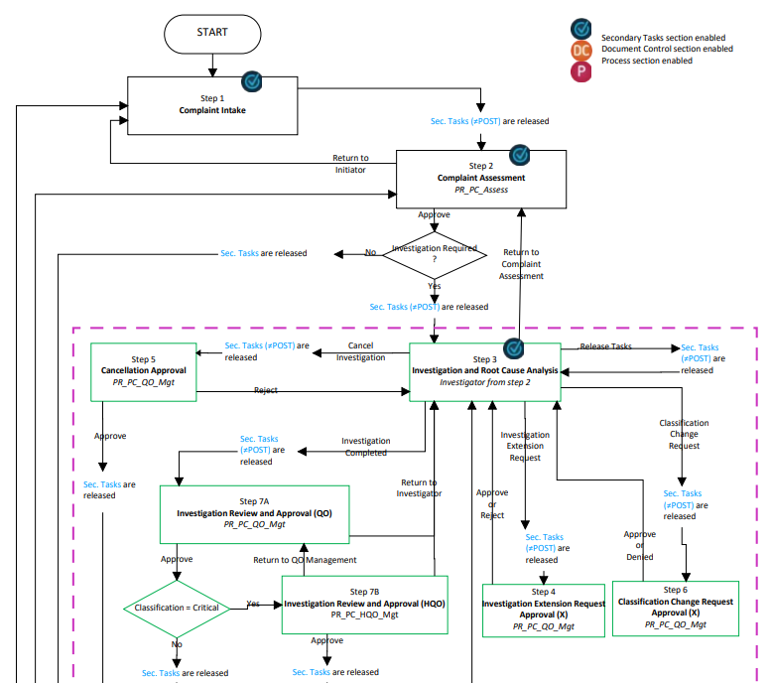

Continued on next page...

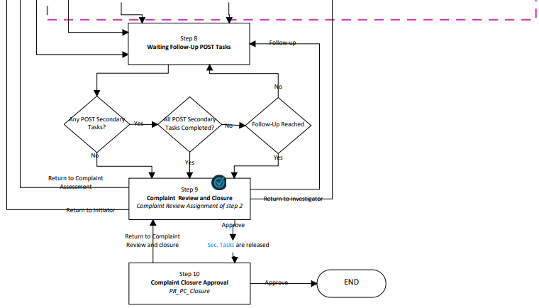

There are some Options that will be available with this Process APP in a future release. Some of these options result in changes to the process flow represented in the above Flow Chart. See Page 48 for additional detail on these future options.

Pharmaceutical Product Complaint (PPC) Process – Process Roles
Decisions made by those involved in the process act to progress the workflow to the next Step or return it to a prior Step. The following PPC Process Roles are associated with the Pharmaceutical Product Complaint Process P0056 and must be assigned to the Users in SOLABS QM10 who will make the related decisions.
When SOLABS QM10 Users are assigned a Process Role, their names are then available on drop-down lists to be selected for their assigned steps in the process. The process will automatically notify them to Act On that Step. They will see the step in the Process Section of their SOLABS QM10 HOME Page and will also receive an email Notification. Contact your SOLABS System Administrator if any of these PPC Process Roles need to be assigned to additional Users.
PR_PPC_Assess:
This Process Role must be assigned to those Users who will need to Act on the following Step:
- Step 2: Complaint Assessment
If there are no users assigned that process role, Step 2 will go to all users with the SOLABS Document Administrator role. If there are no uses with that role, it will go to all users with the SOLABS System Administrator role.
PR_PPC_Inv:
This Process Role must be assigned to those Users who will need to Act on the following Step:
- Step 3: Investigation and Root Cause Analysis
PR_PPC_ QO_Management:
This Process Role must be assigned to those Users who will need to Act on the following Steps:
- Step 4: Investigation Extension Request Approval
- Step 5: Cancellation Approval
- Step 6: Classification Change Request Approval
- Step 7A: Investigation Review and Approval (QO)
If there are no users in the role of PR_PPC_QO_Management the process will go to all users with the SOLABS Document Administrator role. If there are no uses with that role, it will go to all users with the SOLABS System Administrator role.

PR_PPC_HQO_Management:
This Process Role must be assigned to those Users who will need to Act on the following Steps:
- Step 7B: Investigation Review and Approval (HQO)
If there are no users in the role of PR_PPC_HQO_Management the process will go to all users with the SOLABS Document Administrator role. If there are no uses with that role, it will go to all users with the SOLABS System Administrator role.
PR_PPC_Review:
This Process Role must be assigned to those Users who will need to Act on the following Step:
- Step 9: Complaint Review and Closure
PR_PPC_Closure:
This Process Role must be assigned to those Users who will need to Act on the following Step:
- Step 10: Complaint Closure Approval
If there are no users in the role of PR_PPC_Closure the process will go to all users with the SOLABS Document Administrator role. If there are no uses with that role, it will go to all users with the SOLABS System Administrator role.

Starting the Pharmaceutical Product Complaint (PPC) Process
From the PROCESS Section in SOLABS QM10, choose Start Process from the Quick Access Process Menu.
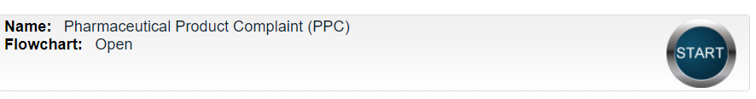
At the next screen, locate the listing for the PPC Process and click the blue START button.

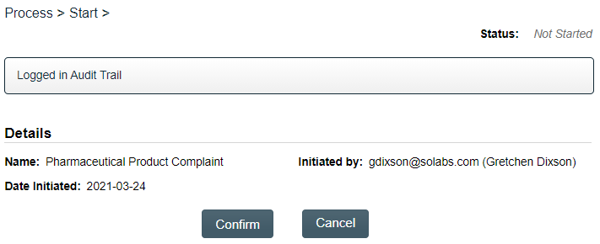
You will then be asked to Confirm this action, to move Status from Not Started to In Process. At this point a Unique ID will be assigned to the PPC Process.

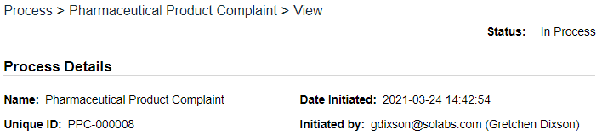

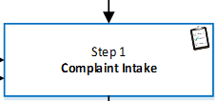
The first Step on the Process Flowchart will now be highlighted when the flowchart is opened.

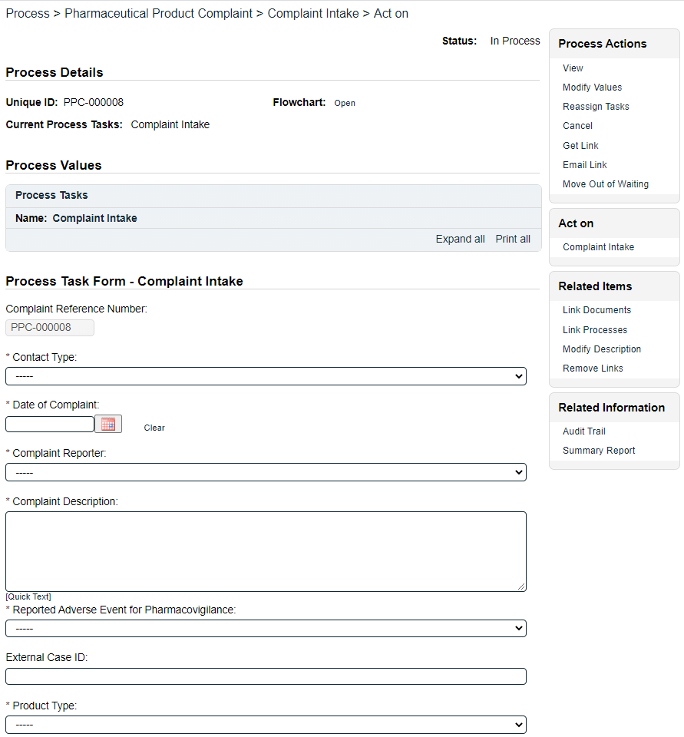
Step 1: Complaint Intake
At Step 1 the user initiating the PPC enters all the required information into the Process Task Form.
The fields on the Process Task Form include editable text fields, text areas, single-item selection fields or multi-item selection fields. Those with an asterisk (*) are mandatory.
The right-hand Related Items menu allows the initiator to Link Documents or Link Processes, if applicable.
Refer to the separate document SOLABS QM10: Introduction to PROCESS Section for information on use of the right-hand menus since they are common to all SOLABS QM Process APP screens.
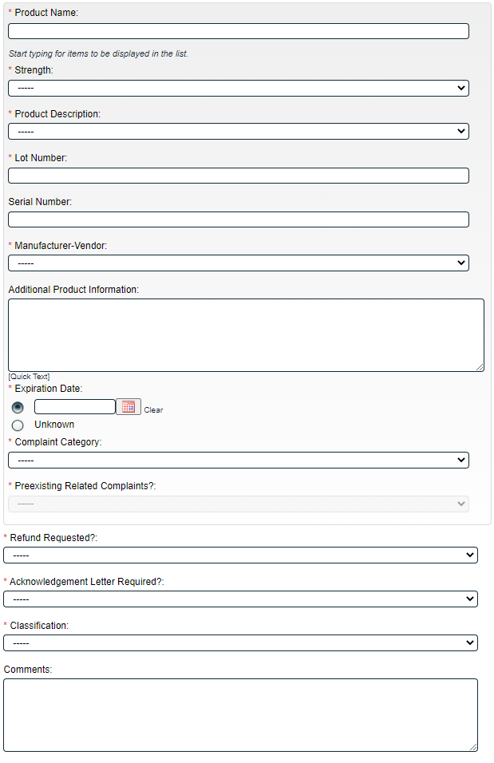
Some of the information entered at Step 1 will determine how the process flows through the remaining steps.
Secondary Tasks can be initiated at Step 1 and are released to assignees upon submission of Step 1, unless they are POST tasks. Related Processes and Document Control Processes cannot be initiated at this step so the related options are grayed out.
Each of the fields in the Process Task Form will be displayed more clearly and described starting on the next page.
At the very bottom of the screen there is a Save Draft option if you cannot complete all the required fields at one time or when you need to use the right-hand menus to Link Documents or to Link Processes.
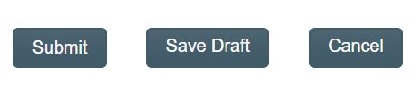

CAUTION: If you navigate away from this page without clicking on either Submit or Save Draft, all entries will be lost. To complete the information after the Save Draft option, you can either choose the Act On option from the Process section of your HOME Page, or search for the In-Process PPC and then use the right-hand Act on Menu to open the Process Task Form fields.

Completing the Process Task Form:
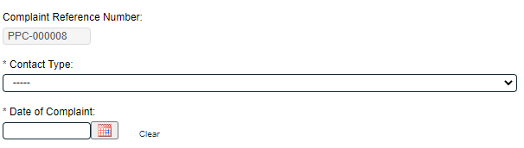
This sub-section covers the information required for each of the fields in the Process Task Form at PPC Process Step 1.
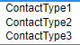

The Complaint Reference Number field will be automatically populated with the assigned Unique ID.

The Contact Type field is a mandatory single-item selection list of values from a configurable Custom List.

The Date of Complaint is mandatory date field that can be populated with today’s date or with previous dates, using the calendar.
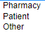
Complaint Reporter is a mandatory single-item selection field that is not customizable and includes a list of 3 set values. Each choice will bring up a set of Contact Group fields to enter the reporter information.

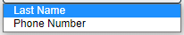
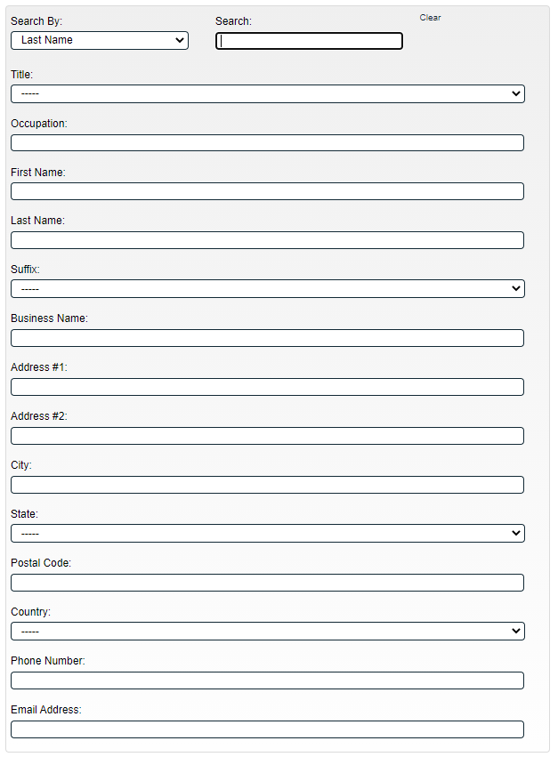
The Contact Group fields can be populated manually, or you can Search By Last Name or Phone Number for previous values that are stored in an EDI Table (EDI list Contact) after entry.

Clear values brought in by Search, with the Clear option.
The following Contact Group fields are Single-item selection fields populated by values from configurable Custom Lists:
Title:
Suffix:
State:
Country:
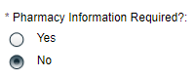
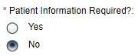
If Complaint Reporter = Patient, a Yes/No option for Pharmacy Information Required? is displayed. A choice of “Yes” brings up another set of Contact Group fields for entry of that information. Similarly, if Complaint Reporter = Pharmacy, a Yes/No option for Patient Information Required? is displayed. A choice of “Yes” brings up another set of Contact Group fields for entry of that information.
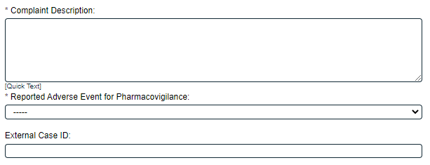
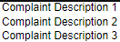

Complaint Description is a mandatory Text Area field allowing for up to 8000 characters. It can also be populated by Quick Text. Quick Text is an editable Custom List of values.

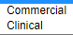
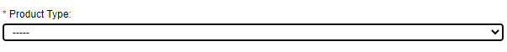
Reported Adverse Event for Pharmacovigilance is a mandatory single-item selection field that is not customizable and allows for a selection of either Yes or No. If Yes is selected, the External Case ID field will become mandatory. This is a Text Field allowing for up to 1024 characters.

Product Type is a mandatory single-item selection field that is not customizable and includes a list of 2 set values.
- If Product Type = Clinical, the following fields are displayed:
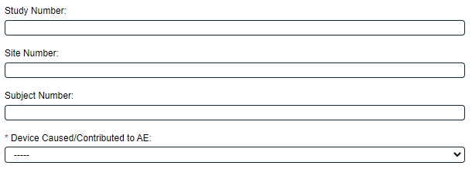

Study Number, Site Number and Site Number are all optional Text Fields allowing entry of up to 1024 characters each. Device Caused/Contributed to AE is a mandatory single-item selection field that is not customizable and allows for a selection of either Yes, No or N/A.
- For either Product Type, a set of Product Group fields are displayed in order to enter the product information.
The Product Name, Strength, Product Description, Manufacturer-Vendor and Complaint Category are all mandatory single-item selection fields with values from an EDI Table EDI list Product that you provide to SOLABS so that they can create dependencies on the values for these fields. Once the Product Name is entered, the values displayed in the Strength, Product Description, Manufacturer-Vendor and Complaint Category lists will be only the ones that apply to that particular product.
Reference Knowledge Base article titled Client Procedure for Updating EDI Tables for more information on EDI Tables.
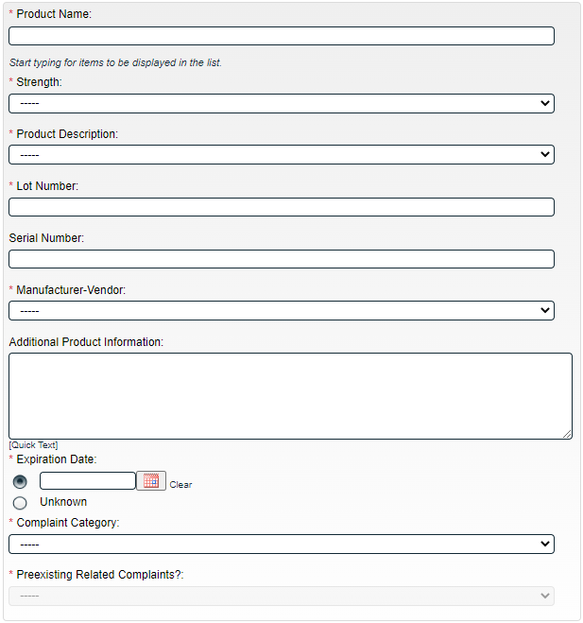

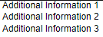

Lot Number and Serial Number are text fields allowing for entry of up to 1024 characters. The Lot Number field is mandatory.
Additional Product Information is an optional text area field allowing for entry of up to 8000 characters and/or the use of Quick Text. Quick Text is an editable Custom List of values.

Expiration Date is a mandatory radio button allowing for either entry of a date or selection of Unknown.
The Preexisting Related Complaints? field is not editable at Step 1. It is editable at Step 3, where it is a mandatory single-item Yes or No selection that is not customizable. When Yes is selected a mandatory Complaint History text area field will be displayed, allowing entry of up to 8000 characters.
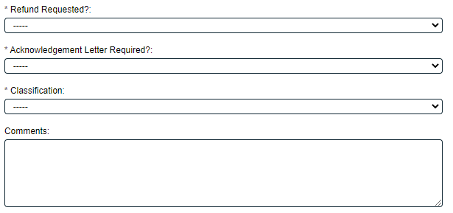

Refund Requested? is a mandatory single-item selection field that is not customizable and that allows for selection of either Yes or No.
Acknowledgement Letter Required? is a mandatory single-item selection field that is not customizable and that allows for selection of either Yes or No.
Classification is a mandatory single-item selection field that is not customizable and that allows for selections of Critical, Major, Moderate, Minor, TBD and N/A. Your internal SOPs should define when each of these are to be used. Whenever the process may be sent back to Step 1, this field will be populated with the latest confirmed value and is modifiable.
Comments is an optional text field allowing for entry of up to 8000 characters.

Creating Secondary Tasks
The initiator of the Pharmaceutical Product Complaint (PPC) Process can create Secondary Tasks that will be associated with the PPC. These Secondary Tasks can be assigned to appropriate Users for activities required to support completion of the PPC. All but Post tasks will be released to assignees upon submission/confirmation of Step 1.
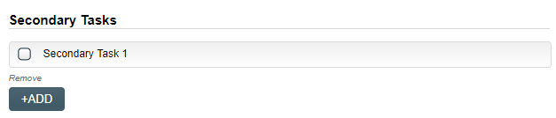
The Secondary Task section is underneath the Process Task Form, but still on the Complaint Intake > Act on screen. A +ADD button is available to create as many Secondary Tasks as needed.
After selecting Secondary Task 1, additional fields will be displayed to define and assign that task.
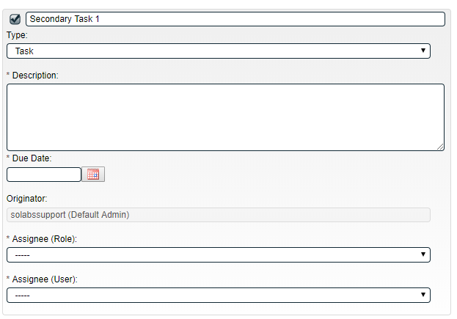
Replace the text “Secondary Task 1” with an appropriate Title for the task.
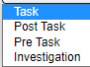
The task Type can then be chosen from a drop-down list of four types.
The Description and Due Date fields are mandatory for each Secondary Task. Choose due dates appropriate to ensure tasks are completed in a time frame that supports on time closure of the Pharmaceutical Product Complaint process.
The Originator field will default to the User initiating the PPC Process and completing Step 1.
Both the Assignee (Role) and the Assignee (User) fields must be completed for the chosen User. The drop-down lists will bring up the Active Roles list and the Active Users list. It is a good practice to consult with the planned Assignee ahead of time to ensure they are able to complete the task in a timeframe that supports on time closure of the process.
To assign by Role, choose the appropriate Function Role from the list. All Users with that Role will then appear in the Assignee (User) drop-down list so that the appropriate person can be selected. To assign by User, choose the appropriate User from the list. Their Function Role will then appear in the Assignee (Role) drop-down list and must be selected.
Use the +ADD button to create additional Secondary Tasks as needed.
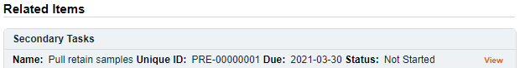
When Step 1 is submitted and confirmed, the Assignees will receive email Notifications and see the View/Act On options for their assigned Secondary Tasks on their SOLABS QM10 HOME Page. The Secondary Tasks, and the status, are listed under Related Items at the bottom of the screen at any Process Step.

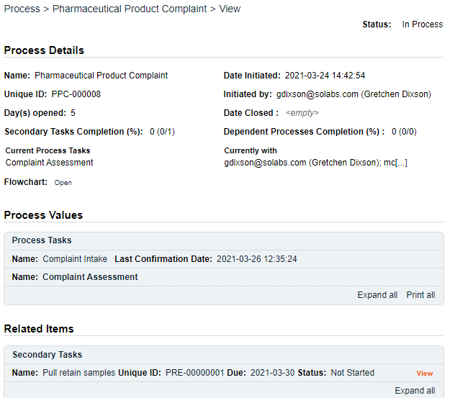
As mentioned previously, Related Processes and related Document Control Processes cannot be initiated at Step 1 so those sections are grayed out.

Submit and Confirm
When all information has been entered into the Process Task Form, any Linked Documents or Linked Processes have been added and any Secondary Tasks have been created, click Submit and then Confirm to progress the PPC process to Step 2 – Complaint Assessment.
The Process Flowchart will highlight the next step of the process. Step 2 will be assigned to users with the Process Role PR_PPC_Assess. They will receive an email Notification.
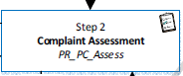

Step 2: Complaint Assessment
At this step in the PPC Process, users with the role PR_PPC_Assess will receive an email Notification and will see the Complaint Assessment task listed in the Process section of the SOLABS QM10 HOME Page.
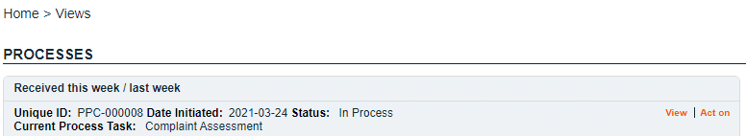

Viewing the Complaint Assessment Task
When the user with the role PR_PPC_Assess clicks on the View option to the right of the Process Task, they will get the same screen shown above.
From the View screen, there are Expand all options under the Process Values table and the Related Items table, that can be used to see more detail on the information entered at Step 1. They can also click on the View option to the right of any individual Related Items (Secondary Tasks, Linked Documents, Linked Processes) to go to the Task Details, Document Details or Process Details screens associated with those Related Items. From any of those screens they can quickly return to the PPC Process since it will be listed as a Related Item on all of those screens. See example below.
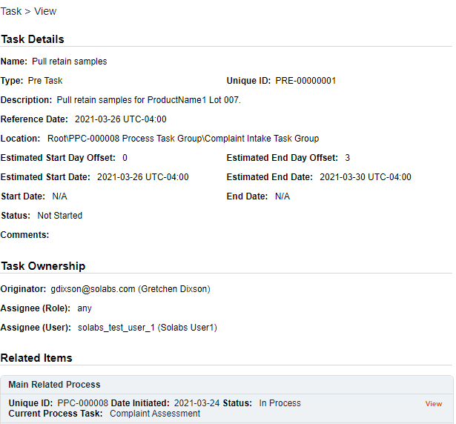
In this example, clicking on View for a Secondary Task listed in PPC-000008 brings up the Task Details screen for that assigned Task.
PPC-000008 is listed as a Related Item for that Task. To get back to PPC-000008, the Reviewer can click on the View option.

Acting on the Complaint Assessment Task
When the user with the PR_PPC_Assess role clicks on the Act on option to the right of the Process Task, they will go immediately to the Act on screen for their Complaint Assessment task. As described above, the Expand all option under the Process Values table can be used to review all information entered at Step 1.
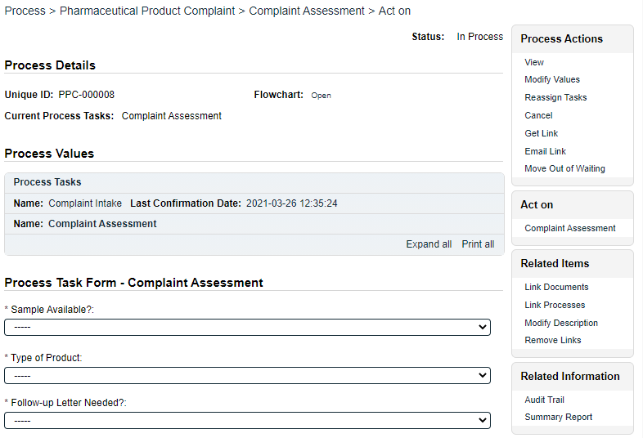
The Process Task Form for Step 2 includes fields to enter information related to the complaint assessment. Fields with an asterisk (*) are mandatory. Some fields will be pre-populated with information from Step 1 but are editable.
Each of the fields in the Process Task Form will be displayed more clearly and described in detail later in this section.
The right-hand Related Items menus can be used to Link Documents or Link Processes. Refer to the separate document SOLABS QM10: Introduction to PROCESS Section for information on use of the right-hand menus since they are common to all SOLABS QM Process APPs.
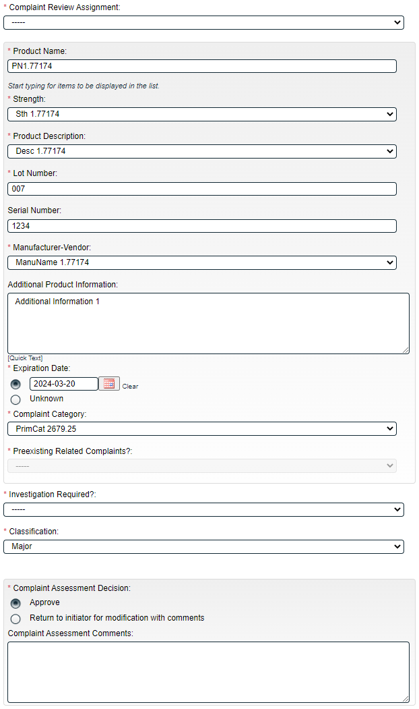
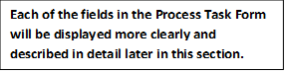
Initiation of more Secondary Tasks, is allowed at Step 2.
There is a Save Draft option at the bottom if all the required fields cannot be completed at one time or when using the right-hand menu to Link Documents or Link Processes.
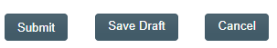

CAUTION: Navigating away from this page without clicking on either Submit or Save Draft, will result in all entries being lost. To complete the information after the Save Draft option, choose either the Act On option from the Process section of your HOME Page, or search for the PPC Process and then use the right-hand Act on Menu to open the Process Task Form fields.

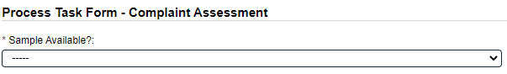

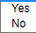
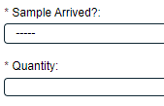
Sample Available? is a single-item selection field that is not customizable and allows values of Yes or No. If Yes is selected, two additional mandatory fields are displayed: Sample Arrived? and Quantity.
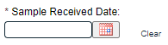
- Sample Arrived? is a single-item selection field that is not customizable and allows values of Yes or No.
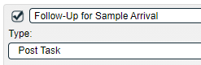
  - If Yes is selected, a mandatory Sample Received Date field is displayed.
  - If No is selected, a POST Secondary Task is automatically generated for Follow-up for Sample Arrival that is editable for details and can be assigned with a due date to any user.
- Quantity is a mandatory text field allowing for up to 1024 characters.

The Type of Product field is a mandatory single-item selection list of values from a configurable Custom List.

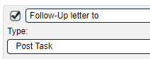
Follow-up Letter Needed?? is a single-item selection field that is not customizable and allows values of Yes or No. If Yes is selected, a POST Secondary Task is automatically generated for Follow-up letter to that is editable for details and can be assigned with a due date to any user.

The Complaint Review Assignment field is a mandatory single-item selection list of users who have the process role assignment of PR_PPC_Review.
The set of Product Group fields is displayed at Step 2. The following 9 fields are pre-populated with the information entered at Step 1 but can be edited. See Page 10 for a description of these fields.
- Product Name  - Strength  - Product Description | - Lot Number  - Serial Number  - Manufacturer-Vendor | - Additional Product Information  - Expiration Date  - Complaint Category

Investigation Required? is a single-item selection field that is not customizable with values of Yes or No.
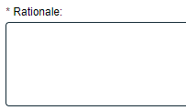
- If No is selected, a mandatory text area field is displayed for Rationale. It allows entry of up to 8000 characters. Also, if No is selected the Sample Available? field is no longer mandatory (see Page 15).
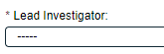
- If Yes is selected, a mandatory single-item selection field for Lead Investigator is displayed. It is a list of users who have the process role assignment of PR_PPC_Inv.

The Classification field (see Page 11) field will be pre-populated with the value selected at Step 1 or the last Confirmed Step (if the process is sent back) but is editable.
NOTE: If the Investigation Required? field = Yes but the Classification field is set to either TBD or N/A, Step 2 will not be able to be submitted. The Submit button will be grayed out and the following message will be displayed in red underneath the Classification field. “The Classification level must be selected before proceeding with the investigation. Values TBD and N/A are not accepted.”
If one or more Secondary Tasks of Task Type = PRE do not have a status of either Completed or Cancelled, the following warning will appear above the Complaint Assessment Decision section. This is for informational purposes.

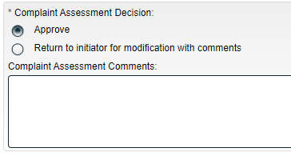
The Complaint Assessment Decision section for Step 2 includes two choices:
- Approve – if this choice is selected, the Complaint Assessment Comments field is not mandatory. Depending on the selections for other fields, certain conditions will apply.
- Return to initiator for modification with comments – if this choice is selected, the Complaint Assessment Comments field will be mandatory and the PPC Process will move back to Step 1.

If Approve is selected for Complaint Assessment Decision and the selection for Lead investigator and Complaint Review Assignment is the same, the following error message is displayed in red and the process is not submitted when the Submit button is clicked. “Please have different users selected as Lead Investigator and Complaint Review Assignment.”
If Approve is selected for Complaint Assessment Decision and Investigation Required? = Yes, all Secondary Tasks except for Task Type = POST will be released to the assignees and the PPC process moves to Step 3, Investigation and Root Cause Analysis on confirmation.
If Approve is selected for Complaint Assessment Decision and Investigation Required? = No, all Secondary Tasks will be released to the assignees and the PPC process moves to Step 8, Waiting Follow-Up POST Tasks on confirmation.

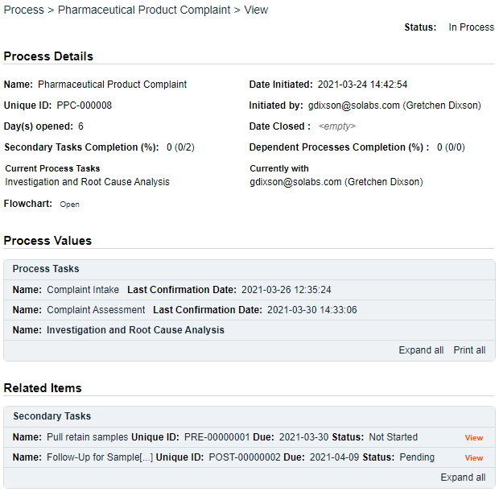
Submit and Confirm
When all information has been entered into the Process Task Form, any Linked Documents or Linked Processes have been added and any Secondary Tasks have been created, click Submit and then Confirm to progress the PPC process to Step 3 – Investigation and Root Cause Analysis or to Step 8 – Waiting Follow-up POST Tasks (see Page 36).
The Process Flowchart will highlight the next step of the process. Step 3 will be assigned to the chosen Lead Investigator. They will receive an email Notification.
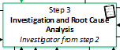

Step 3: Investigation and Root Cause Analysis
At this step in the PPC Process, the Lead Investigator chosen at Step 2 will receive an email Notification and will see the Investigation and Root Cause Analysis task listed in the Process section of the SOLABS QM10 HOME Page.
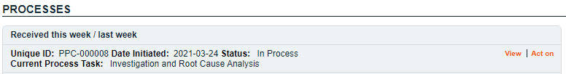

Viewing the Investigation and Root Cause Analysis Task
If the Lead Investigator clicks on the View option to the right of the Process Task, they will get the same screen shown above.
From there, they can use the Expand all options under the Process Values table and the Related Items table to see more detail on the information entered at prior steps. They can also click on the View option to the right of any individual Related Items to go to the Task Details, Document Details or Process Details screens associated with those Related Items. From any of those screens they can quickly return to the Process since it will be listed as a Related Item on all of those screens.

Acting on the Investigation and Root Cause Analysis Task
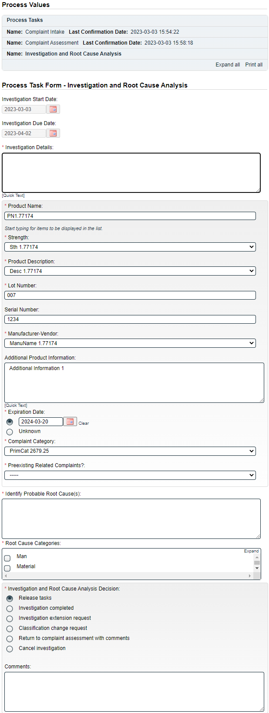
When the Lead Investigator clicks on the Act on option to the right of the Process Task, they will go immediately to the Act on screen for their Investigation and Root Cause Analysis task.
As described above, the Lead Investigator can use the Expand all option under the Process Values table to see all information entered in prior steps.
Each of the fields in the Process Task Form will be displayed more clearly and described starting on the next page.
The right-hand Related Items menu allows the Assigned Reviewer to Link Documents or Link Processes, if applicable.
Refer to the separate document SOLABS QM10: Introduction to PROCESS Section for information on use of the right-hand menus since they are common to all SOLABS QM Process APPs.
Initiation of Secondary Tasks is allowed at Step 3. Any initiated will all have Task Type = Investigation, but Task Type can be edited. Initiation of Related Processes or of a Document Control Process are not allowed at Step 3 so those sections are grayed out.
There is a Save Draft option at the bottom if all the required fields cannot be completed at one time or when using the right-hand menu to Link Documents or Link Processes.

CAUTION: Navigating away from this page without clicking on either Submit or Save Draft, will result in all entries being lost. To complete the information after the Save Draft option, choose either the Act On option from the Process section of your HOME Page, or search for the PPC Process and then use the right-hand Act on Menu to open the Process Task Form fields.
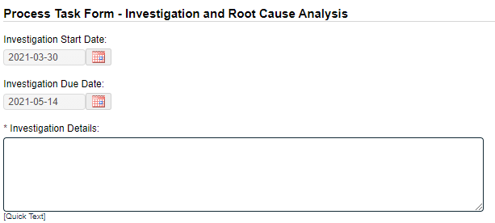

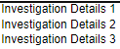

The Investigation Start Date field defaults to the date on which Step 3 is initiated for the first time and is not editable.
The Investigation Due Date field is set based on the following rules and is not editable:
Classification and Corresponding Delay | Is it the first time Investigation Due Date is calculated? | Sample Received Date has a date | Investigation Due Date value
Critical: Delay = 21 days | No | Yes | max(actual Investigation Due Date; Sample Received Date + 21 days)
Critical: Delay = 21 days | No | No | max(actual Investigation Due Date; Investigation Start Date + 21 days)
Critical: Delay = 21 days | Yes | Yes | Sample Received Date + 21 days
Critical: Delay = 21 days | Yes | No | Investigation Start Date + 21 days
Major: Delay = 30 days | No | Yes | max(actual Investigation Due Date; Sample Received Date + 30 days)
Major: Delay = 30 days | No | No | max(actual Investigation Due Date; Investigation Start Date + 30 days)
Major: Delay = 30 days | Yes | Yes | Sample Received Date + 30 days
Major: Delay = 30 days | Yes | No | Investigation Start Date + 30 days
Moderate: Delay = 30 days | No | Yes | max(actual Investigation Due Date; Sample Received Date + 30 days)
Moderate: Delay = 30 days | No | No | max(actual Investigation Due Date; Investigation Start Date + 30 days)
Moderate: Delay = 30 days | Yes | Yes | Sample Received Date + 30 days
Moderate: Delay = 30 days | Yes | No | Investigation Start Date + 30 days
Minor: Delay = 45 days | No | Yes | max(actual Investigation Due Date; Sample Received Date + 45 days)
Minor: Delay = 45 days | No | No | max(actual Investigation Due Date; Investigation Start Date + 45 days)
Minor: Delay = 45 days | Yes | Yes | Sample Received Date + 45 days
Minor: Delay = 45 days | Yes | No | Investigation Start Date + 45 days
Investigation Details is a text area allowing for entry of up to 8000 characters and that can also be populated by Quick Text – a configurable Custom List of values.
The set of Product Group fields is displayed again at Step 3. The following 9 fields are pre-populated with the information entered at Step 1 but can be edited. See Page 10 for a description of these fields.
- Product Name  - Strength  - Product Description | - Lot Number  - Serial Number  - Manufacturer-Vendor | - Additional Product Information  - Expiration Date  - Complaint Category
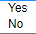

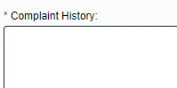
The Preexisting Related Complaints? field, which was part of the Product Group in Steps 1 and 2 but was grayed out, is now a mandatory single-item selection field with options of Yes or No selection that is not customizable.
When Yes is selected, a mandatory text area for Complaint History is displayed, allowing for entry of up to 8000 characters.
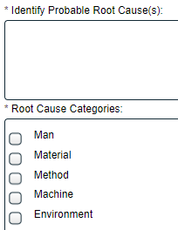
Identify Probable Root Cause(s) is a mandatory text area allowing for entry of up to 8000 characters.

Root Cause Categories is a multiple-item Selection field with set choices of Man, Material, Method, Machine or Environment. For each category selected, another single-item Selection field will be displayed for a more detailed Root Cause. The values for those fields are configurable from shared Custom Lists maintained by the System Administrator.

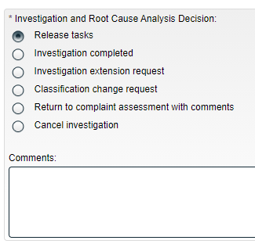
Secondary Tasks initiated at Step 3 will default to a Task Type of Investigation. If one or more Secondary Tasks of Task Type = Investigation are not at a status of Completed or Cancelled, the Investigation completed option will be grayed out in the Investigation and Root Cause Analysis Decision section.
The Investigation and Root Cause Analysis Decision section includes 6 choices and an 8000 character text area for Comments. Confirmation of any choices will release all Secondary Tasks except Task Type = POST to the assignees.
- For decisions of Release tasks or Investigation completed, the Comments field is not mandatory.
  - The Release tasks decision will keep the PPC process at Step 3, Investigation and Root Cause Analysis upon confirmation.
  - The Investigation completed decision will move the PPC process to Step 7A, Investigation Review and Approval (QO) upon confirmation.
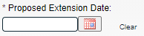
- For a decision of Investigation extension request a mandatory Proposed Extension Date field is displayed. Confirmation of this decision will move the PPC process to Step 4, Investigation Extension Request Approval upon confirmation.
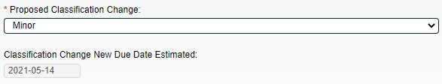
- For a decision of Classification change request two additional fields are displayed – a single-item selection for Proposed Classification Change and an uneditable field for Classification Change New Due Date Estimated. The date in that field is calculated based on the rules on Page 20. Confirmation of this decision will move the PPC process to Step 6, Classification Change Request Approval.

- Confirmation of a decision of Return to complaint assessment with comments will move the PPC process back to Step 2, Complaint Assessment.
- Confirmation of a decision of Cancel investigation will move the PPC process to Step 5, Cancellation Approval.

Submit and Confirm
When all information has been entered into the Process Task Form, any Linked Documents or Linked Processes have been added and any Secondary Tasks have been created, click Submit and then Confirm to progress the PPC process as described above. The Process Flowchart will highlight the next step of the process and the Process View page will identify the current step and assignees. Assignees will receive an email Notification for their assigned process step. Use the Table of Contents to see information on the various process steps.

Step 4: Investigation Extension Request Approval
At this step in the PPC Process, users with the process role assignment PR_PPC_QO_Management will receive an email Notification and will see the Investigation Extension Request Approval task listed in the Process section of the SOLABS QM10 HOME Page. The number in parenthesis after task name indicates the number of times an Investigation Extension has been requested. In this example, it is the first time.
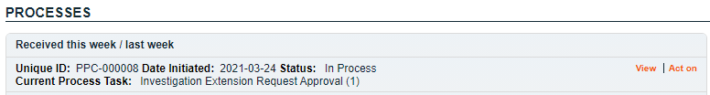

Viewing the Investigation Extension Request Approval Task
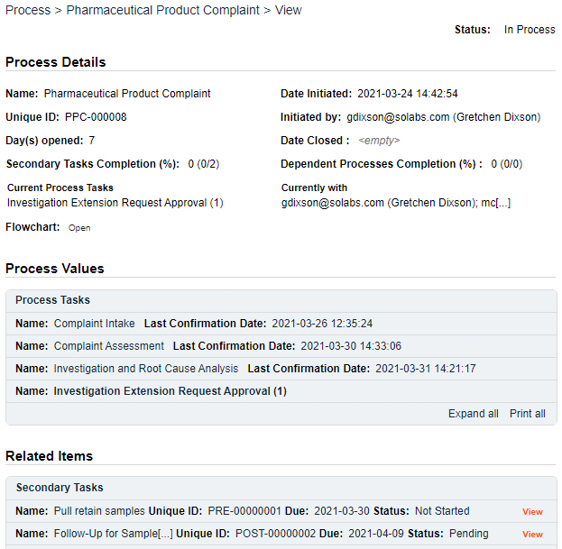
If the assigned user clicks on the View option to the right of the Process Task, they will get the following screen.
From there, they can use the Expand all options under the Process Values table and the Related Items table to see more detail on the information entered at prior steps.
They can also click on the View option to the right of any individual Related Items to go to the Task Details, Document Details or Process Details screens associated with those Related Items. From any of those screens they can quickly return to the Process since it will be listed as a Related Item on all of those screens.

Acting on the Investigation Extension Request Approval Task
When the assignee clicks on the Act on option to the right of the Process Task, they will go immediately to the Act on screen for their Investigation Extension Request Approval task.
As described above, the assignee can use the Expand all option under the Process Values table to see all information entered in prior steps. The right-hand Related Items menu allows the assignee to Link Documents or Link Processes, if applicable.
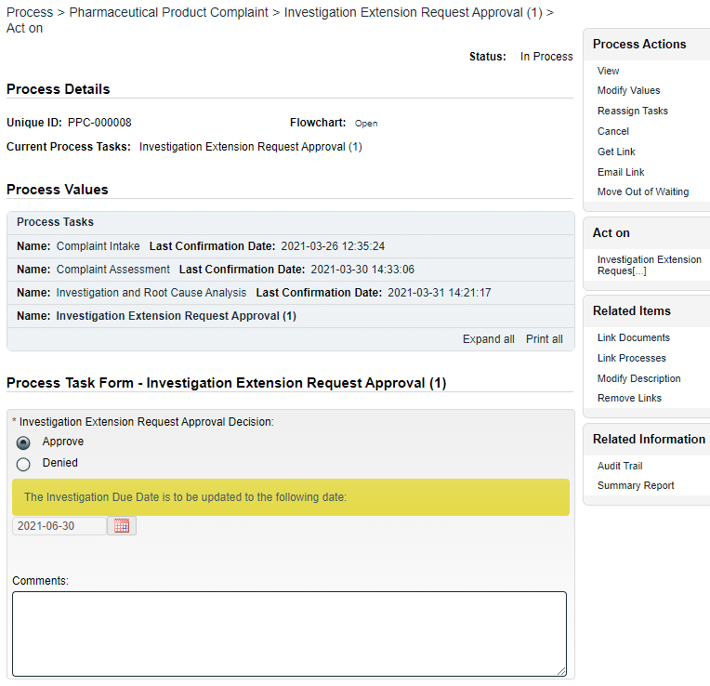
Initiation of Secondary Tasks, Related Processes or a Document Control Process are not allowed at Step 4 so those sections are grayed out.

The Investigation Extension Request Approval Decision defaults to Approve and displays the requested date in a noneditable date field. There is also a statement in a yellow box indicating the request for an updated date.
There is a Save Draft option at the bottom if all the required fields cannot be completed at one time or when using the right-hand menu to Link Documents or Link Processes.

CAUTION: Navigating away from this page without clicking on either Submit or Save Draft, will result in all entries being lost. To complete the information after the Save option click the Act on option from the Process section of your HOME Page, or search for the PPC Process and then use the right-hand Act on Menu to open the Process Task Form fields.
If the Investigation Extension Request Approval Decision is changed to Denied, the 8000-character text area field for Comments becomes a mandatory field.
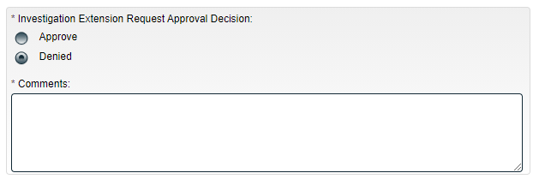

A decision of Approve moves the PPC process back to Step 3, Investigation and Root Cause Analysis and the Investigation Due Date will have been changed to the new date.
A decision of Denied will also move the PPC process back to Step 3, Investigation and Root Cause Analysis but the Investigation Due Date will not have been changed. The Lead Investigator will have the opportunity to review and respond to the Comments.
- At that point the Lead Investigator will again have the option to request a new Due Date. That request will go back to Step 4 with (2) after the task name.

Submit and Confirm
When all information has been entered into the Process Task Form and any Linked Documents or Linked Processes have been added, click Submit and then Confirm to move the PPC process back to Step 3, Investigation and Root Cause Analysis. Refer back to Page 19.

Step 5: Cancellation Approval
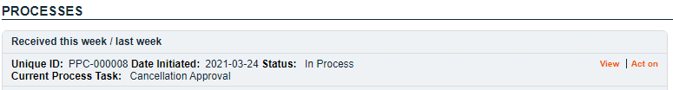
At this step in the PPC Process, users with the process role assignment PR_PPC_QO_Management will receive an email Notification and will see the Cancellation Approval task listed in the Process section of the SOLABS QM10 HOME Page.

Viewing the Cancellation Approval Task
If the assigned user clicks on the View option to the right of the Process Task, they will get the following screen.
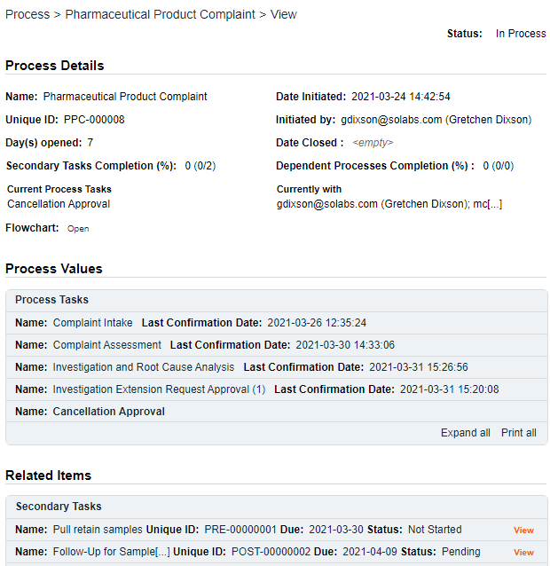
From there, they can use the Expand all options under the Process Values table and the Related Items table to see more detail on the information entered at prior steps.
They can also click on the View option to the right of any individual Related Items to go to the Task Details, Document Details or Process Details screens associated with those Related Items. From any of those screens they can quickly return to the Process since it will be listed as a Related Item on all of those screens.

Acting on the Cancellation Approval Task
When the assignee clicks on the Act on option to the right of the Process Task, they will go immediately to the Act on screen for their Cancellation Approval task.
As described above, the assignee can use the Expand all option under the Process Values table to see all information entered in prior steps. The right-hand Related Items menu allows the assignee to Link Documents or Link Processes, if applicable.
Initiation of Secondary Tasks, Related Processes or a Document Control Process are not allowed at Step 5 so those sections are grayed out.

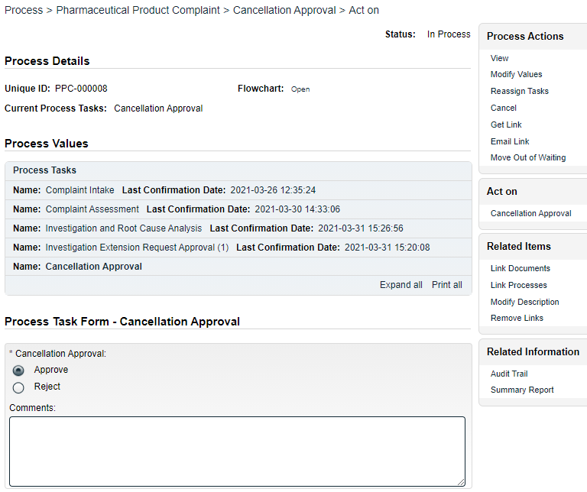

The Cancellation Approval decision defaults to Approve with an 8000-character text area for Comments that is not mandatory.
There is a Save Draft option at the bottom if all the required fields cannot be completed at one time or when using the right-hand menu to Link Documents or Link Processes.

CAUTION: Navigating away from this page without clicking on either Submit or Save Draft, will result in all entries being lost. To complete the information after the Save option click the Act on option from the Process section of your HOME Page, or search for the PPC Process and then use the right-hand Act on Menu to open the Process Task Form fields.
If the Cancellation Approval Decision is changed to Reject, the 8000-character text area field for Comments becomes a mandatory field.
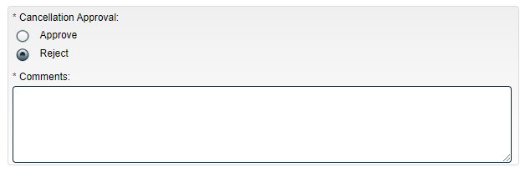

A decision of Approve moves the PPC process back to Step 8, Waiting Follow-up POST Tasks. All Secondary Tasks are released to their assignees upon confirmation of that decision.
A decision of Reject will move the PPC process back to Step 3, Investigation and Root Cause Analysis and results in the Comments field becoming mandatory. The Lead Investigator will have the opportunity to review and respond to the Comments.

Submit and Confirm
When all information has been entered into the Process Task Form and any Linked Documents or Linked Processes have been added, click Submit and then Confirm to move the PPC as described above. Refer to the Table of Contents for this document for information on the specific steps.

Step 6: Classification Change Request Approval
At this step in the PPC Process, users with the process role assignment PR_PPC_QO_Management will receive an email Notification and will see the Classification Change Request Approval task listed in the Process section of the SOLABS QM10 HOME Page. The number in parenthesis after task name indicates the number of times a Classification Change has been requested. In this example, it is the first time.
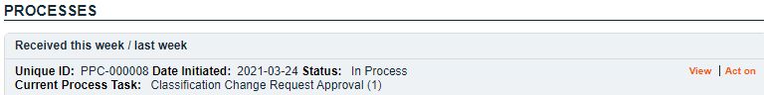

Viewing the Classification Change Request Approval Task
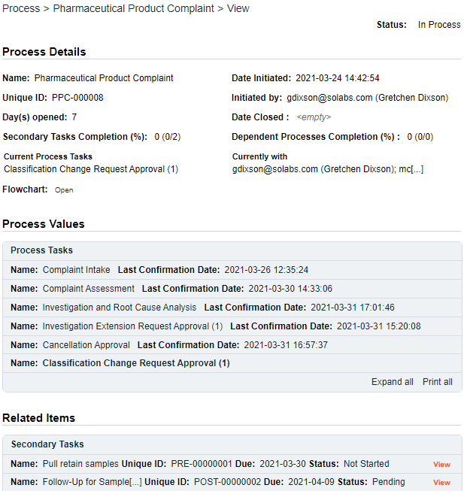
If the assigned user clicks on the View option to the right of the Process Task, they will get the following screen.
From there, they can use the Expand all options under the Process Values table and the Related Items table to see more detail on the information entered at prior steps.
They can also click on the View option to the right of any individual Related Items to go to the Task Details, Document Details or Process Details screens associated with those Related Items. From any of those screens they can quickly return to the Process since it will be listed as a Related Item on all of those screens.

Acting on the Classification Change Request Approval Task
When the assignee clicks on the Act on option to the right of the Process Task, they will go immediately to the Act on screen for their Classification Change Request Approval task.
As described above, the assignee can use the Expand all option under the Process Values table to see all information entered in prior steps. The right-hand Related Items menu allows the assignee to Link Documents or Link Processes, if applicable.
Initiation of Secondary Tasks, Related Processes or a Document Control Process are not allowed at Step 6 so those sections are grayed out.

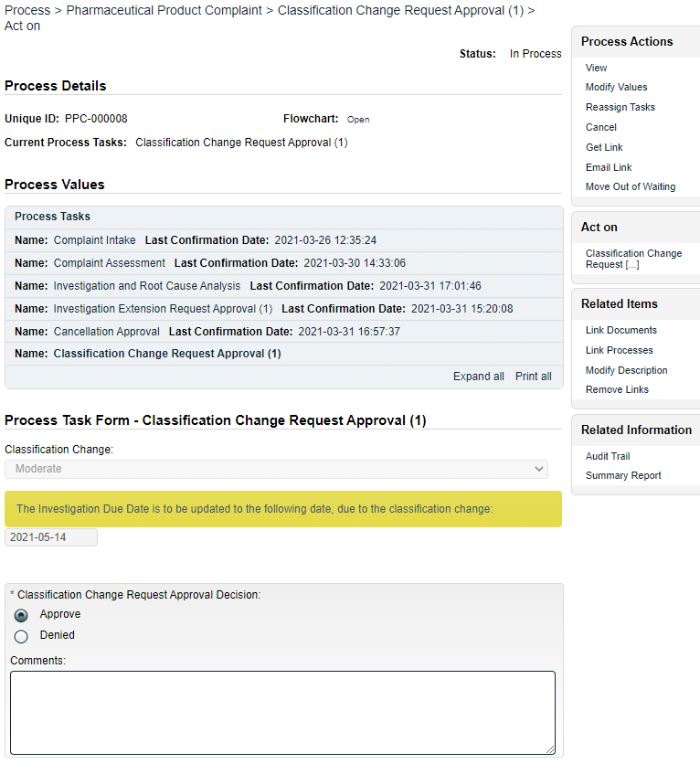

The Classification Change Request Approval Decision defaults to Approve and displays the proposed Classification Change and the revised Investigation Due Date associated with the requested classification (refer to Table on Page 20), both in noneditable fields. There is also a statement in a yellow box indicating that the Investigation Due Date is to be updated due to the classification change. An 8000-character text area is available for Comments.
There is a Save Draft option at the bottom if all the required fields cannot be completed at one time or when using the right-hand menu to Link Documents or Link Processes.

CAUTION: Navigating away from this page without clicking on either Submit or Save Draft, will result in all entries being lost. To complete the information after the Save option click the Act on option from the Process section of your HOME Page, or search for the PPC Process and then use the right-hand Act on Menu to open the Process Task Form fields.
If the Classification Change Request Approval Decision is changed to Denied, the 8000-character text area field for Comments becomes a mandatory field.
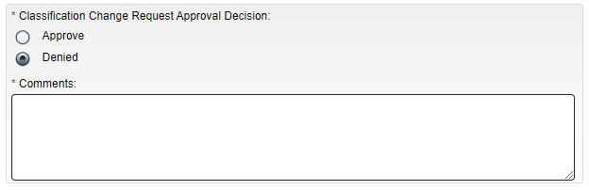

A decision of Approve moves the PPC process back to Step 3, Investigation and Root Cause Analysis where the Classification and the Investigation Due Date will have been changed to reflect the new information.
A decision of Denied will also move the PPC process back to Step 3, Investigation and Root Cause Analysis but the Classification and the Investigation Due Date will not have been changed. The Lead Investigator will have the opportunity to review and respond to the Comments.
- At that point the Lead Investigator will again have the option to request a new Classification. That request will go back to Step 6 with (2) after the task name.

Submit and Confirm
When all information has been entered into the Process Task Form and any Linked Documents or Linked Processes have been added, click Submit and then Confirm to move the PPC process back to Step 3, Investigation and Root Cause Analysis. Refer back to Page 19.

Step 7A: Investigation Review and Approval (QO)
Step 7A can be reached only when the Investigation and Root Cause Analysis Decision at Step 3, Investigation and Root Cause Analysis is Investigation completed.
At this step in the PPC Process, users with the process role assignment PR_PPC_QO_Management will receive an email Notification and will see the Investigation Review and Approval (QO) task listed in the Process section of the SOLABS QM10 HOME Page.
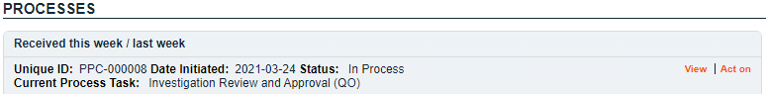

Viewing the Investigation Review and Approval Task
If the assigned user clicks on the View option to the right of the Process Task, they will get the following screen.
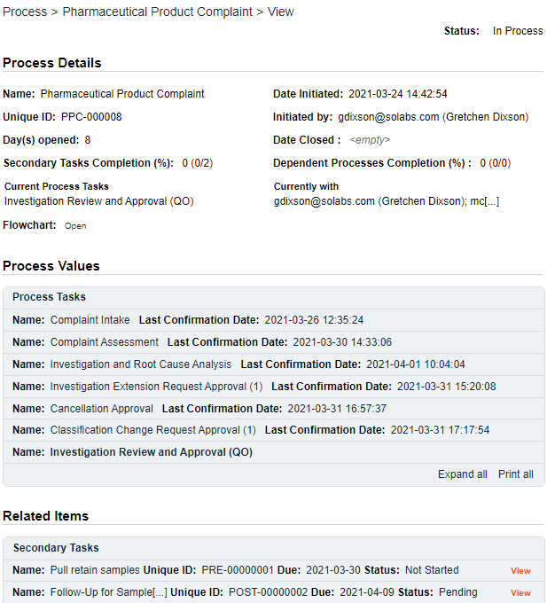
From there, they can use the Expand all options under the Process Values table and the Related Items table to see more detail on the information entered at prior steps.
Depending on how many times the PPC process may have gone to Steps 4, 5 or 6 for Extension Requests, Classification Change Requests or Cancellation Requests, there could be many steps in the Process Values table by this point.
They can also click on the View option to the right of any individual Related Items to go to the Task Details, Document Details or Process Details screens associated with those Related Items. From any of those screens they can quickly return to the Process since it will be listed as a Related Item on all of those screens.

Acting on the Investigation Review and Approval (QO) Task
When the assignee clicks on the Act on option to the right of the Process Task, they will go immediately to the Act on screen for their Investigation Review and Approval (QO) task. As described above, the assignee can use the Expand all option under the Process Values table to see all information entered in prior steps. The right-hand Related Items menu allows the assignee to Link Documents or Link Processes, if applicable.
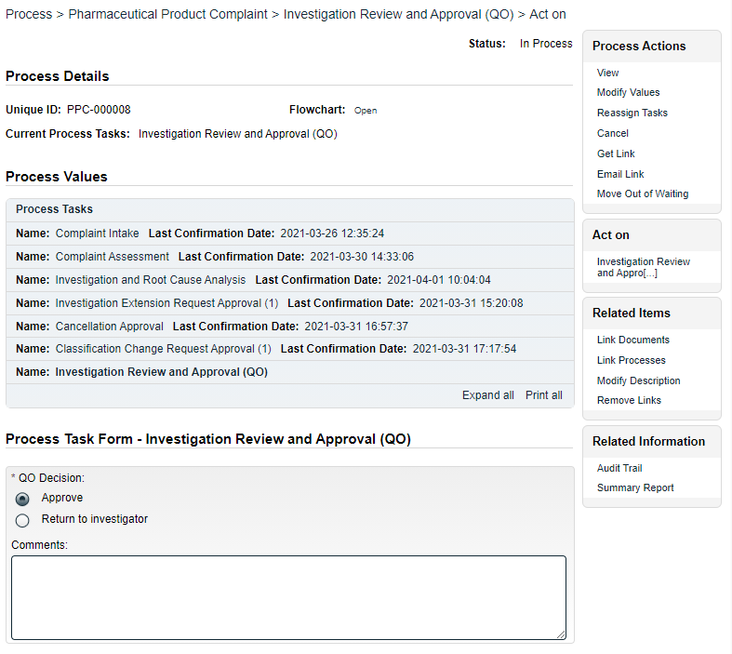
Initiation of Secondary Tasks, Related Processes or a Document Control Process are not allowed at Step 7A so those sections are grayed out.

The QO Decision section includes two options. It defaults to Approve, with an 8000-character text area for Comments, that is not mandatory.
- An Approve decision for complaint Classification = Critical will move the PPC process to Step 7B, Investigation Review and Approval (HQO) upon confirmation.
- An Approve decision for complaint Classification ≠ Critical will move the PPC process to Step 8, Waiting Follow-up POST Tasks upon confirmation. All Secondary Tasks will be released to the assigniees and each Secondary Task with Task Type = POST will have its Due Date set to 10 days after confirmation of Step 7A.
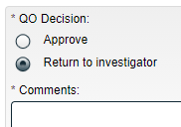
- A Return to investigator decision will require mandatory Comments and move the PPC process back to Step 3, Investigation and Root Cause Analysis upon confirmation.

Submit and Confirm
When all information has been entered into the Process Task Form and any Linked Documents or Linked Processes have been added, click Submit and then Confirm to move the PPC process as described above. Refer to Page 19 for information on Step 3 and see below for information on Steps 7B and 8.

Step 7B: Investigation Review and Approval (HQO)
Step 7B is applicable only when a complaint of Classification = Critical is approved at Step 7A.
At this step in the PPC Process, users with the process role assignment PR_PPC_HQO_Management will receive an email Notification and will see the Investigation Review and Approval (HQO) task listed in the Process section of the SOLABS QM10 HOME Page.
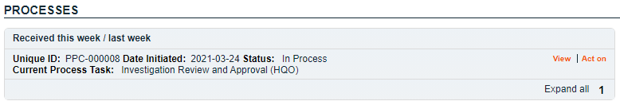

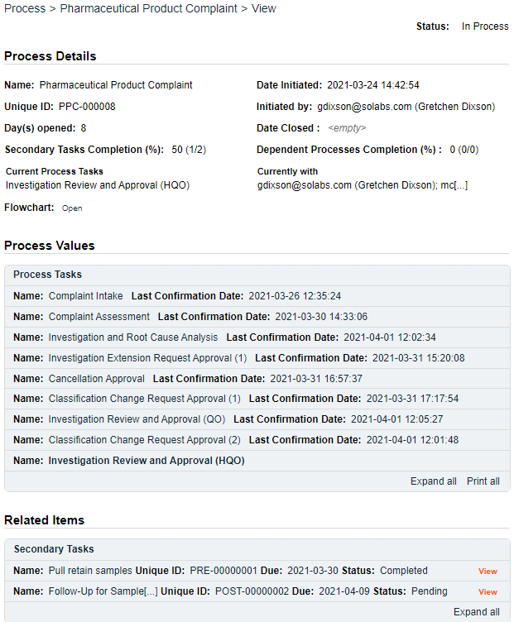
Viewing the Investigation Review and Approval (HQO) Task
If the assigned user clicks on the View option to the right of the Process Task, they will get the following screen.
From there, they can use the Expand all options under the Process Values table and the Related Items table to see more detail on the information entered at prior steps.
They can also click on the View option to the right of any individual Related Items to go to the Task Details, Document Details or Process Details screens associated with those Related Items. From any of those screens they can quickly return to the Process since it will be listed as a Related Item on all of those screens.

Acting on the Investigation Review and Approval (HQO) Task
When the assignee clicks on the Act on option to the right of the Process Task, they will go immediately to the Act on screen for their Investigation Review and Approval (HQO) task. As described above, the assignee can use the Expand all option under the Process Values table to see all information entered in prior steps. The right-hand Related Items menu allows the assignee to Link Documents or Link Processes, if applicable.
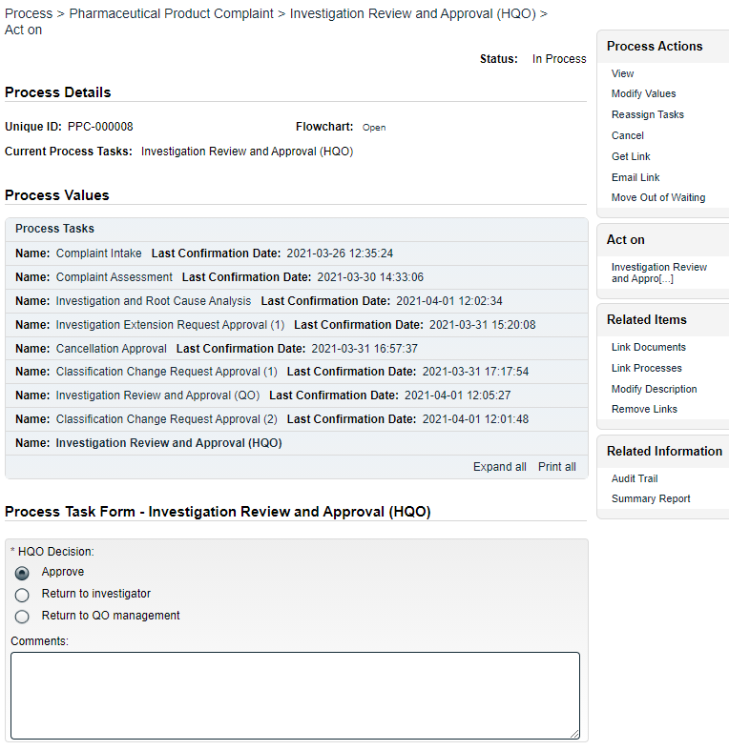
Initiation of Secondary Tasks, Related Processes or a Document Control Process are not allowed at Step 7B so those sections are grayed out.

The HQO Decision section includes three options. It defaults to Approve, with an 8000-character text area for Comments, that is not mandatory.
- An Approve decision will move the PPC process to Step 8, Waiting Follow-up POST Tasks upon confirmation. All Secondary Tasks will be released to the assigniees and each Secondary Task with Task Type = POST will have its Due Date set to 3 days after confirmation of Step 7B.
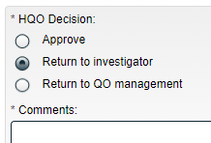
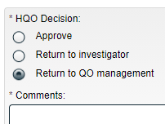
- A Return to investigator decision will require mandatory Comments and move the PPC process back to Step 3, Investigation and Root Cause Analysis upon confirmation.
- A Return to QO management decision will require mandatory Comments and move the PPC process back to Step 7A, Investigation Review and Approval (QO).

Submit and Confirm
When all information has been entered into the Process Task Form and any Linked Documents or Linked Processes have been added, click Submit and then Confirm to move the PPC process as described above.

Step 8: Waiting Follow-up POST Tasks
Step 8 is a Waiting Phase for any Secondary Tasks that have not been completed or cancelled. As mentioned in Steps 7A and 7B, due dates for POST Task Types will have been set at either 10 days after confirmation of Step 7A or 3 days after confirmation of Step 7B.
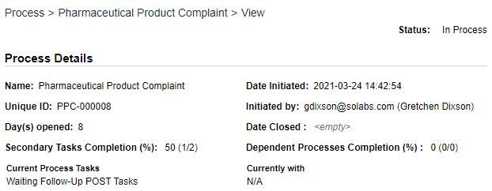
NOTE: If there are no POST Tasks the PPC Process will have skipped Step 8 and will have progressed to Step 9, Complaint Review and Closure.

If all POST Tasks are at a status of either Completed or Cancelled the PPC Process will move to Step 9, Complaint Review and Closure.
Under certain other situations, the PPC process will also move from Step 8 to Step 9, Complaint Review and Closure:
- The PPC Process at this point is not back at Step 8 from Step 9 and the complaint Classification ≠ Critical and the current date is now 9 days past the date Step 8 was initiated
- The PPC Process at this point is not back at Step 8 from Step 9 and the complaint Classification = Critical and the current date is now 2 days past the date Step 8 was initiated
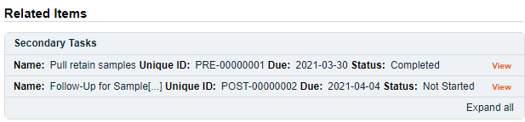
All Secondary Tasks are listed in the Related Items section where their status is visible when viewing the PPC Process View screen. Clicking on the listing for Secondary Tasks not at a status of Completed, will provide detail on who it is assigned to, in order to allow follow-up with the assignee as necessary.

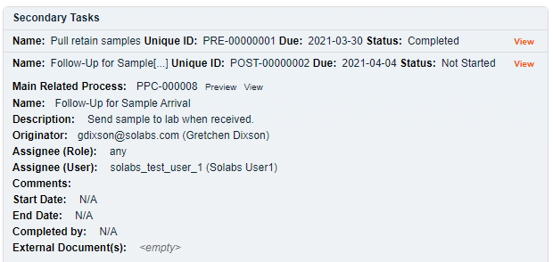

Step 9: Complaint Review and Closure
When this step in the PPC Process is reached, the user selected at Step 2 for Complaint Review Assignment will receive an email Notification and will see the Complaint Review and Closure task listed in the Process section of the SOLABS QM10 HOME Page.
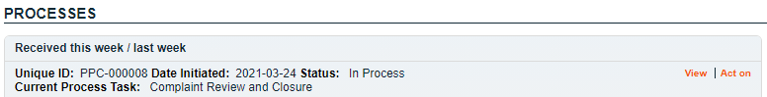

Viewing the Complaint Review and Closure Task
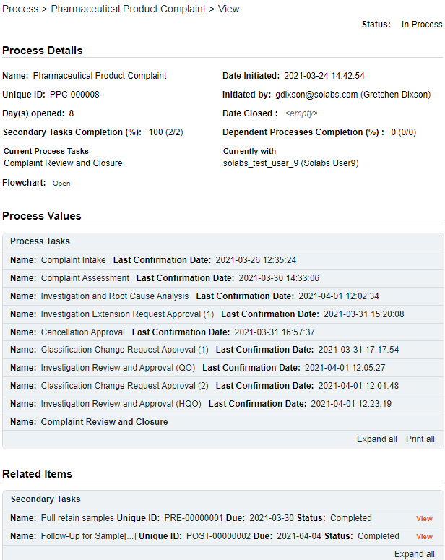
If the assigned user clicks on the View option to the right of the Process Task, they will get the following screen.
From there, they can use the Expand all options under the Process Values table and the Related Items table to see more detail on the information entered at prior steps.
They can also click on the View option to the right of any individual Related Items to go to the Task Details, Document Details or Process Details screens associated with those Related Items. From any of those screens they can quickly return to the Process since it will be listed as a Related Item on all of those screens.
Creation of additional Secondary Tasks is allowed at Step 9.
Initiation of Related Processes or a Document Control Process is not allowed at Step 9 so those sections are grayed out.

Acting on the Complaint Review and Closure Task
When the assignee clicks on the Act on option to the right of the Process Task, they will go immediately to the Act on screen for their Complaint Review and Closure task. As described above, the assignee can use the Expand all option under the Process Values table to see all information entered in prior steps. The right-hand Related Items menu options are available to allow the assignee to Link Documents or Link Processes, if applicable.

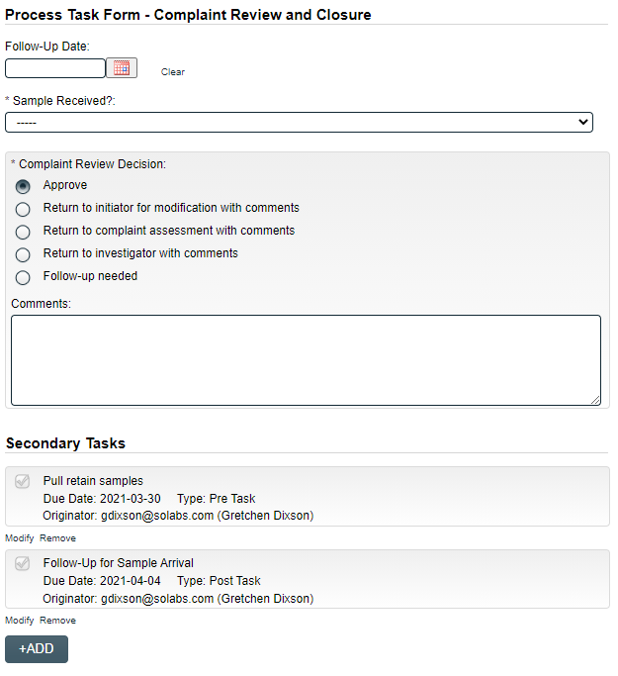

The fields displayed on this page, and the options enabled in the Complaint Review Decision section will vary based on selections made at this step and at some previous steps.
The Follow-Up Date field is mandatory only if the Complaint Review Decision is chosen as Follow-up needed. It will not allow entry of dates in the past.
The 8000-character text area for Comments is mandatory for all Complaint Review Decision selections except for Approve.
The mandatory Sample Received? field is displayed only if at Step 2 Sample Available? = Yes and Sample Arrived? = No. It is a single-item selection field with values of Yes or No. If Yes is selected, the Complaint Review Decision will default to Return to complaint assessment with comments. Other decisions are still available.
If the entry at Step 2 for Investigation Required? = No, the Complaint Review Decision of Return to investigator with comments is disabled and grayed out.
If there are any Secondary Tasks of Task Type = POST that are not at a status of either Completed or Cancelled, the following warning message is displayed in orange: “Secondary Tasks of type POST are not completed.”
If there are any Secondary Tasks of Task Type = POST that are not at a status of either Completed or Cancelled, the Complaint Review Decision of Approve will be disabled and grayed out.
If there are any Secondary Tasks of Task Type = POST that are not at a status of either Completed or Cancelled and Sample Received? ≠ Yes, the Complaint Review Decision will default to Follow-up needed.
The confirmed selection for Complaint Review Decision will move the PPC Process as follows:
- Approve moves the PPC process to Step 10, Complaint Closure Approval
- Return to initiator for modification with comments moves the PPC process to Step 1, Complaint Intake
- Return to complaint assessment with comments moves the PPC process to Step 2, Complaint Assessment
- Return to investigator with comments moves the PPC process to Step 3, Investigation and Root Cause Analysis
- Follow-up needed moves the PPC process to Step 8, Waiting Follow-Up POST Tasks

Submit and Confirm
When all information has been entered into the Process Task Form and any Linked Documents or Linked Processes have been added, click Submit and then Confirm to move the PPC process as described above.

Step 10: Complaint Closure Approval
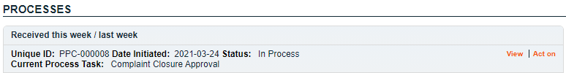
When this step in the PPC Process is reached, all users with the process role PR_PPC_Closure will receive an email Notification and will see the Complaint Review and Closure task listed in the Process section of the SOLABS QM10 HOME Page.

Viewing the Complaint Closure Approval Task
This is the last step in the Pharmaceutical Product Complaint (PPC) Process If the assigned user clicks on the View option to the right of the Process Task, they will get the same right-hand menu options as described in other steps. Secondary Tasks, Related Processes and a Document Control Process cannot be initiated at this step so those sections are grayed out.

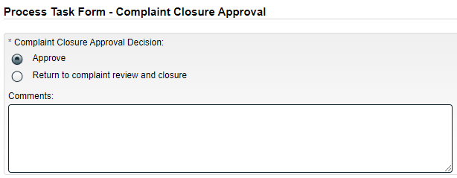
Acting on the Complaint Closure Approval Task

The Complaint Closure Approval Decision section includes two options. It defaults to Approve, with an 8000-character text area for Comments, that is not mandatory.
A decision of Approve will close the PPC process upon confirmation, putting the status to Completed.
If at least one Secondary Task is not at a status of Completed or Cancelled, the Approve option is disabled and the following message is displayed in red below the Decision field: “Process cannot be closed. Some Secondary Tasks are pending.”
A decision of Return to complaint review and closure will result in the Comments field becoming mandatory, and will move the PPC process back to Step 9, Complaint Review and Closure upon confirmation.
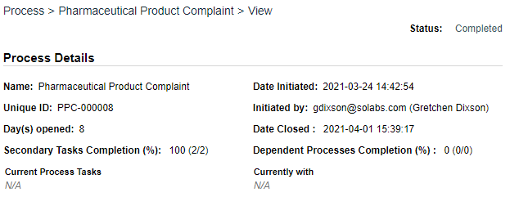

Viewing Details for a Completed Pharmaceutical Product Complaint (PPC) Process
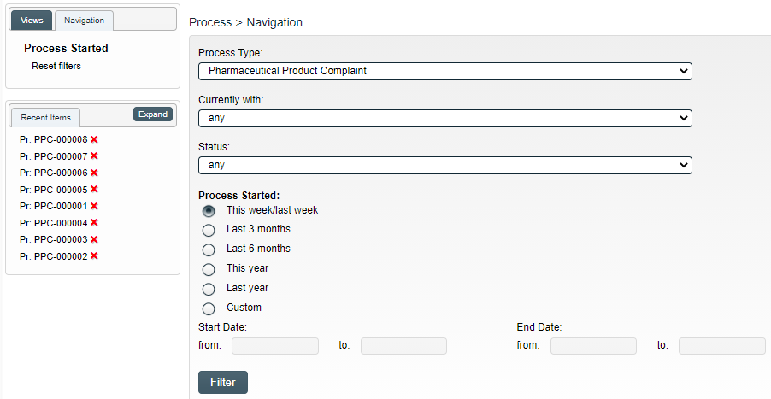
Users are able to search for and view processes at any stage, using the Navigation tab in the PROCESS Section of SOLABS QM10. If the Process was recently worked on, it will also be available in the Recent Items section.

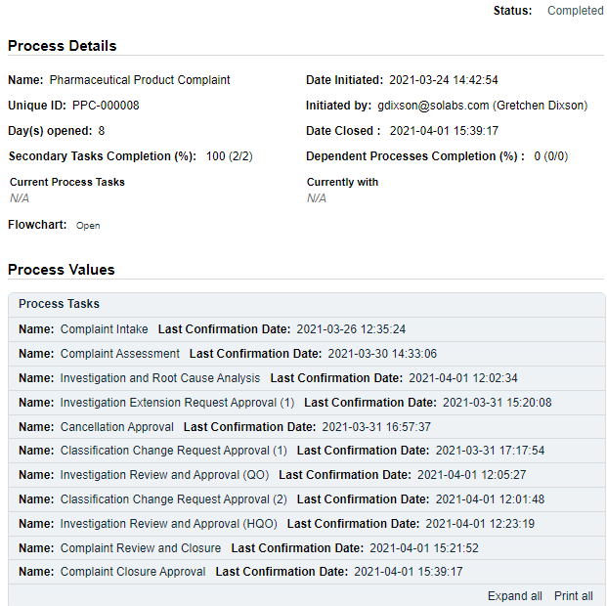
Using the Process Values Table
Process Tasks can be viewed by using the Expand all or Print all options at the bottom of the Process Values table. An individual Process Task can be expanded by clicking on it within the Process Values table.

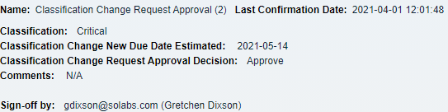

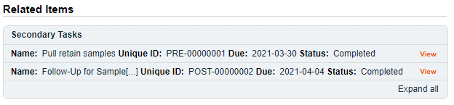
Using the Related Items Table
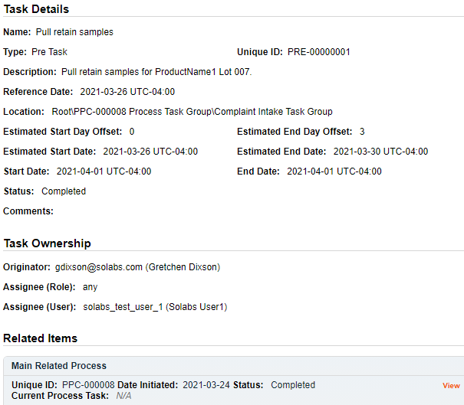
Information on any Secondary Tasks can be accessed by clicking on the View option beside the listing in the Related Items section of the screen. From any of those Details screens, the Process will be listed under Related Items – you can quickly toggle back to the Main Process by clicking View next to it.

Creating a Summary Report
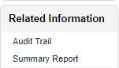
Under the right-hand Related Information menu, click on the Summary Report option.
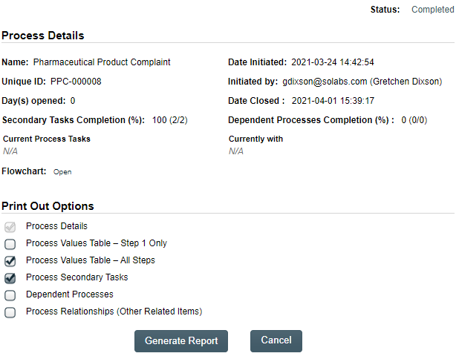
Select the desired Print Out Options and then click on Generate Report. A multi-page PDF Report will be generated, with any company header information set in System Configurations, and will include details on each step requested for the report.
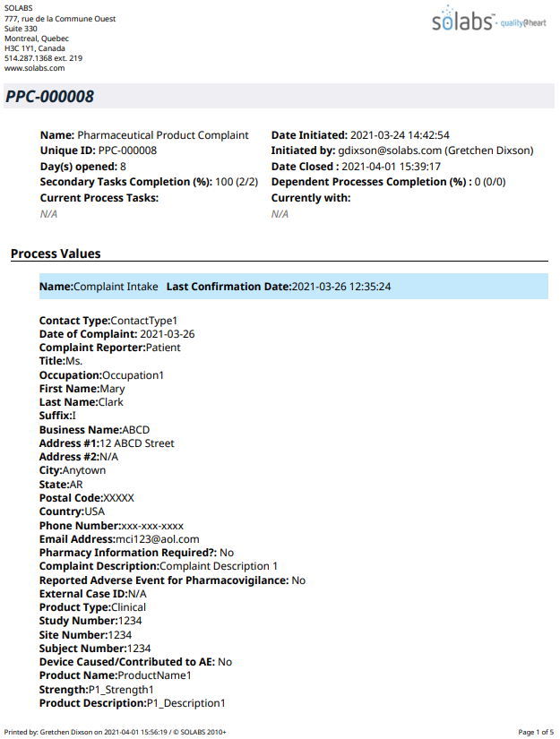

Using the Audit Trail
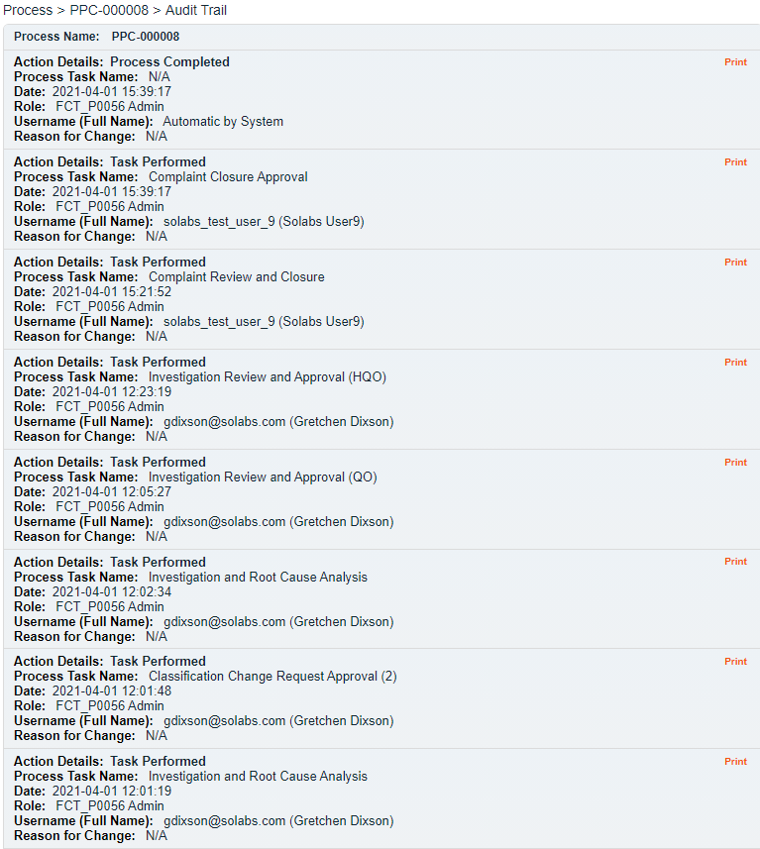
Users with the SOLABS System Administrator role assignment, will also see the Audit Trail option on the right-hand Related Information menu.
There you will find all the details for every step of the PPC Process, from Process Completed all the way down to Process Started, with options to expand or print the entire process or any individual steps.

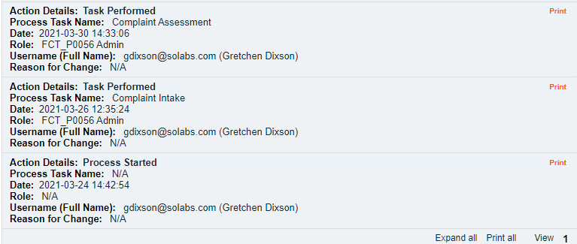

Pharmaceutical Product Complaint (PPC) Process Notifications
As mentioned throughout this document, Users will see process tasks listed on their SOLABS QM10 HOME Page and can View or Act on them from there. They will also receive Email Notifications, that include a link to SOLABS QM10.
General information on SOLABS QM10 Notifications available with the Core Software can be found in the SOLABS Knowledge Base in a document titled SOLABS QM10: Notifications Guide.
Some additional Custom Notifications are available with Pharmaceutical Product Complaint (PPC) Process P0056.

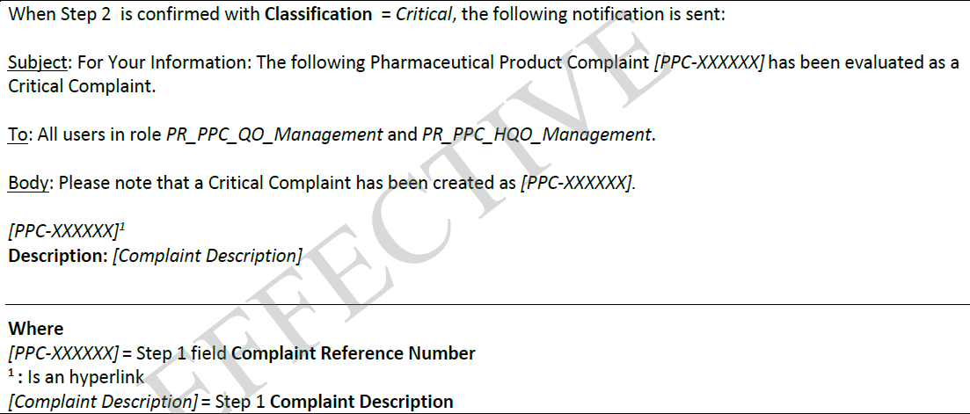
Custom Notifications

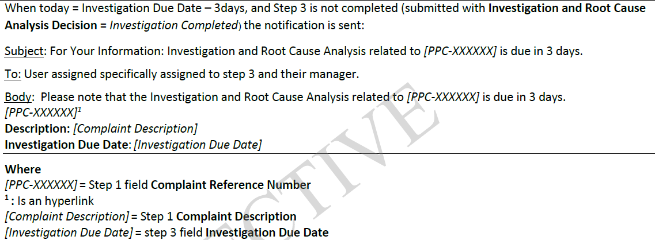

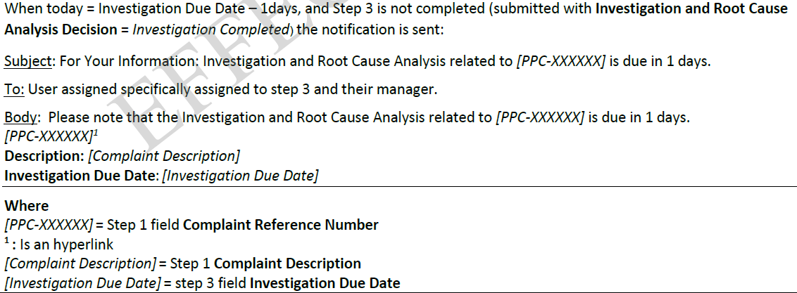

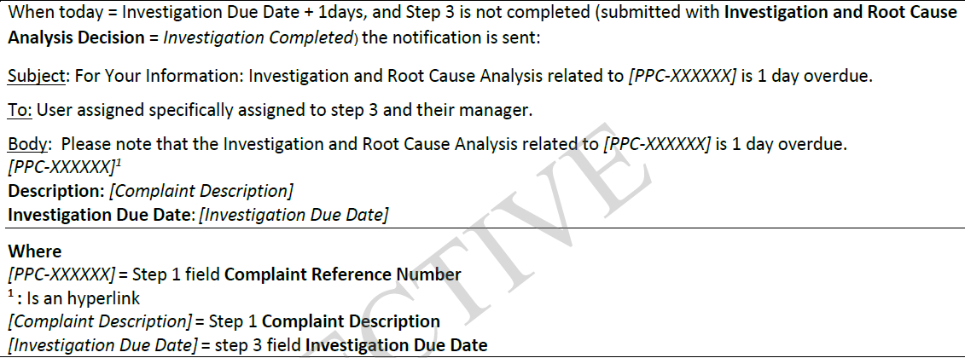

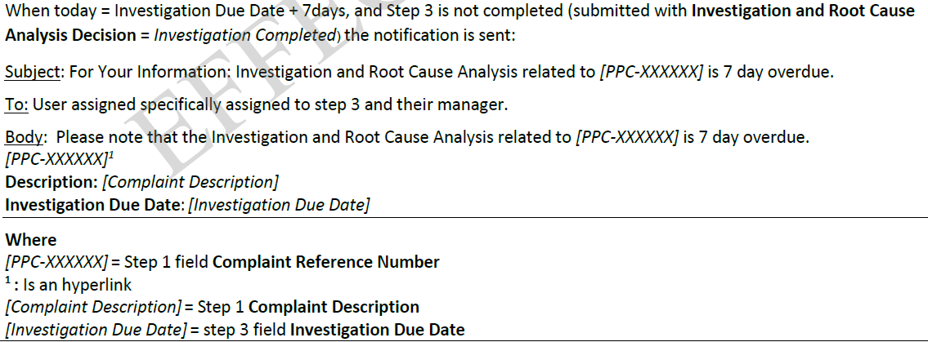

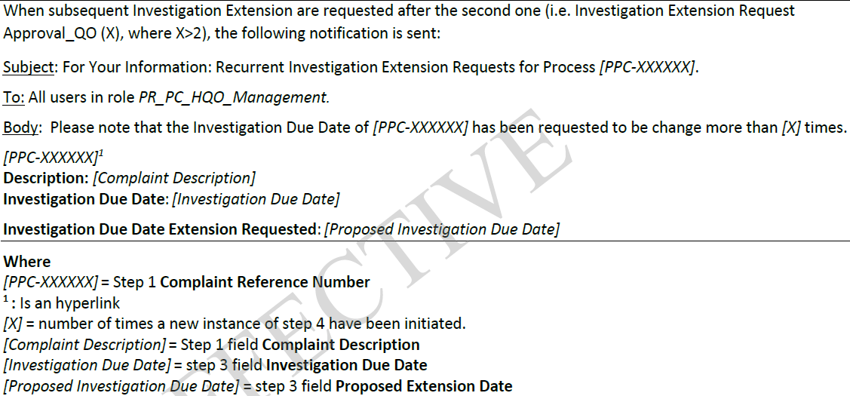

Available Options for Pharmaceutical Product Complaint (PPC) Process
NOTE: The options described in this section are planned for a future release of this Process APP.
Option 1A: Option to change some of the field labels on the Process Task Forms
Option 2: This option modifies the flow of the process to by-pass the second investigation approval (Step 7B). If the QO Decision = Approve and the Step 2 field Classification = Critical, all Secondary Tasks are made available to their assignees on confirmation. Each Secondary Task with a Task Type of POST will have the Due Date set to {Date of Step 7B confirmation} + 3 days.
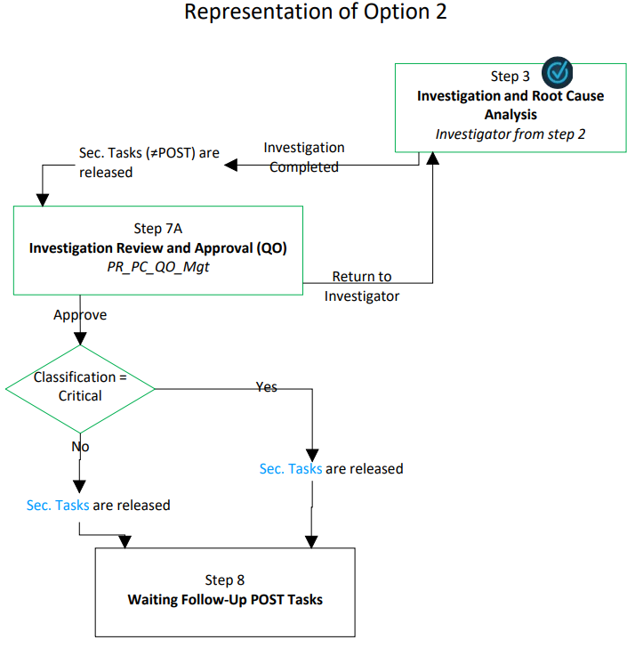
Option 3: This option limits the number of investigation extensions that are allowed. If 2 or more Investigation Extensions have been approved (via Step 4), the option Investigation Extension is grayed out and disabled in the Investigation and Root Cause Analysis Decision at Step 3.
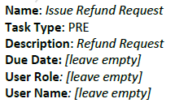
Option 4: This option automatically creates a Secondary Task for Refund. If Yes is selected for Refund Requested? At Step 1, the following Secondary Task is automatically generated:

Option 5: This option modified the flow of the process to by-pass Step 10, allowing the process to close after Step 9. A Complaint Review Decision of Approve at Step 9 closes the process on confirmation. If at least one Secondary Task is not Completed or Cancelled, the decision option Approve is disabled and the following message is displayed in red below the Decision field: “Process cannot be closed. Some Secondary Tasks are pending.”
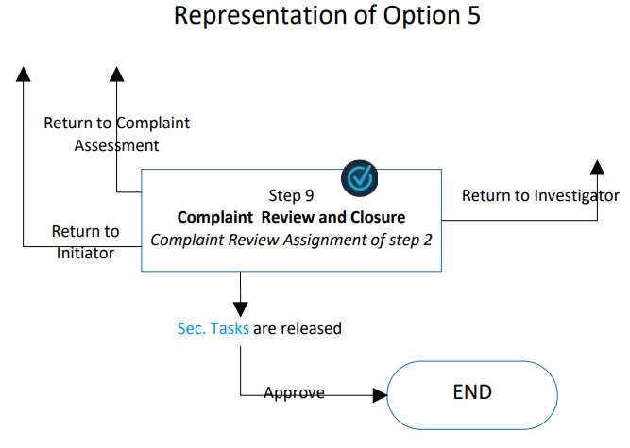
Option 6: This option modifies the flow of the process to add an Adverse Drug Reaction investigation, Step 3A. At Step 2, if Investigation Required? = Yes, then a mandatory Yes/No field ADR Investigation Required? is displayed. If ADR Investigation Required? = Yes, then the field ADR Investigator is displayed.
If Approve is selected for Complaint Assessment Decision at Step 2 and the selection for ADR Investigator and Complaint Review Assignment is the same, the following error message is displayed in red below the decision and the process is not submitted when the Submit button is clicked: “Please have different users selected as ADR Investigator and Complaint Review Assignment.”
If Approve is selected for Complaint Assessment Decision at Step 2, Investigation Required? = Yes and ADR Investigation Required? = Yes, the process moves to Step 3 and 3A on confirmation.
At Step 3, if ADR Investigation Required? = Yes and Step 3A is not completed, the decision option of Investigation Completed is disabled and grayed out.
If implementing this option, Step 3A is called ADR Investigation and is assigned to the user selected in Step 2 as ADR Investigator. This step includes a mandatory 8000-character Text Area called ADR Investigation Details that can be populated with Quick Text. Secondary Tasks can be added at this step but Related Processes and Document Control Processes cannot. Secondary Tasks initiated at Step 3A have a Task Type that defaults to ADR Investigation. If one or more of these tasks does not have the status of Completed or Cancelled, the decision ADR Investigation Completed is disabled and grayed out.
If the ADR Investigation Decision is set to Release Tasks or to ADR Investigation Completed the Comments field is not mandatory.
If the ADR Investigation Decision = Release Tasks, the process moves back to Step 3A on confirmation.
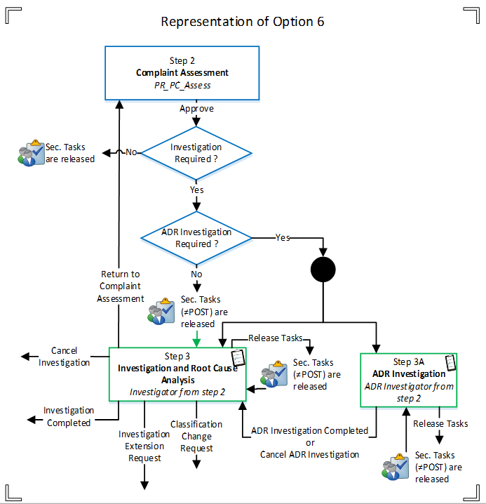
If the ADR Investigation Decision = ADR Investigation Completed or Cancel ADR Investigation, the process continues to other steps on confirmation. All Secondary Tasks, except Task Type = POST are made available to their assignees on confirmation of Step 3A.

