SOLABS QM10: Deviation Process P0054 User Guide
Introduction 2
Deviation Process Flowcharts 3
Deviation Process – Process Roles 4
Starting the Deviation Process 5
Step 1: Initiation and Immediate Action(s) 6
Completing the Process Task Form: 7
Creating Secondary Tasks 9
Initiating a Related Process 10
Submit and Confirm 11
Step 2: QA Assessment 12
Viewing a QA Assessment Task 12
Acting on the QA Assessment Task 13
QA Assessment Decision – Submit and Confirm 15
Secondary Task Assignments – Assignee Actions 17
Viewing the Secondary Task 17
Acting on the Secondary Task 18
Step 3: Investigation Plan 19
Acting on the Investigation Plan Task 19
Extension Request Step 21
Acting on the Extension Request Task 21
Extension Request Approval Step 22
Acting on the Extension Request Approval Task 22
Step 4: QA Investigation Plan Approval 24
Acting on the QA Investigation Plan Approval Task 25
Step 5: Investigation Execution 26
Acting on the Investigation Execution Task 26
Investigation Execution Decision 28
Additional Tasks 30
Acting on the Additional Tasks Task 30
Investigation Technical Approval 32
Acting on the Investigation Technical Approval Task 32
Step 6: Final QA Assessment 33
Acting on the Final QA Assessment Task 34
Step 7: Head of Quality Final Approval 36
Acting on the Head of Quality Final Approval Task 36
Viewing Details for a Completed Deviation Process 37
Using the Process Values Table 37
Creating a Summary Report 38
Using the Audit Trail 39
Deviation Process Notifications 40
Included Notifications 40
Additional Notification Available on Request – Option 2 43

Introduction
This document provides instructions on the use of the SOLABS QM10 Deviation Process APP P0054 – by guiding you through each step in the process and providing information on the activities, settings and options associated with each step. Detailed information on this process, including any available options that can be chosen by the client, are available in the Process User Functional Design Specification (PUFDS) document that comes with deployment of the Process in your instance of SOLABS QM10.
Refer to the following documents available in the SOLABS Knowledge Base for general information, navigation and functionality common to any SOLABS QM Process APP in the SOLABS QM PROCESS Section.
- SOLABS QM10: Introduction to PROCESS Section
- SOLABS QM10: Notifications Guide
- SOLABS QM10 PROCESS Section: Parent/Child Process Relationships
Different steps in a process are assigned to different roles and/or users in the system. You take action on the step assigned to you. For example, you may be assigned a QA Assessment step in a Deviation process. A manager can monitor the status of process tasks assigned to their employees by using the Process Section search capabilities or the Process Reports to query process status by user.

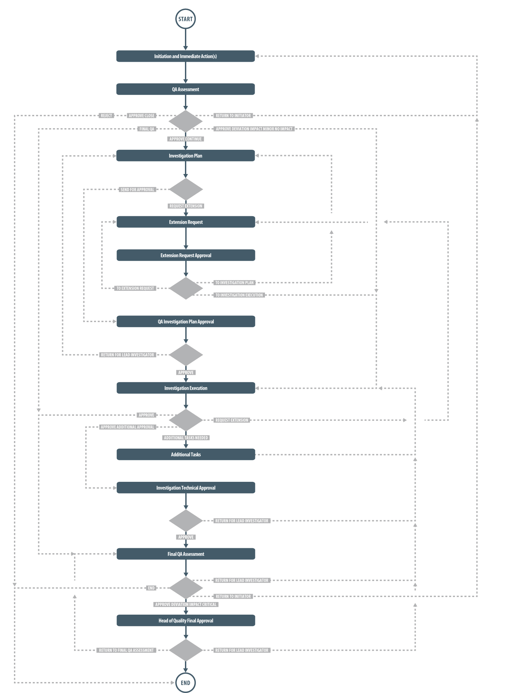
Deviation Process Flowcharts
The Deviation Process Flowcharts are displayed on this page for informational purposes only - to show that it is a complex multi-step process with many related decision paths.
The Flowchart shown at the right is available within the Process App. As the process moves along, the active step in that Flowchart is highlighted.
The Flowchart shown below is available as part the User Functional Specification (UFDS) document that is provided with the Process App.

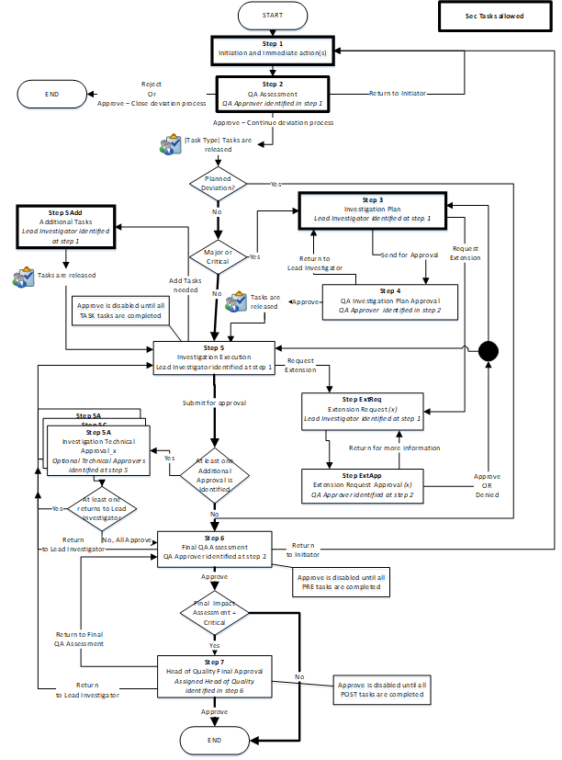

This User Guide is organized into sections for each of the Steps in the Deviation Process. The flowchart section for each of those steps will be displayed in larger, more readable format within those sections.

Deviation Process – Process Roles
The major steps in the process are displayed in the Process Flowchart by dark-shaded boxes. These major steps are considered Primary Tasks in the process. Decisions made by those involved in the process act to progress it to the next Step or return it to a prior Step.
The following Deviation Process Roles are associated with the Deviation Process P0054 and need to be assigned to the Users in SOLABS QM10 who will make the related decisions and/or need to receive process email Notifications.
When SOLABS QM10 Users are assigned a Process Role, their names are then available on drop-down lists to be selected for their assigned steps in the process. The process will automatically notify them to Act On that process step. They will see the task for that step in the Process Section of their SOLABS QM10 HOME Page and will also receive an email Notification. Contact your SOLABS System Administrator when any of these Deviation Process Roles need to be assigned to additional Users.
PR_DEV_Committee_Notification:
This Process Role must be assigned to those Users who should be notified at the following Steps in the Deviation Process. This is an optional Process Role. The related field can be selected as Yes, No or N/A.
- Step 2 - QA Assessment
- Step 6 – Final QA Assessment
- Step 7 – Head of Quality Final Approval
PR_DEV_Lead_Investigator:
This Process Role must be assigned to those Users who will be asked to perform the following Steps in the Deviation Process:
- Investigation Plan
- Extension Request
- Investigation Execution
- Additional Tasks
When all Secondary Tasks of type = TASK have a status of Completed or Cancelled, the chosen Lead Investigator will get an email Notification.
PR_DEV_QA_Approver:
This Process Role must be assigned to those Users from Quality who will be asked to perform the following Steps in the Deviation Process:
- QA Assessment
- Extension Request Approval
- QA Investigation Plan Approval
- Final QA Assessment
When Step 1 is confirmed with a choice of “Yes” for Does this deviation impact distributed product? Everyone with this role assignment will get an email Notification.
When all Secondary Tasks of type = Pre-Disposition have a status of Completed or Cancelled, the chosen QA Approver will get an email Notification.

PR_DEV_QA_Head:
This Process Role must be assigned to those Users from Quality who will be asked to perform the following Steps in the Deviation Process:
- Head of Quality Final Approval
When all Secondary Tasks of type = Post-Disposition have a status of Completed or Cancelled, the chosen QA Head will get an email Notification.

Starting the Deviation Process
From the PROCESS Section in SOLABS QM10, choose Start Process from the Quick Access Process Menu.
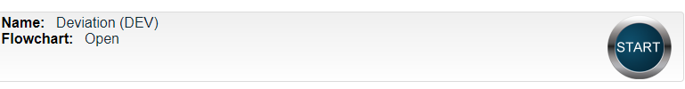
At the next screen, locate the listing for the Deviation Process and click the blue START button.

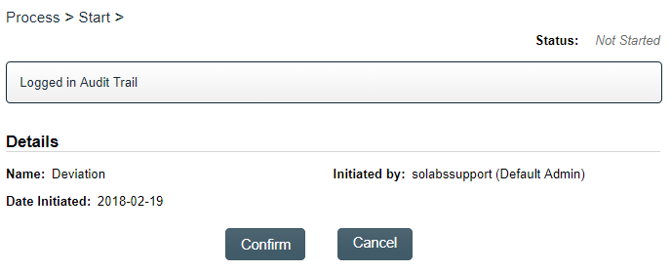
You will then be asked to Confirm this action, to move Status from Not Started to In Process. At this point a Unique ID will be assigned to the Deviation Process.

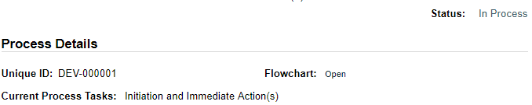

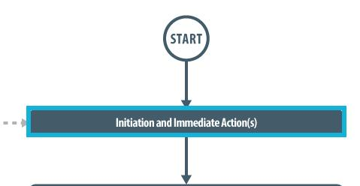
The first Step on the Process Flowchart will now be highlighted when the flowchart is opened.

Step 1: Initiation and Immediate Action(s)
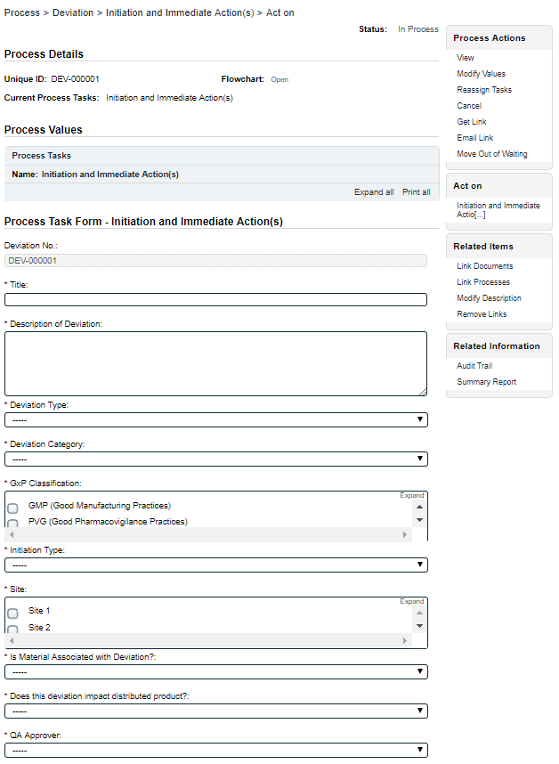
At Step 1 the user initiating the Deviation enters all the required information into the Process Task Form.
As seen on the screen shot to the right, there are many fields to be completed by the initiator at this step. This page provides some general information on the various types of fields.
Some of the fields on the Process Task Form are editable text fields or text areas. Others are single-item selection drop-down lists or multi-item selection fields. Fields with an asterisk (*) are mandatory.
The right-hand Related Items menu allows the initiator to Link Documents or Link Processes, if applicable. There are also sections under the Process Task Form section to initiate Secondary Tasks and to initiate new Related Processes. Initiation of a Document Control Process is not allowed at Step 1.
Refer to the separate document SOLABS QM10: Introduction to PROCESS Section for information on use of the right-hand menus since they are common to all SOLABS QM Process APPs.
Each of the fields in the Process Task Form will be described starting on the next page.
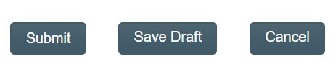
At the bottom of the screen there is a Save Draft option if all required fields cannot be completed at one time or before using the right-hand menus to Link Documents or Link Processes.
CAUTION: If you navigate away from this page without clicking on either Submit or Save Draft, all entries will be lost. To complete the information after the Save Draft option, you can either choose the Act On option from the Process section of your HOME Page, or search for the In-Process Deviation and then use the right-hand Act on Menu to open the Process Task Form fields.

Completing the Process Task Form:
This sub-section covers the information required for each field in the Process Task Form at Deviation Process Step 1.
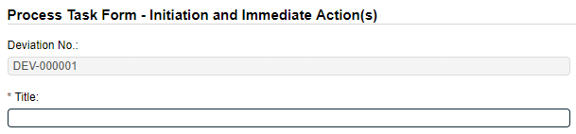
The Deviation No. field will be automatically populated with the next available Deviation number.
The Title field is mandatory. Choose a clear, concise and intuitive title for the Deviation that will quickly communicate the subject. Titles will appear in Deviation Reports.
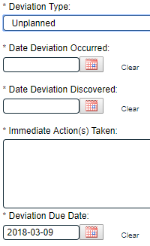
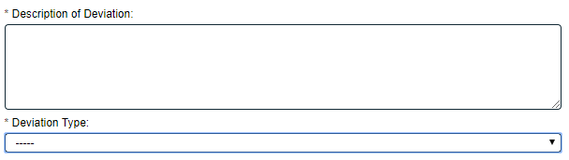
The Description of Deviation field is a mandatory text area field (4000 characters) to provide information about the Deviation.
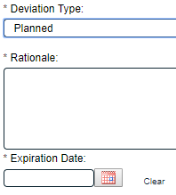
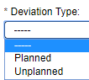
The Deviation Type field is a mandatory single-item selection field to choose the type of Deviation being initiated – either Planned or Unplanned. Depending on the section, additional mandatory fields will be displayed.
Planned deviations require a Rationale and entry of an Expiration Date.
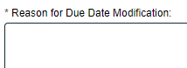
Unplanned deviations require entry of Date Deviation Occurred, Date Deviation Discovered, Immediate Action(s) Taken (a text area allowing 4000 characters) and a Deviation Due Date. The Deviation Due Date will default to 30 days from the initiation of the Deviation but can be changed. If it is changed, a mandatory free-text field to enter a Reason for Due Date Modification is displayed. A Lead Investigator field will also be displayed for Unplanned Deviations.
The Deviation Category field is a mandatory field where the category of the Deviation can be selected. It is a single-item selection field populated by an editable Custom List of values maintained by the SOLABS System Administrator. If the value Other is selected, a field for Specify Deviation Category is required.

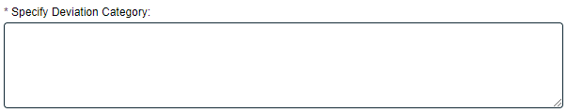
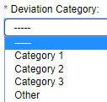

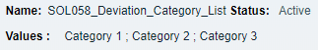
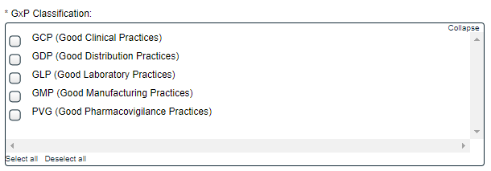
The GxP Classification field is a mandatory multi-item selection field allowing for up to five selections.
The Initiation Type field is a mandatory single-item selection field to choose either Internal or External.
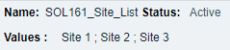
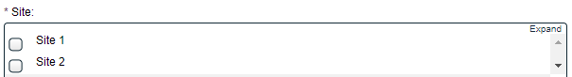
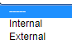
The Site field is a mandatory multi-item selection field. It is populated by an editable Custom List maintained by the SOLABS System Administrator.

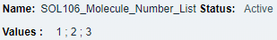
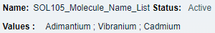
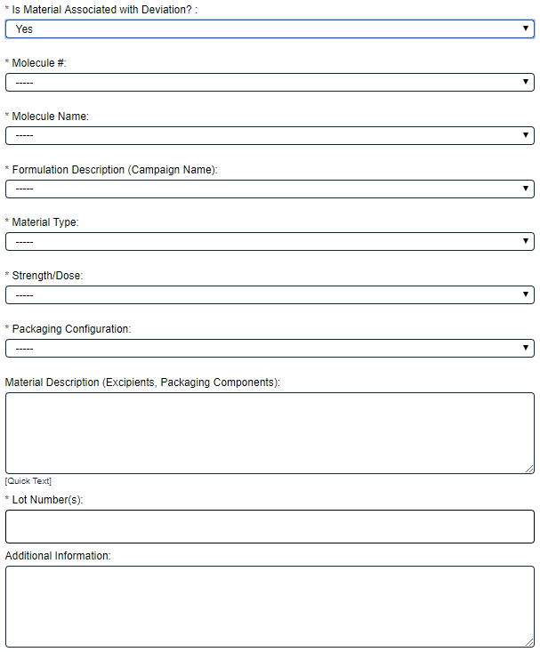
The Is Material Associated with Deviation? field is a single-item selection field allowing for Yes or No. If Yes is selected, additional single-item selection fields will be displayed for entry of information regarding the material. The values for those fields are populated from editable Custom Lists.
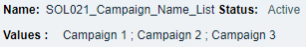
- The fields for Molecule # and Molecule Name initially appear to both be mandatory. However, when one is filled in, the other becomes non-mandatory.
- Formulation Description (Campaign Name) and Material Type are mandatory.
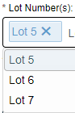
- When a Material Type is selected, the mandatory Strength/Dose and Packaging Configuration fields picklists will be populated with the appropriate values available for that Material Type, according to a client-specific EDI Table lists.
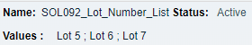
- Material Description (Excipients, Packaging Components) and Additional Information are non-mandatory text areas allowing 4000 and 8000 characters respectively.

- The Lot Number(s) field is mandatory. It is an Autocomplete, Multiple, Delimited Values based on an editable Custom List. Starting to type a number will bring up existing numbers that include those digits. When selected, each Lot Number will have an “X” after it, to allow removal.
The mandatory field for Does this potentially impact distributed Product? is a single-item selection field allowing for Yes or No.
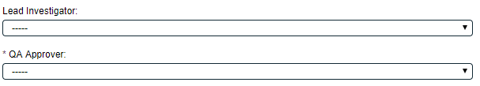

The Lead Investigator field is displayed when the Deviation Type of Unplanned is selected. It is not a mandatory field at Step 1. If it is not completed until Step 2, the name selected at Step 2 will then populate the field at Step 1. It is a single-item selection field that allows selection of Users who are assigned the Process Role of PR_DEV_Lead_Investigator.
QA Approver is a mandatory field. It is a single-item selection field that allows selection of Users who are assigned the Process Role of PR_DEV_QA_Approver.
After the Process Task Form fields are completed, the sections for Secondary Tasks and Related Processes can be completed. The Document Control / Impacted Documents section is grayed out since it is not available at Step 1. The right-hand Link Documents and Link Processes option are available to link existing documents or processes as Related Items.

Creating Secondary Tasks
The initiator of the Deviation Process can create Secondary Tasks that will be associated with the Deviation. These Secondary Tasks can be assigned to appropriate Users for activities required to support completion of the Deviation but that are not part of the Primary Tasks (process workflow steps).
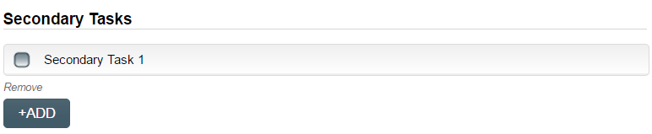
The Secondary Task section is under the Process Task Form, but still on the Deviation Initiation and Immediate Action(s) screen. This section is available at various Steps of the Process, allowing others involved in the review, implementation and approval of the Deviation to assign additional Secondary Tasks.
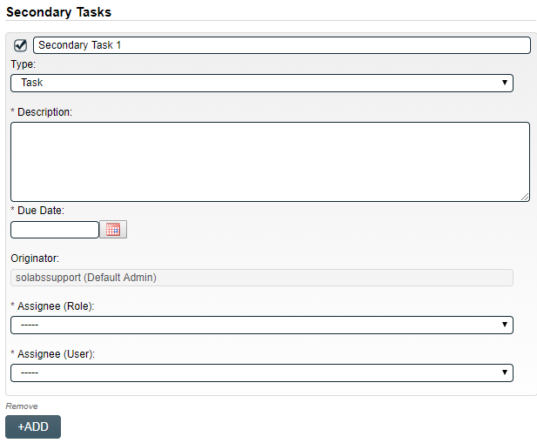
After selecting Secondary Task 1, additional fields will be displayed to define and assign that task. Replace the text “Secondary Task 1” with an appropriate Title for the task.
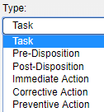
The appropriate task Type can then be chosen from a drop-down list. Types Task, Pre-Disposition and Post-Disposition are used in the Deviation Process. The Step number listed beside each Task Type below indicates the Step by which it will need to be completed, in order for the process to progress.
- Task Prefix = TASK Step 4
- Pre-Disposition Prefix = PREDI Step 6
- Post-Disposition Prefix = POSTDI Step 7
Enter a Description and a Due Date for the Task.
The Originator field will default to the User initiating the Deviation Process and completing Step 1.
Both the Assignee (Role) and the Assignee (User) fields must be completed for the chosen User. The drop-down lists will bring up the Active Roles list and the Active Users list. It is a good practice to consult with the planned Assignee ahead of time to ensure they are able to complete the task in a timeframe that supports on time Deviation closure. There is an Available Option for this process to add a notification when Secondary Tasks are overdue. If this option is enabled, email notifications will go to the Assignee and their Department Head.
To assign by Role, choose the appropriate Function Role from the list. All Users with that Role will then appear in the Assignee(User) drop-down list so that the appropriate person can be selected. To assign by User, choose the appropriate User from the list. Their Function Role will then appear in the Assignee (Role) drop-down list and must be selected.
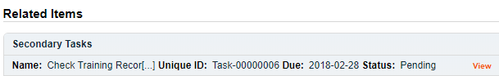
The +ADD button can be used to create additional Secondary Tasks. The Assignees for Task Type = Task will receive email Notifications and see the View/Act On options for their Secondary Tasks only when they are released after confirmation of Step 2 - QA Assessment. Task Types of Pre-Disposition and Post-Disposition will be release at later steps in the process. All Secondary Tasks are listed under Related Items at the bottom of the screen at any Deviation Step. Until the Tasks are released, the status is listed as Pending.

Initiating a Related Process
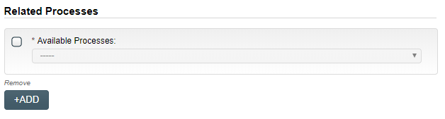
To initiate a new SOLABS QM10 Process from within this Process, check the Available Processes box.
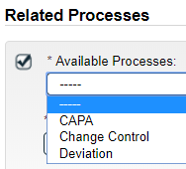
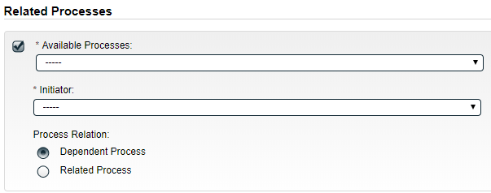
The Available Processes field is a Single-item selection field populated with a list of the Process APPs deployed at your organization.
Choose the Process Relation as either a Dependent Process (must be completed before the Deviation is closed), or a Related Process.

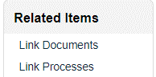
The mandatory Initiator to field is a Single-item selection field populated by the list of all Active Users. The person chosen in this field will be the person who will be assigned Step 1 of the process being initiated. There is also an option to choose myself, if you would like to initiate both processes concurrently as the initiator. The Deviation process will then be the Parent Process of the new process being initiated.
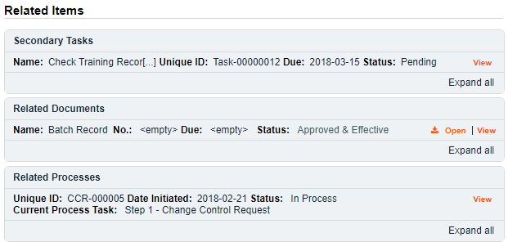
If a Related Process was already initiated, separately from this Deviation, it can be linked as a Related Item using the right-hand menu option under Related Items. In this case, do not select the Available Processes box and instead use the Link Processes option.
Whether linking an existing process or initiating a new one, the Related Processes will be listed in the Related Items section, along with any Secondary Tasks and Related Documents, when Deviation Step 1 is Submitted and Confirmed.

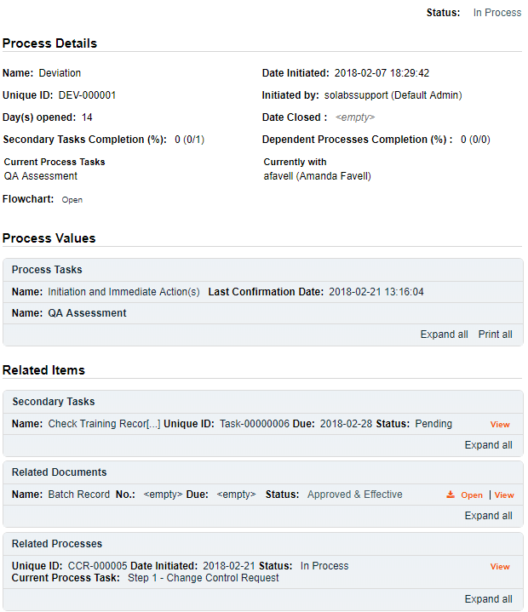
Submit and Confirm
When all information has been entered into the Process Task Form, any Linked Documents or Linked Processes have been added, any Secondary Tasks have been created and any new Related Processes have been initiated, click Submit and then Confirm to progress the Deviation process to Step 2 – QA Assessment.
The Process Flowchart will highlight the next step of the process and the person chosen in Step 1 as the QA Approver will be listed. The QA Approver will also receive an email Notification and will see the QA Assessment task listed on their SOLABS QM HOME Page.
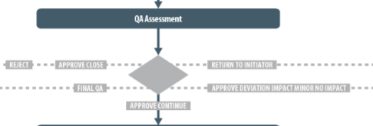

Upon Submission of Step 1, the following email Notifications will be sent by QM10:
- The Department Head of the Initiator will receive a Notification that a Deviation was initiated.
- If a choice of “Yes” for Does this deviation impact distributed product? was selected, everyone with with the process role of PR_DEV_QA_Approver will receive a Notification.

Step 2: QA Assessment
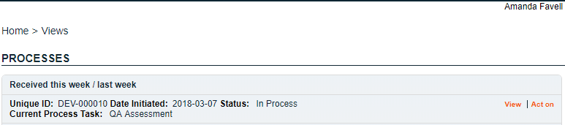
At this step in the Deviation Process, the QA Approver chosen at Step 1 will receive an email Notification and will see the QA Assessment task listed in the Process section of their SOLABS QM HOME Page.

Viewing a QA Assessment Task
If the QA Approver clicks on the View option to the right of the Process Task, they can view the Process Details.
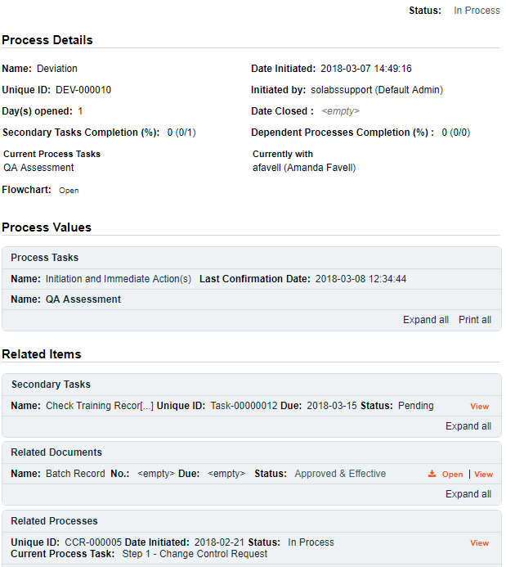
From the View screen, there are Expand all options for the Process Values table and the Related Items table (if any were included at Step 1), that can be used to see detailed information entered by the Initiator at Step 1.
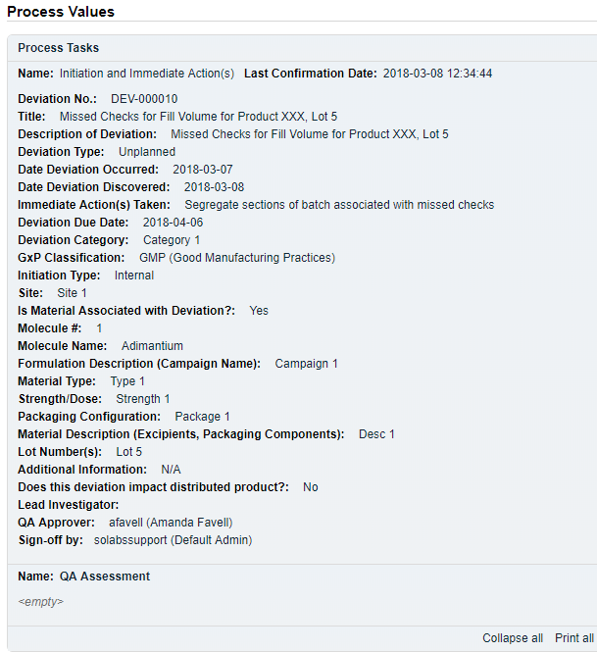

The View option to the right of any listed Related Item (Secondary Tasks, Related Documents, Related Processes) would bring up the Task Details, Document Details or Process Details screens associated with those Related Items. The parent Deviation Process will be listed as a Related Item on those screens, allowing easy access back to the Deviation Process. The QA Assessment section of the Expanded Process Values table is <empty> at this point because the QA Approver has not yet Acted on this step in the process.

Acting on the QA Assessment Task
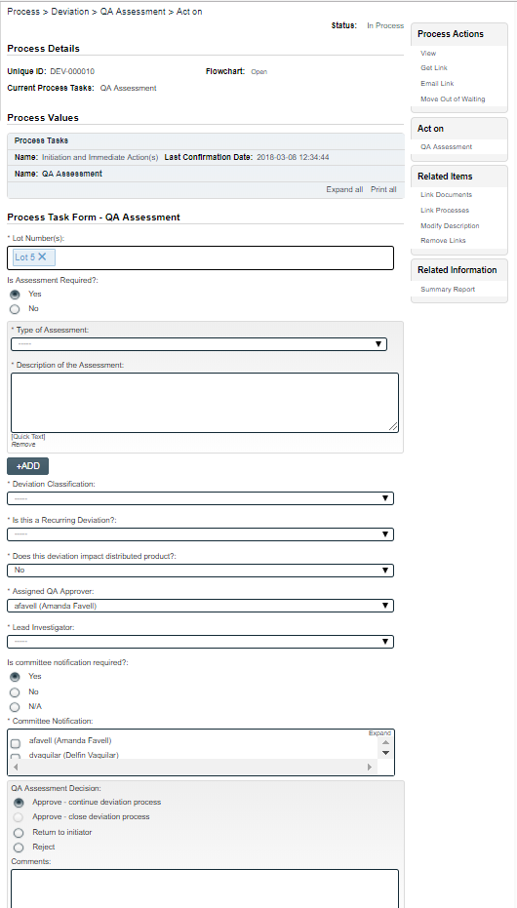
When the QA Approver clicks on the Act on option to the right of the Process Task, they will go immediately to the Act on screen for their QA Assessment task.
As described on the last page, the QA Approver can use the Expand all option under the Process Values table to see all information entered by the Initiator at Step 1.
The Process Task Form includes editable text fields, text areas, single-item selection fields or multi-item selection fields. Fields with an asterisk (*) are mandatory.
The right-hand Related Items menu allows the QA Approver to Link Documents or Link Processes, if applicable. There are also sections under the Process Task Form section to initiate more Secondary Tasks and to initiate new Related Processes. Initiation of a Document Control Process is not allowed at Step 2.
Refer to the separate document SOLABS QM10: Introduction to PROCESS Section for information on use of the right-hand menus since they are common to all SOLABS QM Process APPs.
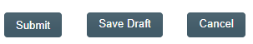
There is a Save Draft option at the bottom if all the required fields cannot be completed at one time or when using the right-hand menu to Link Documents or Link Processes.

CAUTION: Navigating away from this page without clicking on either Submit or Save Draft, will result in all entries being lost.
To complete the information after the Save Draft option, choose either the Act On option from the Process section of your HOME Page, or search for the Deviation Process and then use the right-hand Act on Menu to open the Process Task Form fields.
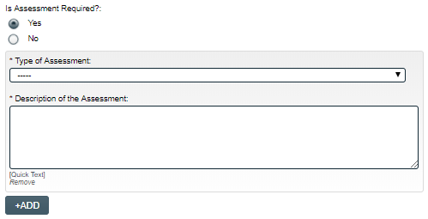
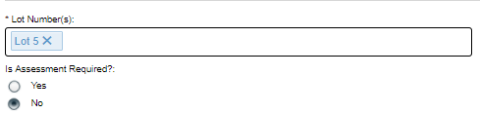
The Lot Number(s) field will be displayed if the Is Material Associated with Deviation? section was Yes at Step 1. It will be pre-populated with any lot numbers added at that time. Additional lot numbers can be added. Starting to type a number will bring up existing numbers that include those digits.
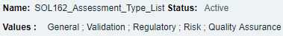
Is Assessment Required? must be selected as either Yes or No. If Yes is selected, a group of mandatory fields for Type of Assessment and Description of the Assessment will be displayed. If there is more than one Type of Assessment required, the +ADD button will bring up another set of fields.
Example values
Type of Assessment is a single-item selection field populated by values from an editable Custom List maintained by the SOLABS System Administrator.
The Description of the Assessment field can be completed with free text (up to 8000 characters) or by using Quick Text options populated from an editable Custom List maintained by the SOLABS System Administrator.

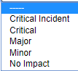
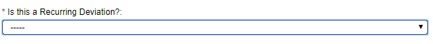
The mandatory Initial Deviation Classification field is a single-item selection field with 5 options for classifying the deviation. For Unplanned Deviations, a selection of Critical Incident or Critical will require entry of an Assigned Head of Quality at Step 6 and will include an additional approval Step 7: Head of Quality Final Approval.

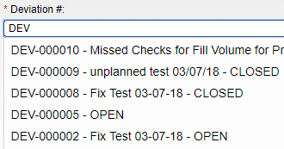
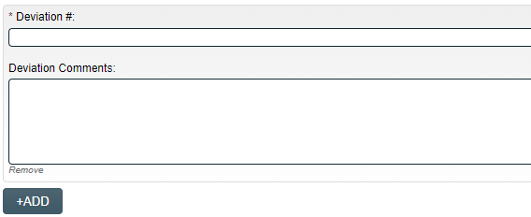
The mandatory Is this a Recurring Deviation? field is a single-item selection field with Yes or No options. If Yes is selected, a group of additional fields will appear to enter the Deviation # and any optional Deviation Comments (up to 8000 characters). Starting to type either a Deviation Number or Title will bring up the list of existing Deviation Processes to choose from.
The chosen Deviation will then be listed under Related Processes, in the Related Items section. If there is more than one recurring deviation, the +ADD button can be used to bring up another group of fields.

Does this deviation impact distributed product? is a Yes or No choice.

The mandatory Assigned QA Approver field will be pre-populated with the QA Approver chosen at Step 1 but is editable.
The Lead Investigator field is mandatory at Step 2.
This field is a single-item selection field, populated with the names of Users who are assigned the process role PR_DEV_Lead_Investigator. This field was available at Step 1 but was not mandatory. If a Lead Investigator was chosen at Step 1, the field will be pre-populated with that person, but can be edited.
If no Lead Investigator was chosen at Step 1, a choice must be made at Step 2. The choice at Step 2 will then auto-populate the value at Step 1, since this is a Shared field.
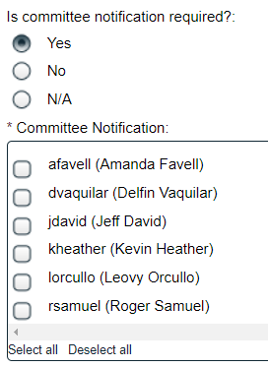
The section for Is committee notification required? and the related mandatory, multi-item selection Committee Notification field is displayed, and defaults to a selection of Yes, if at least one User is assigned the process role PR_DEV_Committee_Notification.
The Users listed in the Committee Notification section are all Users who have the process role PR_DEV_Committee_Notification assigned to them. One or more can be selected and will receive an email Notification when Steps 2, 6 and 7 are confirmed. The selection can be changed to No, if no notifications are required.
If no Users are assigned the process role of PR_DEV_Committee_Notification, this section defaults to a selection of N/A.

Before the final QA Assessment Decision is made, the QA approver can create any additional Secondary Tasks that may be required, can Link Documents, Link Processes or initiate a Related Process.
Caution: Use the Save Draft option prior to using the right-hand menus to link a document or process, or data entered so far will be lost and have to be entered again.

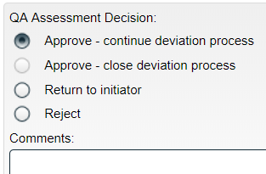
QA Assessment Decision – Submit and Confirm
When all information has been entered in the Process Task Form, and any Secondary Tasks, Linked Documents, Linked Processes or new Related Processes have been added, the QA Assessment Decision is made ty the QA Approver. There are four available choices for the QA Assessment Decision, some of which may not be enabled in certain situations.
The option of Approve – close deviation process is greyed out if Deviation Type = Unplanned was selected at Step 1. It will be the default option when Deviation Type = Planned was selected with no Secondary Tasks.
With a decision of Approve – close deviation process, the Deviation Process will move to the end and be at a status of Completed. If there are still outstanding Secondary Tasks, the following warning message will be displayed below the decision field: Some secondary tasks have been initiated and won’t be monitored and/or released to their assignee.
The decisions of Return to initiator and Reject will both change the Comments field to a mandatory field. Return to initiator will move Deviation Process back to Step 1 when submitted. Reject will close the Deviation Process, to a status of Completed when submitted.
A QA Assessment Decision of Approve – continue deviation process will progress the Deviation Process as follows, depending on the selections made for Deviation Type and for Deviation Classification:
- If Deviation Type = Unplanned and Deviation Classification = Major, Critical or Critical incident, the process moves to Step 3 – Investigation Plan on confirmation.
- If Deviation Type = Unplanned and Deviation Classification = Minor or No Impact, the process moves to Step 5 – Investigation Execution on confirmation.
- If Deviation Type = Planned, the process moves to Step 6 – Final QA Assessment on confirmation.
The decision of Approve – continue deviation process will also result in the following:
- All Secondary Tasks will be released to the Assignees. They will receive email Notifications and will see the Tasks listed in the Task Section of their SOLABS QM Home Page.
- Any new Related Processes that were initiated as Dependent Processes and were at a status of Awaiting Confirmation from Parent Process, are now available to the Assignees to Act on.
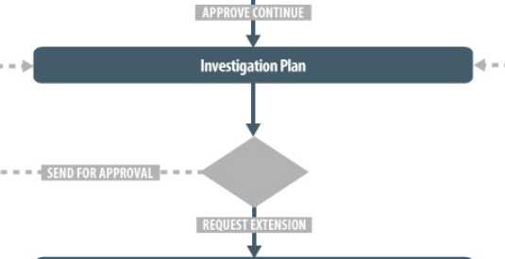
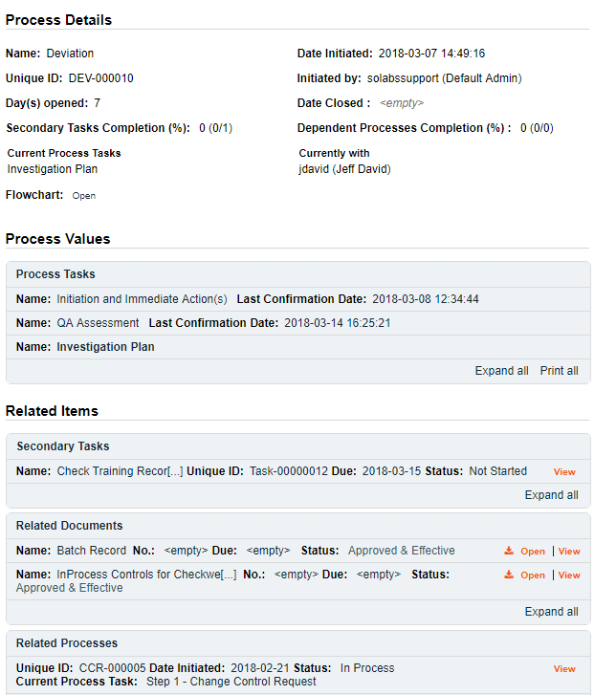
The Process Flowchart will highlight that step of the process. The Process Details screen will display the Current Process Task and who it is Currently with. The assigned Secondary Tasks, Linked Documents and Linked Processes will be listed in the Related Items section.

Secondary Task Assignments – Assignee Actions
If there were any Secondary Tasks assigned at Step 1 or 2, they are now released to Act on since the QA Assessment step has been completed by the QA Approver.
Assignees of Secondary Tasks will receive an email Notification and will also see the tasks listed in the TASKS section of their SOLABS QM HOME Page.
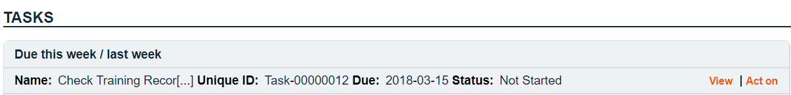

Viewing the Secondary Task
When the Assignee for a Secondary Task chooses the View option from their HOME Page, they are brought to the Task > View screen for that Task. They can now review what has been assigned to them and can also toggle to the Deviation Process that triggered the Task, since it is listed at the bottom of the screen as a Related Item.
The task Assignee has various options under their Task Actions and Related Items right-hand menus to help manage completion of their task. Any actions they take will be visible to those acting on the Primary Task steps in the Deviation Process if they choose to View a Secondary Task.
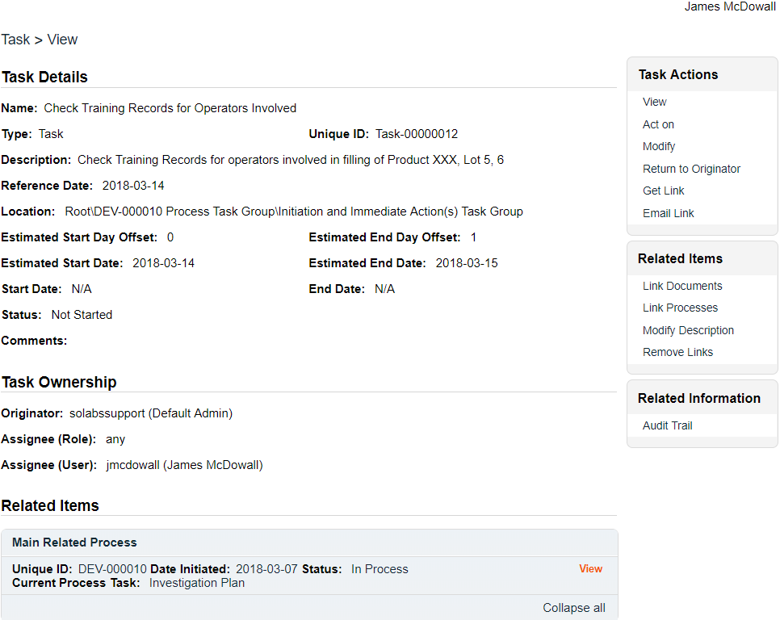

Acting on the Secondary Task

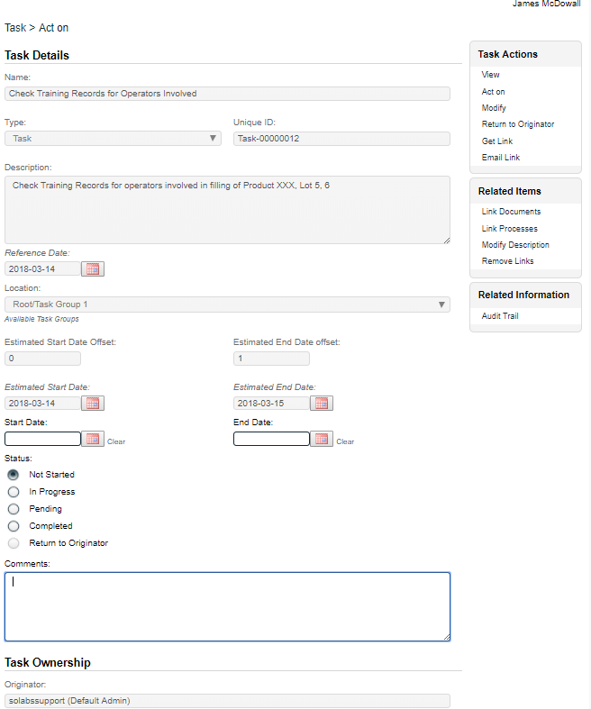
When the Assignee for a Secondary Task chooses the Act on option from their HOME Page, they are brought to the Task > Act on screen for that Task.
From this screen, the Assignee can also review the Task Details.
The fields they have available to them are to select a Start Date, enter an End Date when they are finished with the task and to change the Status as they progress it.
They can also enter free-text Comments at any point.
The task will default to a status of Not Started. If a status of In Progress is selected, the Start Date field will be populated with the current date. If a Start Date is entered, the Status will automatically move to In Progress. For longer term tasks, it is best practice to periodically log in and provide status updates in the Comments field.
If a status of Pending is selected, the Start Date field will be grayed out.
If a status of Completed is selected, the End Date field will be populated with the current date. If an End Date is entered, the Status will automatically move to Completed.
The Return to Originator option is grayed out since it is currently not available.
If the Assignee would like to add evidence / documentation to support completion of the task, the Link Documents option is available on the right-hand menu.

Step 3: Investigation Plan
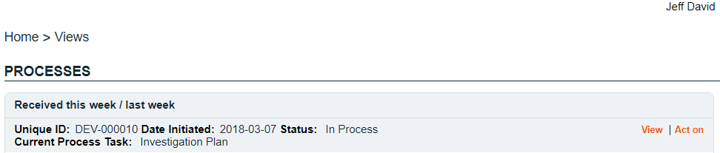
The Lead Investigator chosen by the Initiator at Step 1 or Step 2 for an unplanned Deviation classified as Major, Critical or Critical Incident will receive an email Notification and see the Investigation Plan task listed on their SOLABS QM10 HOME Page.

Acting on the Investigation Plan Task
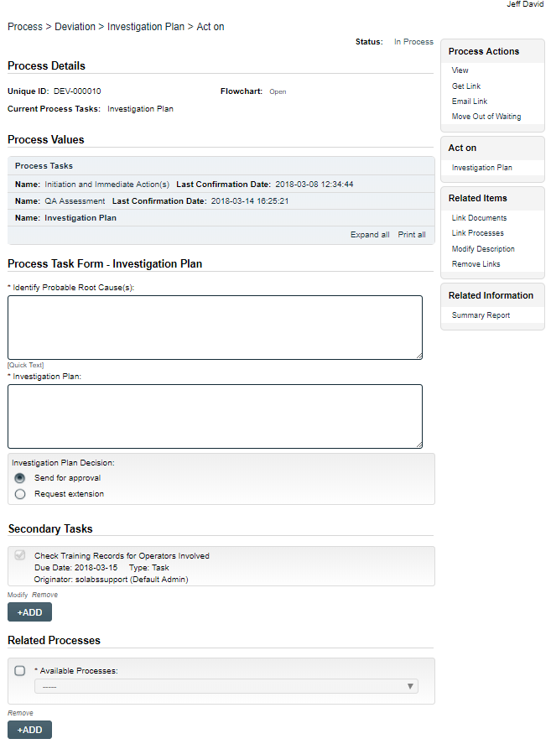
When the Lead Investigator clicks on the Act on option to the right of the Process Task, they will go immediately to the Act on screen for their Investigation Plan task.
As described for the previous sections, the Lead Investigator can use the Expand all option under the Process Values table to see all information entered at Steps 1 and 2.
The Process Task Form includes mandatory text fields or text areas, one of which can be set to be populated by Quick Text (Custom List) options. These will be used to Identify Probable Root Causes(s) and to describe the Investigation Plan.
The right-hand Related Items menu allows the Lead Investigator to Link Documents or Link Processes, if applicable. There are also sections under the Process Task Form section to initiate more Secondary Tasks or Related Processes. Initiation of a Document Control Process is not allowed at Step 3.
Refer to the separate document SOLABS QM10: Introduction to PROCESS Section for information on use of the right-hand menus since they are common to all SOLABS QM Process APPs.
There is a Save Draft option at the bottom if all the required fields cannot be completed at one time or when using the right-hand menus to Link Documents or to Link Processes.
CAUTION: Navigating away from this page without clicking on either Submit or Save Draft, will result in all entries being lost. To complete the information after the Save Draft option, choose either the Act On option from the Process section of your HOME Page, or search for the Deviation Process and then use the right-hand Act on Menu to open the Process Task Form fields.
The Investigation Plan Decision section includes two choices: Send for Approval or Request extension. If any Secondary Tasks of Task Type = Task are not yet completed, the Send for Approval option will be grayed out.
- When a choice of Request extension is Submitted and Confirmed, the Deviation Process will move to the Extension Request Step.
- When a choice of Send for Approval is Submitted and confirmed, the Deviation Process will move to Step 4: QA Investigation Plan Approval.
The Process Flowchart will highlight the next step of the process. The Process Details screen will display the Current Process Task and who it is Currently with:
- the QA Approver if Send for Approval was Submitted and Confirmed
- the Lead Investigator again, if Request extension was Submitted and Confirmed
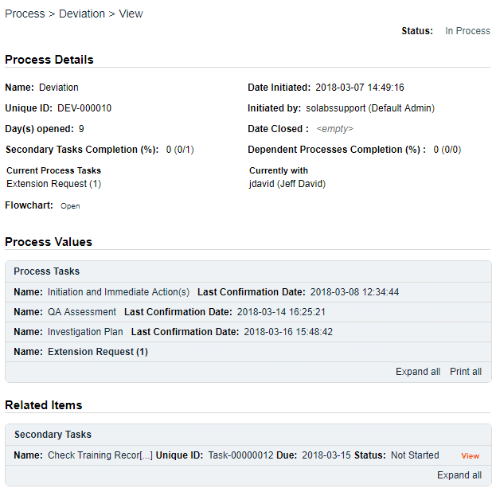

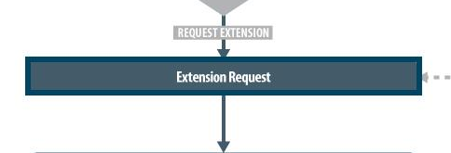

Extension Request Step
At this step in the Deviation Process, the Lead Investigator will receive an email Notification and will see the Request Extension task listed in the Process section of their SOLABS QM HOME Page. Extension Requests are formally captured as a separate Step, even though it will go to the same person. The number in parenthesis – in this case (1) – indicates the number of the extension requested by the Lead Investigator. If another one should be necessary, it would show (2).
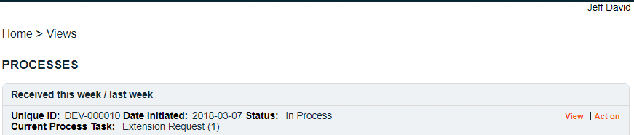

Acting on the Extension Request Task
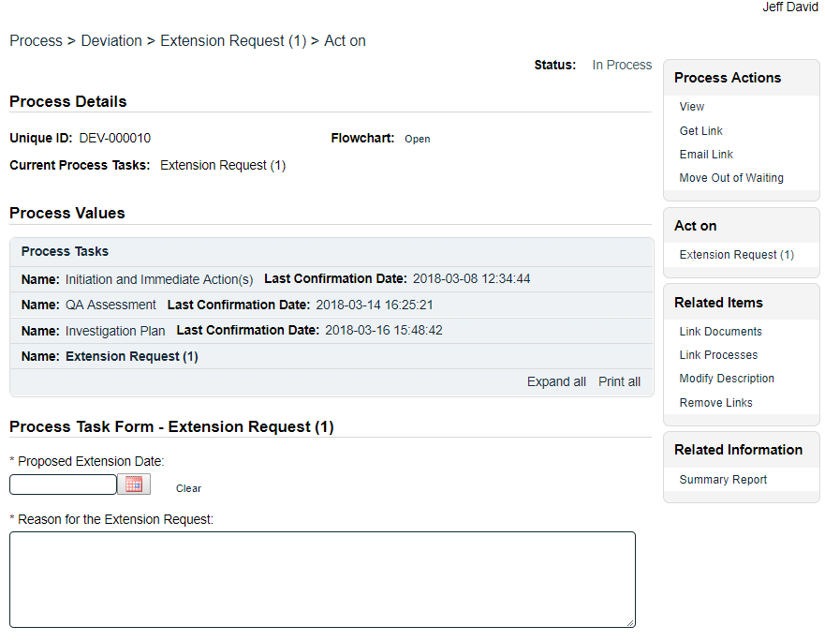
When the Lead Investigator clicks on the Act on option to the right of the Extension Request task, they will go immediately to the Act on screen for their Extension Request task.
At this point, they need to enter a date in the Proposed Extension Date field and complete the mandatory Reason for the Extension Request field.
Secondary Tasks cannot be added at this Step so the +ADD option is grayed out.
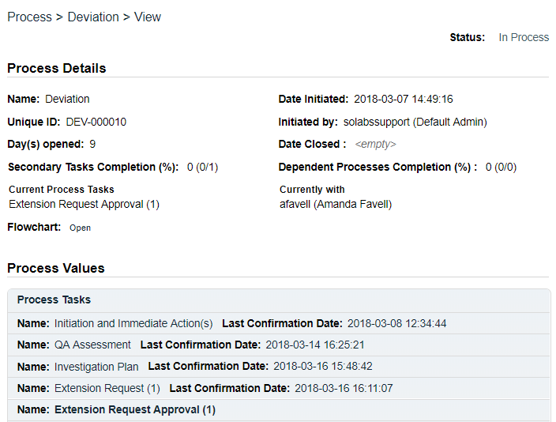
When this step is Submitted and Confirmed, the process will progress to the Extension Request Approval Step.
The Process Flowchart will highlight that step of the process. The Process Details screen will display the Current Process Task and who it is Currently with: QA Approver.
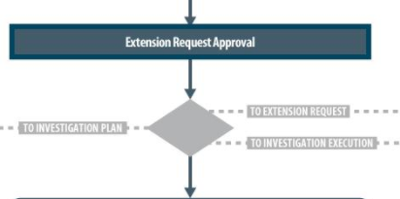

Extension Request Approval Step
At this step in the Deviation Process, the QA Approver will receive an email Notification and will see the Extension Request Approval task listed in the Process section of their SOLABS QM HOME Page.
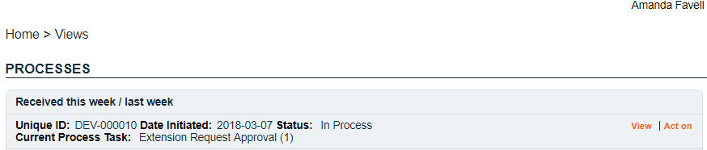

Acting on the Extension Request Approval Task
When the QA Approver clicks on the Act on option to the right of the Extension Request Approval task, they will go immediately to the Act on screen for their Extension Request Approval task.
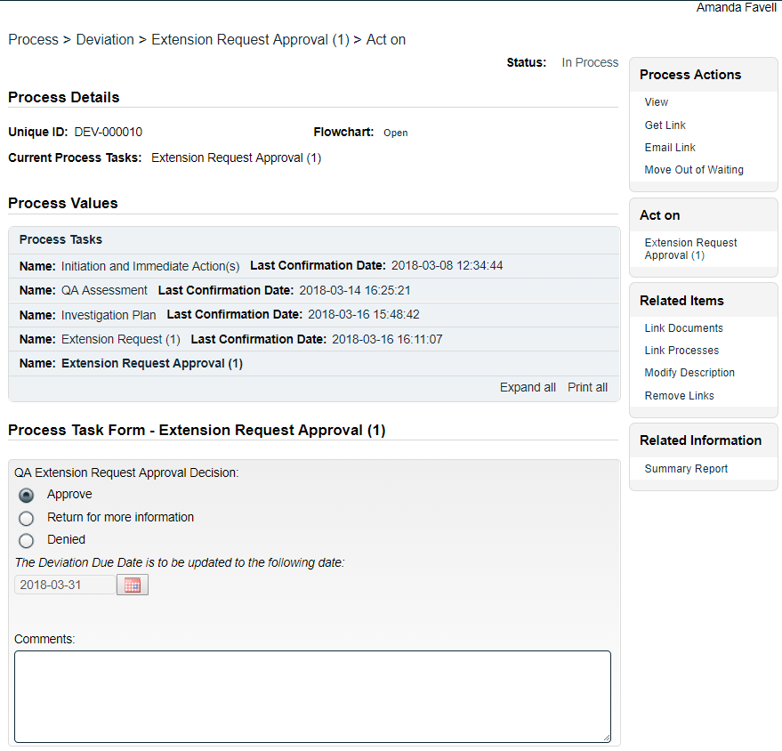
At the Act on screen for the Extension Request Approval task, the QA Approver can view information entered at all previous steps by choosing the Expand all option in the Process Values Table. Steps can be expanded individually or the entire table can be expanded.
Secondary Tasks cannot be added at this Step so the +ADD option is grayed out.
At this point, they need to enter the QA Extension Request Approval Decision.
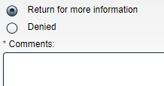
A choice of either Return for more information or Denied, will result in the Comment field being mandatory. The process will then go back to the previous Step so that the Lead Investigator can address the comment.
A QA Extension Request Approval Decision of Approve, will send the Deviation Process back to Step 3 – Investigation Plan with a new Deviation Due Date.
At this point the Lead Investigator can continue to monitor for completion of activities related to the plan, incorporating the revised Deviation due date.
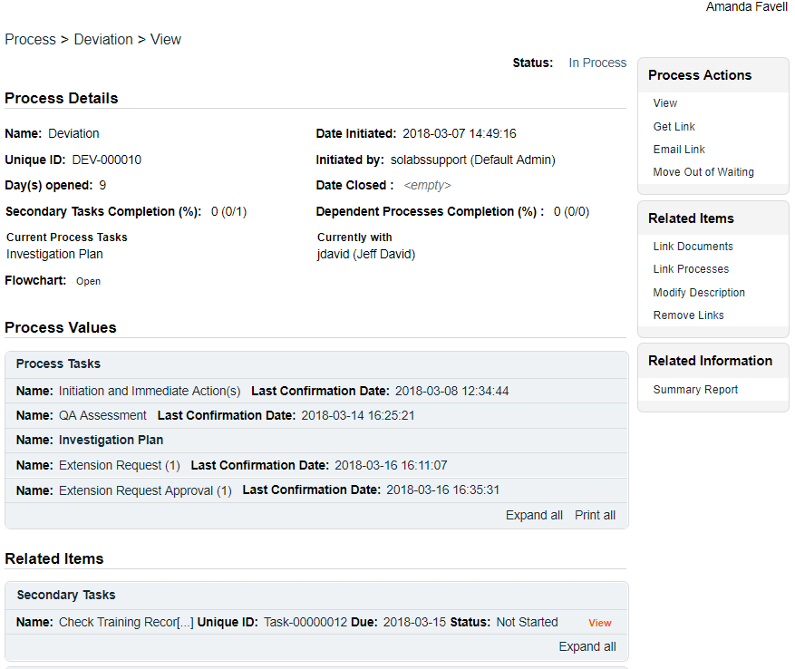

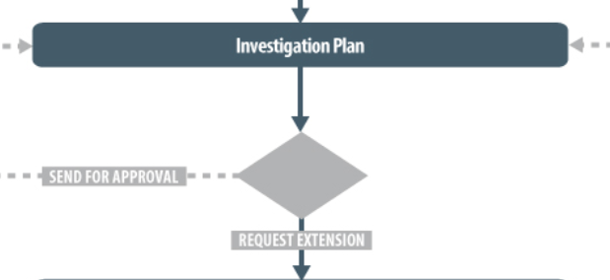

From the Process Values table, we can see that the Lead Investigator had requested an extension and that it was approved. At that point, the Deviation Process went back to Step 3 – Investigation Plan.
The Lead Investigator will now receive another Notification – just like they did prior to requesting the extension and will see the Investigation Plan task listed in the Process section of their SOLABS QM HOME Page.
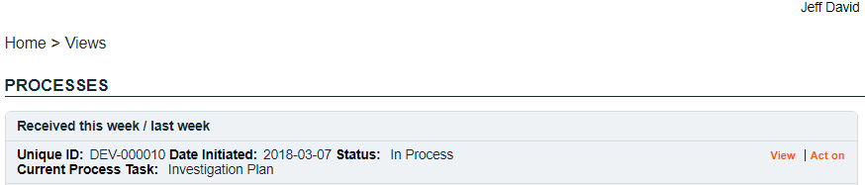

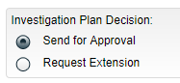
The Deviation Process they own is now accepted for an extension. They can choose the View option to access all information previously entered. When the Lead Investigator is ready to choose an Investigation Plan Decision of Send for Approval the Deviation Process will progress to Step 4 – QA Investigation Plan Approval.
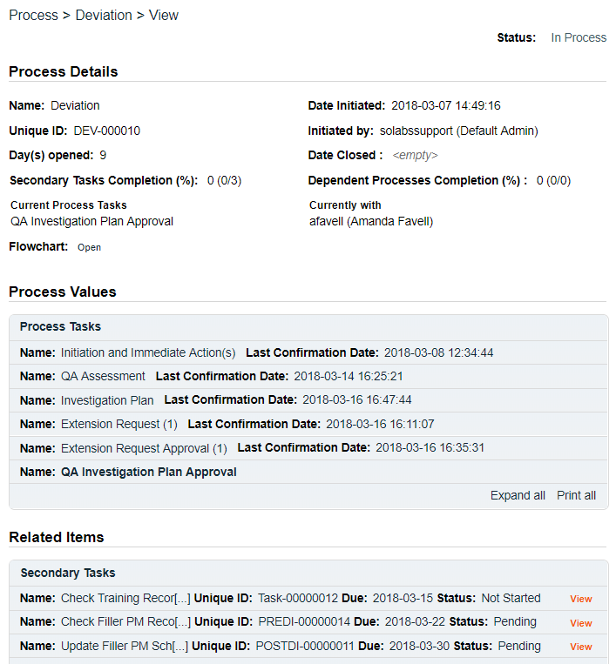
The Process Flowchart will highlight that step of the process. The Process Details screen will display the Current Process Task and who it is Currently with: QA Approver.

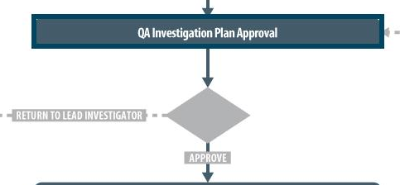

Step 4: QA Investigation Plan Approval
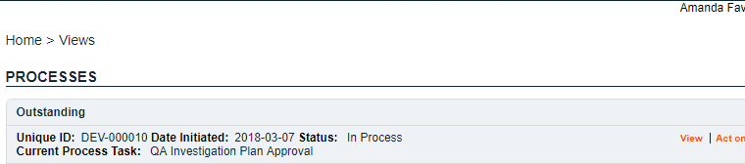
At this step in the Deviation Process, the QA Approver will receive an email Notification and will see the QA Investigation Plan Approval task listed in the Process section of their SOLABS QM HOME Page.

Acting on the QA Investigation Plan Approval Task
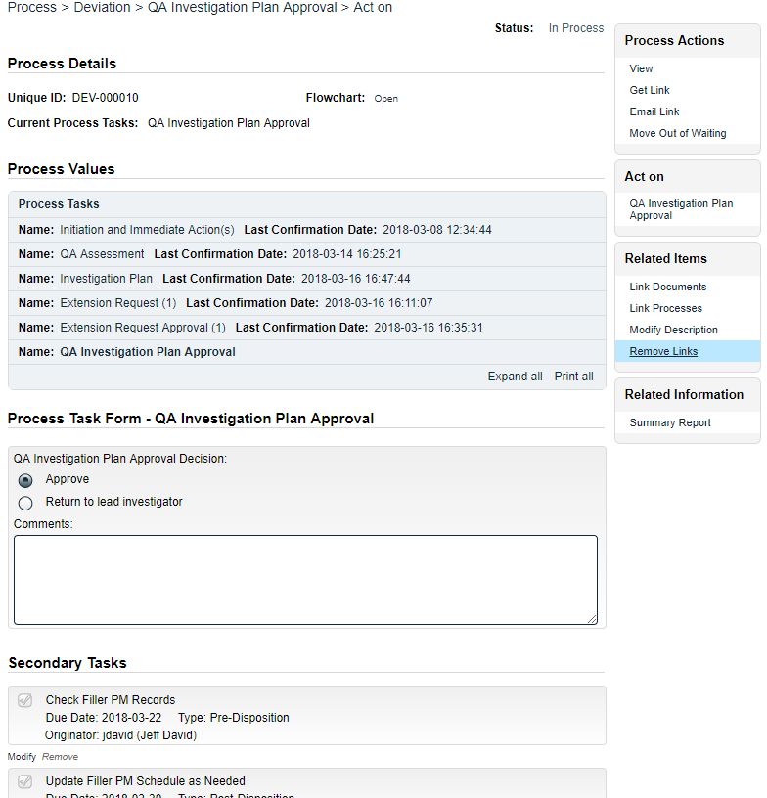
When the QA Approver clicks on the Act on option to the right of the QA Investigation Plan Approval task, they will go immediately to the Act on screen for their QA Investigation Plan Approval task.
At the Act on screen for the QA Investigation Plan Approval task, the QA Approver can view information entered at all previous steps by choosing the Expand all option in the Process Values Table. Steps can be expanded individually or the entire table can be expanded.
Secondary Tasks cannot be added at this Step so the +ADD option is grayed out. Linked Documents, Linked Processes or new Related Processes could be added if appropriate.
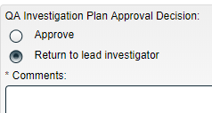
At this point, they need to enter the QA Investigation Plan Approval Decision.
- If they choose Return to lead investigator, the Comment field is mandatory. The process will then go back to the Step 3: Investigation Plan so the Lead Investigator can address the comment.
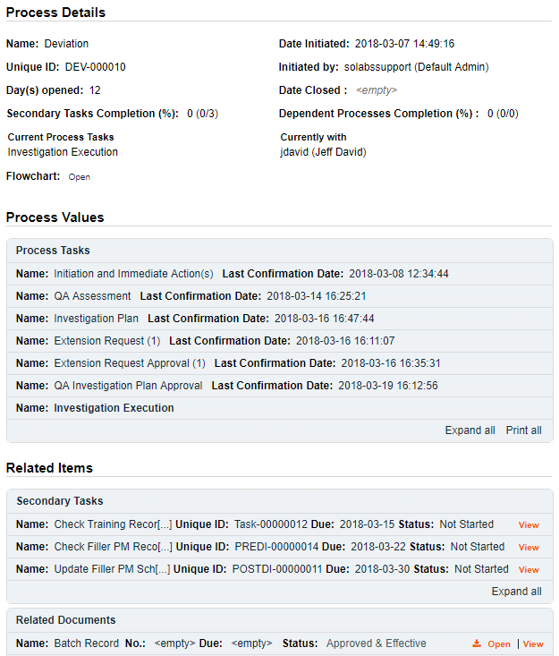
- If they choose Approve, the Deviation Process will progress to Step 5 – Investigation Execution and all Secondary Tasks will be released to the assignees. The Process Flowchart will highlight that step of the process. The Process Details screen will display the Current Process Task and who it is Currently with: Lead Investigator.
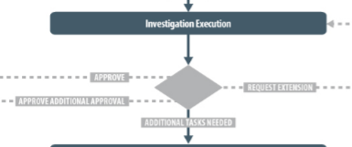

Step 5: Investigation Execution
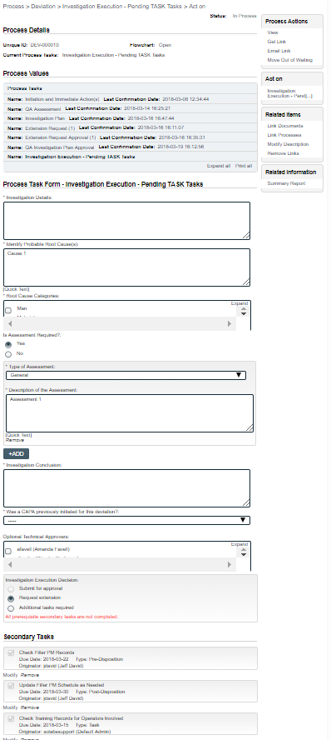
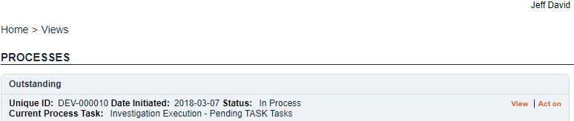
At this step in the Deviation Process, the Lead Investigator will receive an email Notification and will see the Investigation Execution task listed in the Process section of their SOLABS QM HOME Page. If there is at least one Secondary Task of Task Type = TASK, the name of this step will be Investigation Execution – Pending TASK Tasks. Note – due to QM10 system timers, “- Pending TASK Tasks” will not be visible for at least 5 minutes after submission of the previous step.

Acting on the Investigation Execution Task
When the Lead Investigator clicks on the Act on option to the right of the Investigation Execution task, they will go immediately to the Act on screen for that task.
The Process Task Form includes free-text fields, single-item selection fields and multi-item selection fields. Those with an asterisk (*) are mandatory. Each field in the Process Task Form will be described starting on the next page.
The right-hand Related Items menu allows the Lead Investigator to Link Documents or Link Processes, if applicable. New Related Processes can also be added if needed. Refer to the separate document SOLABS QM10: Introduction to PROCESS Section for information on use of the right-hand menus since they are common to all SOLABS QM Process APP screens.
Secondary Tasks cannot be added at this Step so the +ADD option is grayed out, but the Investigation Execution Decision includes an option for Additional tasks required, which will formally capture that need as a Process Step called Additional Tasks.
Use the Save Draft option if all required fields cannot be completed at one time.

CAUTION: As mentioned for previous steps, if you navigate away from this page or use the right-hand menus without clicking on either Submit or Save Draft, all entries will be lost.

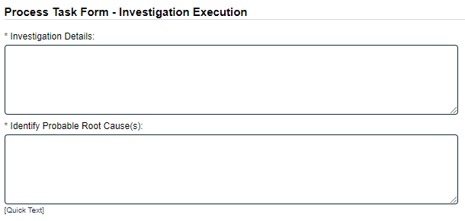
The mandatory Investigation Details field is a free-text area allowing up to 4000 characters.
The mandatory Identify Probable Root Cause(s) field is a free-text area allowing up to 4000 characters that can also be populated using a Quick Text Custom List maintained by the SOLABS System Administrator.
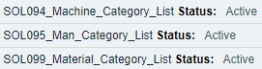
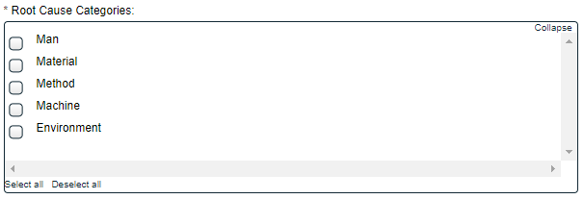
The mandatory Root Cause Categories field is a multi-select list of options. For each option chosen, an additional single-item selection field will appear to choose the next level Category. These lists are populated from editable Custom Lists maintained by the SOLABS System Administrator.
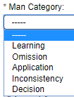
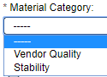
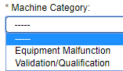
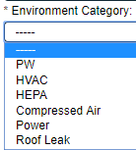
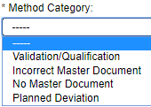

Example Values

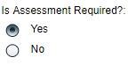
The Is Assessment Required? field is a Yes or No selection. If Yes is selected, a group of mandatory fields for Type of Assessment and Description of the Assessment will be displayed. If there is more than one Type of Assessment required, the +ADD button will bring up another set of fields. These fields are also available at Step 2 – QA Assessment. See Page 14 for more information on setting up the values, since this field shares an editable Custom List with that Step.
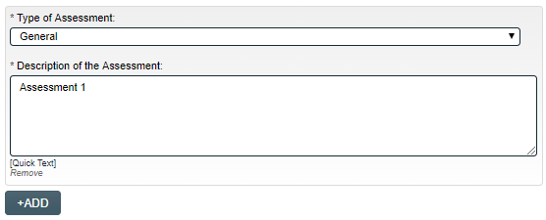

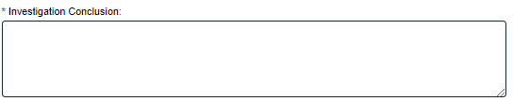
The mandatory Investigation Conclusion field is a free-text area allowing up to 4000 characters.
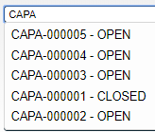
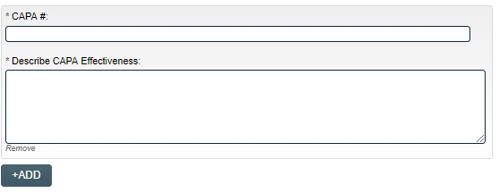
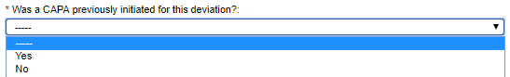
The mandatory Was a CAPA previously initiated for this deviation? field is a single-item selection Yes or No field. If Yes is selected, a group of mandatory fields for CAPA # and Describe CAPA Effectiveness will be displayed. If there is more than one previous CAPA, the +ADD button will bring up another set of fields.
Starting to type CAPA into the CAPA # field will bring up a list of existing CAPA Processes in SOLABS QM.
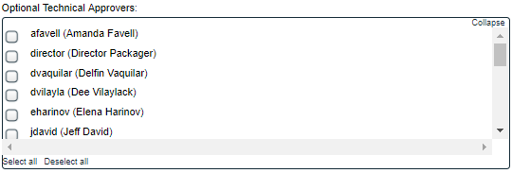
The Optional Technical Approvers field is not mandatory. It is a multi-item selection field populated with the list of all active SOLABS QM Users.

If Optional Technical Approvers are selected, the process will formally capture those approvals by progressing to a Process Step called Investigation Technical Approval when Step 5 is Submitted and Confirmed, unless the Investigation Execution Decision is either Request extension or Additional tasks required. In those cases, the Investigation Technical Approvals will be released when that information is provided.

Investigation Execution Decision
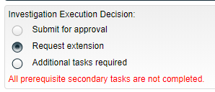
The Submit for approval option will be grayed out if there are any Secondary Tasks of Task Type = TASK that are not yet complete.
If Request Extension is selected, the process will go back to the Extension Request step (see Page 21) and be assigned to the Lead Investigator to formally document the new Extension Request.
As when an extension was requested for the Investigation Plan, the process will then move to the Extension Request Approval step (see Page 22) and be assigned to the QA Approver to approve the new Due Date.
If Additional tasks required is selected, the process will go to the Additional Tasks step, and be assigned to the Lead Investigator to define those tasks. The Submit for Approval option will stay as grayed out in that case.
If the Secondary Tasks of Task Type = Task are complete, there are no Additional Tasks Required and there is no need to Request Extension, then a choice of Submit for approval will progress the process as follows:
- If any Optional Technical Approvers were selected, it will move to Investigation Technical Approval.
- If no Optional Technical Approvers are required, it will move to Step 6: Final QA Assessment.
In any case, the Process Flowchart will highlight that step of the process. The Process Details screen will display the Current Process Task and who it is Currently with:
- Lead Investigator if the process goes back to either Extension Request or Additional Tasks
- Technical Approver(s) if any were selected for Investigation Technical Approval
- QA Approver if the process progresses to Step 6: Final QA Assessment

In this example, the Investigation Execution Decision is Additional tasks required.
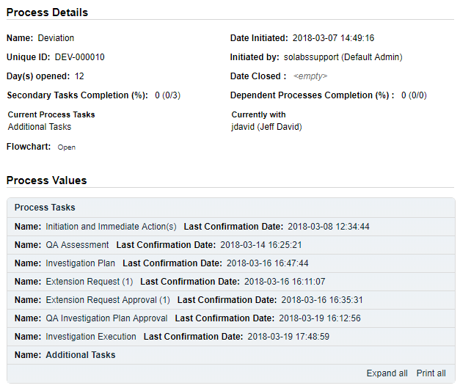

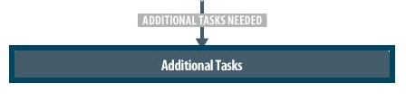

Additional Tasks
At this step in the Deviation Process, the Lead Investigator will receive an email Notification and will see the Additional Tasks task listed in the Process section of their SOLABS QM HOME Page. This allows the decision to create additional Secondary Tasks at this point in the process to be formally captured.
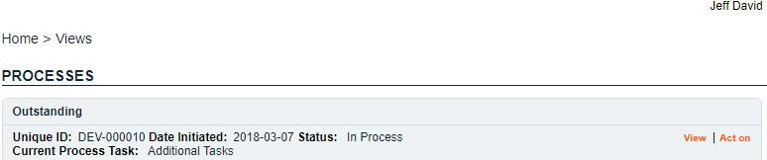

Acting on the Additional Tasks Task
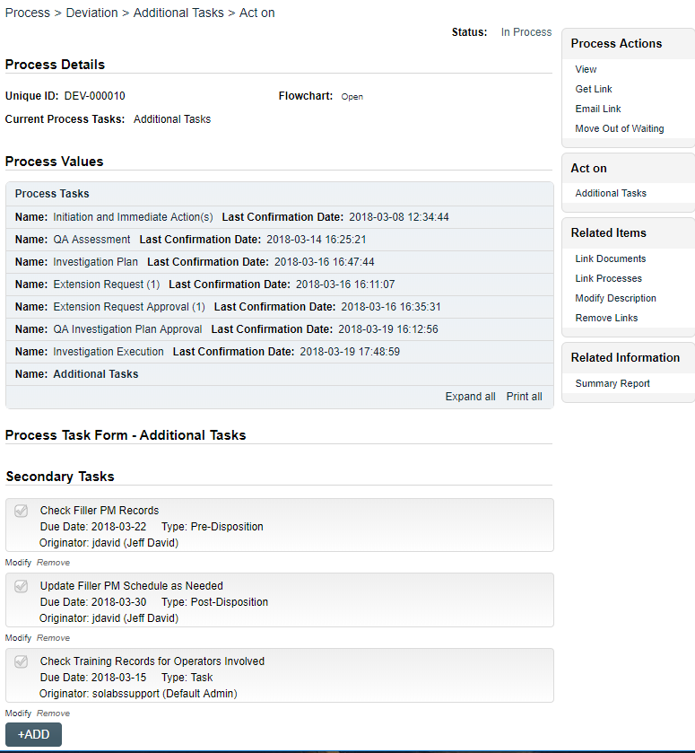
When the Lead Investigator clicks on the Act on option to the right of the Additional Tasks task, they will go immediately to the Act on screen for that task.
From this screen, they can use the +ADD button in the Secondary Tasks section to add additional Secondary Tasks.
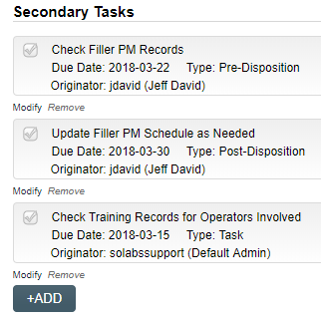

Refer to Page 9 of this document for instructions on Creating Secondary Tasks.
After Submitting and Confirming the Additional Tasks step, the Secondary Tasks will be immediately released to the assignees and the Deviation process will return to Step 5: Investigation Execution.
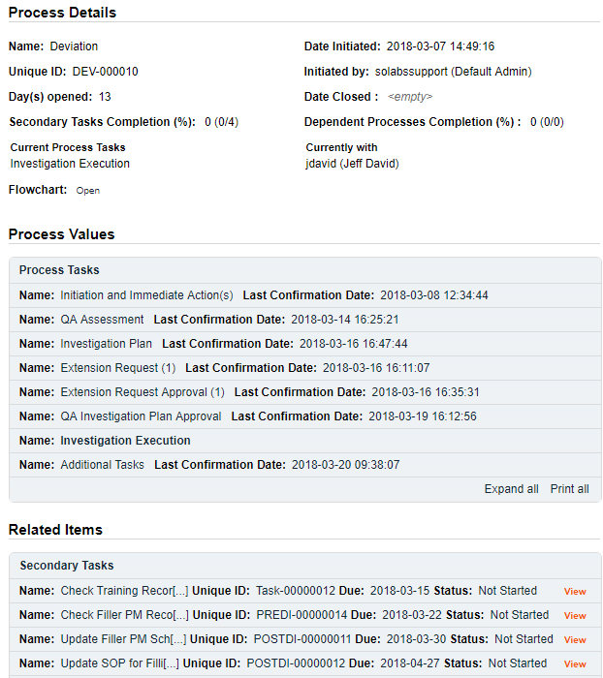
The Process Flowchart will highlight that step of the process. The Process Details screen will display the Current Process Task and who it is Currently with: still the Lead Investigator. The additional Secondary Tasks will be listed under Related Items.

The Lead Investigator will continue to monitor the process until they are ready to make the Investigation Execution Decision of Submit for Approval. As mentioned on Page 28 of this document, that decision will not be possible until all Secondary Tasks of Task Type = Task are completed.

When a choice of Submit for Approval is able to be selected, the process will progress as follows:
- If any Optional Technical Approvers were selected, it will move to Investigation Technical Approval.
- If no Optional Technical Approvers are required, it will move to Step 6: Final QA Assessment.
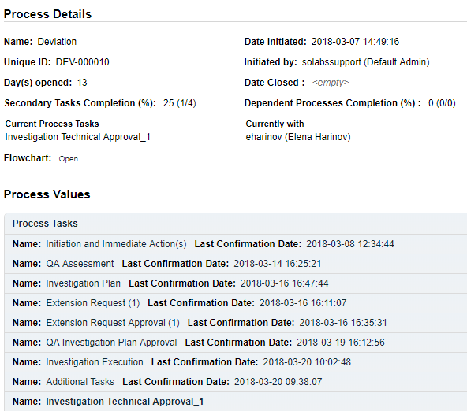
The Process Flowchart will highlight that step of the process. The Process Details screen will display the Current Process Task and who it is Currently with: in this case the Technical Approver(s) selected at Step 7.
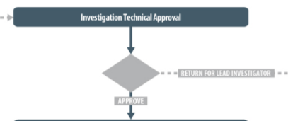
The number listed after the Investigation Technical Approval Process Task represents the number of Technical Approvers chosen – in this example there was just one chosen. If multiple were chosen, they would all be listed.

Investigation Technical Approval
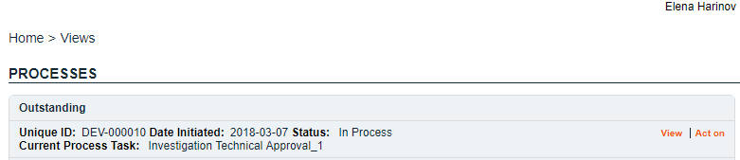
At this step in the Deviation Process, the Technical Approver(s) will receive an email Notification and will see the Investigation Technical Approval task listed in the Process section of their SOLABS QM HOME Page. Each person selected will need to Act on that task. In this example there was just one person assigned the task, so the numbers _1 appears beside the task. If there were others, they would see _2, _3, etc. to differentiate the separate reviews.

Acting on the Investigation Technical Approval Task
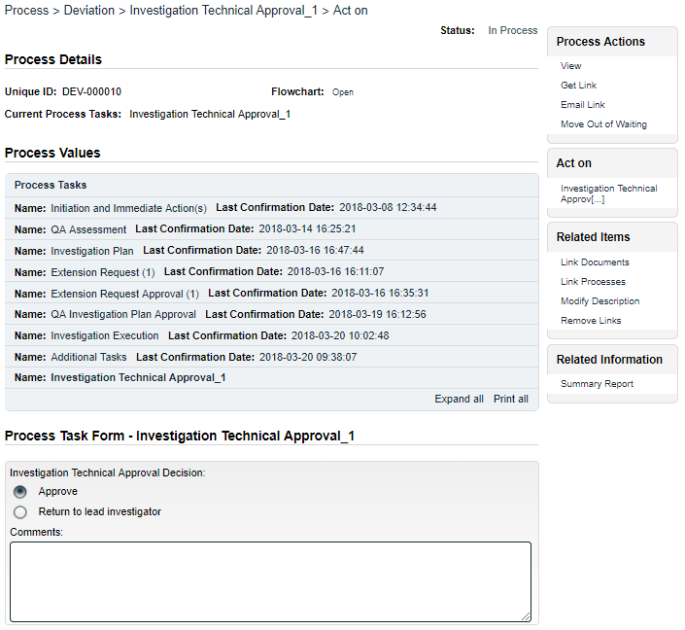
When the Technical Approver clicks on the Act on option to the right of the Investigation Technical Approval task, they will go immediately to the Act on screen for that task.
They can use the Expand all option under the Process Values table to view all information entered for the Deviation Process up to this point. If they go to the Process Actions >View option, they can see all Related Items at the bottom of the screen as well.
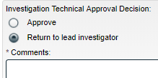
Secondary Tasks cannot be added at this Step so the +ADD option is grayed out. The Related Processes, Link Documents and Link Processes options are available.
The Technical Approvers have an optional free-text area for Comments that allows up to 8000 characters.
The Investigation Technical Approval Decision has two options: Approve or Return to lead investigator. A decision of Return to lead investigator makes the Comments field become mandatory. When this decision is Submitted and Confirmed, the process will go back to Step 5: Investigation Execution and be assigned to the Lead Investigator to address the comments.
An Investigation Technical Approval Decision of Approve will progress the Deviation Process to Step 6: Final QA Assessment.

The Process Flowchart will highlight that step of the process. The Process Details screen will display the Current Process Task and who it is Currently with: in this case the QA Approver.
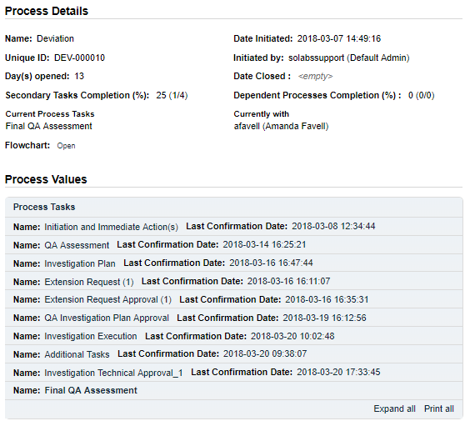

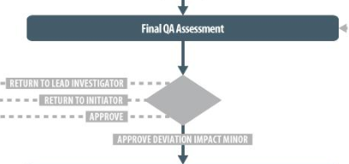

Step 6: Final QA Assessment
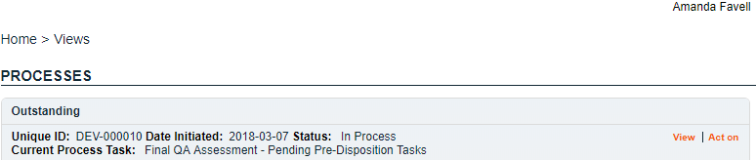
At this step in the Deviation Process, the QA Approver will receive an email Notification and will see the Final QA Assessment task listed in the Process section of their SOLABS QM HOME Page. If there are any pending Secondary Tasks of Task Type = Pre-Disposition, the name of this step will be Final QA Assessment – Pending Pre-Disposition Tasks, since the QA Approver will not be able to Approve this step until those are complete. (Note: due to QM10 system timers, “- Pending Pre-Disposition Tasks” will not be visible for at least 5 minutes after submission of the previous step. There is also a statement highlighted in red on the Act on screen if there are any pending Secondary Tasks of Task Type = Pre-Disposition.

Acting on the Final QA Assessment Task
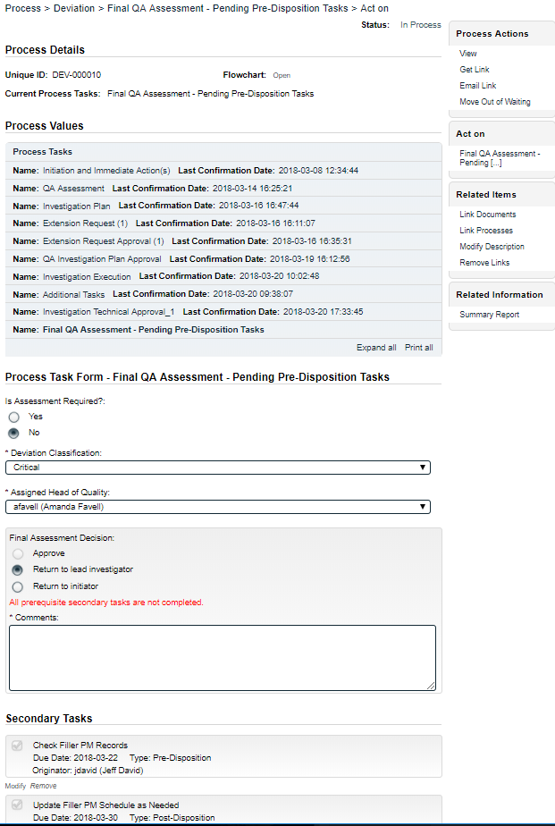
When the QA Approver clicks on the Act on option to the right of the Final QA Assessment task, they will go immediately to the Act on screen for that task.
They can use the Expand all option under the Process Values table to view all information entered for the Deviation Process up to this point. If they go to the Process Actions >View option, they can see all Related Items and can then View them as well.
Secondary Tasks cannot be added at this Step so the +ADD option is grayed out. The Related Processes, Link Documents and Link Processes options are available.
The QA Approver can use the Is Assessment Required? selection to add additional Assessment Types as needed. See page 14 of this document for the fields associated with a Yes selection.
The mandatory Deviation Classification field will be pre-populated with the Initial Deviation Classification entered by the QA Approver at Step 2. The QA Approver can change the Classification at this point if warranted.
As mentioned at Step 2, if the classification was entered as either Critical or Critical Incident, then an Assigned Head of Quality field will be mandatory and will be displayed at this step. It is a single-item selection drop-down list populated with the list of users who have the process role PR_DEV_QA_Head assignment.
At this point the QA Approver will make the Final Assessment Decision.
A decision of Return to lead investigator will make the Comments field mandatory. When this decision is Submitted and Confirmed, the Deviation Process will go back to Step 5: Investigation Execution and be assigned to the Lead Investigator to address the comments.
A decision of Return to initiator will also make the Comments field mandatory. When this decision is Submitted and Confirmed, the Deviation Process will go back to Step 1: Initiation and Immediate Action(s) and be assigned to the Initiator to address the comments. If Deviation Type is Planned, the decision Return to initiator is greyed out.
The decision of Approve is grayed out if any Secondary Tasks of Task Type = Pre-Disposition are not complete.
When a decision of Approve is able to be Submitted and Confirmed, the Deviation Process will progress as follows:
- If the Deviation was not classified as either Critical or Critical Incident, the process will be complete and go to END.
- If the Deviation was classified as either Critical or Critical Incident, the process will progress to Step 7: Head of Quality Final Approval.
The Process Flowchart will highlight that step of the process. The Process Details screen will display the Current Process Task and who it is Currently with: in this case the Head of Quality.
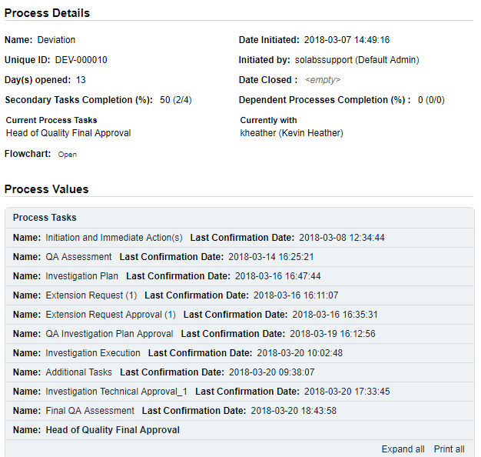

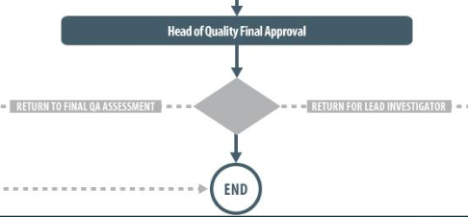

Step 7: Head of Quality Final Approval
At this step in the Deviation Process, the Head of Quality will receive an email Notification and will see the Head of Quality Final Approval task listed in the Process section of their SOLABS QM HOME Page. If there are any pending Secondary Tasks of Task Type = Post-Disposition, the name of this step will be Head of Quality Final Approval – Pending Post-Disposition Tasks, since the Head of Quality will not be able to Approve this step until those are complete. (Note: due to QM10 system timers, “- Pending Post-Disposition Tasks” will not be visible for at least 5 minutes after submission of the previous step. There is also a statement highlighted in red on the Act on screen if there are any pending Secondary Tasks of Task Type = Post-Disposition.

Acting on the Head of Quality Final Approval Task
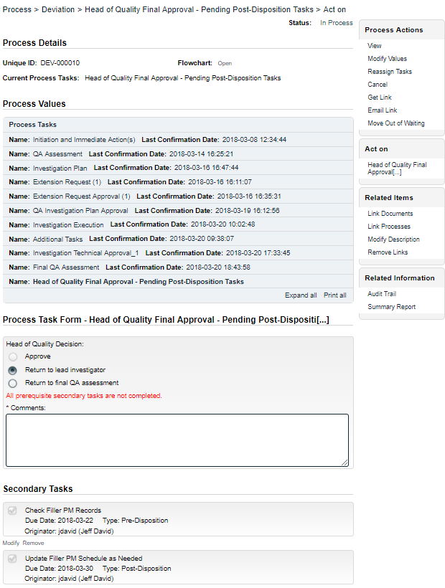
When the Head of Quality clicks on the Act on option to the right of the Head of Quality Final Approval task, they will go immediately to the Act on screen for that task.
They can use the Expand all option under the Process Values table to view all information entered for the Deviation Process up to this point. If they go to the Process Actions >View option, they can see all Related Items at the bottom of the screen and view them as well.
Secondary Tasks cannot be added at this Step so the +ADD option is grayed out. The Related Processes, Link Documents and Link Processes options are available if needed.
At this point the Head of Quality will make the Head of Quality Decision.
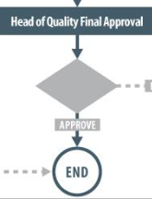
A decision of Return to lead investigator will make the Comments field mandatory. When this decision is Submitted and Confirmed, the Deviation Process will go back to Step 5: Investigation Execution and be assigned to the Lead Investigator to address the comments.

A decision of Return to final QA assessment also makes the Comments field mandatory. When this decision is Submitted and Confirmed, the Deviation Process will go back to Step 6: Final QA Assessment, and be assigned to the QA Approver to address the comments.
A decision of Approve will move the Deviation Process goes to a status of Completed and is at the END.

Viewing Details for a Completed Deviation Process
Users are able to search for and view processes at any stage, using the Navigation tab in the PROCESS Section of SOLABS QM. If the Process was recently worked on, it will also be available in the Recent Items section.
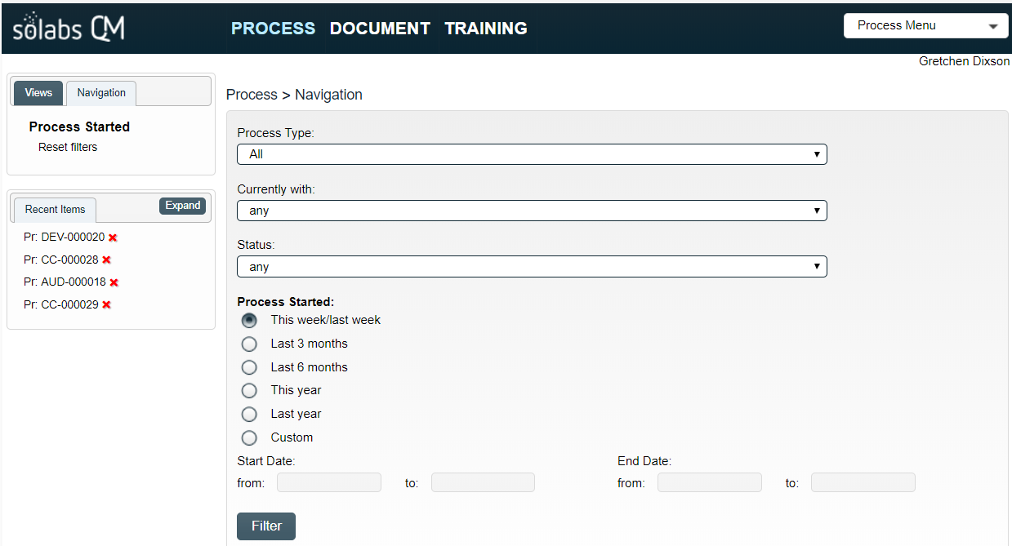
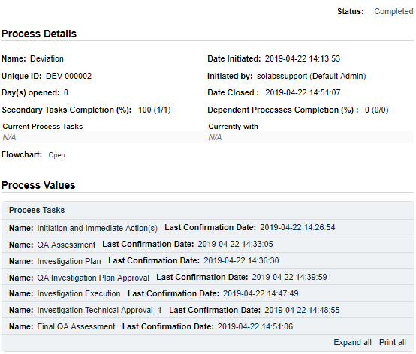

Using the Process Values Table
Process Tasks can be viewed by using the Expand all or Print all options at the bottom of the Process Values table. An individual Process Task can be expanded by clicking on it within the Process Values table.

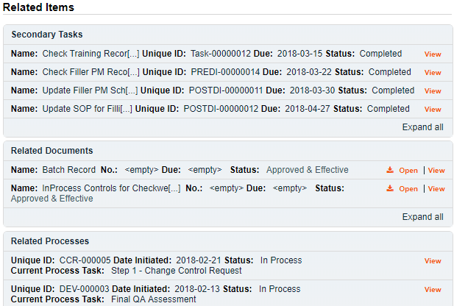
Using the Related Items Table
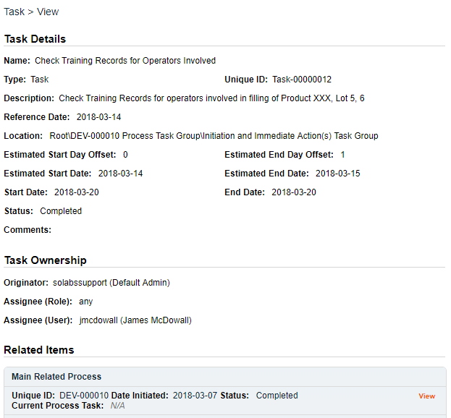
Information on any Secondary Tasks, Related Processes or Related Documents can be accessed by clicking on the View option beside the listing in the Related Items section of the screen. From any of those Details screens, the Process will be listed under Related Items – you can quickly toggle back to the Main Process by clicking View next to it.

Creating a Summary Report
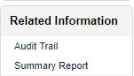
Under the right-hand Related Information menu, click on the Summary Report option.
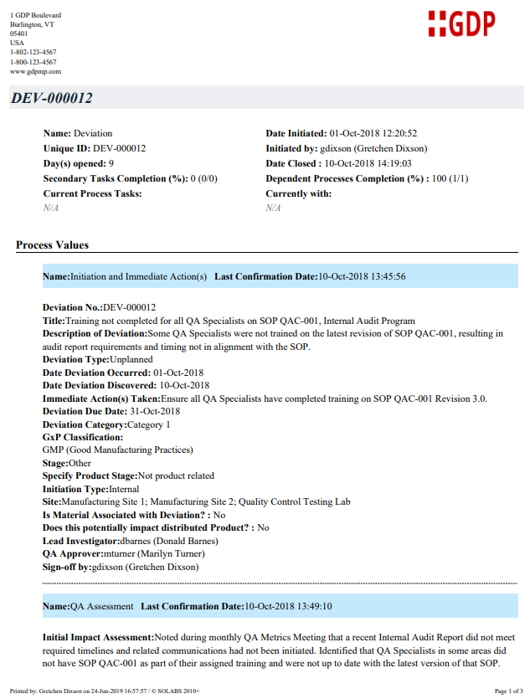
Select the desired Print Out Options and then click on Generate Report. A multi-page PDF Report will be generated, with any company header information set in System Configurations, and will include details on each step requested for the report.
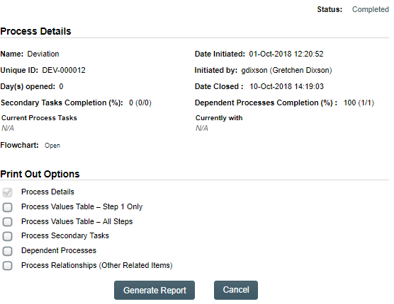

Using the Audit Trail
Users with the SOLABS System Administrator role assignment, will also see the Audit Trail option on the right-hand Related Information menu.

There you will find all the details for every step of the Deviation Process, from Process Completed all the way down to Process Started, with options to expand or print the entire process or any individual steps.
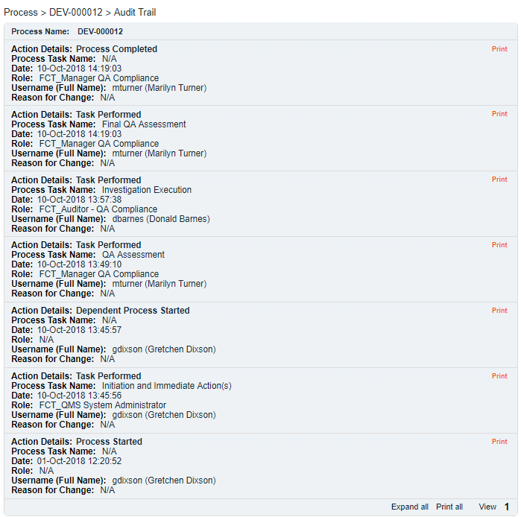

Deviation Process Notifications
The Notifications available with the Off-the-Shelf Deviation Process APP P0054 are identified in the Process Roles section of this User Guide and at the related Process Steps. The content of these email Notifications is described below.
General information on SOLABS QM10 Notifications available with the Core Software can be found in the SOLABS Knowledge Base in a document titled SOLABS QM10: Notifications Guide.

Included Notifications
The following Notifications are associated with the off-the-shelf Deviation Process P0054 APP.
When Step 1 is confirmed with a value of Does this deviation impact distributed Product? = yes, the following notification is sent:
To: All users in the role of PR_DEV_QA_Approver
Subject: Deviation DEV-XXXXXX is potentially impacting distributed product
Body:
DEV-XXXXXX
Deviation Title: [Step 1 field Title]
Description: [Step 1 field Description of Deviation]
Initiation Date: [date the process was initiated format yyyy-mm-dd]
Date Deviation Occurred: [Step 1 field Date Deviation Occurred]
-------------------------------------------------------------------------------------------------------------------------------
Where DEV-XXXXXX is a hyperlink to the process
The label and value Date Deviation Occurred is displayed only if Deviation Type = Unplanned.

When Step 1 is confirmed, the following notification is sent:
To: Department Head of user who confirmed Step 1
Subject: Deviation DEV-XXXXXX has been initiated
Body:
DEV-XXXXXX
Deviation Title: [Step 1 field Title]
Description: [Step 1 field Description of Deviation]
Initiation Date: [date the process was initiated format yyyy-mm-dd]
Date Deviation Occurred: [Step 1 field Date Deviation Occurred]
Initiator: [User who confirmed Step 1]
-------------------------------------------------------------------------------------------------------------------------------
Where DEV-XXXXXX is a hyperlink to the process
The label and value Date Deviation Occurred is displayed only if Deviation Type = Unplanned.

When Step 2 is confirmed with Decision = Approve – continue deviation process or Approve – close deviation process, the following notification is sent:
To: Users selected in Step 2 Committee Notification
Subject: Deviation DEV-XXXXXX has been opened
Body:
DEV-XXXXXX
Deviation Title: [Step 1 field Title]
Description: [Step 1 field Description of Deviation]
Initiation Date: [date the process was initiated format yyyy-mm-dd]
Date Deviation Occurred: [Step 1 field Date Deviation Occurred]
-------------------------------------------------------------------------------------------------------------------------------
Where DEV-XXXXXX is a hyperlink to the process
The label and value Date Deviation Occurred is displayed only if Deviation Type = Unplanned.

When Step 6 is confirmed with Decision = Approve and Deviation Classification ≠ Critical or Critical Incident, the following notification is sent:
To: Users selected in Step 2 Committee Notification
Subject: Deviation DEV-XXXXXX has been dispositioned
Body:
DEV-XXXXXX
Deviation Title: [Step 1 field Title]
Description: [Step 1 field Description of Deviation]
Initiation Date: [date the process was initiated format yyyy-mm-dd]
Date Deviation Occurred: [Step 1 field Date Deviation Occurred]
-------------------------------------------------------------------------------------------------------------------------------
Where DEV-XXXXXX is a hyperlink to the process
The label and value Date Deviation Occurred is displayed only if Deviation Type = Unplanned.

When Step 7 is confirmed with Decision = Approve, the following notification is sent:
To: Users selected in Step 2 Committee Notification
Subject: Deviation DEV-XXXXXX has been dispositioned
Body:
DEV-XXXXXX
Deviation Title: [Step 1 field Title]
Description: [Step 1 field Description of Deviation]
Initiation Date: [date the process was initiated format yyyy-mm-dd]
Date Deviation Occurred: [Step 1 field Date Deviation Occurred]
-------------------------------------------------------------------------------------------------------------------------------
Where DEV-XXXXXX is a hyperlink to the process
The label and value Date Deviation Occurred is displayed only if Deviation Type = Unplanned.
When all Secondary Tasks of type TASK have a status of Completed, the following notification is sent:
To: Users identified as Lead Investigator
Subject: All TASK Secondary Task are completed for Deviation DEV-XXXXXX
Body:
DEV-XXXXXX
Deviation Title: [Step 1 field Title]
Description: [Step 1 field Description of Deviation]
Initiation Date: [date the process was initiated format yyyy-mm-dd]
Date Deviation Occurred: [Step 1 field Date Deviation Occurred]
-------------------------------------------------------------------------------------------------------------------------------
Where DEV-XXXXXX is a hyperlink to the process
Must be reevaluated every time Secondary Task of type = TASK change status.
The label and value Date Deviation Occurred is displayed only if Deviation Type = Unplanned.

When all Secondary Tasks of type Pre-Disposition have a status of Completed, the following notification is sent:
To: Users identified as Assigned QA Approver
Subject: All Pre-Disposition Secondary Task are completed for Deviation DEV-XXXXXX
Body:
DEV-XXXXXX
Deviation Title: [Step 1 field Title]
Description: [Step 1 field Description of Deviation]
Initiation Date: [date the process was initiated format yyyy-mm-dd]
Date Deviation Occurred: [Step 1 field Date Deviation Occurred]
-------------------------------------------------------------------------------------------------------------------------------
Where DEV-XXXXXX is a hyperlink to the process
Must be reevaluated every time Secondary Task of type = Pre-Disposition change status.
The label and value Date Deviation Occurred is displayed only if Deviation Type = Unplanned.

When all Secondary Tasks of type Post-Disposition have a status of Completed, the following notification is sent:
To: Users identified as Assigned Head of Quality
Subject: All Post-Disposition Secondary Task are completed for Deviation DEV-XXXXXX
Body:
DEV-XXXXXX
Deviation Title: [Step 1 field Title]
Description: [Step 1 field Description of Deviation]
Initiation Date: [date the process was initiated format yyyy-mm-dd]
Date Deviation Occurred: [Step 1 field Date Deviation Occurred]
-------------------------------------------------------------------------------------------------------------------------------
Where DEV-XXXXXX is a hyperlink to the process
Must be reevaluated every time Secondary Task of type = Post-Disposition change status.
The label and value Date Deviation Occurred is displayed only if Deviation Type = Unplanned.

Additional Notification Available on Request – Option 2
There is one additional Notification available as “Option 2” per the PUFDS. It can be enabled upon request.
When Secondary Task Due Date < Today, the following notification is sent:
To: Secondary Task Assignee and Secondary Task Assignee’s Department Head
Subject: The Secondary Task [Secondary Task Name] is overdue.
Body:
The Secondary Task [Secondary Task Name] associated with process DEV-XXXXXX is overdue.
-------------------------------------------------------------------------------------------------------------------------------
Where DEV-XXXXXX is a hyperlink to the process
Where [Secondary Task Name] is a hyperlink to the Secondary Task view page (in the body only).

