SOLABS QM10: CAPA Process P0050 User Guide
Introduction 2
CAPA Process Flowchart 3
CAPA Process – Process Roles 4
Starting the CAPA Process 5
Step 1: Initiation and CAPA Definition 6
Completing the Process Task Form: 7
Creating Secondary Tasks 9
Document Control / Impacted Documents 10
Submit and Confirm 10
Step 2: CAPA Plan Acceptance 10
Viewing a CAPA Plan Acceptance Task 11
Acting on the CAPA Plan Acceptance Task 11
Step 3: CAPA Plan QA Evaluation and Acceptance 13
Acting on the CAPA Plan QA Evaluation and Acceptance Task 13
Secondary Task Assignments – Assignee Actions 15
Viewing the Secondary Task 15
Acting on the Secondary Task 16
Step 4: With Owner for CAPA Completion 17
Acting on the With Owner for CAPA Completion Task 17
Step 5: CAPA Due Date Extension Request 18
Acting on the CAPA Due Date Extension Request 19
Step 6: CAPA Due Date Extension Request Approval 20
Acting on the CAPA Due Date Extension Request Approval Task 21
Step 7: CAPA Completion 23
Acting on the CAPA Completion Task 24
Step 8: CAPA Completion and VOE Plan - QA 25
Acting on the CAPA Completion and VOE Plan – QA Task 26
Step 9 – VOE Completion 27
Acting on the VOE Completion Task 28
Step 10: VOE Due Date Extension Request 28
Acting on the VOE Due Date Extension Request 29
Step 11: VOE Due Date Extension Request Approval 30
Acting on the VOE Due Date Extension Request Approval 30
Step 12: CAPA Closure 31
Acting on the CAPA Closure Step 32
Viewing Details for a Completed CAPA Process 33
Using the Process Values Table 33
Using the Related Items Table 33
Using the Audit Trail 34
CAPA Process Notifications 35
Included Notifications 35
Available Options for CAPA Process P0050 35

Introduction
This document provides instructions on the use of the SOLABS QM10 CAPA Process APP P0050 – by guiding you through each step in the process and providing information on the activities, settings and options associated with each step. Detailed information on this process, including any available options that can be chosen by the client (field labels, additional notifications, etc.) are available in the User Functional Design Specification (UFDS) document that comes with deployment of the Process in your instance of SOLABS QM10. Any options for CAPA Process P0050 will be referenced at the applicable steps.
Refer to the following documents available in the SOLABS Knowledge Base for general information, navigation and functionality common to any SOLABS QM Process APP in the SOLABS QM10 PROCESS Section.
- SOLABS QM10: Introduction to PROCESS Section
- SOLABS QM10: Notifications Guide
- SOLABS QM10 PROCESS Section: Parent/Child Process Relationships
Different steps in a process are assigned to different roles and/or users in the system. You take action on the step assigned to you. For example, you may be assigned a CAPA Approval step in a CAPA process. A manager can monitor the status of process tasks assigned to their employees by using the Process Section search capabilities or the Process Reports to query process status by user.

CAPA Process Flowchart
The entire CAPA Process Flowcharts are displayed on this page for informational purposes only - to show that it is a complex multi-step process with many related decision paths.
This document is organized into sections for each of the Steps in the Change Control Process. The flowchart section for each of those steps will be displayed in larger, more readable format within those sections.
The Flowchart on the left is available within the Process App. As the process moves along, the active step in that Flowchart is highlighted.
The more detailed Flowchart on the right is available as part the User Functional Design Specification (UFDS) document that is provided with the Process App.
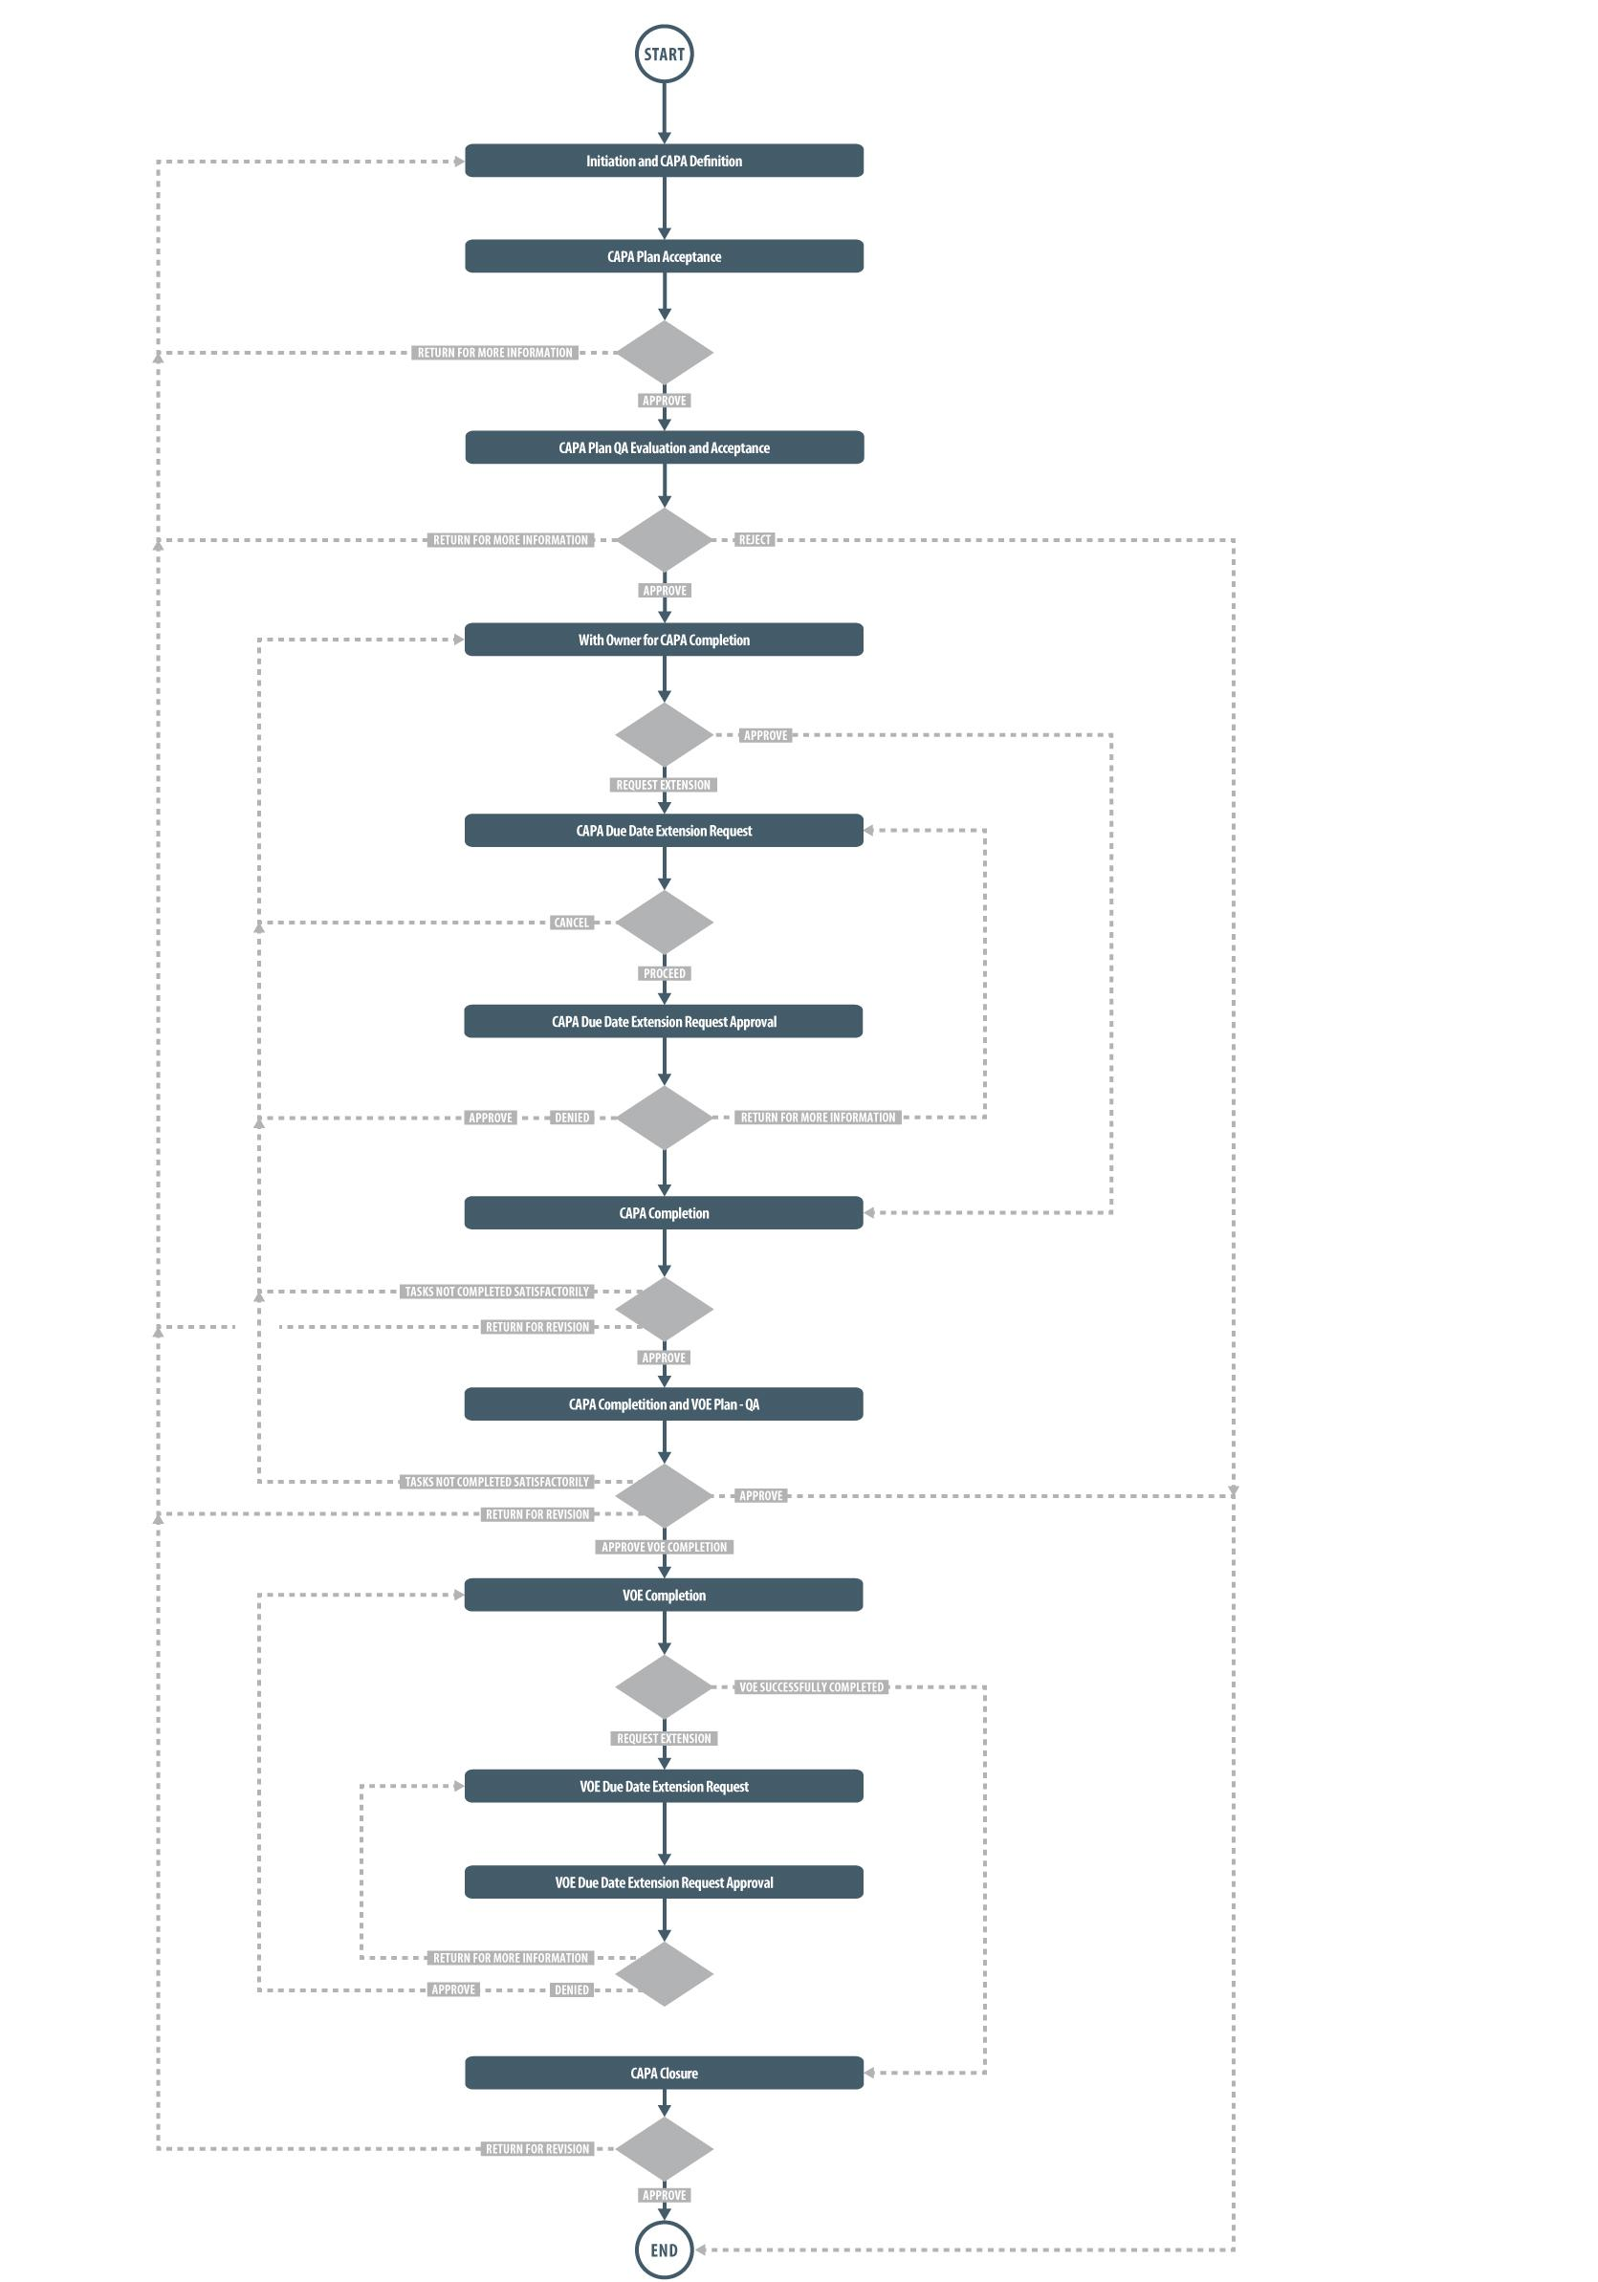

CAPA Process – Process Roles
Decisions made by those involved in the process act to progress the workflow to the next Step or return it to a prior Step. The following CAPA Process Roles are associated with CAPA Process P0050 and must be assigned to the Users in SOLABS QM10 who will make the related decisions and/or need to receive process email Notifications.
When SOLABS QM10 Users are assigned a Process Role, their names are then available on drop-down lists to be selected for their assigned steps in the process. The process will automatically notify them to Act On that Step/Primary Task. They will see the task in the Process Section of their SOLABS QM10 HOME Page and will also receive an email Notification.
Contact your SOLABS System Administrator if any of these CAPA Process Roles need to be assigned to additional Users. If these Process Roles are not assigned to any Users, the related process tasks will instead go to Users who have the System Role assignment of SOLABS Documentation Administrator. If that role is not assigned, the process tasks would go to the SOLABS System Administrator.
PR_CAPA_Owner:
This Process Role must be assigned to those Users who would be considered the responsible owner of a CAPA. They will need to Act on the following Primary Tasks in the CAPA Process.
- With Owner for CAPA Completion
- CAPA Due Date Extension Request
If CAPA Due Date is ≤ today + 5 days all users with this role assignment will receive an email Notification (notification is sent only once i.e. the first time this condition is met).
PR_CAPA_Reviewer:
This Process Role must be assigned to any Users who will be asked to review the CAPA process at any stage. This may occur as part of the following steps in the CAPA Process:
- CAPA Plan Acceptance
- CAPA Completion
PR_CAPA_Approver:
This Process Role must be assigned to any Users who will be asked to perform the following Primary Tasks in the CAPA Process:
- CAPA Plan QA Evaluation and Acceptance
- CAPA Due Date Extension Request Approval
- CAPA Completion and VOE Plan – QA
- VOE Completion
- VOE Due Date Extension Request
- VOE Due Date Extension Request Approval
- CAPA Closure
If VOE Due Date is ≤ today + 5 days the following the person selected at Step 1 as the CAPA Approver will receive an email Notification (notification is sent only once i.e. the first time this condition is met).

Starting the CAPA Process

From the PROCESS Section in SOLABS QM10, choose Start Process from the Quick Access Process Menu.

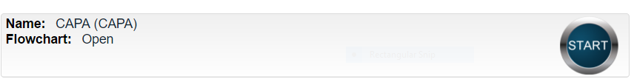
At the next screen, locate the listing for the CAPA Process and click the blue START button.

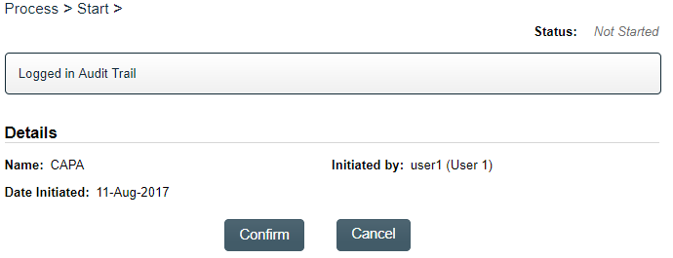
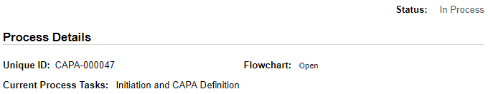
You will then be asked to Confirm this action, to move Status from Not Started to In Process. At this point a Unique ID will be assigned to the CAPA Process.

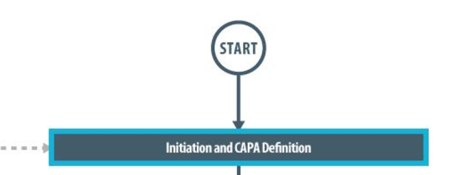
The first Primary Task box on the Process Flowchart will now be highlighted when it is opened.

Step 1: Initiation and CAPA Definition
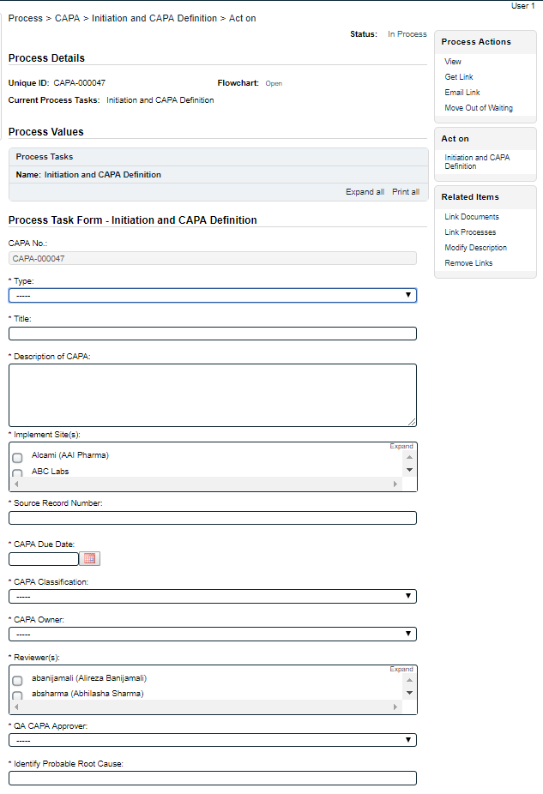
At Step 1 the user initiating the CAPA enters all the required information and metadata into the Process Task Form.
Some of the fields on the Process Task Form are drop-down menus, and others are editable text fields, single-select fields or multi-select fields. Those with an asterisk (*) are mandatory.
The right-hand Related Items menu allows the initiator to Link Documents or Link Processes, if applicable.
Refer to the separate document SOLABS QM10: Introduction to PROCESS Section for information on use of the right-hand menus since they are common to all SOLABS QM Process APP screens.
Each of the fields in the Process Task Form will be described starting on the next page.
Some of the information entered at Step 1 will determine how the process flows through the remaining steps.

At the bottom of the screen there is a Save Draft option if you cannot complete all the required fields at one time.

CAUTION: If you navigate away from this page without clicking on either Submit or Save Draft, all entries will be lost. To complete the information after a Save Draft option, you can either choose the Act On option from the Process section of your HOME Page, or search for the In Process CAPA and then use the right-hand Act on Menu to open the Process Task Form fields.

Completing the Process Task Form:
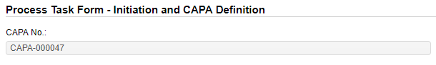
This sub-section covers the information required for the Process Task Form at CAPA Process Step 1. See the Options Section at the end of this User Guide for options available at Step 1 which may apply to your implementation and may therefore look different that what is seen below.
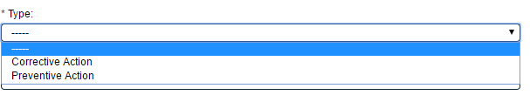
The CAPA No. field will be automatically populated with the next available CAPA number.
The Type field is a mandatory field where you will choose the type of CAPA being initiated – either Corrective Action or Preventive Action.
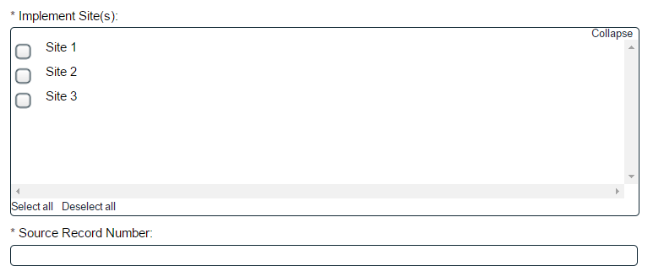
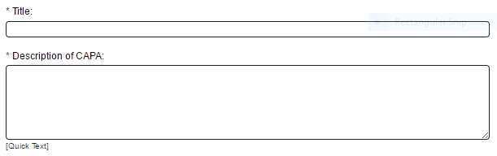
The Title field is mandatory. Choose a clear, concise and intuitive title for the CAPA that will quickly communicate the subject. Titles will appear in CAPA Reports. The Description of CAPA field can be populated with free text or by Quick Text options. Options to label these fields differently are available.
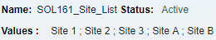
The Implement Site(s): field is a mandatory field. It is set up as a Multi-Select field populated from an editable Custom List of Site Names that your SOLABS System Administrator can customize for your organization.
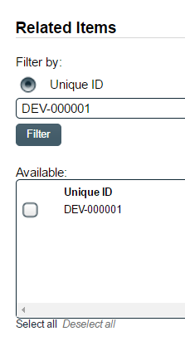
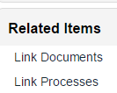
The Source Record Number field is a mandatory free-text field where you can enter the source of the record. One of the available Options for Step 1 is to for this field to be labeled CAPA Source. If it is from a Quality event for which another deployed SOLABS QM10 APP was used, you can also use the right-hand Related Items menu and choose Link Process to tie the two processes together.

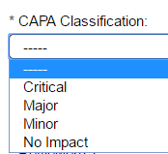
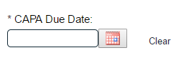
CAPA Due Date is a mandatory field that can be populated by a calendar. Try to set a CAPA due date that will include sufficient time for completion of related activities, as well as the approvals. When the CAPA Due Date is within 5 days of the current date, an email Notification will go to ALL users with the PR_CAPA_Owner role assignment.

CAPA Classification is a mandatory field where the criticality of the CAPA can be selected from a Single-select drop-down list. Another available Option for Step 1 is to remove the CAPA Classification of “No Impact”.
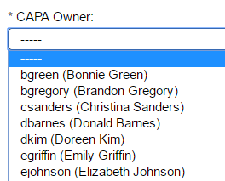
CAPA Owner is a mandatory field. It is a drop-down list that will be populated with names of the SOLABS QM10 Users who have been assigned the Process Role PR_CAPA_Owner. This person will be responsible for monitoring the CAPA Process and will be trigged to Act on Steps 4 and 5 of the CAPA Process. Before assigning the CAPA Owner, check with them first to verify their availability to take on the responsibilities.
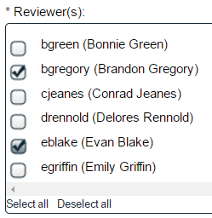
Reviewer(s) is a mandatory field. It is a multi-select list that will be populated with names of the SOLABS QM10 Users who have been assigned the Process Role PR_CAPA_Reviewer. The names chosen in this field will be triggered to Act on Steps 2 and 7 of the CAPA Process. Before assigning Reviewers, check with the CAPA Owner or others to ensure you select the appropriate people.

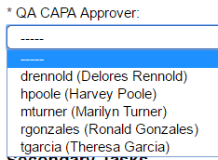
QA CAPA Approver is a mandatory field. It is a drop-down list that will be populated with names of the SOLABS QM10 Users from Quality who have been assigned the Process Role PR_CAPA_Approver. The name chosen in this field will be triggered to Act on a number of CAPA Process steps as the QA Approver.

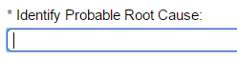
Identify Probable Root Cause is a mandatory free-text field where you can provide an initial probable root cause for the event that triggered the CAPA.
When you complete the above field, a mandatory multi-select field will be displayed to choose Root Cause Categories. Depending on which one(s) you select, additional single-select drop down lists for a more specific Root Cause Category will appear. The values for this more specific category come from an editable Custom List of root causes that your SOLABS System Administrator can customize for your organization. When it is not clear which value to select, consult with the QA Approver.
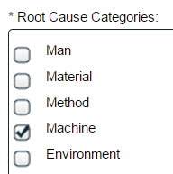
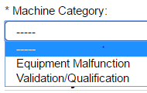


Creating Secondary Tasks
The initiator of the CAPA Process can create Secondary Tasks that will be associated with the CAPA. These Secondary Tasks can be assigned to appropriate Users for activities required to support completion of the CAPA but that are not part of the Primary Tasks.
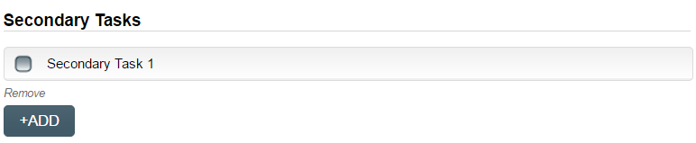
The Secondary Task section is under the Process Task Form, but still on the CAPA Initiation and Definition screen. This section is available at various Primary Task Steps of the CAPA Process, allowing others involved in the review, implementation and approval of the CAPA to assign additional Secondary Tasks.
After selecting Secondary Task 1, additional fields will be displayed to define and assign that task.
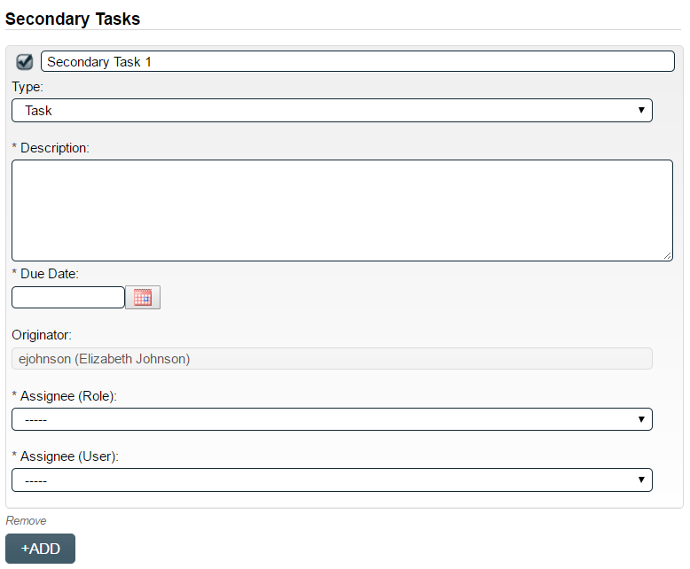
Replace the text “Secondary Task 1” with an appropriate Title for the task.
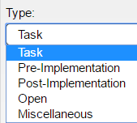
The task Type can then be chosen from a drop-down list. Pre-Implementation tasks will need to be completed prior to CAPA Closure. Do not choose Open as it is not related to the CAPA Process. Additional Task Types are available with Option 7.
Enter a Description and a Due Date for the Task. Choose due dates appropriate to ensure tasks are completed in a time frame that supports on time CAPA closure.
The Originator field will default to the User initiating the CAPA Process and completing Step 1.

The Assignee can be chosen either by Role or by User. These drop-down lists will bring up the Active Roles list and the Active Users list. People should not be assigned as task without being consulted first and must understand they are responsible for ensuring completion of the task in a timeframe that supports on time CAPA closure.
To assign by Role, choose the appropriate Function Role from the list. All Users with that Role will then appear in the Assignee(User) drop-down list so that the appropriate person can be selected. To assign by User, choose the appropriate User from the list. Their Function Role will then appear in the Assignee (Role) drop-down list and must be selected.
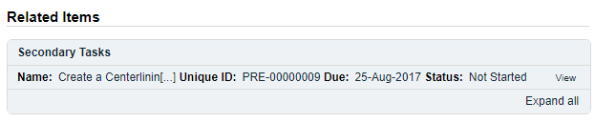
The +ADD button can be used to create additional Secondary Tasks. The Assignees will receive email Notifications and see the View/Act On options for their Secondary Tasks only after the CAPA Plan QA Evaluation and Acceptance Step of the CAPA Process is completed at Step 3. Until then the Task status is Not Started. The Secondary Tasks are listed under Related Items at the bottom of the screen any CAPA Step.

Document Control / Impacted Documents
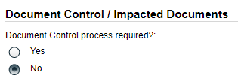
If the SOLABS QM10 Document Control Process will be used to manage any document updates required for the CAPA, select Yes and then initiate that process.

Submit and Confirm
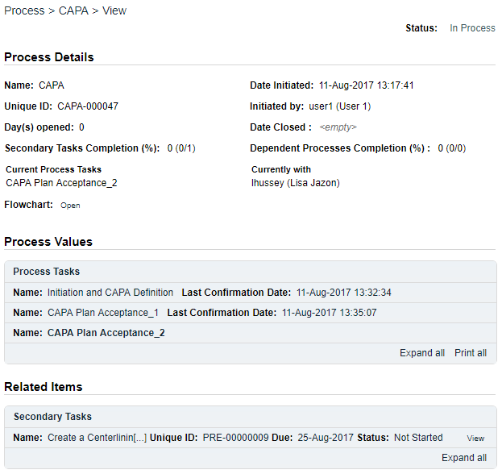
When all information has been entered in the Process Task Form, and any Secondary Tasks, Linked Documents or Linked Processes have been added, click Submit and then Confirm to change the Status to In Process and to progress the process to Step 2 – CAPA Plan Acceptance. The Process Flowchart will highlight the next step of the process and any Reviewers chosen at Step 1 will be listed. Those Reviewers will also receive email Notifications and will see the Review task listed on their SOLABS QM10 HOME Page.

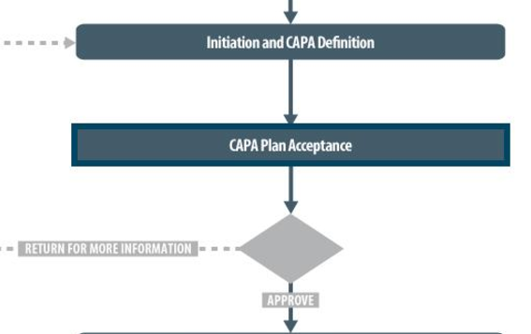

Step 2: CAPA Plan Acceptance
At this step in the CAPA Process, any Reviewers chosen at Step 1 will receive an email Notification and will see their Review task listed in the Process section of their SOLABS QM10 HOME Page.

Viewing a CAPA Plan Acceptance Task
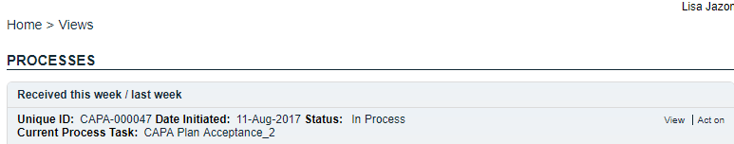
If the Reviewer clicks on the View option to the right of the Process Task, they will get the same screen shown on the previous page of this document.

From the View screen, there are Expand all options under the Process Values table and the Related Items table, that can be used to see more detail on the information entered by the initiator at Step 1. They can also click on the View option to the right of any individual Related Items (Secondary Tasks, Linked Documents, Linked Processes) to go to the Task Details, Document Details or Process Details screens associated with those Related Items. From any of those screens they can quickly return to the Process since it will be listed as a Related Item on all of those screens. See example below.
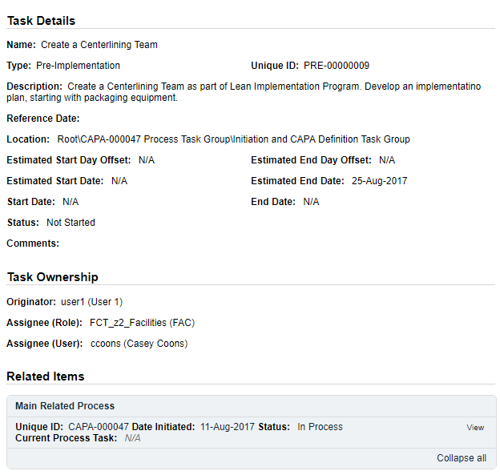
In this example, clicking on View for the Secondary Task listed in CAPA-000047 brings up the Task Details screen for that assigned Task.
CAPA-000047 is listed as a Related Item for that Task. To get back to CAPA-000047, the Reviewer can click on the View option.

Since Secondary Tasks are used to outline the CAPA Plan, the Reviewers should always look for that particular listing under Related Items, use the View option to open up the Task Details screen for that Secondary Task so they can review and determine whether it is acceptable.

Acting on the CAPA Plan Acceptance Task
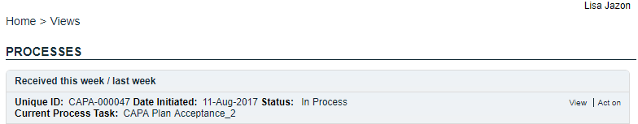
If the Reviewer clicks on the Act on option to the right of the Process Task, they will go immediately to the Act on screen for their Review task.

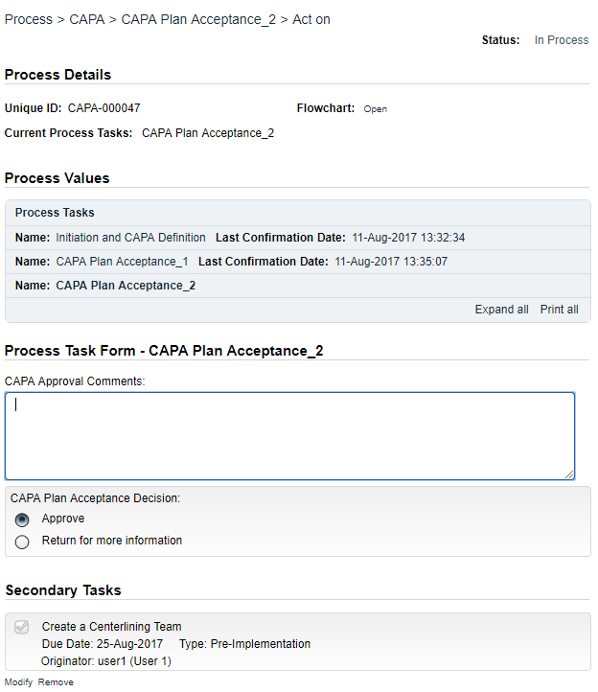
At the Act on screen for the CAPA Plan Acceptance Task, each Reviewer can view all details of the information entered at Step 1 by choosing the Expand all option under Process Values.
Each Reviewer can provide CAPA Approval Comments – this is not mandatory.
Reviewers can choose the Modify option under any Secondary Task to see the related fields and make any edits they might need to make, including removal of the Task.
Finally, each Reviewer will make their CAPA Plan Acceptance Decision. They will either Approve or Return for more information.
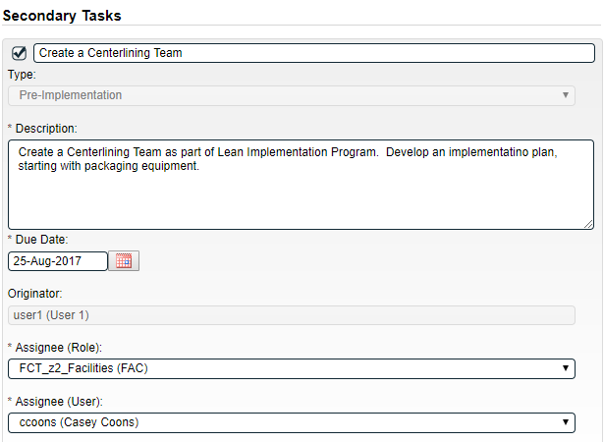
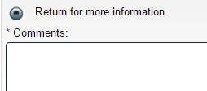
If they choose to return it, a Comment is mandatory. The process will to back to Step 1, after all Reviewers have provided input, so that the Initiator make the requested changes. If there are multiple Reviewers, each should check the Process Values table to see if any other Reviewer chose to Return it.
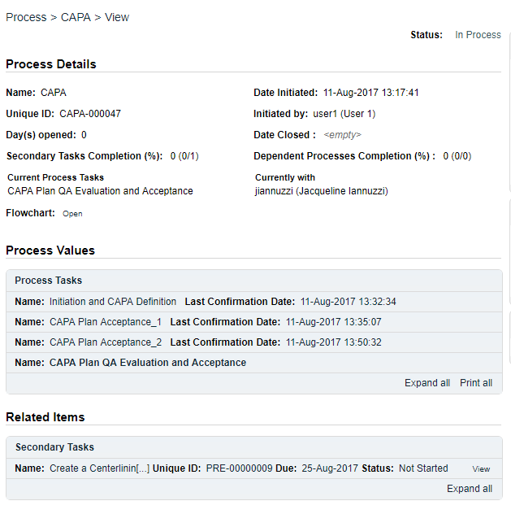
If all Reviewers choose the Approve option, the process will move to the next Primary Task in the Process: Step 3 – CAPA Plan QA Evaluation and Acceptance.

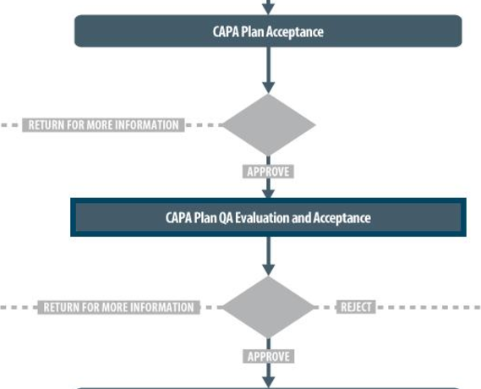

Step 3: CAPA Plan QA Evaluation and Acceptance
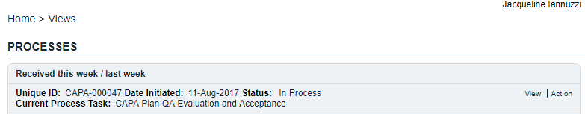
At this step in the CAPA Process, the QA CAPA Approver chosen at Step 1 will receive an email Notification and will see their CAPA Plan QA Evaluation and Acceptance task listed in the Process section of their SOLABS QM10 HOME Page. As described for Step 2 above, if they choose the View option they can access all information ahead of making a decision. If they choose the Act on option they can still review the Process Values Table but from their Act on screen.

Acting on the CAPA Plan QA Evaluation and Acceptance Task
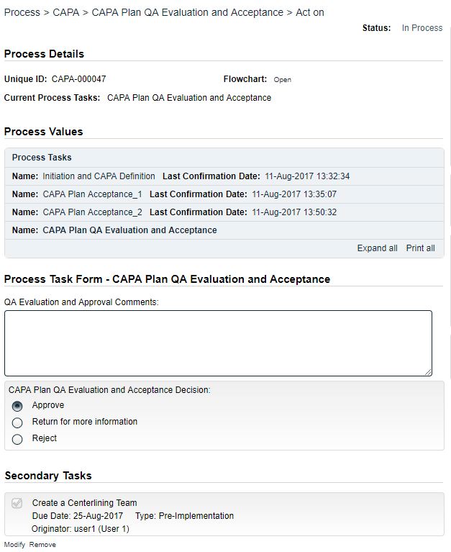
When the QA CAPA Approver clicks on the Act on option to the right of the Process Task, they will go immediately to the Act on screen for their Approval task.
At the Act on screen for the CAPA Plan QA Evaluation and Acceptance task, the Approver can view information entered at previous steps by choosing the Expand all option in the Process Values table. Steps can be expanded individually or the entire table can be expanded.
The Approver can provide QA Evaluation and Approval Comments – this is not mandatory.
The Approver can review Secondary Tasks to see the related fields. They can choose to Modify or Remove the existing Secondary Tasks and can also choose to +ADD one or more Secondary Tasks at this step.
The Approver can review Related Processes, including linked Doc Control Processes, and also Remove or +ADD any as needed.
Finally, the Approver will make their CAPA Plan QA Evaluation and Acceptance Decision. They will either Approve, Return for more information or Reject.
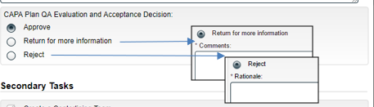
If they choose Return for more information, a Comment is mandatory, and the process will to back to Step 1, where the Initiator will work with the QA CAPA Approver to modify the CAPA plan.
If they choose Reject, a Rationale is mandatory, and the process will go to the END.
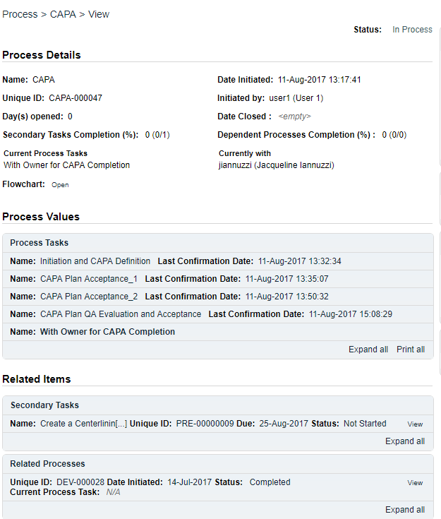
If they choose the Approve option, the process will move to the next Primary Task in the Process: Step 4 – With Owner for CAPA Completion. At this point, Secondary Task(s) and Processes are released and the Assignees receive notification of their assigned tasks.

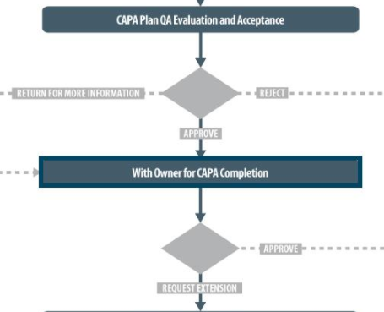

As the CAPA Process progresses from Step to Step, notice how each step is added to the Process Values table so that it is available for those acting on later steps to review.
If Secondary Tasks, Related Documents or Related Processes are added along the way, they will be added to the Related Items section.
As mentioned previously, with each Primary Task assignment, Users can use the View option from their HOME Page to see the above screen and be able to toggle back and forth between the Process and any Related Items.
At this point in the CAPA Process, Assignees of any Secondary Tasks will receive email Notifications and see those activities listed in the TASKS section of their SOLABS QM10 HOME Page.
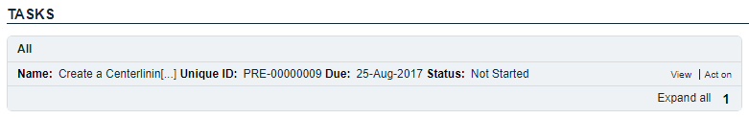

Secondary Task Assignments – Assignee Actions
If there were any Secondary Tasks assigned at Step 1, they are now released to Act on since the CAPA Process has been approved by the Reviewers and the QA CAPA Approver.

Viewing the Secondary Task
When the Assignee for a Secondary Task chooses the View option from their HOME Page, they are brought to the Task > View screen for that Task. They can now review what has been assigned to them and can also toggle to the CAPA Process that triggered the Task, since it is listed at the bottom of the screen as a Related Item.
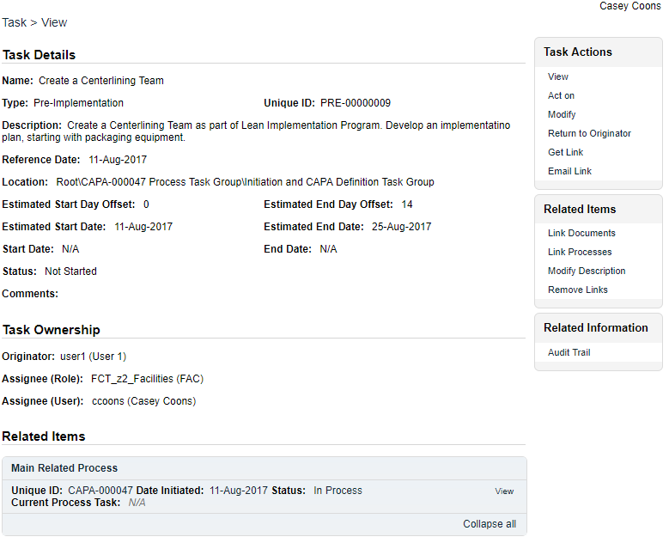
The task Assignee has various options under their Task Actions and Related Items right-hand menus to help manage completion of their task. Any actions they take will be visible to those acting on the Primary Task steps in the CAPA Process if they choose to View a Secondary Task.

Acting on the Secondary Task
When the Assignee for a Secondary Task chooses the Act on option from their HOME Page, they are brought to the Task > Act on screen for that Task.

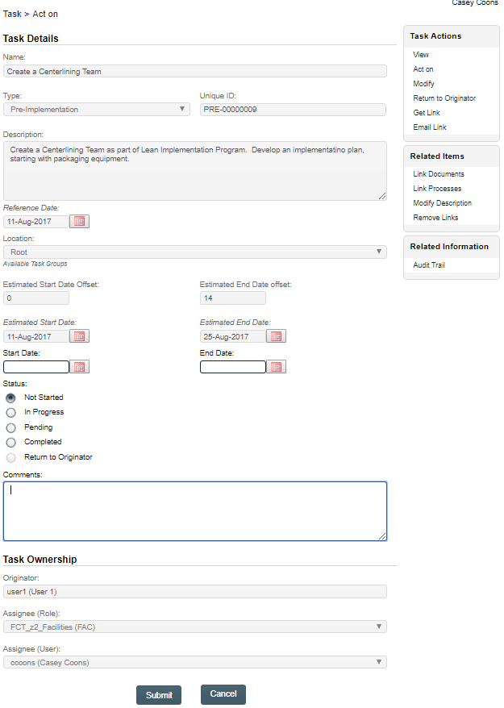
From this screen, the Assignee can also review the Task Details.
The fields they have available to them are to select a Start Date, enter an End Date when they are finished with the task and to change the Status as they progress it.
They can also enter free-text Comments at any point.
The task will default to a status of Not Started. If a status of In Progress is selected, the Start Date field will be populated with the current date. If a Start Date is entered, the Status will automatically move to In Progress. For longer term tasks, it is best practice to periodically log in and provide status updates in the Comments field.
If a status of Pending is selected, the Start Date field will be grayed out.
If a status of Completed is selected, the End Date field will be populated with the current date. If an End Date is entered, the Status will automatically move to Completed.
The Return to Originator option is grayed out since it is currently not available.
If the Assignee would like to add evidence / documentation to support completion of the task, the Link Documents option is available on the right-hand menu.

Step 4: With Owner for CAPA Completion
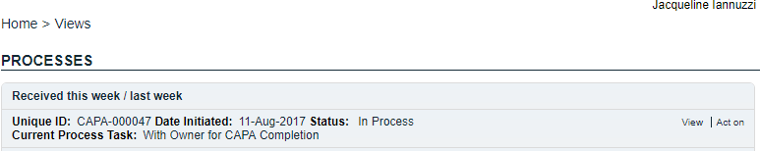
At this step in the CAPA Process, the CAPA Owner chosen at Step 1 will receive an email Notification and will see the With Owner for CAPA Completion task listed in the Process section of their SOLABS QM10 HOME Page. The CAPA plan is now approved to be executed. They can choose the View option to access all information previously entered. If they choose the Act on option they can still review the Process Values table but from their Act on screen.

Acting on the With Owner for CAPA Completion Task
When the CAPA Owner clicks on the Act on option to the right of the Process Task, they will go immediately to the Act on screen for the With Owner for CAPA Completion task. The CAPA Owner is responsible to monitor the CAPA plan, any Secondary Tasks and Related Processes until they are completed. At that point, they can complete this Step.
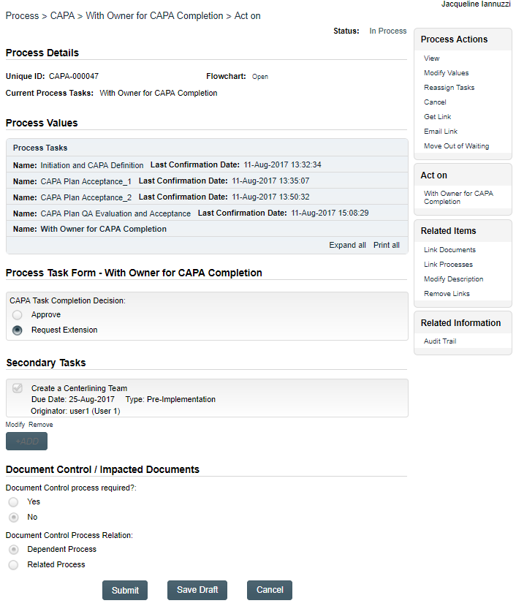
At the View or Act on screen the CAPA Owner can view information entered at previous steps by choosing the Expand all option in the Process Values table. Steps can be expanded individually or the entire table can be expanded. They can also view the Secondary Tasks and Related Processes associated with the CAPA.
When the CAPA plan / Secondary Tasks have been completed, the CAPA Owner will use this screen to enter their CAPA Task Completion Decision. In this example, the Approve option is grayed out which means some Related Items are not yet complete. Otherwise, the Approve option would be available and the process would move directly to Step 7 - CAPA Completion.
If needed, a decision of Request Extension can be chosen. The request should be made proactively, prior to the CAPA due date. The CAPA Process will move to Step 5 – CAPA Due Date Extension Request.
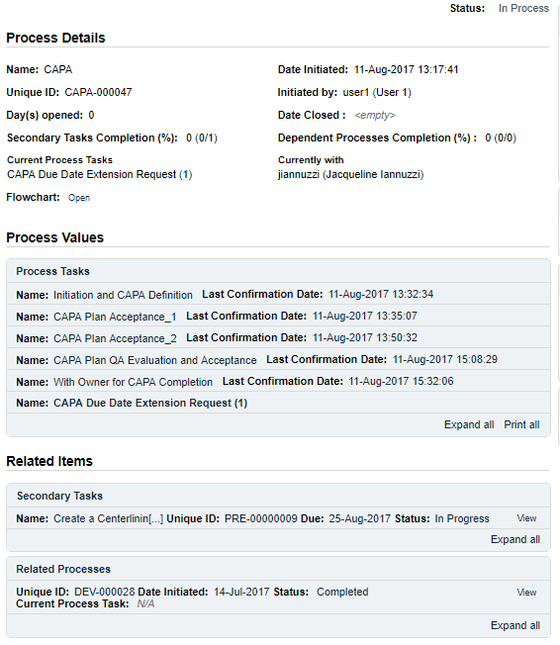

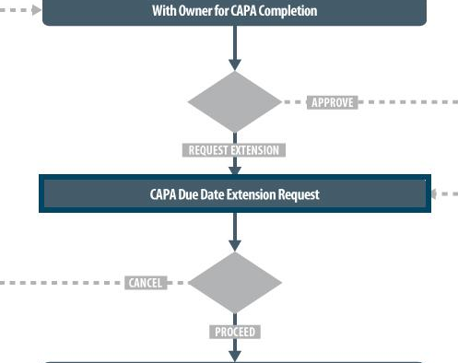

Step 5: CAPA Due Date Extension Request
At this step in the CAPA Process, the CAPA Owner will receive an email Notification and will see the CAPA Due Date Extension Request task listed in the Process section of their SOLABS QM10 HOME Page. Extension Requests are formally captured as a CAPA Process Primary Task, even though it will go to the same person. The number in parenthesis – in this case (1) – indicates the number of the extension requested by the CAPA Owner. If another one should be necessary, it would show (2).
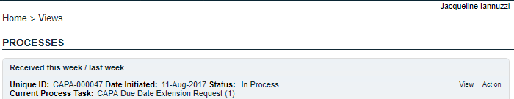

Acting on the CAPA Due Date Extension Request
When the CAPA Owner clicks on the Act on option to the right of the CAPA Due Date Extension Request task, they will go immediately to the Act on screen for their CAPA Due Date Extension Request task.
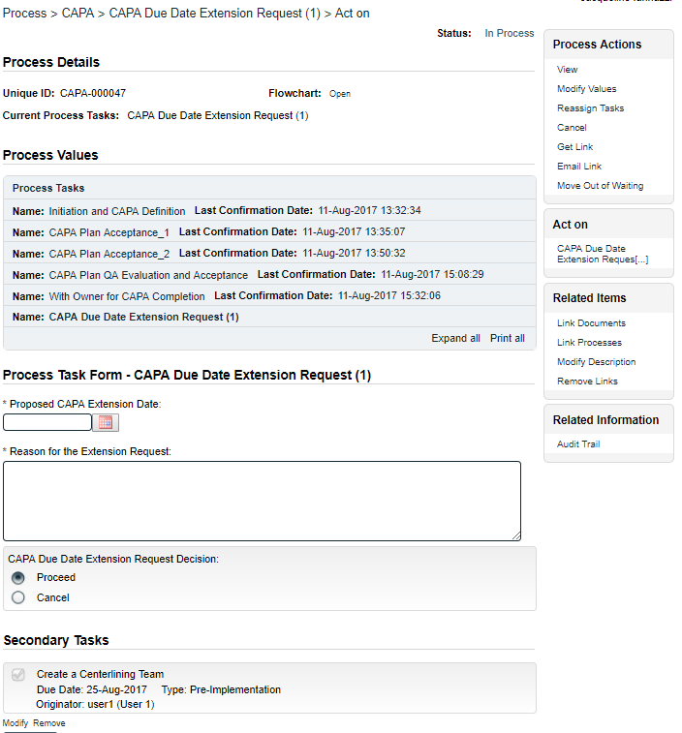
At this point, they need to enter a date in the Proposed CAPA Extension Date field and complete the mandatory Reason for the Extension Request field.
They then need to make their formal CAPA Due Date Extension Request. They can choose to Cancel the request – perhaps because anticipated delays were resolved – or they can choose Proceed, which will send the process to Step 6 – CAPA Due Date Extension Request Approval.

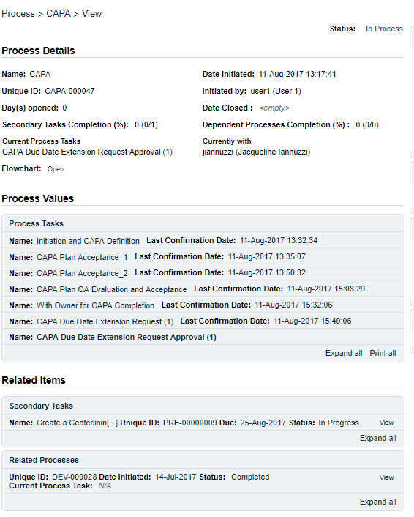

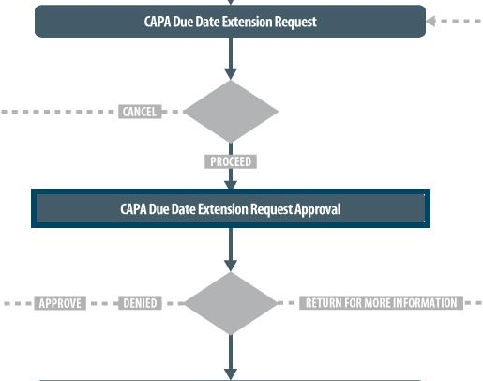

Step 6: CAPA Due Date Extension Request Approval
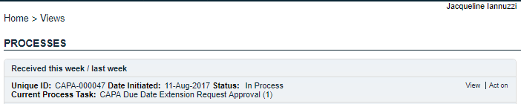
At this step in the CAPA Process, the QA CAPA Approver will receive an email Notification and will see the CAPA Due Date Extension Request Approval task listed in the Process section of their SOLABS QM10 HOME Page.

Acting on the CAPA Due Date Extension Request Approval Task
When the QA CAPA Approver clicks on the Act on option to the right of the CAPA Due Date Extension Request Approval task, they will go immediately to the Act on screen for their CAPA Due Date Extension Request Approval task.
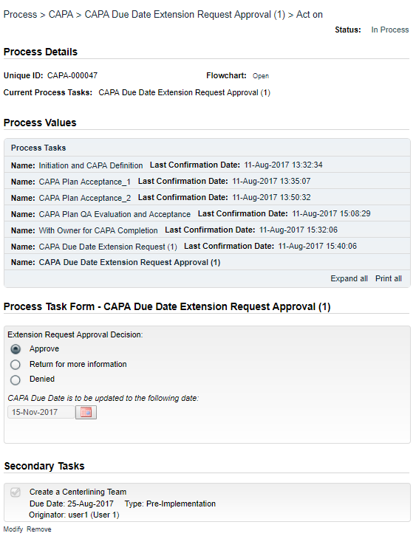
At the Act on screen for the CAPA Due Date Extension Request Approval task, the QA CAPA Approver can view information entered at previous steps by choosing the Expand all option in the Process Values Table. Steps can be expanded individually or the entire table can be expanded.
At this point, they need to enter the Extension Request Approval Decision.
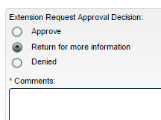
If they choose Return for more information, a Comment field is mandatory. The process will go back to the previous Step so that the CAPA Owner can address the comment.
If they choose Denied, a Rationale field is mandatory. The process will again go back to the previous Step.
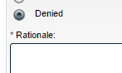
If they choose Approve, the CAPA Process will go back to Step 4 – With Owner for CAPA Completion and the CAPA due date is updated with the approved extension date.
At this point the CAPA Owner can continue to monitor for completion of related activities.

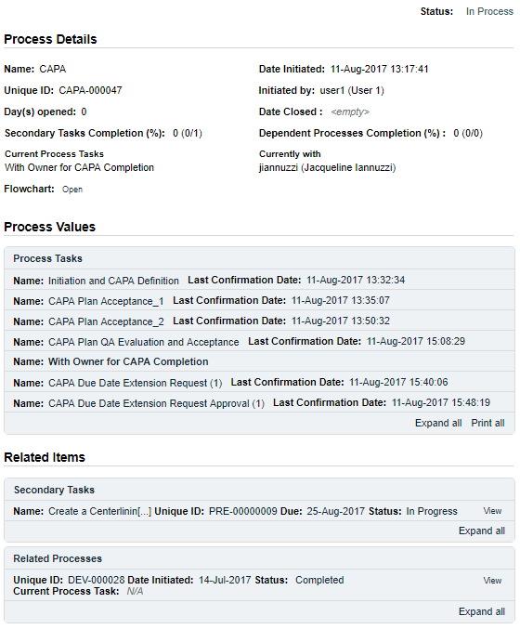

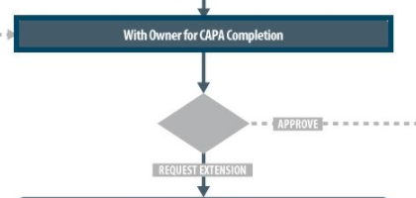

From the Process Values table, we can see that the CAPA Owner had requested an extension and that it was approved. At that point, the CAPA Process went back to Step 4 - With Owner for CAPA Completion.
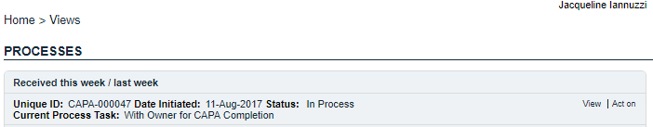
The CAPA Owner will now receive another Notification – just like they did prior to requesting the extension, and will see the With Owner for Completion task listed in the Process section of their SOLABS QM10 HOME Page.

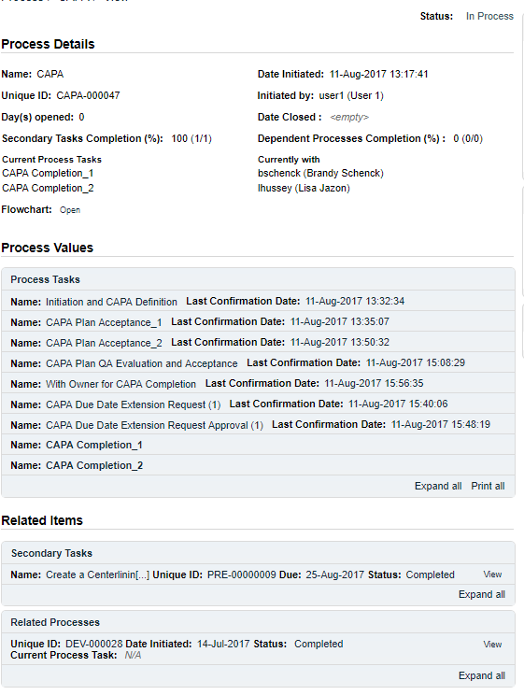
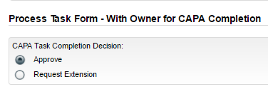
The CAPA Process they own is now accepted for an extension. They can choose the View option to access all information previously entered. Looking at the Related Items section, the Secondary Task has now completed so the CAPA Owner can Act on the CAPA Process and choose the Approve option, to bring it to Step 7 – CAPA Completion.

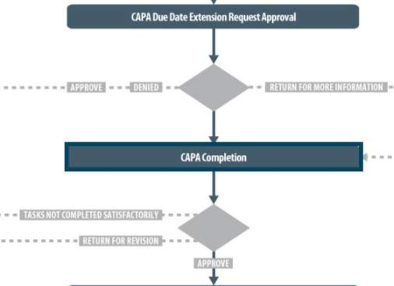

Step 7: CAPA Completion
At this step in the CAPA Process, each of the Reviewers chosen at Step 1, and who reviewed the CAPA at Step 2, will receive an email Notification and will see the CAPA Completion task listed in the Process section of their SOLABS QM10 HOME Page.
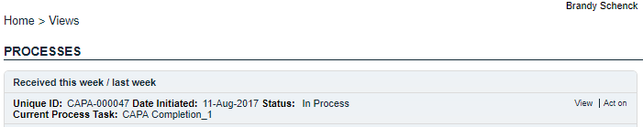

Acting on the CAPA Completion Task
Each Reviewer can choose to View the CAPA Process, and then choose CAPA Completion from the right-hand Act on Menu, or they can choose Act on from their HOME Page.
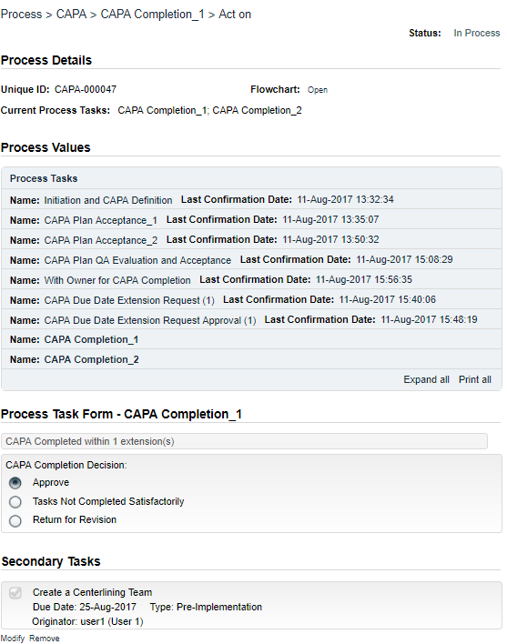
At this point, with the CAPA Owner having communicated CAPA Completion, they are getting this task in order to make their CAPA Completion Decision.
If a Reviewer chooses Tasks Not Completed Satisfactorily, they will be required to enter a Rationale. The CAPA Process will then return to Step 4 - With Owner for CAPA Completion.
If a Reviewer chooses Return for Revision, they will be required to enter a Comment. The CAPA Process will then return to CAPA Initiator.
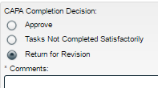
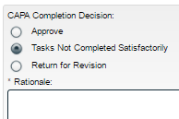
NOTE: If only one Reviewer chooses the Tasks Not Completed Satisfactorily or the Return for Revision option, the other Reviewers must still make their CAPA Completion Decision before the process goes back to the CAPA Owner or the Initiator. Each Reviewer can see the decisions of the others in the Process Values table.
If all Reviewers choose Approve, the CAPA Process will progress to Step 8 – CAPA Completion and VOE Plan – QA.
The decision as to whether or not this CAPA should have a Verification of Efficacy (VOE) is the responsibility of the assigned QA CAPA Approver and happens in the next step.
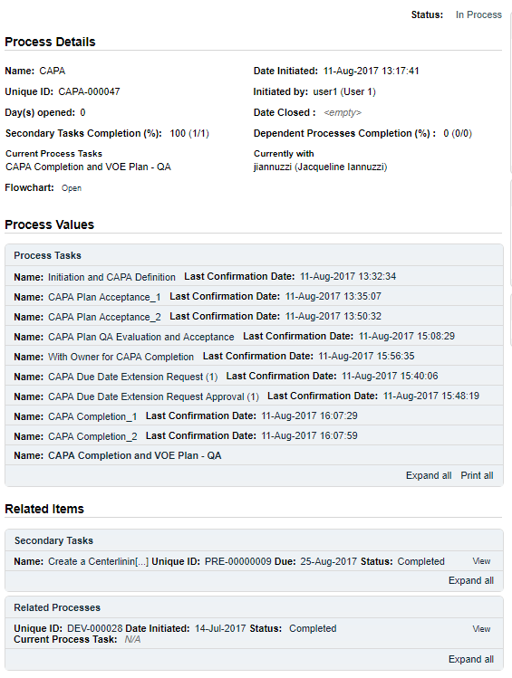

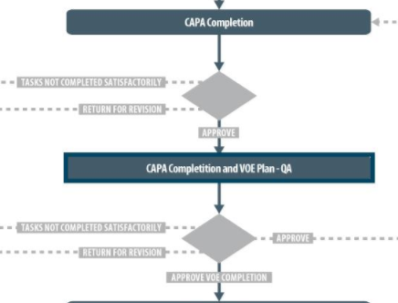

Step 8: CAPA Completion and VOE Plan - QA
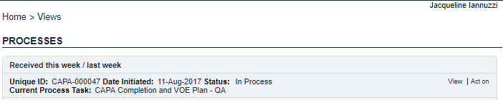
At this step in the CAPA Process, the QA CAPA Approver will receive a Notification and will see the CAPA Completion and VOE Plan - QA task listed in the Process section of their SOLABS QM10 HOME Page.

Acting on the CAPA Completion and VOE Plan – QA Task
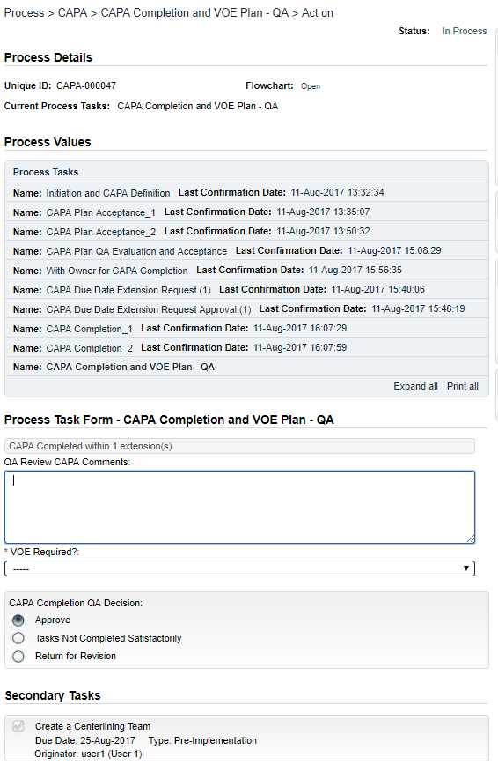
At this step in the CAPA Process, the QA CAPA Approver has the same options described at Step 7 above for the Reviewers.
The QA CAPA Approver also has some additional fields to complete.
- QA Review CAPA Comments
- VOE Required?
The QA Review CAPA Comments field is optional.
The VOE Required? field is mandatory and is a single-select drop-down list:
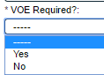

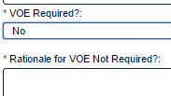
A selection of No brings up a mandatory Rationale field. If the CAPA Completion QA Decision is then to Approve, the CAPA Process will then close upon confirmation of this step.

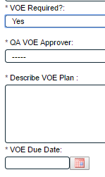

A selection of VOE Required is Yes brings up the mandatory fields for a QA VOE Approver, VOE Plan and VOE Due Date.
When the VOE Due Date is within 5 days of the current date, an email Notification will be sent to the CAPA Approver.

When they then choose a CAPA Completion QA Decision of Approve the CAPA Process will progress to Step 9 – VOE Completion but will stay with the original QA CAPA Approver since they are responsible for monitoring and then determining the final effectiveness of the CAPA.
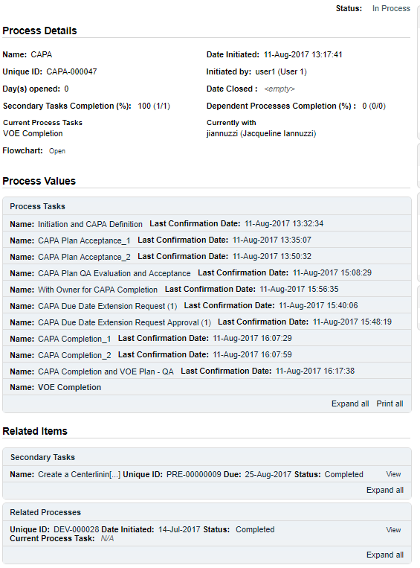

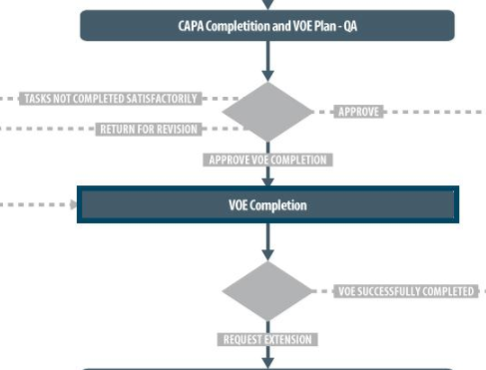

Step 9 – VOE Completion
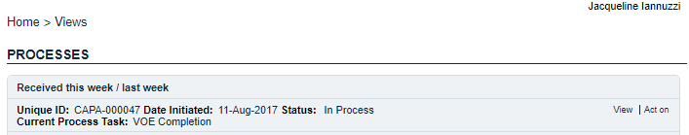
At this step, even though the CAPA Process stays with the same person – the QA CAPA Approver – they will receive a Notification for the new VOE Completion task.

Acting on the VOE Completion Task
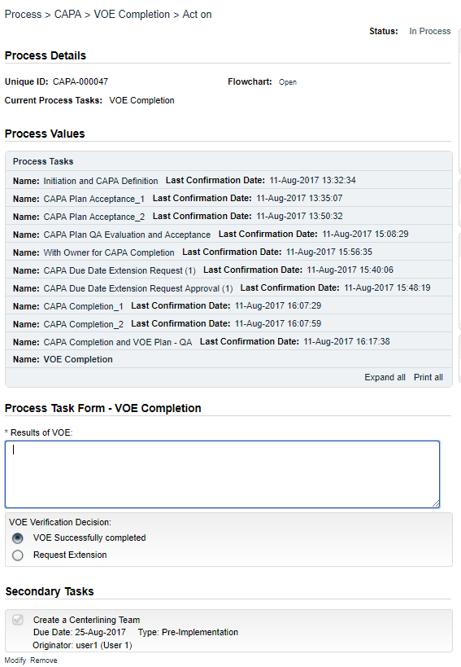
This VOE Completion task will stay with the QA CAPA Approver until such time as they are ready to make the VOE Verification Decision.
If the VOE Plan takes longer than may have been anticipated, they will have the option to submit a VOE Due Date Extension Request and to get VOE Due Date Extension Request Approval. These will be formally captured within the CAPA Process as Steps 10 and 11.
If Request Extension is chosen, the Results of VOE field is still mandatory but can be used to provide an update on the status of the VOE to date.
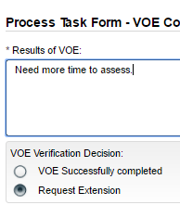

Step 10: VOE Due Date Extension Request
This CAPA Process Step will also stay with the QA CAPA Approver but they will get another Notification and an Act on the VOE Due Date Extension Request task in order to choose a date and to formally capture the information as part of the CAPA Process.

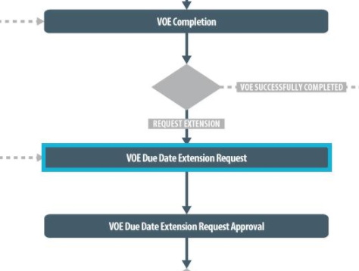
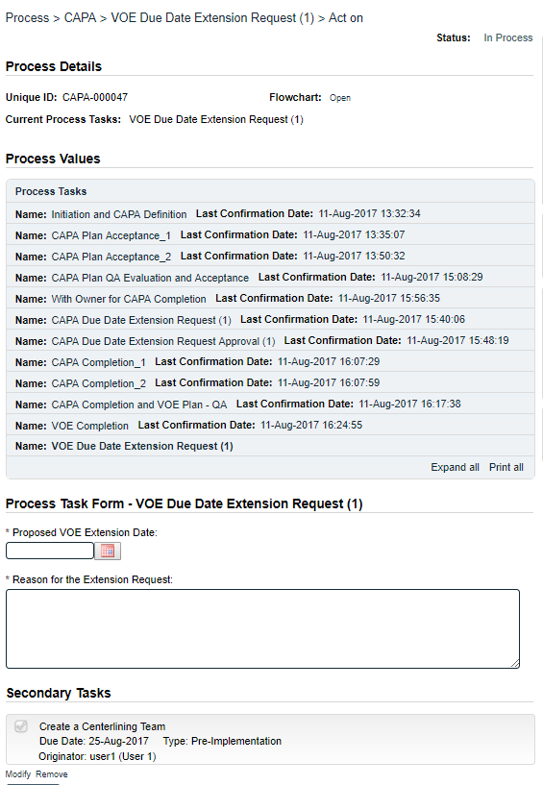

Acting on the VOE Due Date Extension Request
At this point the CAPA Approver must enter a Proposed VOE Extension Date and a Reason for the Extension Request.
At this point the CAPA Process will move to Step 11 – VOE Due Date Extension Request Approval and will be assigned to the QA VOE Approver who was selected at Step 8.

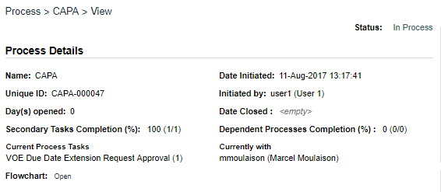

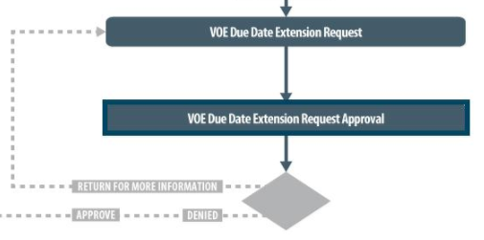

Step 11: VOE Due Date Extension Request Approval
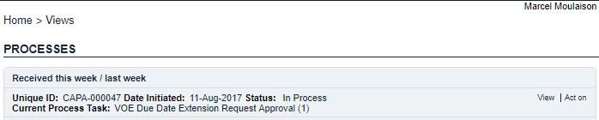
The QA VOE Approver, chosen by the QA CAPA Approver at Step 8, will now receive a Notification to formally approve this VOE Due Date Extension Request.

Acting on the VOE Due Date Extension Request Approval
A choice to Return for more information will require a mandatory Comment and send the Extension Request back to the Requester.
A choice of Denied will require a mandatory Rationale and send the CAPA Process back to the Requester.
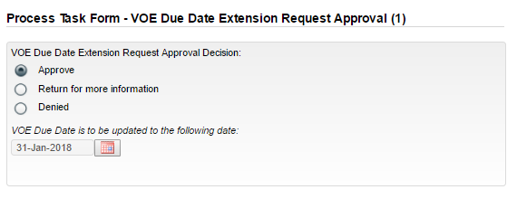
A VOE Due Date Extension Request Approval Decision of Approve will extend the due date and send the CAPA Process back to Step 9 – VOE Completion, with the QA CAPA Approver.
When the CAPA Process originally reached Step 9, if the QA CAPA Approver had not chosen to request an extension, the other VOE Verification Decision was VOE Successfully completed.
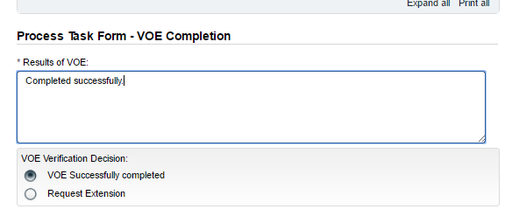
At whatever point the QA CAPA Approver chooses the decision of VOE Successfully completed – either without needing an extension or after an extension – the CAPA Process will then move to Step 12 – CAPA Closure.

Step 12: CAPA Closure
At this final Step in the CAPA Process, the QA CAPA Approver receives a CAPA Closure Notification, and will have the option to View the Process Values and any Related Items.
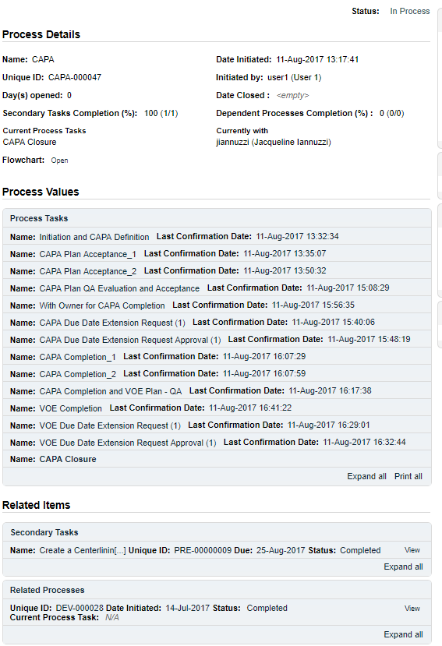

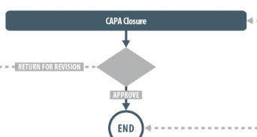

At this step in the process, the QA CAPA Approver will make the decision as to whether the CAPA actions were successful in solving the problem/issue, make any final QA comments, and either return it for any necessary revisions or approve it.

Acting on the CAPA Closure Step
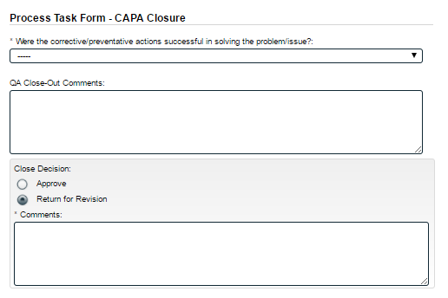
If Yes is selected from the drop-down list, the QA CAPA Approver can make their Close Decision as either Approve or Return for Revision.
If Return for Revision is chosen, a Comment is mandatory and the process will return to Step 1 with the CAPA Initiator.
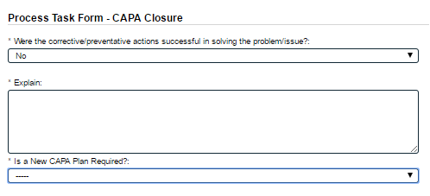
If No is selected from the drop-down list, additional mandatory fields will need to be completed.
In this case the QA CAPA Approver must Explain why they feel the corrective/preventative actions did not solve the problem/issue. They must also decide Is a New CAPA Plan Required?
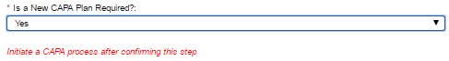

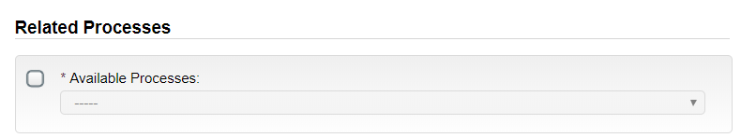
If Yes is selected, a reminder will appear to initiate another CAPA after closing this one. It is also possible to initiate another CAPA from within the current CAPA Process using the Related Processes section. The two CAPA Processes will then be Related Items of each other. If No is selected, a Rationale is mandatory.
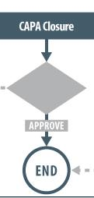
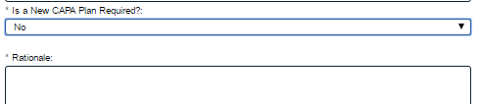
If the CAPA Actions are successful, and a Close Decision of Approve is Submitted and Confirmed by the CAPA Approver, the CAPA Process goes to a status of Completed and is at the END.

Viewing Details for a Completed CAPA Process
Users are able to search for and view processes at any stage, using the Navigation tab in the PROCESS Section of SOLABS QM10.

Using the Process Values Table
Process Tasks can be viewed by using the Expand all or Print all options at the bottom of the Process Values table. An individual Process Task can be expanded by clicking on it within the Process Values table.

Using the Related Items Table
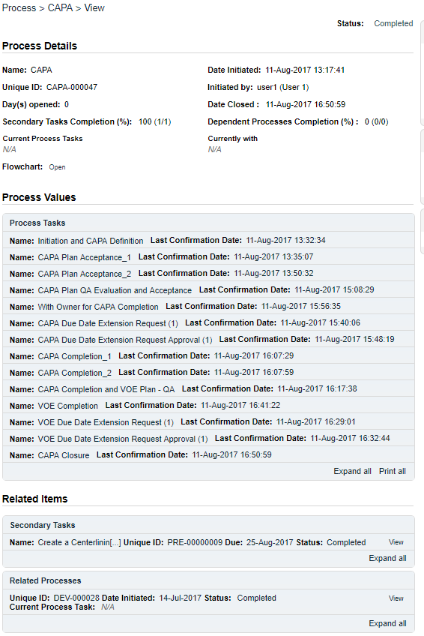
Information on any Secondary Tasks, Related Processes or Related Documents can be accessed by clicking on the View option beside the listing in the Related Items section of the screen. From any of those Detail screens, the Process will be listed under Related Items – you can quickly toggle back to the Main Process by clicking View next to it.

Using the Audit Trail
Under the right-hand Related Information menu, click on the Audit Trail option.
There you will find all the details for every step of the CAPA Process, from Process Completed all the way down to Process Started, with options to expand or print the entire process or any individual steps.
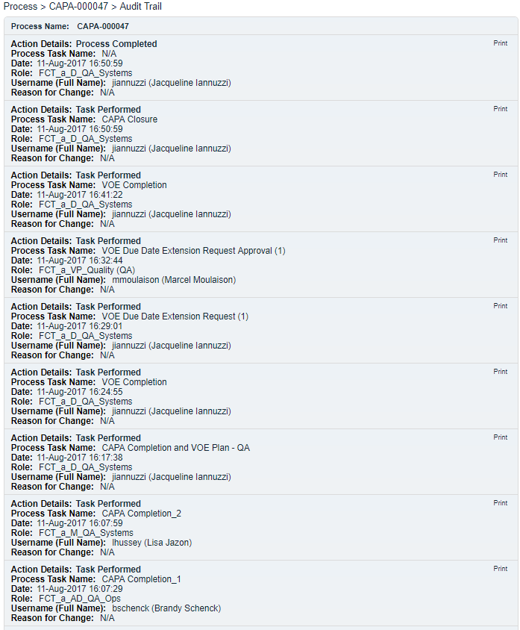

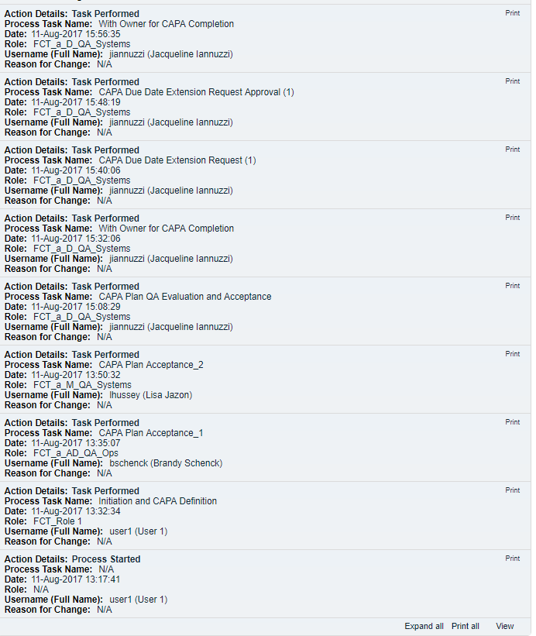

CAPA Process Notifications
The Notifications available with the Off-the-Shelf CAPA Process APP P0050 are identified in the Process Roles section of this User Guide and at the related Process Steps. The content of these email Notifications is described below.
General information on SOLABS QM10 Notifications available with the Core Software can be found in the SOLABS Knowledge Base in a document titled SOLABS QM10: Notifications Guide.

Included Notifications
The following two Notifications are associated with the off-the-shelf CAPA Process P0050 APP.
If VOE Due Date is ≤ today + 5 days the following notification is sent (notification is sent only once i.e. the first time this condition is met)
To: QA CAPA Approver identified in Step 1
Subject: The VOE for CAPA-XXXXX is due on [VOE Due Date]
Body:
The VOE for CAPA-XXXXX is due on [VOE Due Date]
Where CAPA-XXXXX is an hyperlink to the process
This condition is reevaluated every time VOE Due Date is modified

If CAPA Due Date is ≤ today + 5 days the following notification is sent (notification is sent only once i.e. the first time this condition is met)
To: all users in the role of PR_CAPA_Owner
Subject: CAPA-XXXXX is due on [CAPA Due Date]
Body:
The CAPA-XXXXX is due on [CAPA Due Date]
Where CAPA-XXXXX is an hyperlink to the process
This condition is reevaluated every time CAPA Due Date is modified

Available Options for CAPA Process P0050
Option 1A – option to change some of the field Labels at Step 1 in the CAPA Process:
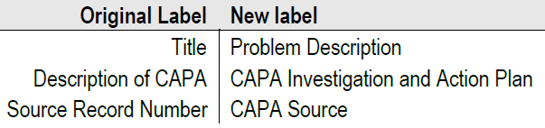
Option 2 – this option removes the option “No impact” as a value for the CAPA Classification field at Step 1
Option 3 – this option changes the field type for Source Record Number at Step 1 from a text field to a text area, allowing for up to 4000 characters.
Option 4 – this option changes the field type for Probable Root Cause at Step 1 from a text field to a text area, allowing for up to 4000 characters.
Option 5 - this option changes the field type for Title at Step 1 from a text field to a text area, allowing for up to 4000 characters.
Option 6 – this option changes the values for the Type field at Step 1
From: Corrective Action, Preventative Action
To: Corrective and Preventative Action, Continuous Improvement
The Root Cause Categories will be displayed for the choice of Corrective and Preventative Action.
Option 7 – this option adds additional Secondary Task Types
