SOLABS QM10: Laboratory Investigation Request Process P0055 User Guide
Introduction 2
Laboratory Investigation Request (LIR) Process Flowcharts 3
Starting the Laboratory Investigation Request (LIR) Process 5
Step 1: Initiation of Lab Investigation (Phase I) 6
Completing the Process Task Form: 7
Creating Secondary Tasks 9
Submit and Confirm 10
Step 2: Laboratory Investigation Conclusion (Phase I) 11
Viewing the Laboratory Investigation Conclusion (Phase I) Task 11
Acting on the Laboratory Investigation Conclusion (Phase I) Task 11
Initiating a Related Process 14
Submit and Confirm 15
Step 3: Reviewer Approval 16
Viewing the Reviewer Approval Task 17
Acting on the Reviewer Approval Task 17
Submit and Confirm 18
Step 4: QA Review 19
Viewing the QA Review Task 19
Acting on the QA Review Task 19
Step 5: Manufacturing Investigation (Phase II) 22
Viewing the Manufacturing Investigation (Phase II) Task 22
Acting on the Manufacturing Investigation (Phase II) Task 22
Step ExtApp 5: Manufacturing Extension Request Approval (x) 24
Viewing the Manufacturing Extension Request Approval Task 25
Acting on the Manufacturing Extension Request Approval Task 25
Step 6: Laboratory Investigation (Phase II) 26
Viewing the Laboratory Investigation (Phase II) Task 26
Acting on the Laboratory Investigation (Phase II) Task 26
Step ExtApp 6: Laboratory Extension Request Approval (x) 29
Step 7: QA Approval of Investigation 29
Viewing the QA Approval of Investigation Task 29
Acting on the QA Approval of Investigation Task 30
Step 8: Additional Testing 32
Viewing the Additional Testing Task 32
Acting on the Additional Testing Task 33
Step ExtApp 8: Additional Testing Extension Request Approval (x) 35
Step 9: Interpretation of Investigation Results and Release Decision 35
Viewing the Interpretation of Investigation Results and Release Decision Task 36
Acting on the Interpretation of Results and Release Decision Task 36
Viewing Details for a Completed Laboratory Investigation Request (LIR) Process 38
Using the Process Values Table 38
Using the Related Items Table 39
Creating a Summary Report 39
Using the Audit Trail 40
Laboratory Investigation Request (LIR) Process Notifications 41
Custom Notifications 41

Introduction
This document provides instructions on the use of the SOLABS QM10 Laboratory Investigation Request (LIR) Process APP P0055 – by guiding you through each step in the process and providing information on the activities, settings and options associated with each step. Detailed information on this process, including any available options that can be chosen by the client, are available in the Process User Functional Design Specification (PUFDS) document that comes with deployment of the Process in your instance of SOLABS QM10.
Refer to the following documents available in the SOLABS Knowledge Base for general information, navigation and functionality common to any SOLABS QM Process APP in the SOLABS QM10 PROCESS Section.
- SOLABS QM10: Introduction to PROCESS Section
- SOLABS QM10: Notifications Guide
- SOLABS QM10 PROCESS Section: Parent/Child Process Relationships
Different steps in a process are assigned to different roles and/or users in the system. You take action on the step assigned to you. For example, you may be assigned a QA Approval of Investigation step in a LIR process. A manager can monitor the status of process tasks assigned to their employees by using the Process Section search capabilities or the Process Reports to query process status by user.

Laboratory Investigation Request (LIR) Process Flowcharts
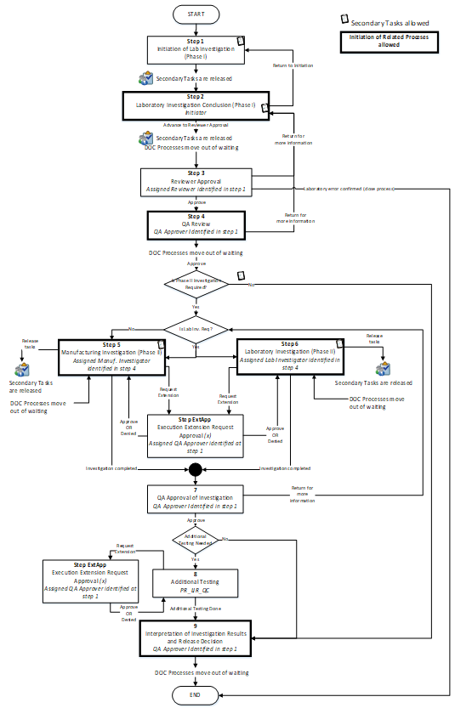
The LIR Process Flowcharts are displayed on this page for informational purposes only – to show that it is a multi-step process with related decision paths.
The flowchart shown at the right is available as part of the Process User Functional Design Specification (UFDS) document that is provided with the Process App.
The Flowchart shown below is available within the Process App. As the process moves along, the active step in that Flowchart is highlighted.
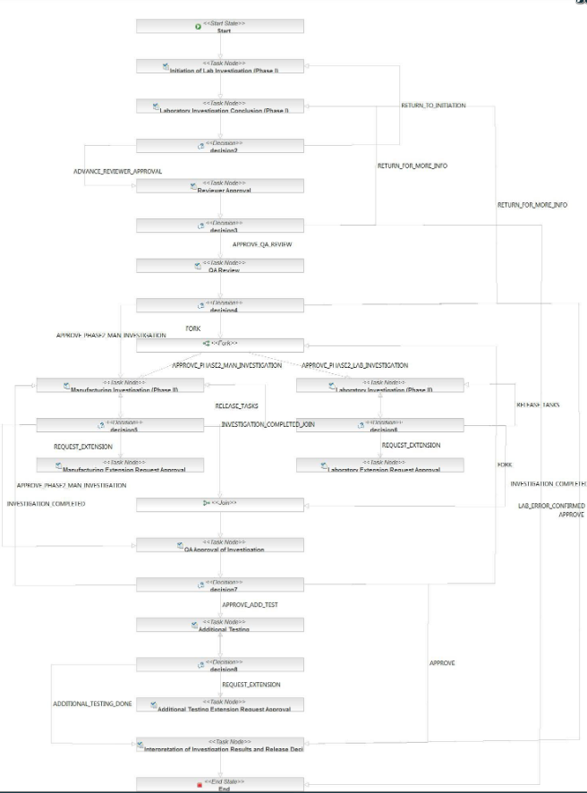

This User Guide is organized into sections for each of the Steps in the LIR Process. The flowchart section for each of those steps will be displayed in larger, more readable format within those sections.
Laboratory Investigation Request (LIR) Process – Process Roles
Decisions made by those involved in the process act to progress the workflow to the next Step or return it to a prior Step. The following LIR Process Roles are associated with the Laboratory Investigation Process P0055 and must be assigned to the Users in SOLABS QM 0 who will make the related decisions.
When SOLABS QM10 Users are assigned a Process Role, their names are then available on drop-down lists to be selected for their assigned steps in the process. The process will automatically notify them to Act On that Step. They will see the step in the Process Section of their SOLABS QM10 HOME Page and will also receive an email Notification.
Contact your SOLABS System Administrator if any of these LIR Process Roles need to be assigned to additional Users.
PR_LIR_Laboratory_Investigator:
This Process Role must be assigned to those Users who will need to Act on the following Steps:
- Step 6: Laboratory Investigation (Phase II)

PR_LIR_Manufacturing_Investigator:
This Process Role must be assigned to those Users who will need to Act on the following Steps:
- Step 5: Manufacturing Investigation (Phase II)

PR_LIR_QA_Approver:
This Process Role must be assigned to those Users who will need to Act on the following Steps:
- Step 4: QA Review
- Step 7: QA Approval of Investigation
- Extension Request Approvals
- Step 9: Interpretation of Investigation Results and Release Decision

PR_LIR_QC:
This Process Role must be assigned to those Users who will need to Act on the following Steps:
- Step 8: Additional Testing

PR_LIR_QA_Reviewer:
This Process Role must be assigned to those Users who will need to Act on the following Steps:
- Step 3: Reviewer Approval

Starting the Laboratory Investigation Request (LIR) Process
From the PROCESS Section in SOLABS QM10, choose Start Process from the Quick Access Process Menu.
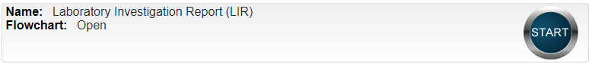
At the next screen, locate the listing for the LIR Process and click the blue START button.

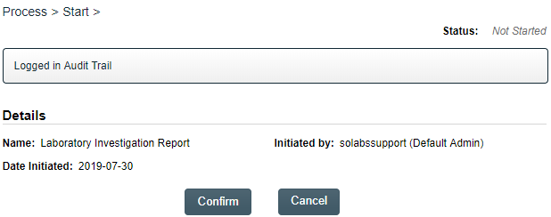
You will then be asked to Confirm this action, to move Status from Not Started to In Process. At this point a Unique ID will be assigned to the LIR Process.

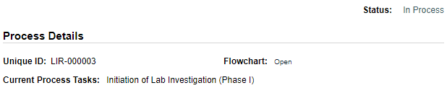

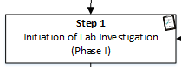
The first Step on the Process Flowchart will now be highlighted when the flowchart is opened.

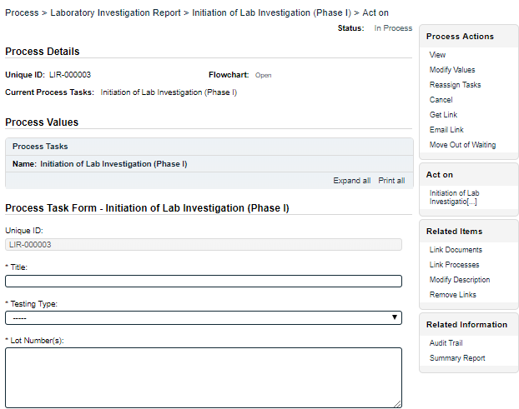
Step 1: Initiation of Lab Investigation (Phase I)
At Step 1 the user initiating the LIR enters all the required information into the Process Task Form.
The fields on the Process Task Form include editable text fields, text areas, single-item selection fields or multi-item selection fields. Those with an asterisk (*) are mandatory.
The right-hand Related Items menu allows the initiator to Link Documents or Link Processes, if applicable.
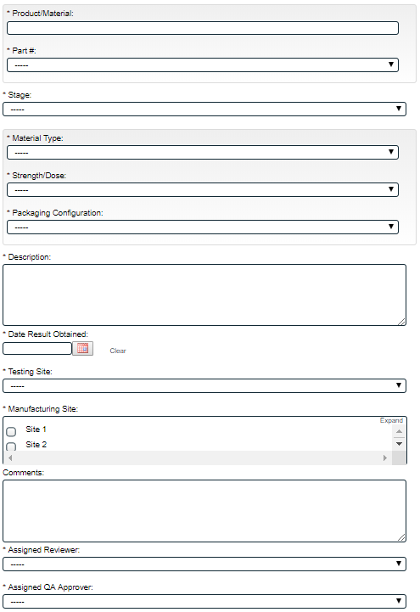
Refer to the separate document SOLABS QM10: Introduction to PROCESS Section for information on use of the right-hand menus since they are common to all SOLABS QM Process APP screens.
Each of the fields in the Process Task Form will be displayed more clearly and described starting on the next page.
Some of the information entered at Step 1 will determine how the process flows through the remaining steps.
Secondary Tasks can be initiated at Step 1 and are released to assignees upon submission of Step 1. Related Processes and Document Control Processes cannot be initiated at this step, so the related options are grayed out.
At the bottom of the screen there is a Save Draft option if you cannot complete all the required fields at one time or when you need to use the right-hand menus to Link Documents or to Link Processes.
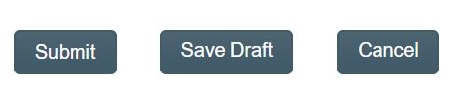

CAUTION: If you navigate away from this page without clicking on either Submit or Save Draft, all entries will be lost. To complete the information after the Save Draft option, you can either choose the Act On option from the Process section of your HOME Page, or search for the In-Process LIR and then use the right-hand Act on Menu to open the Process Task Form fields.

Completing the Process Task Form:
This sub-section covers the information required for each of the fields in the Process Task Form at LIR Process Step 1.
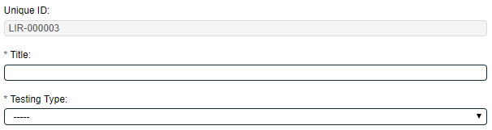
The Unique ID field will be automatically populated with the next available LIR number.
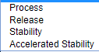
The Title field is mandatory. Choose a clear, concise and intuitive title for the LIR that will quickly communicate the subject. Titles will appear in LIR Reports.
The Testing Type is mandatory Single-item Selection field with a set list of values.
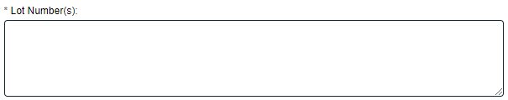
Lot Numbers(s) is a mandatory text area field allowing for up to 8000 characters.

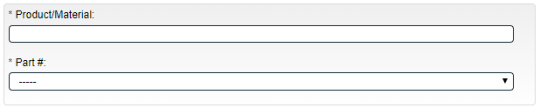
Product/Material is a mandatory Autocomplete, Delimited Values field based on the productname column of the client-specific EDI List EDI_Product.
Part # is a mandatory, customizable Single-item Selection field based on the codeNumber column of the client-specific EDI List EDI_Product.
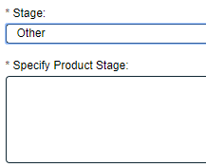
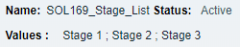
Stage is a mandatory Single-item Selection field. The values are configurable using a shared Custom List called SOL169_Stage_List. There is also a value for Other.
When Other is selected, a mandatory field called Specify Product Stage is displayed, allowing for entry of up to 8000 characters.

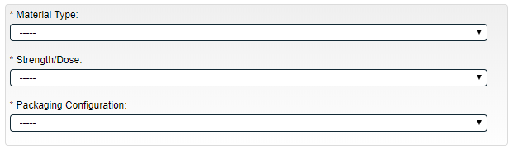
Material Type is a mandatory configurable Single-item Selection field based on the materialType column of the client-specific EDI List PR_EDI_Material.

Material Type is grouped with mandatory Single-item Selection fields for Strength/Dose and Packaging Configuration. Both fields are configurable based on the strengthDose column of the client specific EDI list PR_EDI_Material and the packagingConfiguration column of the client specific EDI list PR_EDI_Material.
Description is a mandatory text area field allowing for up to 8000 characters.
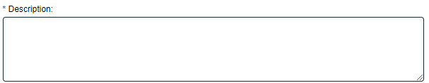
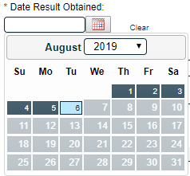

Date Result Obtained is a mandatory date field that can is populated from a calendar. It does not allow input of future dates.
Testing Site is a mandatory Single-item Selection field. The values are configurable using a shared Custom List called SOL_161_Site_List.

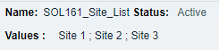
Manufacturing Site is a mandatory Multiple-item Selection field with values also configurable using the shared Custom List called SOL_161_Site_List.
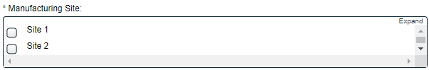

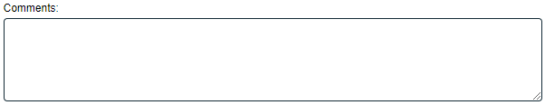
Comments is an optional text area field allowing up to 8000 characters.
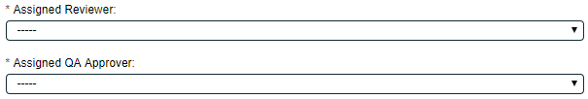
The Assigned Reviewer and Assigned QA Approver fields are both mandatory.
- Assigned Reviewer is a Single-item Selection field that includes the list of SOLABS QM10 Users are assigned the Process Role PR_LIR_QA_Reviewer.
- Assigned QA Approver is a Single-item Selection field that includes the list of SOLABS QM10 Users are assigned the Process Role PR_LIR_QA_Approver.

Creating Secondary Tasks
The initiator of the Laboratory Investigation Request (LIR) Process can create Secondary Tasks that will be associated with the LIR. These Secondary Tasks can be assigned to appropriate Users for activities required to support completion of the LIR and will be released to assignees upon submission/confirmation of Step 1.
The Secondary Task section is underneath the Process Task Form, but still on the Initiation of Lab Investigation (Phase I) screen. A +ADD button is available to create as many Secondary Tasks as needed.
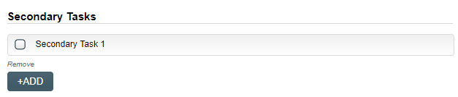
After selecting Secondary Task 1, additional fields will be displayed to define and assign that task.

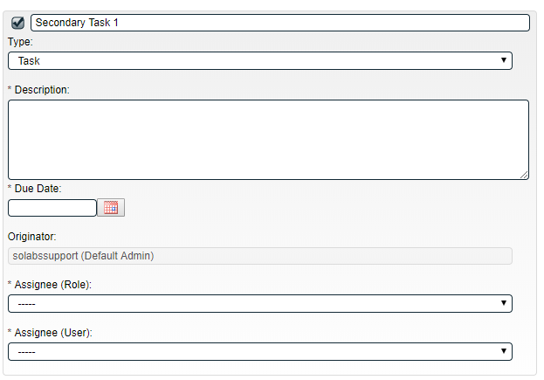
Replace the text “Secondary Task 1” with an appropriate Title for the task.
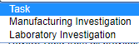
The task Type can then be chosen from a drop-down list of three types.
The Description and Due Date fields are mandatory for each Secondary Task. Choose due dates appropriate to ensure tasks are completed in a time frame that supports on time closure of the Laboratory Investigation process.
The Originator field will default to the User initiating the LIR Process and completing Step 1.

Both the Assignee (Role) and the Assignee (User) fields must be completed for the chosen User. The drop-down lists will bring up the Active Roles list and the Active Users list. It is a good practice to consult with the planned Assignee ahead of time to ensure they are able to complete the task in a timeframe that supports on time closure of the process.
To assign by Role, choose the appropriate Function Role from the list. All Users with that Role will then appear in the Assignee (User) drop-down list so that the appropriate person can be selected. To assign by User, choose the appropriate User from the list. Their Function Role will then appear in the Assignee (Role) drop-down list and must be selected.
Use the +ADD button to create additional Secondary Tasks as needed.
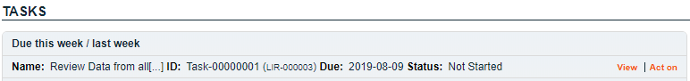
When Step 1 is submitted and confirmed, the Assignees will receive email Notifications and see the View/Act On options for their assigned Secondary Tasks on their SOLABS QM10 HOME Page. The Secondary Tasks, and the status, are listed under Related Items at the bottom of the screen at any Process Step.

As mentioned previously, Related Processes and related Document Control Processes cannot be initiated at Step 1, so those sections are grayed out.

Submit and Confirm
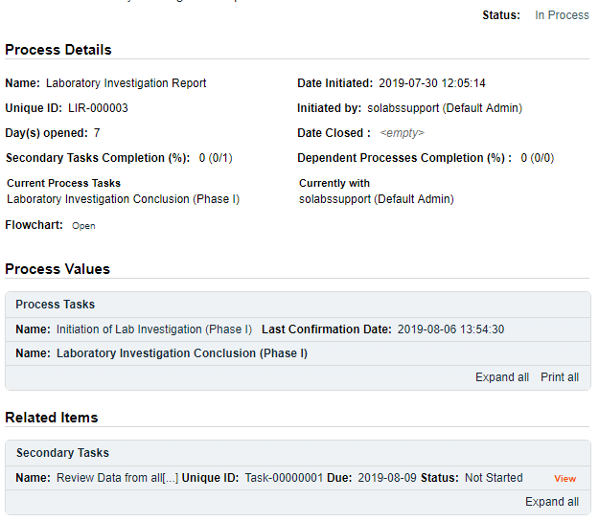
When all information has been entered into the Process Task Form, any Linked Documents or Linked Processes have been added and any Secondary Tasks have been created, click Submit and then Confirm to progress the LIR process to Step 2 – Laboratory Investigation Conclusion (Phase I).
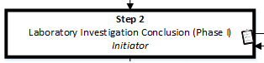
The Process Flowchart will highlight the next step of the process. Step 2 will be assigned to the same person who initiated Step 1. They will receive a new email Notification so that activities for Laboratory Investigation Conclusion (Phase I) are captured as a separate step.

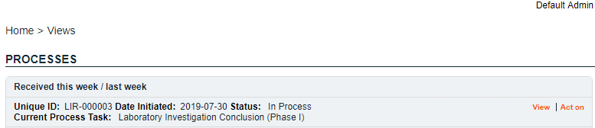

Step 2: Laboratory Investigation Conclusion (Phase I)

Viewing the Laboratory Investigation Conclusion (Phase I) Task
If the initiator clicks on the View option to the right of the Process Task, they will get the same screen shown above.
From the View screen, there are Expand all options under the Process Values table and the Related Items table, which can be used to see more detail on the information entered at Step 1. They can also click on the View option to the right of any individual Related Items (Secondary Tasks, Linked Documents, Linked Processes) to go to the Task Details, Document Details or Process Details screens associated with those Related Items. From any of those screens they can quickly return to the LIR Process since it will be listed as a Related Item on all of those screens. See example below.
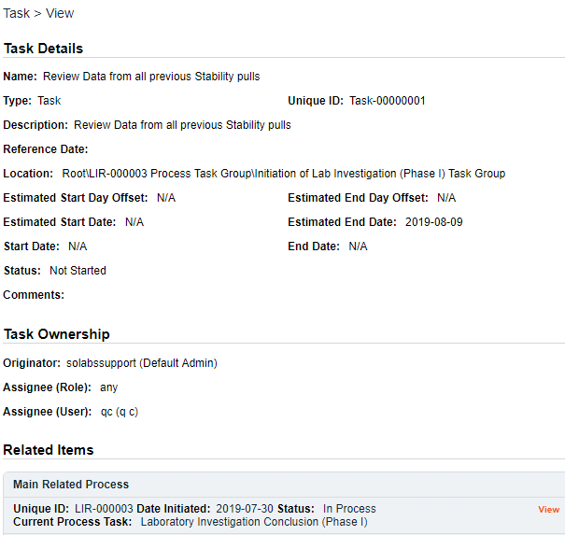
In this example, clicking on View for a Secondary Task listed in LIR-000003 brings up the Task Details screen for that assigned Task.
LIR-000003 is listed as a Related Item for that Task. To get back to LIR-000003, the Reviewer can click on the View option.

Acting on the Laboratory Investigation Conclusion (Phase I) Task
When the Initiator clicks on the Act on option to the right of the Process Task, they will go immediately to the Act on screen for their Laboratory Investigation Conclusion (Phase I) task.
As described above, the Expand all option under the Process Values table can be used to review all information entered at Step 1.

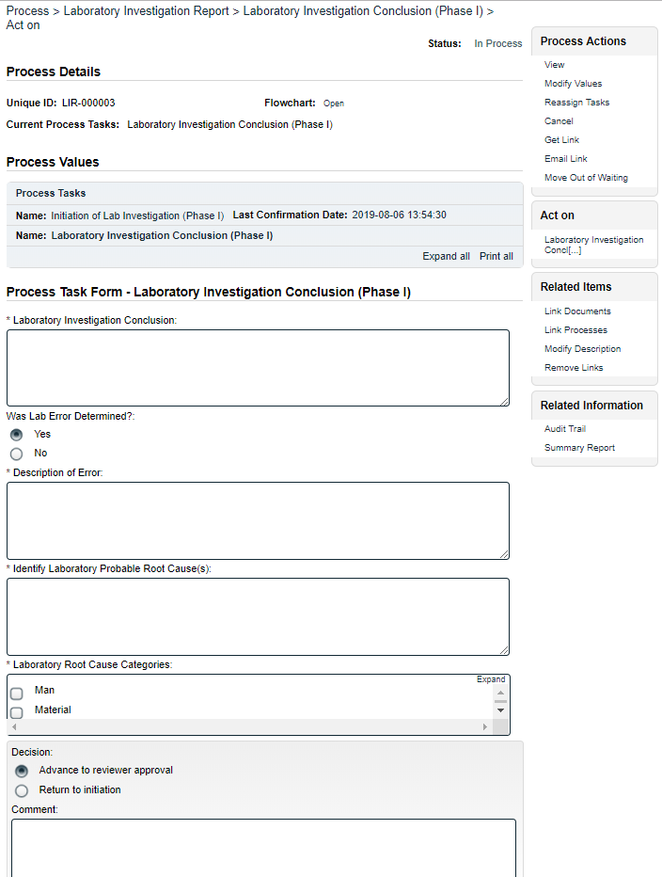
The Process Task Form for Step 2 includes fields to enter information related to the laboratory investigation. Fields with an asterisk (*) are mandatory. More information on the use of these fields is provided starting below.
The right-hand Related Items menus can be used to Link Documents or Link Processes, if applicable.
Refer to the separate document SOLABS QM10: Introduction to PROCESS Section for information on use of the right-hand menus since they are common to all SOLABS QM Process APPs.
Initiation of more Secondary Tasks, Related Processes or a Document Control Process are all allowed at Step 2.
Each of the fields in the Process Task Form will be displayed more clearly and described starting below.
There is a Save Draft option at the bottom if all the required fields cannot be completed at one time or when using the right-hand menu to Link Documents or Link Processes.
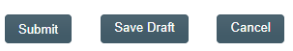

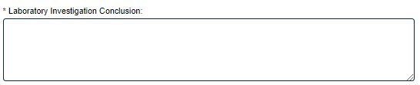
CAUTION: Navigating away from this page without clicking on either Submit or Save Draft, will result in all entries being lost. To complete the information after the Save Draft option, choose either the Act On option from the Process section of your HOME Page, or search for the LIR Process and then use the right-hand Act on Menu to open the Process Task Form fields.
The mandatory Laboratory Investigation Conclusion field allows up to 8000 characters to describe the investigation conducted.
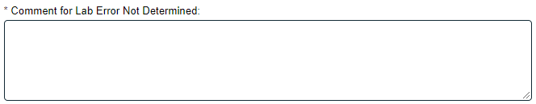
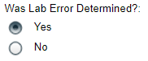
Was Lab Error Determined? is a Radio Button allowing for a selection of Yes or No, that defaults to Yes. If No is selected, the following mandatory field is displayed and allows for up to 8000 characters.

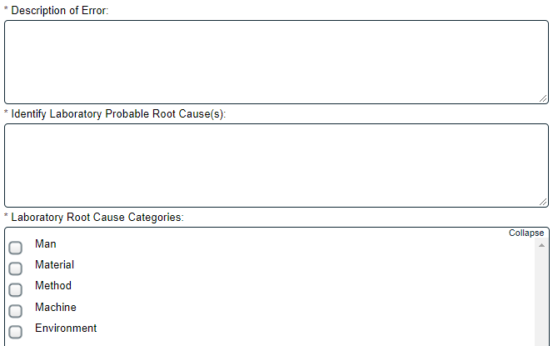
When Was Lab Error Determined? is selected as Yes, a group of fields are displayed to enter the related information.
Description of Error and Identify Laboratory Probable Root Cause(s) are mandatory text area fields allowing for up to 8000 characters.
Laboratory Root Cause Categories is a Multiple-item Selection field with set choices of Man, Material, Method, Machine or Environment. For each category selected, another Single-item Selection field will be displayed for a more detailed Root Cause. The values for those fields are configurable from shared Custom Lists maintained by the System Administrator.
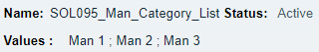
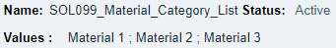
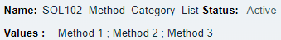
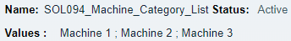

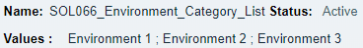
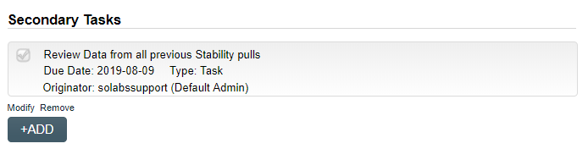
Use the +ADD button if more Secondary Tasks are required at Step 2. See Page 9-10 for using this section.

Related Processes and Document Control Processes can also be initiated at Step 2.

Initiating a Related Process
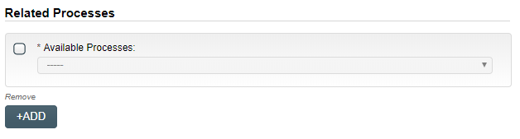
To initiate a new SOLABS QM10 Process from within this Process, check the Available Processes box.
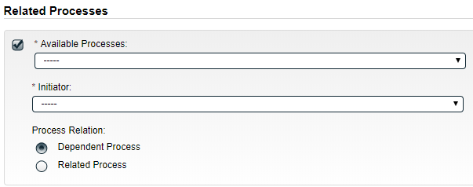
The Available Processes field is a Single-item selection field populated with a list of the Process Apps deployed at your organization.
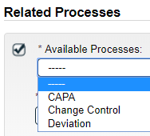
Choose the Process Relation as either a Dependent Process (must be completed before the LIR is closed), or a Related Process.

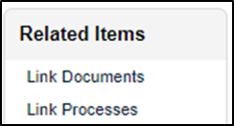
The mandatory Initiator to field is a Single-item selection field populated by the list of all Active Users. The person chosen in this field will be the person who will be assigned Step 1 of the process being initiated. There is also an option to choose myself, if you would like to be the initiator for both processes. The LIR process will then be the Parent Process of the new process being initiated.
If a Related Process was already initiated, separately from this Laboratory Investigation Request, it can be linked as a Related Item using the right-hand menu option under Related Items. In this case, do not select the Available Processes box and instead use the Link Processes option.
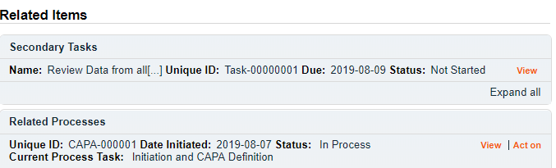
Whether linking an existing process or initiating a new one, the Related Processes will be listed in the Related Items section, along with any Secondary Tasks and Related Documents, when LIR Step 2 is Submitted and Confirmed.

Initiating a Document Control Process
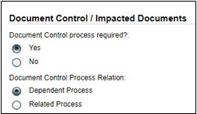
To initiate a new SOLABS QM10 Document Control Process to manage any document updates required for this Laboratory Investigation, select Yes. One or more documents can be included in a Document Control Process.
When the Yes option is selected, also choose whether it will be a Dependent Process (must be completed before the LIR is closed), or a Related Process.
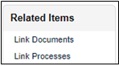
When the Process Relation is selected as Dependent Process, the process from which it was initiated is considered the Parent Process.
If a Document Control Process was already initiated, separately from this LIR, it can be linked as a Related Item using the right-hand menu option under Related Items. In this case, leave the above setting at the default of No.
When the Yes option is selected, Step 1 of the Document Control Process will be launched immediately upon submission of Step 2 – Laboratory Investigation Conclusion (Phase I), so that the person initiating the LIR can also concurrently initiate the Document Control Process. The LIR Process will be considered the Parent Process.
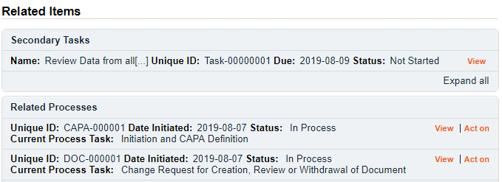
Whether linking an existing Doc Control Process or initiating a new one, it will be listed in the Related Items section when LIR Step 2 is Submitted and Confirmed.

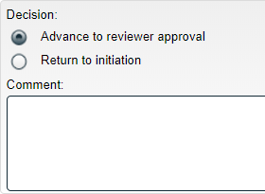
The Decision section for Step 2 includes two choices:
- Advance to reviewer approval will progress the LIR Process to Step 3 – Reviewer Approval. A Comment field is available for optional comments.
- Return to initiation will send the LIR Process back to Step 1 – Initiation of Lab Investigation (Phase I). The Comment field is then mandatory.

Submit and Confirm
When all information has been entered into the Process Task Form, any Linked Documents or Linked Processes have been added and any new Secondary Tasks, Related Processes or Document Control Processes have been initiated, click Submit and then Confirm to progress the LIR process to Step 3 – Reviewer Approval.
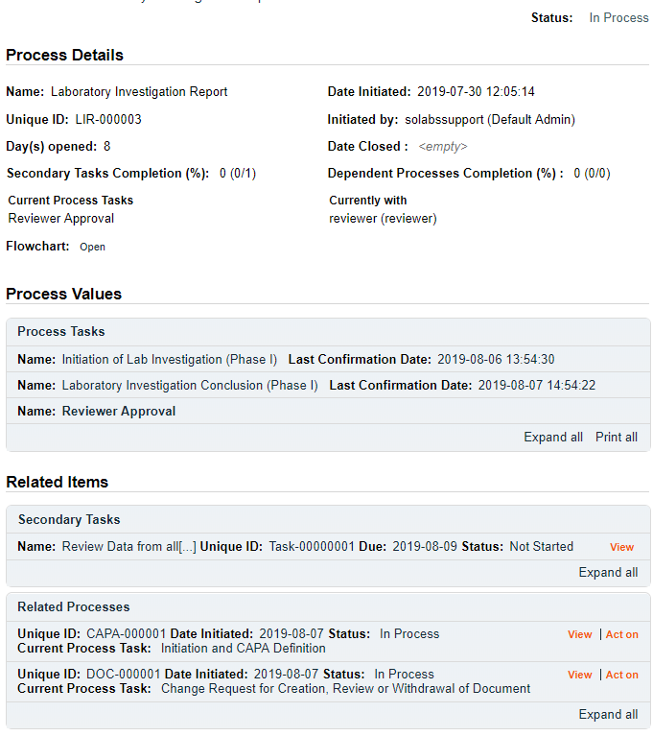
The Process Details will list the Current Process Task and who it is Currently with (the Assigned Reviewer selected at Step 1).
The Process Flowchart will highlight the next step of the process.

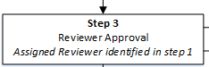

Step 3: Reviewer Approval
At this step in the LIR Process, the Assigned Reviewer chosen at Step 1 will receive an email Notification and will see their Reviewer Approval task listed in the Process section of their SOLABS QM10 HOME Page.
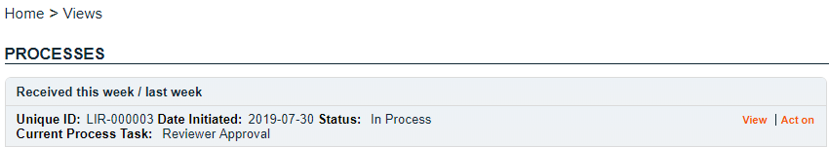

Viewing the Reviewer Approval Task
If the Assigned Reviewer clicks on the View option to the right of the Process Task, they will get the same screen shown above.
From the View screen, they can use the Expand all options under the Process Values table and the Related Items table to see more detail on the information entered at prior steps. They can also click on the View option to the right of any individual Related Items (Secondary Tasks, Linked Documents, Linked Processes) to go to the Task Details, Document Details or Process Details screens associated with those Related Items. From any of those screens they can quickly return to the Process since it will be listed as a Related Item on all of those screens.

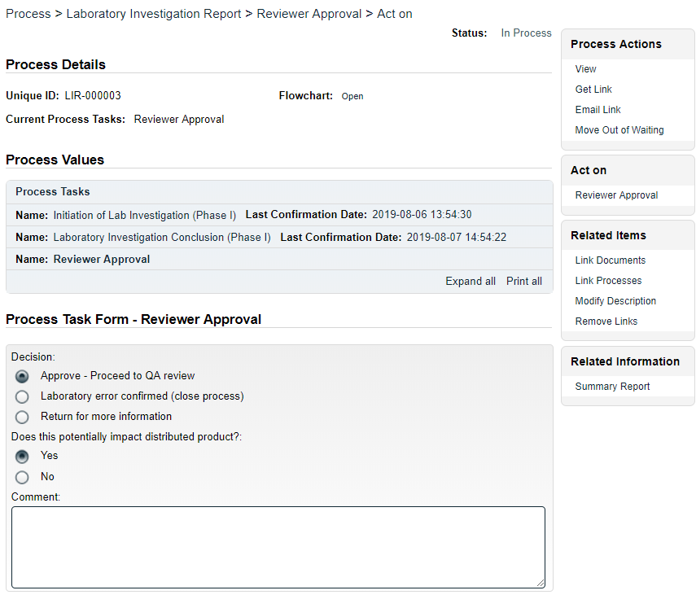
Acting on the Reviewer Approval Task
When the Assigned Reviewer clicks on the Act on option to the right of the Process Task, they will go immediately to the Act on screen for their Reviewer Approval task.
As described above, the Assigned Reviewer can use the Expand all option under the Process Values table to see all information entered in prior steps.
The right-hand Related Items menu allows the Assigned Reviewer to Link Documents or Link Processes, if applicable.
Refer to the separate document SOLABS QM10: Introduction to PROCESS Section for information on use of the right-hand menus since they are common to all SOLABS QM Process APPs.

Initiation of Secondary Tasks, Related Processes or a Document Control Process are not allowed at Step 3, so those sections are grayed out.
There is a Save Draft option at the bottom if all the required fields cannot be completed at one time or when using the right-hand menu to Link Documents or Link Processes.

CAUTION: Navigating away from this page without clicking on either Submit or Save Draft, will result in all entries being lost. To complete the information after the Save Draft option, choose either the Act On option from the Process section of your HOME Page, or search for the LIR Process and then use the right-hand Act on Menu to open the Process Task Form fields.

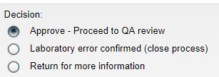
The Decision section at LIR Step 3 allows three choices:
The default is Approve – Proceed to QA review and will bring up additional fields to enter information about possible impacted product and a related Comment.
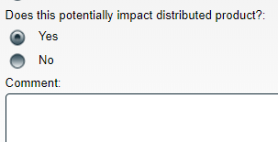
Submission and confirmation of this decision moves the LIR Process to Step 4 – QA Review.
A decision of Laboratory error confirmed (close process) at Step 3 will close the Laboratory Investigation Request process. The Comment field is mandatory with this decision.
A decision of Return for more information at Step 3 will send the LIR Process back to Step 2. The Comment field is mandatory with this decision so that the initiator can then provide the requested information.

Submit and Confirm
When all information has been entered into the Process Task Form and any Linked Documents or Linked Processes have been added, click Submit and then Confirm.
If the Decision was Approve – Proceed to QA review, the LIR process will move to Step 4 – QA Review.
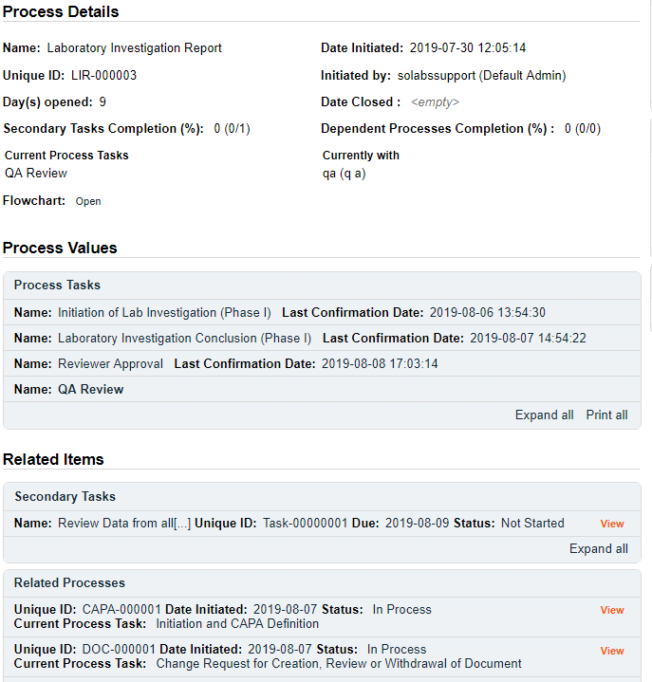
The Process Details will list the Current Process Task and who it is Currently with (the Assigned QA Approver selected at Step 1).
The Process Flowchart will highlight the next step of the process.
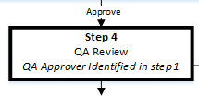

Step 4: QA Review
At this step in the LIR Process, the Assigned QA Approver chosen at Step 1 will receive an email Notification and will see their QA Review task listed in the Process section of their SOLABS QM10 HOME Page.
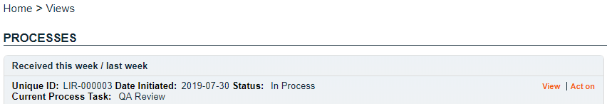

Viewing the QA Review Task
If the Assigned QA Approver clicks on the View option to the right of the Process Task, they will get the same screen shown above.
From the View screen, they can use the Expand all options under the Process Values table and the Related Items table to see more detail on the information entered at prior steps. They can also click on the View option to the right of any individual Related Items (Secondary Tasks, Linked Documents, Linked Processes) to go to the Task Details, Document Details or Process Details screens associated with those Related Items. From any of those screens they can quickly return to the Process since it will be listed as a Related Item on all of those screens.

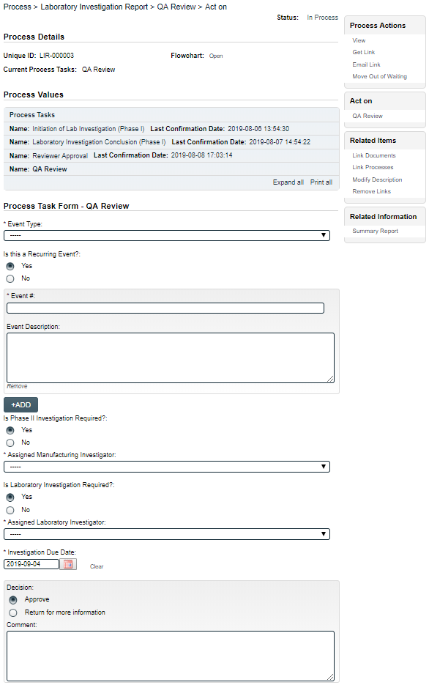
Acting on the QA Review Task
When the Assigned QA Approver clicks on the Act on option to the right of the Process Task, they will go immediately to the Act on screen for their QA Review task.
As described above, the Assigned QA Approver can use the Expand all option under the Process Values table to see all information entered in prior steps.
The right-hand Related Items menu allows the Assigned QA Approver to Link Documents or Link Processes, if applicable.
Refer to the separate document SOLABS QM10: Introduction to PROCESS Section for information on use of the right-hand menus since they are common to all SOLABS QM Process APPs.
Each of the fields in the Process Task Form are displayed more clearly and described starting on the next page.
New Secondary Tasks are not allowed at Step 4 but new Related Processes or a Document Control Process can be initiated.
The Save Draft option is at the bottom if all the required fields cannot be completed at one time or when using the right-hand menu to Link Documents or Link Processes.
CAUTION: Navigating away from this page without clicking on either Submit or Save Draft, will result in all entries being lost. To complete the information after the Save Draft option, choose either the Act On option from the Process section of your HOME Page, or search for the LIR Process and then use the right-hand Act on Menu to open the Process Task Form fields.
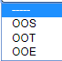
Event Type is a mandatory Single-item Selection field with three choices: OOS, OOT or OOE.
NOTE:
OOS = Out of Specification
OOT = Out of Trend
OOE = Out of Expectation
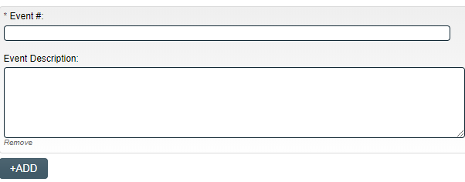
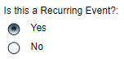
Is this a Recurring Event? is a Yes or No radio button that defaults to Yes. The selection of Yes brings up a group of additional fields to provide information on the previous events. A +ADD button is available to add another group of fields if there were multiple previous events.
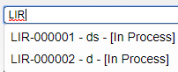
Event# is a mandatory, autocomplete, field that will bring up LIR processes that are present in the system with a status ≠ Cancelled. Starting to type the LIR number or title will bring up a list of LIR Processes matching that criterion. Click on one to select it.
Event Description is an optional Text Area field, allowing entry of up to 8000 characters.
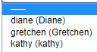
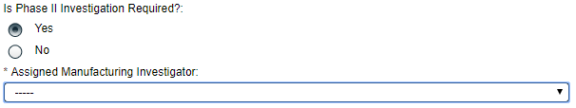
Is Phase II Investigation Required? is a Yes or No radio button that defaults to Yes.
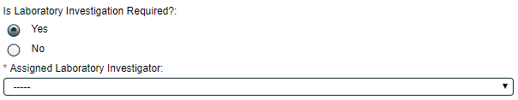
The selection of Yes brings up a Single-item Selection field to choose the Assigned Manufacturing Investigator. The values include all active users who are assigned the Process Role PR_LIR_Manufacturing_Investigator. It also brings up the field Is Laborator Investigation Required?
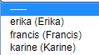
Is Laboratory Investigation Required? is a Yes or No radio button that defaults to Yes.
The selection of Yes brings up a Single-item Selection field to choose the Assigned Laboratory Investigator. The values include all active users who are assigned the Process Role PR_LIR_Laboratory_Investigator.
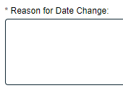
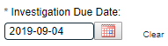
Investigation Due Date is a mandatory date field that is auto-populated with a date 30 days from the Date Result Obtained that was entered at Step 1. If the default date is changed (past dates are not allowed), a mandatory text field is displayed for entry of the Reason for Date Change.
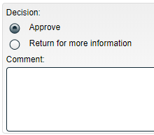
There are two choices for a Decision at Step 4.
- A choice of Approve will progress the LIR Process to Step 5 – Manufacturing Investigation (Phase II) and possibly Step 6 – Laboratory Investigation (Phase II), depending on the choices made at this step.
- A choice of Return for more information will send the LIR Process back to Step 2. The Comment field is mandatory for that choice.

If Yes was selected at Step 4 for Is Phase II Investigation Required, the LIR Process moves to Step 5 – Manufacturing Investigation (Phase II) and is assigned to the Assigned Manufacturing Investigator. | If Yes was selected at Step 4 for Is Laboratory Investigation Required, the LIR Process also moves to Step 6 – Manufacturing Investigation (Phase II) and is assigned to the Assigned Laboratory Investigator.
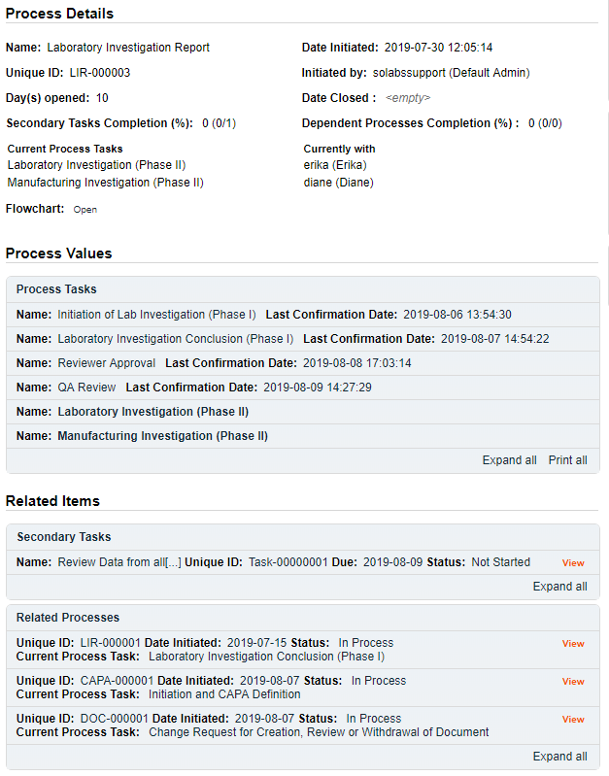
The Process Details will list the Current Process Tasks and who they are Currently with (the Assigned Manufacturing Investigator and/or the Assigned Laboratory Investigator selected at Step 4).
The Process Flowchart will highlight the next step(s) of the process.

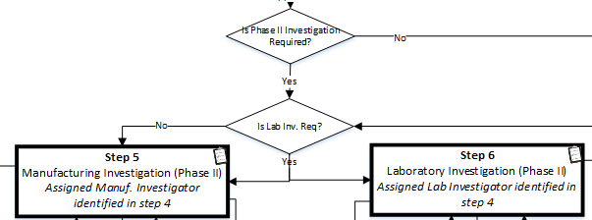

Step 5: Manufacturing Investigation (Phase II)
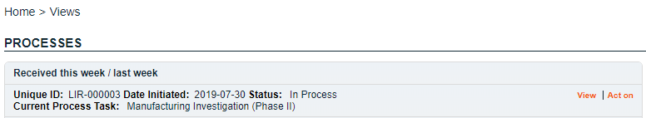
At this step in the LIR Process, the Assigned Manufacturing Investigator chosen at Step 4 will receive an email Notification and will see their Manufacturing Investigation (Phase II) task listed in the Process section of their SOLABS QM10 HOME Page.

Viewing the Manufacturing Investigation (Phase II) Task
If the Assigned Manufacturing Investigator clicks on the View option to the right of the Process Task, they will get the same screen shown on page 21 above.
As with other steps, from the View screen, they can use the Expand all options under the Process Values table and the Related Items table to review detail from prior steps. They can also click on the View option to the right of any individual Related Items (Secondary Tasks, Linked Documents, Linked Processes) to go to the Task Details, Document Details or Process Details screens associated with those Related Items. From any of those screens they can quickly return to the Process since it will be listed as a Related Item on all of those screens.

Acting on the Manufacturing Investigation (Phase II) Task
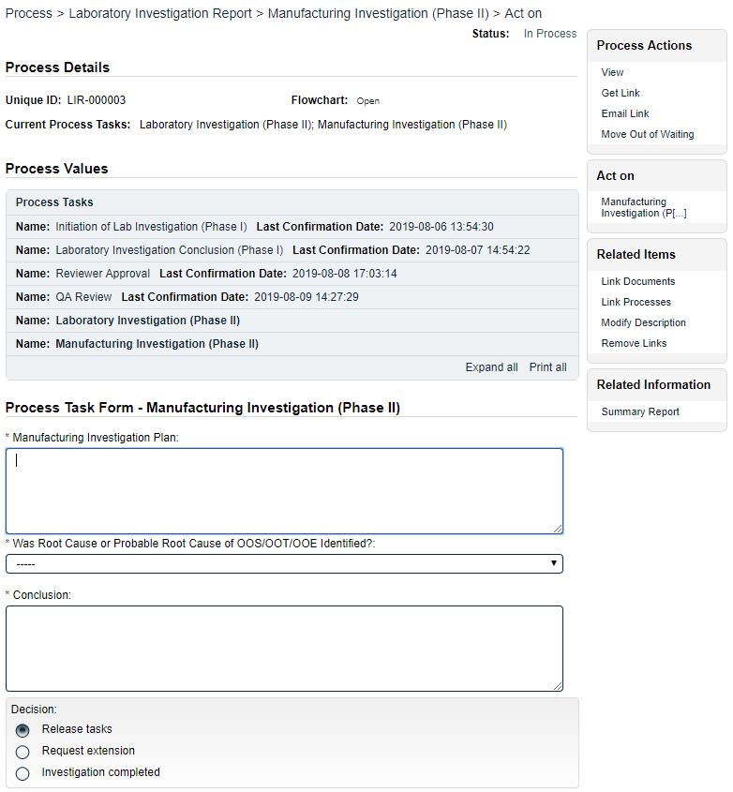
When the Assigned Manufacturing Investigator clicks on the Act on option to the right of the Process Task, they will go immediately to the Act on screen for their Manufacturing Investigation (Phase II) task. As described above, the Assigned Manufacturing Investigator can use the Expand all option under the Process Values table to see all information entered in prior steps.
The Process Task Form includes the fields necessary to enter the details regarding the manufacturing investigation. These are described in more detail on the next page.
Each of the fields in the Process Task Form is displayed more clearly and described on the next page.
The right-hand Related Items menu allows the Assigned Manufacturing Investigator to Link Documents or Link Processes, if applicable.
Refer to the separate document SOLABS QM10: Introduction to PROCESS Section for information on use of the right-hand menus since they are common to all SOLABS QM Process APPs.
New Secondary Tasks, Related Processes and a Document Control Process can be initiated at Step 5. Secondary Tasks initiated at Step 5 default to a Task Type of Manufacturing Investigation and are released to assignees upon submission and confirmation of Step 5.
As with previous steps, there is a Save Draft option at the bottom if all the required fields cannot be completed at one time or when using the right-hand menu to Link Documents or Link Processes.

CAUTION: Navigating away from this page without clicking on either Submit or Save Draft, will result in all entries being lost. To complete the information after the Save Draft option, choose either the Act On option from the Process section of your HOME Page, or search for the LIR Process and then use the right-hand Act on Menu to open the Process Task Form fields.
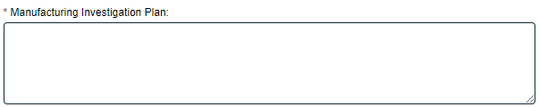
The mandatory Manufacturing Investigation Plan field is a text area that allows up to 8000 characters to enter information about the investigation plan.
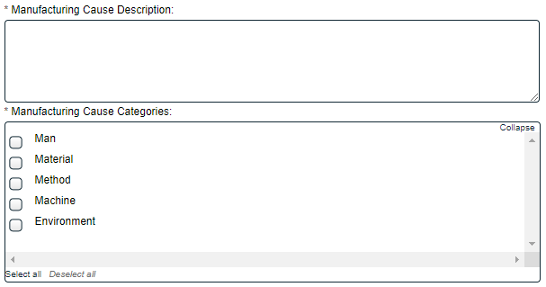
Was Root Cause or Probable Root Cause of OOS/OOT/OOE Identified? is a Single-item Selection field with choices of Yes or No.
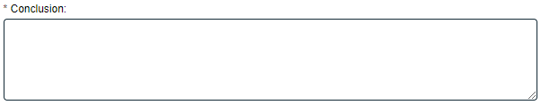
If Yes is selected, additional mandatory fields are displayed for Manufacturing Cause Description (text area for up to 8000 characters) and Manufacturing Cause Categories (Multi-item Selection field). For each category selected, another Single-item Selection field will be displayed for a more detailed Root Cause. The values for those fields are configurable from shared Custom Lists maintained by the System Administrator (refer to Page 13).
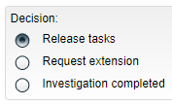
A mandatory Conclusion field (text area allowing up to 8000 characters) is available when the Assigned Manufacturing Investigator is ready.
The Decision at Step 5 allows three choices:
- A decision of Release tasks will release new Secondary Tasks to the assignees. Those new tasks will be Task Type = Manufacturing Investigation. The LIR Process will then stay at Step 5 upon confirmation.
- A decision of Investigation completed moves the Process to Step 7 – QA Approval of Investigation as soon as Step 6 (if required) is completed with a Decision of Investigation Completed. See Page 28.
- A decision of Request extension will bring up additional fields to enter Proposed Extension Date and Reason for the Extension Request.
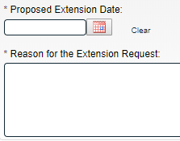
Proposed Extension Date is mandatory and cannot be set before the Investigation Due Date entered at Step 4.
Reason for the Extension Request is a mandatory text area allowing for up to 8000 characters.
This decision will move the LIR Process to Step ExtApp5 – Manufacturing Extension Request Approval upon confirmation.

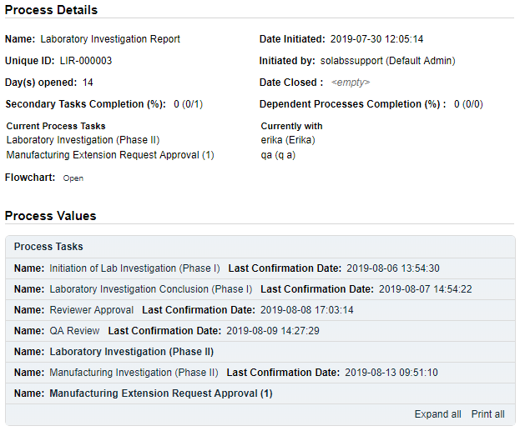
The Process Details will list the Current Process Tasks and who they are Currently with. The number in parenthesis after the Manufacturing Extension Request Approval task indicates the number of extensions requested (in this case the first one). This step is assigned to the Assigned QA Approver entered at Step 1.
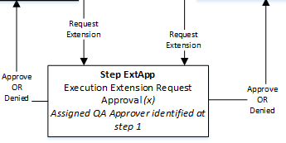
The Process Flowchart will highlight the next step of the process. Since this is the same step used if an extension is required at other process steps, the flowchart is labeled as simply Step ExtApp -Execution Extension Request Approval.

Step ExtApp 5: Manufacturing Extension Request Approval (x)
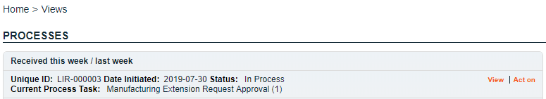
At this step in the LIR Process, the Assigned QA Approver chosen at Step 1 will receive an email Notification and will see their Manufacturing Extension Request Approval (x) task listed in the Process section of their SOLABS QM10 HOME Page. The number in parenthesis will indicate the number of extensions requested so far for this Step 5.

Viewing the Manufacturing Extension Request Approval Task
If the Assigned QA Approver clicks on the View option to the right of the Process Task, they will get the same screen shown above.
From the View screen, they can use the Expand all options under the Process Values table and the Related Items table to see more detail on the information entered at prior steps. They can also click on the View option to the right of any individual Related Items (Secondary Tasks, Linked Documents, Linked Processes) to go to the Task Details, Document Details or Process Details screens associated with those Related Items. From any of those screens they can quickly return to the Process since it will be listed as a Related Item on all of those screens.

Acting on the Manufacturing Extension Request Approval Task
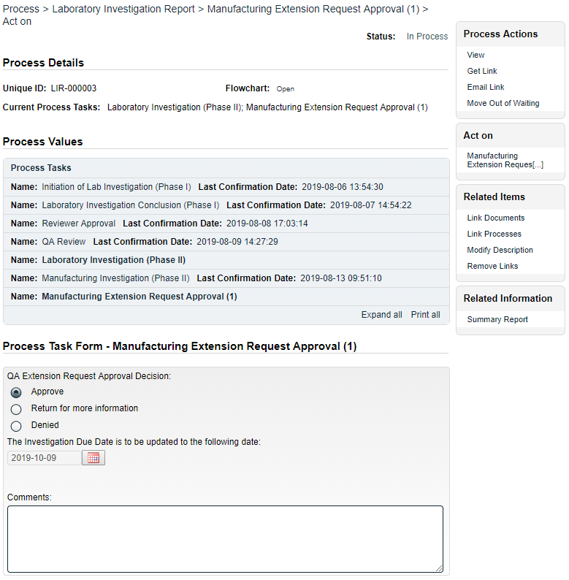
When the Assigned QA Approver clicks on the Act on option to the right of the Process Task, they will go immediately to the Act on screen for their Manufacturing Extension Request Approval task. As described above, the Assigned QA Approver can use the Expand all option under the Process Values table to see all information entered in prior steps.
No Secondary Tasks, Related Processes or Document Control Process can be initiated at this step.
The QA Extension Request Approval Decision allows three choices.
- A decision of Approve will display the requested extended due date in The Investigation Due Date is to be updated to the following date: field. Comments are optional.
- A decision of Return for more information will result in the Comments field being mandatory.
- A decision of Denied will also result in the Comments field being mandatory.
All decisions will move the LIR Process back to Step 5 – Manufacturing Investigation (Phase II) upon confirmation so that the Assigned Investigator can continue to complete their investigation against the new due date.
Refer to Page 22 for Step 5 – Manufacturing Investigation (Phase II).

Step 6: Laboratory Investigation (Phase II)
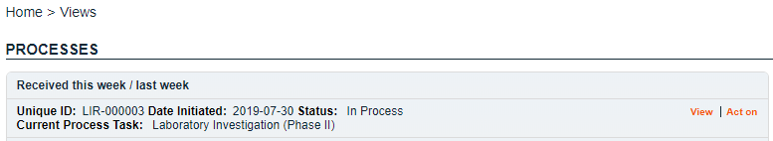
At this step in the LIR Process, the Assigned Laboratory Investigator chosen at Step 4 will receive an email Notification and will see their Laboratory Investigation (Phase II) task listed in the Process section of their SOLABS QM10 HOME Page.

Viewing the Laboratory Investigation (Phase II) Task
If the Assigned Laboratory Investigator clicks on the View option to the right of the Process Task, they will get the same screen shown on page 21 above.
As with other steps, from the View screen, they can use the Expand all options under the Process Values table and the Related Items table to review detail from prior steps. They can also click on the View option to the right of any individual Related Items (Secondary Tasks, Linked Documents, Linked Processes) to go to the Task Details, Document Details or Process Details screens associated with those Related Items. From any of those screens they can quickly return to the Process since it will be listed as a Related Item on all of those screens.

Acting on the Laboratory Investigation (Phase II) Task
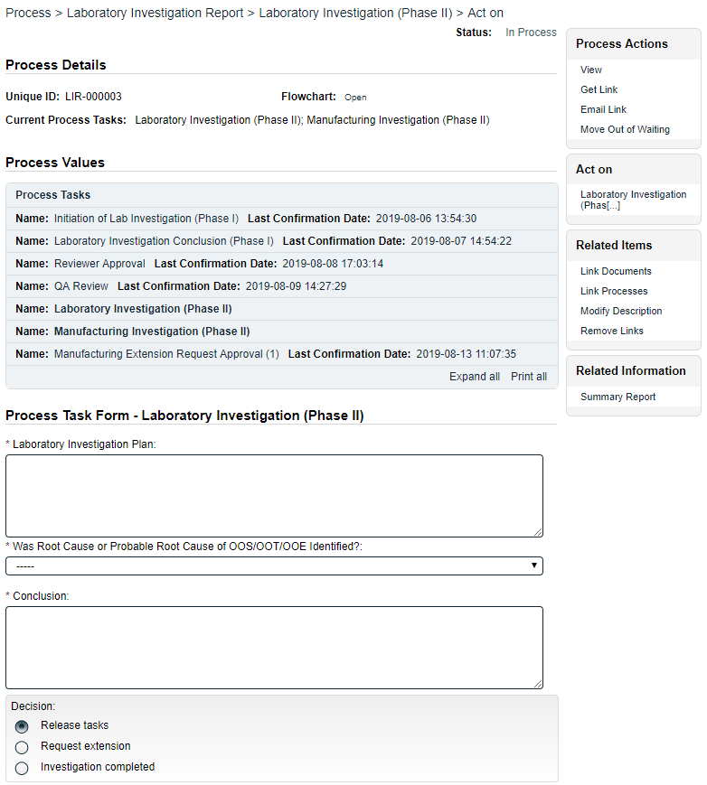
When the Assigned Laboratory Investigator clicks on the Act on option to the right of the Process Task, they will go immediately to the Act on screen for their Laboratory Investigation (Phase II) task. As described above, the Assigned Laboratory Investigator can use the Expand all option under the Process Values table to see all information entered in prior steps.
The Process Task Form includes the fields necessary to enter the details regarding the laboratory investigation. These are described in more detail on the next page.
The right-hand Related Items menu allows the Assigned Laboratory Investigator to Link Documents or Link Processes, if applicable.
The Process Task Form fields will be displayed more clearly and described starting on the next page.
Refer to the separate document SOLABS QM10: Introduction to PROCESS Section for information on use of the right-hand menus since they are common to all SOLABS QM Process APPs.
New Secondary Tasks, Related Processes and a Document Control Process can be initiated at Step 6. Secondary Tasks initiated at Step 6 default to a Task Type of Laboratory Investigation and are released to assignees upon submission and confirmation of Step 6.
As with previous steps, there is a Save Draft option at the bottom if all the required fields cannot be completed at one time or when using the right-hand menu to Link Documents or Link Processes.

CAUTION: Navigating away from this page without clicking on either Submit or Save Draft, will result in all entries being lost. To complete the information after the Save Draft option, choose either the Act On option from the Process section of your HOME Page, or search for the LIR Process and then use the right-hand Act on Menu to open the Process Task Form fields.
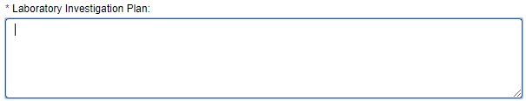
The mandatory Laboratory Investigation Plan field is a text area that allows up to 8000 characters to enter information about the investigation plan.

Was Root Cause or Probable Root Cause of OOS/OOT/OOE Identified? is a Single-item Selection field with choices of Yes or No.

If Yes is selected, additional mandatory fields are displayed for Laboratory Cause Description (text area for up to 8000 characters) and Laboratory Cause Categories (Multi-item Selection field with 5 set choices).
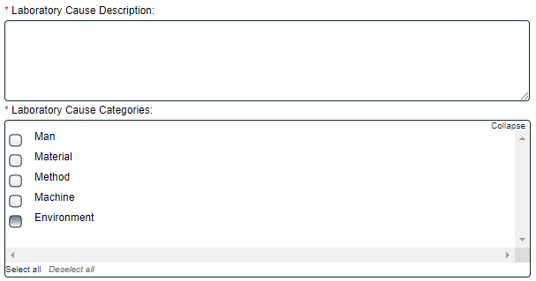
For each category selected, another Single-item Selection field will be displayed for a more detailed Root Cause. The values for those fields are configurable from shared Custom Lists maintained by the System Administrator (refer to Page 13).

A mandatory Conclusion field (text area allowing up to 8000 characters) is available when the Assigned Laboratory Investigator is ready.
The Decision at Step 6 allows three choices:
- A decision of Release tasks will release new Secondary Tasks to the assignees. These tasks will be Task Type = Laboratory Investigation. The LIR Process will then stay at Step 6 upon confirmation.
- A decision of Request extension will bring up additional fields to enter Proposed Extension Date and Reason for the Extension Request. Proposed Extension Date is mandatory and cannot be set before the Investigation Due Date entered at Step 4.
Reason for the Extension Request is a mandatory text area allowing for up to 8000 characters.
This decision will move the LIR Process to Step ExtApp6 – Laboratory Extension Request Approval upon confirmation.

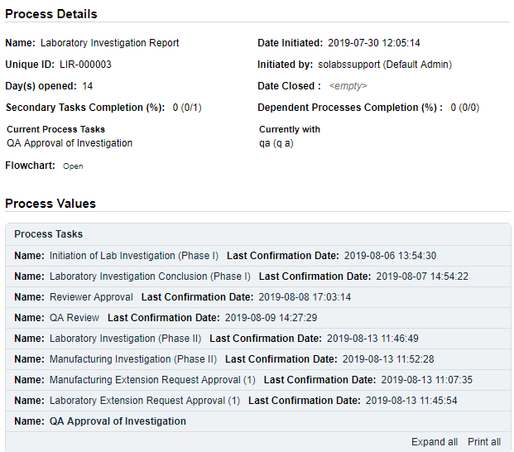
- A decision of Investigation completed moves the Process to Step 7 – QA Approval of Investigation as soon as Step 5 (if required) is completed with a Decision of Investigation Completed.
The Process Details will list the Current Process Task and who it is Currently with. This step is assigned to the Assigned QA Approver entered at Step 1.
The Process Flowchart will highlight the next step of the process.
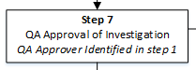

Step ExtApp 6: Laboratory Extension Request Approval (x)
At this step in the LIR Process, the Assigned QA Approver chosen at Step 1 will receive an email Notification and will see their Laboratory Extension Request Approval (x) task listed in the Process section of their SOLABS QM10 HOME Page. The number in parenthesis will indicate the number of extensions requested so far for Step 6. Although the Step Name is different, the options, fields and decisions for this step are exactly the same as for Step ExtApp 5: Manufacturing Extension Request Approval (x). Refer to Page 24-25.
All decisions will move the LIR Process back to Step 6 – Laboratory Investigation (Phase II) upon confirmation so that the Assigned Investigator can continue to complete their investigation against the new due date. Refer to Page 26 for Step 6 – Laboratory Investigation (Phase II).

Step 7: QA Approval of Investigation
At this step in the LIR Process, the Assigned QA Approver chosen at Step 1 will receive an email Notification and will see the QA Approval of Investigation task listed in the Process section of their SOLABS QM10 HOME Page.
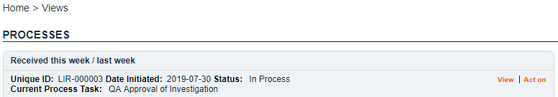

Viewing the QA Approval of Investigation Task
If the Assigned QA Approver clicks on the View option to the right of the Process Task, they will get the same screen shown above.
From the View screen, they can use the Expand all options under the Process Values table and the Related Items table to see more detail on the information entered at prior steps. They can also click on the View option to the right of any individual Related Items (Secondary Tasks, Linked Documents, Linked Processes) to go to the Task Details, Document Details or Process Details screens associated with those Related Items. From any of those screens they can quickly return to the Process since it will be listed as a Related Item on all of those screens.

Acting on the QA Approval of Investigation Task
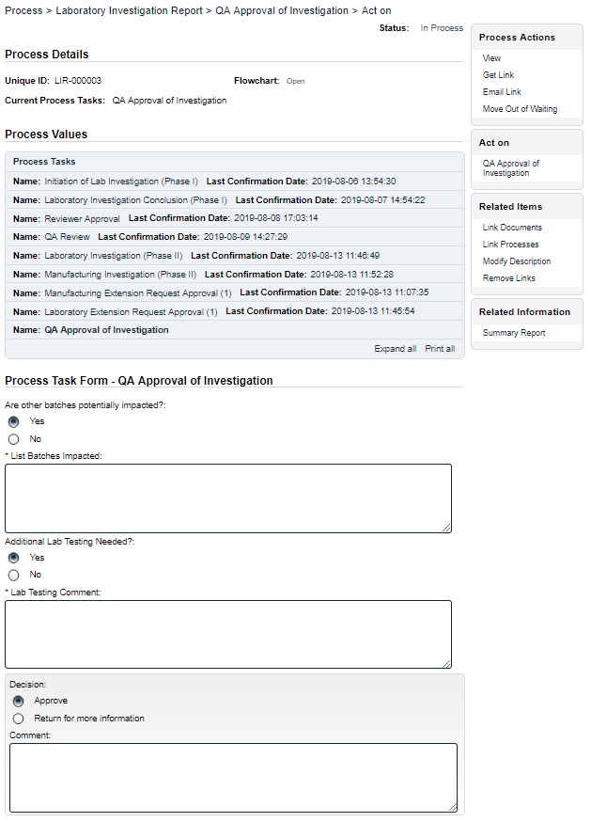
When the Assigned QA Approver clicks on the Act on option to the right of the Process Task, they will go immediately to the Act on screen for their QA Approval of Investigation task. As described above, the Assigned QA Approver can use the Expand all option under the Process Values table to see all information entered in prior steps.
The Process Task Form includes the fields necessary to enter the details regarding the potential impact on batches and whether any additional testing may be needed. These are described in more detail on the next page.
The right-hand Related Items menu allows the Assigned Laboratory Investigator to Link Documents or Link Processes, if applicable.
The Process Task Form fields will be displayed more clearly and described starting on the next page.
Refer to the separate document SOLABS QM10: Introduction to PROCESS Section for information on use of the right-hand menus since they are common to all SOLABS QM Process APPs.
As with previous steps, there is a Save Draft option at the bottom if all the required fields cannot be completed at one time or when using the right-hand menu to Link Documents or Link Processes.

No Secondary Tasks, Related Processes or Document Control Process can be initiated at Step 7.
CAUTION: Navigating away from this page without clicking on either Submit or Save Draft, will result in all entries being lost. To complete the information after the Save Draft option, choose either the Act On option from the Process section of your HOME Page, or search for the LIR Process and then use the right-hand Act on Menu to open the Process Task Form fields.

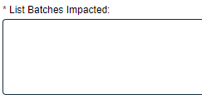
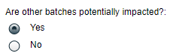
Are other batches potentially impacted? is a Yes or No radio button selection, that defaults to Yes. When Yes is selected, a mandatory text area field (up to 8000 characters) is displayed for List Batches Impacted.

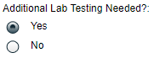
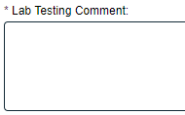
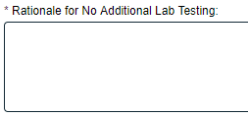
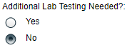
Additional Lab Testing Needed? is a Yes or No radio button selection, that defaults to Yes. When Yes is selected, a mandatory text area field (up to 8000 characters) is displayed for Lab Testing Comment. If No is selected, a mandatory text area field (up to 8000 characters) is displayed for Rationale for No Additional Lab Testing.

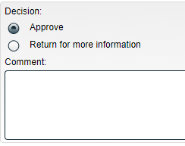
The Decision at Step 7 allows for two options:
  - For a decision of Approve, the Comment field is optional. Confirmation of this decision will move the LIR Process forward as follows:
    - If Additional Lab Testing Needed = Yes, the LIR Process will progress to Step 8 – Additional Testing.
    - If Additional Lab Testing Needed = No, the LIR Process will progress to Step 9 – Interpretation of Investigation Results and Release Decision. (See Page 35)
- For a decision of Return for more information, the Comment field will become mandatory. Confirmation of this decision will move the LIR Process backward as follows:
  - At Step 4, if Is Phase II Investigation Required? = Yes and Is Phase II Laboratory Investigation Required? = Yes, then the LIR Process will move back to Step 5 – Manufacturing Investigation (Phase II) and Step 6 – Laboratory Investigation (Phase II) upon confirmation of Step 7. (See Pages 22 and 26)
  - At Step 4, if Is Phase II Investigation Required? = Yes and Is Phase II Laboratory Investigation Required? = No, then the LIR Process will move back to Step 5 – Manufacturing Investigation (Phase II) upon confirmation of Step 7. (See Page 22)

Step 8: Additional Testing
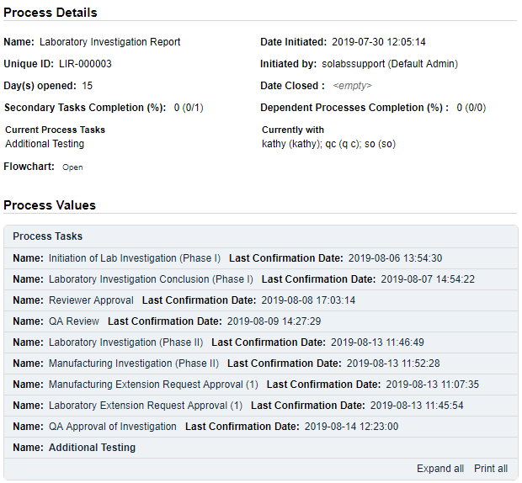
The Process Details will list the Current Process Task and who it is Currently with. This step is assigned to anyone with the Process Role assignment PR_LIR_QC.
The Process Flowchart will highlight the next step of the process.
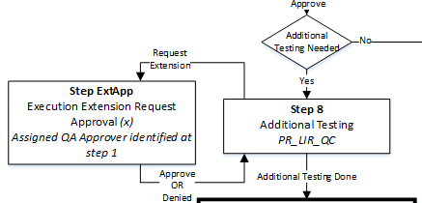

Note that an Extension Request is allowed at Step 8. If needed, it would be Step ExtApp 8 and would follow the same process as Extensions requested at Steps 5 and 6. See Page 24-25 for Extension Request Approval options, fields and decisions.

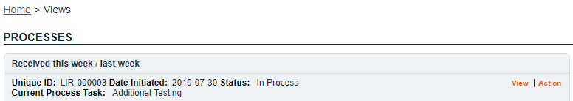
At this step in the LIR Process, all users with the PR_LIR_QC Role assignment will receive an email Notification and will see the Additional Testing task listed in the Process section of their SOLABS QM10 HOME Page.

Viewing the Additional Testing Task
If the user clicks on the View option to the right of the Process Task, they will get the same screen shown above.
From the View screen, they can use the Expand all options under the Process Values table and the Related Items table to see more detail on the information entered at prior steps. They can also click on the View option to the right of any individual Related Items (Secondary Tasks, Linked Documents, Linked Processes) to go to the Task Details, Document Details or Process Details screens associated with those Related Items. From any of those screens they can quickly return to the Process since it will be listed as a Related Item on all of those screens.

Acting on the Additional Testing Task
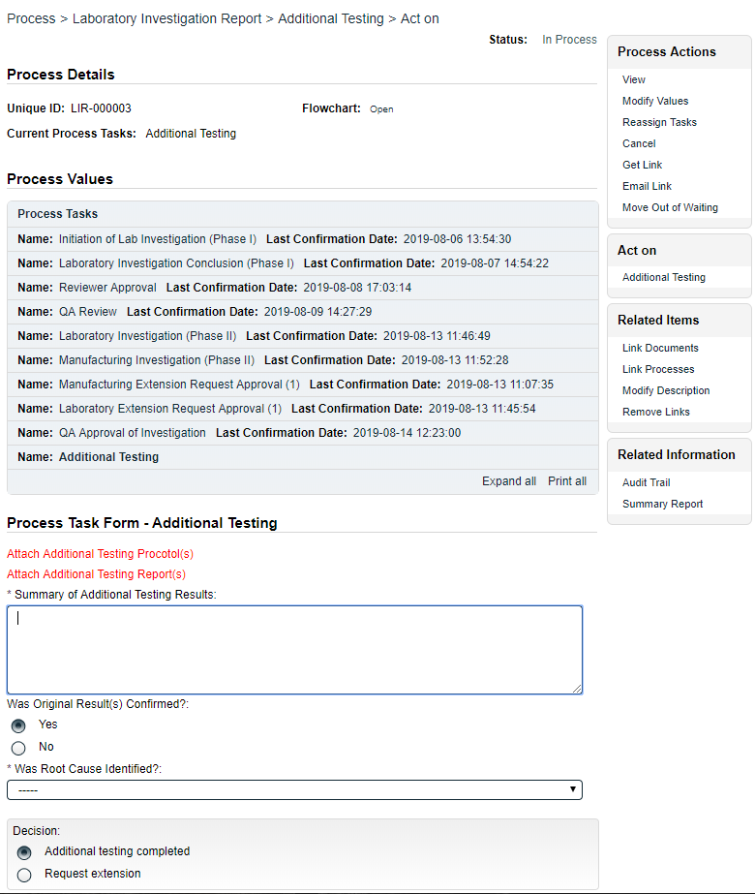
When the QC User clicks on the Act on option to the right of the Process Task, they will go immediately to the Act on screen for their Additional Testing task. As described above, the QC User can use the Expand all option under the Process Values table to see all information entered in prior steps.
The Process Task Form includes the fields necessary to enter the details regarding the results of the additional testing. These are described in more detail starting below.
The right-hand Related Items menu allows the Assigned Laboratory Investigator to Link Documents or Link Processes, if applicable.
Refer to the separate document SOLABS QM10: Introduction to PROCESS Section for information on use of the right-hand menus since they are common to all SOLABS QM Process APPs.
Process Task Form fields are displayed more clearly and described starting on the next page.
As with previous steps, there is a Save Draft option at the bottom if all the required fields cannot be completed at one time or when using the right-hand menu to Link Documents or Link Processes.

No Secondary Tasks, Related Processes or Document Control Process can be initiated at Step 8.
CAUTION: Navigating away from this page without clicking on either Submit or Save Draft, will result in all entries being lost. To complete the information after the Save Draft option, choose either the Act On option from the Process section of your HOME Page, or search for the LIR Process and then use the right-hand Act on Menu to open the Process Task Form fields.
The following sentences are displayed in red at the top of the Process Task Form section:
Attach Additional Testing Protocol(s)
Attach Additional Testing Report(s)
Documents can be attached using the Link Documents option in the right-hand Related Items menu.

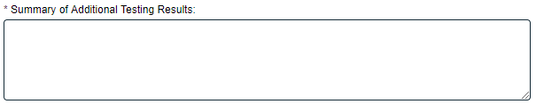
Summary of Additional Testing Results is a mandatory text area field allowing up to 8000 characters.
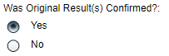
Was Original Result(s) Confirmed? is a Yes or No radio button selection that defaults to Yes.

Was Root Cause Identified? is a mandatory Single-item Selection field with choices of Yes or No.
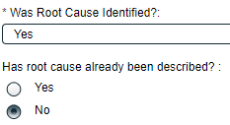
If Yes is selected, then Has root cause already been described? is displayed. It is a Yes or No radio button selection that defaults to No.

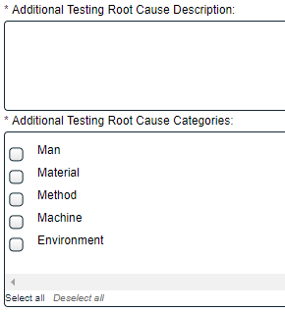
With a selection of No, additional mandatory fields are displayed for Additional Testing Root Cause Description (8000-character text area field) and Additional Testing Root Cause Categories (Multi-item Selection field with five set choices). For each category selected, another Single-item Selection field will be displayed for a more detailed Root Cause. The values for those fields are configurable from shared Custom Lists maintained by the System Administrator (refer to Page 13).
A selection Yes for Has root cause already been described? requires no additional entries.

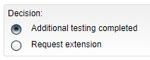
The Decision at Step 8 has two choices:
- The default is Additional testing completed. Confirmation of this decision will move the LIR Process to Step 9 – Interpretation of Investigation Results and Release Decision.
Confirming a decision of Request extension will move the LIR Process to Step ExApp8 – Additional Testing Extension Request Approval. The options, fields and decisions are the same as Extension Request Approvals at Steps 5 and 6. See Pages 24-25 for completing the step.

Step ExtApp 8: Additional Testing Extension Request Approval (x)
At this step in the LIR Process, the Assigned QA Approver chosen at Step 1 will receive an email Notification and will see their Additional Testing Extension Request Approval (x) task listed in the Process section of their SOLABS QM10 HOME Page. The number in parenthesis will indicate the number of extensions requested so far for Step 8. Although the Step Name is different, the options, fields and decisions for this step are exactly the same as for Step ExtApp 5: Manufacturing Extension Request Approval (x) and Step ExtApp6: Laboratory Extension Request Approval (x). Refer to Page 24-25.
All decisions will move the LIR Process back to Step 8 – Additional Testing upon confirmation so that the Assigned Investigator can continue to complete their investigation against the new due date. Refer to Page 32 for Step 6 – Laboratory Investigation (Phase II).

Step 9: Interpretation of Investigation Results and Release Decision
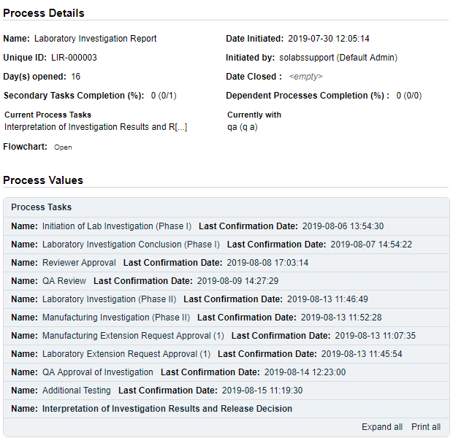
The Process Details will list the Current Process Task and who it is Currently with – the Assigned QA Approver selected at Step 1.
The Process Flowchart will highlight the next step of the process.
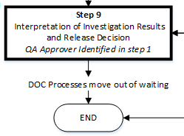
Secondary Tasks cannot be added at Step 9. Related Processes and a Document Control Process can be initiated at Step 9. Any Document Control Process initiated will move out of waiting upon confirmation of this step.

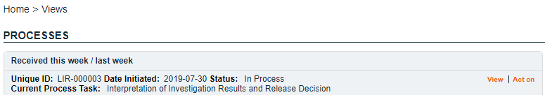
At this step in the LIR Process, the QA Approver will receive an email Notification and will see the Interpretation of Investigation Results and Release Decision task listed in the Process section of their SOLABS QM10 HOME Page.

Viewing the Interpretation of Investigation Results and Release Decision Task
If the QA Approver clicks on the View option to the right of the Process Task, they will get the same screen shown at the end of Page 33.
From the View screen, they can use the Expand all options under the Process Values table and the Related Items table to see more detail on the information entered at prior steps. They can also click on the View option to the right of any individual Related Items (Secondary Tasks, Linked Documents, Linked Processes) to go to the Task Details, Document Details or Process Details screens associated with those Related Items. From any of those screens they can quickly return to the Process since it will be listed as a Related Item on all of those screens.

Acting on the Interpretation of Results and Release Decision Task
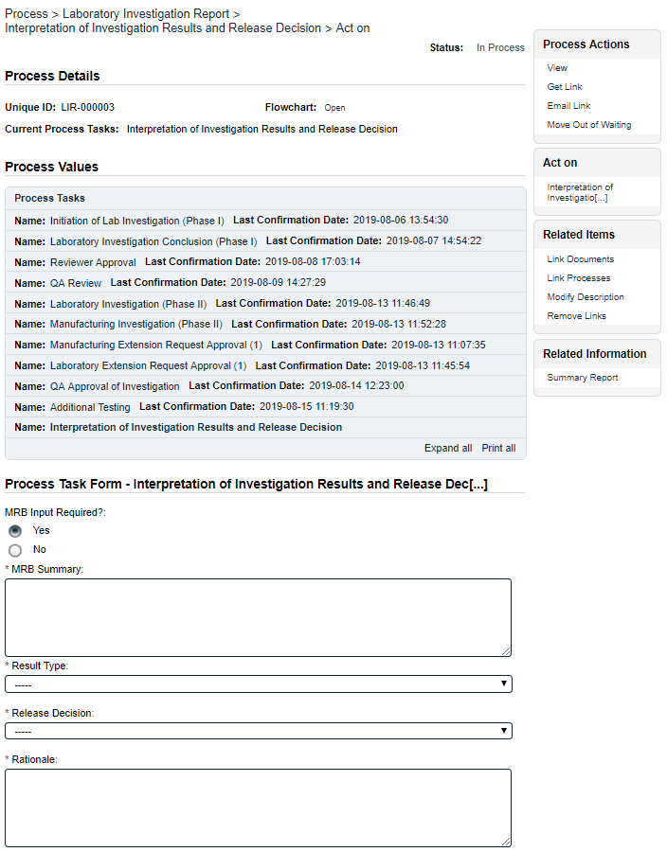
When the QA Approver clicks on the Act on option to the right of the Process Task, they will go immediately to the Act on screen for their Interpretation of investigation Results and Release Decision task. As described above, the QA Approver can use the Expand all option under the Process Values table to see all information entered in prior steps.
The Process Task Form includes the fields necessary to enter the details regarding the interpretation of results and related release decisions. These fields are described in more detail starting on the next page.
The right-hand Related Items menu allows the Assigned Laboratory Investigator to Link Documents or Link Processes, if applicable.
Process Task Form fields are displayed more clearly and described starting on the next page.
Refer to the separate document SOLABS QM10: Introduction to PROCESS Section for information on use of the right-hand menus since they are common to all SOLABS QM Process APPs.

As with previous steps, there is a Save Draft option at the bottom if all the required fields cannot be completed at one time or when using the right-hand menu to Link Documents or Link Processes.

No Secondary Tasks can be initiated at Step 9. Related Processes and a Document Control Process can be initiated at this step.
CAUTION: Navigating away from this page without clicking on either Submit or Save Draft, will result in all entries being lost. To complete the information after the Save Draft option, choose either the Act On option from the Process section of your HOME Page, or search for the LIR Process and then use the right-hand Act on Menu to open the Process Task Form fields.
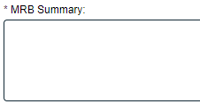
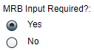
MRB Input Required? is a Yes or No radio button selection that defaults to Yes. When Yes is selected, a mandatory text area field (allows up to 8000 characters) is displayed for MRB Summary. When No is selected, no additional information is required.

Result Type is a mandatory Single-item Selection field with 2 set choices.
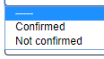

Release Decision is a mandatory Single-item Selection field with 5 set choices.
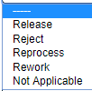

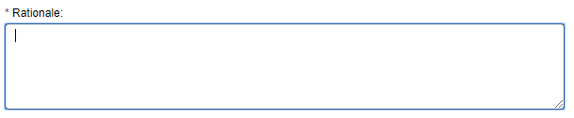
Rationale is a mandatory text area field allowing for up to 8000 characters.

The Laboratory Investigation Request (LIR) Process closes up on confirmation of Step 9. Any Document Control Process initiated at this step will move out of waiting. Any Secondary Tasks that may not have been completed by this point in the process will be removed.

Viewing Details for a Completed Laboratory Investigation Request (LIR) Process
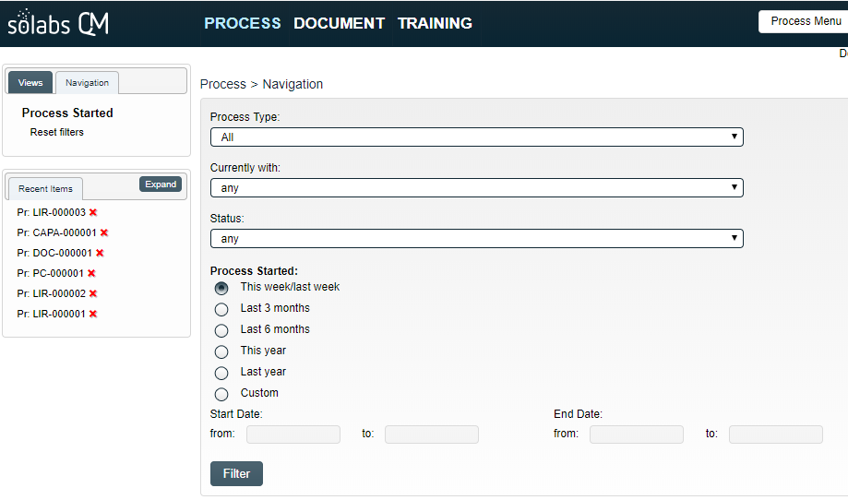
Users are able to search for and view processes at any stage, using the Navigation tab in the PROCESS Section of SOLABS QM10. If the Process was recently worked on, it will also be available in the Recent Items section.

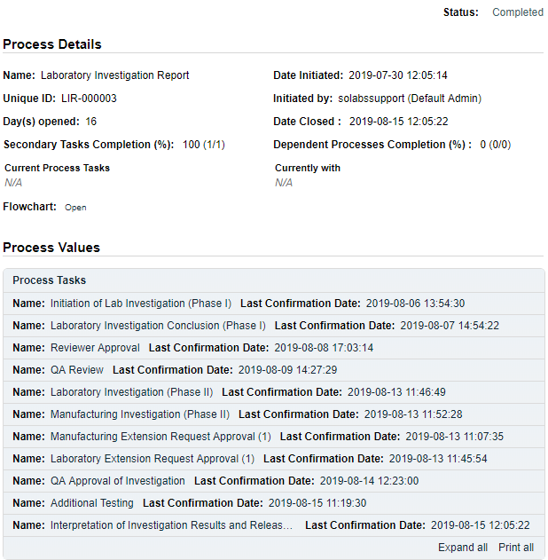

Using the Process Values Table
Process Tasks can be viewed by using the Expand all or Print all options at the bottom of the Process Values table. An individual Process Task can be expanded by clicking on it within the Process Values table.
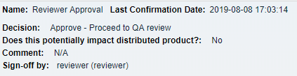

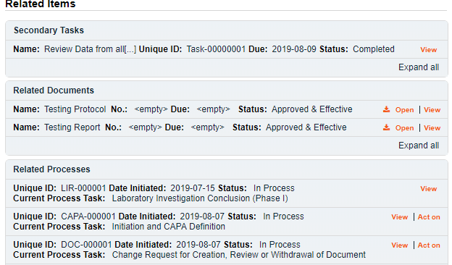
Using the Related Items Table
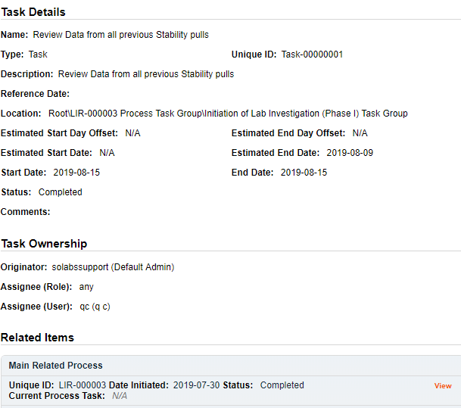
Information on any Secondary Tasks, Related Processes or Related Documents can be accessed by clicking on the View option beside the listing in the Related Items section of the screen. From any of those Details screens, the Process will be listed under Related Items – you can quickly toggle back to the Main Process by clicking View next to it.

Creating a Summary Report
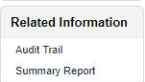
Under the right-hand Related Information menu, click on the Summary Report option.
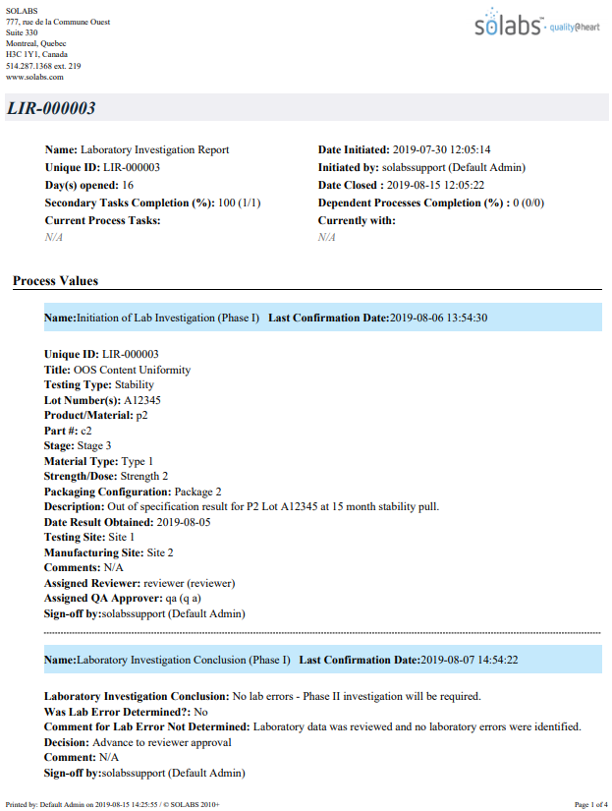
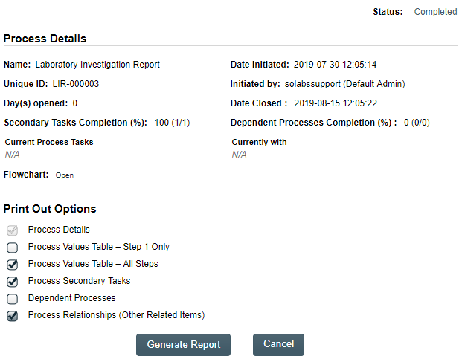
Select the desired Print Out Options and then click on Generate Report. A multi-page PDF Report will be generated, with any company header information set in System Configurations, and will include details on each step requested for the report.

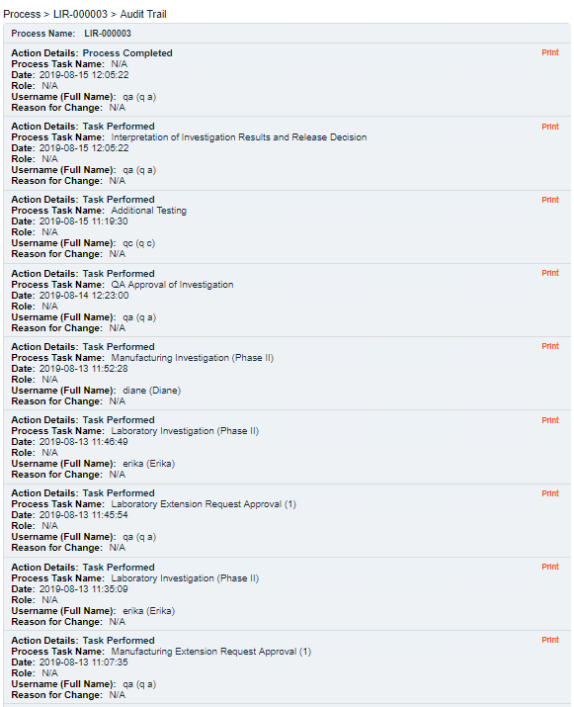
Using the Audit Trail
Users with the SOLABS System Administrator role assignment, will also see the Audit Trail option on the right-hand Related Information menu.

There you will find all the details for every step of the LIR Process, from Process Completed all the way down to Process Started, with options to expand or print the entire process or any individual steps.

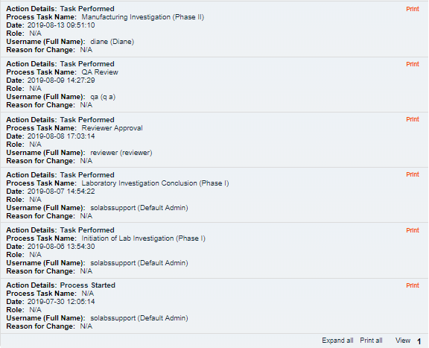

Laboratory Investigation Request (LIR) Process Notifications
As mentioned throughout this document, Users will see process tasks listed on their SOLABS QM10 HOME Page and can View or Act on them from there. They will also receive Email Notifications, which include a link to SOLABS QM10.
General information on SOLABS QM10 Notifications available with the Core Software can be found in the SOLABS Knowledge Base in a document titled SOLABS QM10: Notifications Guide.
Some additional Custom Notifications are available with Laboratory Investigation Request (LIR) Process P0055.

Custom Notifications
