SOLABS QM10

Change Control Process P0036 User Guide
Introduction 2
Change Control Process Flowcharts 3
Change Control Process – Process Roles 4
Starting a Change Control Process 5
Step 1 - Change Control Request 6
Completing the Process Task Form: 7
General Information Fields 8
Creating Secondary Tasks 9
Initiating a Related Process 11
Initiating a Document Control Process 12
Submit and Confirm 12
Step 2 – Quality Assessment and Selection of Reviewers 13
Viewing a Quality Assessment and Selection of Reviewers Task 14
Acting on the Quality Assessment and Selection of Reviewers Task 15
Completing the Process Task Form 16
Reviewing Secondary Tasks and Related Processes 18
Submit and Confirm the Agreement of Change Decision 18
Step 3 - Change Control Review 20
Acting on the Change Control Review Task 20
Step 4 – Regulatory Assessment 22
Acting on the Regulatory Assessment Task 22
Secondary Tasks Created for Submissions and Related Approval Letters 23
Step 5 - QA Approval to Proceed 26
Acting on the QA Approval to Proceed Task 26
Step 6 – Pre Implementation Task Completion 28
Viewing a Secondary Task 29
Acting on a Secondary Task 30
Acting on the Pre Implementation Task Completion Task 31
Step 7 – Owner Implementation Approval 32
Acting on the Change Control Final Approval Task 32
Step 8 – Implementation Approval 35
Acting on the Implementation Approval Task 35
Step 9 – QA Implementation Final Approval 37
Acting on the QA Implementation Final Approval Task 37
Step 10 – Post Implementation Task Completion 39
Acting on the Post Implementation Task Completion Task 40
Step 11 – Close-Out 41
Acting on the Close-Out Task 41
Confirmation of Step 11 – Close-Out 42
Viewing Details for a Completed Change Control Process 43
Using the Process Values Table 43
Using the Related Items Table 44
Creating a Summary Report 44
Using the Audit Trail 45
Change Control Process Notifications 46

Introduction
This document provides instructions on the use of the SOLABS QM10 Change Control Process APP P0036 – by guiding you through each step in the process and providing information on the activities, settings and options associated with each step.
Refer to the following documents available in the SOLABS Knowledge Base for general information, navigation and functionality common to any SOLABS QM Process APP in the SOLABS QM10 PROCESS Section.
- SOLABS QM10: Introduction to PROCESS Section
- SOLABS QM10: Notifications Guide
- SOLABS QM10 PROCESS Section: Parent/Child Process Relationships
Different steps in a process are assigned to different roles and/or users in the system. You take action on the step assigned to you. For example, you may be assigned a QA Approval to Proceed step in a Change Control process. A manager can monitor the status of process tasks assigned to their employees by using the Process Section search capabilities or the Process Reports to query process status by user.
Detailed information on this process is available in the User Functional Design Specification (UFDS) document that comes with deployment of the Process in your instance of SOLABS QM10.

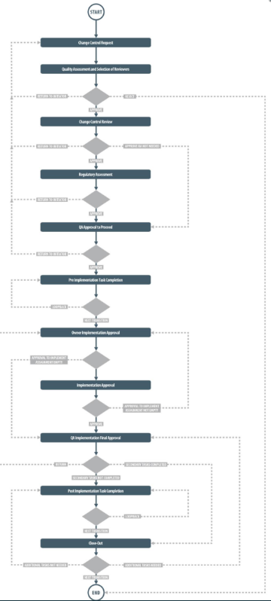
Change Control Process Flowcharts
The Change Control Process Flowcharts are displayed on this page for informational purposes only - to show that it is a complex multi-step process with many related decision paths.
There is a Flowchart available within the Process App. As the process moves along, the active step in that Flowchart is highlighted.
The Flowchart below is available as part the User Functional Design Specification (UFDS) document that is provided with the Process App.
This User Guide is organized into sections for each of the Steps in the Change Control Process. The flowchart section for each of those steps will be displayed in larger, more readable format within those sections.

Change Control Process – Process Roles
Decisions made by those involved in the process act to progress the workflow to the next Step or return it to a prior Step. The following Change Control Process Roles are associated with the Change Control Process P0036 and must be assigned to the Users in SOLABS QM10 who will make the related decisions and need to receive email Notifications related to the ongoing process.
When SOLABS QM10 Users are assigned a Process Role, their names are then available on drop-down lists to be selected for their assigned steps in the process. The process will automatically notify them to Act On that Step/Primary Task. They will see the step in the Process Section of their SOLABS QM10 HOME Page and will also receive an email Notification.
Contact your SOLABS System Administrator if any of these Change Control Process Roles need to be assigned to additional Users. If these Process Roles are not assigned to any Users, the related process tasks will instead go to Users who have the System Role assignment of SOLABS Documentation Administrator. If that role is not assigned, the process tasks would go to the SOLABS System Administrator.
PR_CC_Approver:
This Process Role must be assigned to those Users who will need to Act on the following Primary Tasks:
- Step 2: Quality Assessment and Selection of Reviewers
- Step 5: QA Approval to Proceed
- Step 9: QA Implementation Final Approval
- Step 11: Close-Out
PR_CC_Owner:
This Process Role must be assigned to those Users who will need to Act on the following Primary Tasks:
- Step 6: Pre Implementation Task Completion
- Step 7: Owner Implementation Approval
- Step 10: Post Implementation Task Completion
The User with this role assignment that is selected at Step 1 will receive email Notifications for the following events. Specific details on these Notifications can be found in the Notifications section of this User Guide.
- Step 1 is confirmed
- The implementation date is approaching and there are some Pre-Implementation Secondary Tasks or Dependent Document Control Processes that are not complete
- All Pre-Implementation Secondary Tasks are complete
- All Open Secondary Tasks, Post-Implementation Secondary Tasks and Dependent Document Control Processes are complete
- All Secondary Tasks for a particular Region are complete and it was decided at Step 9 that approvals for each Region (where multiple Regions) should be monitored separately
PR_CC_RA:
This Process Role must be assigned to those Users who will need to Act on the following Primary Tasks:
- Step 4: Regulatory Assessment

Starting a Change Control Process

From the PROCESS Section in SOLABS QM10, choose Start Process from the Quick Access Process Menu.

At the next screen, locate the listing for the Change Control Process and click the blue START button.
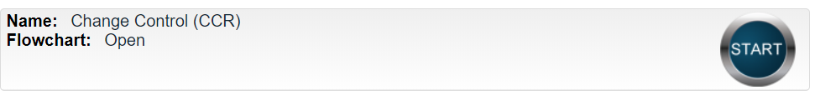

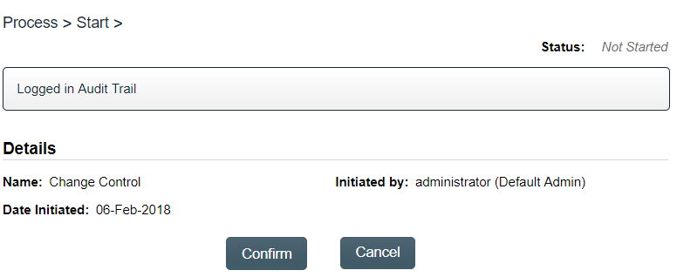
You will then be asked to Confirm this action, to move Status from Not Started to In Process. At this point a Unique ID will be assigned to the Change Control Process.

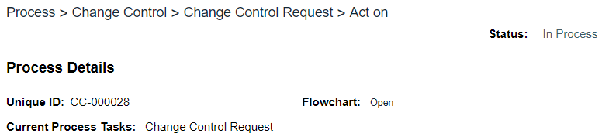

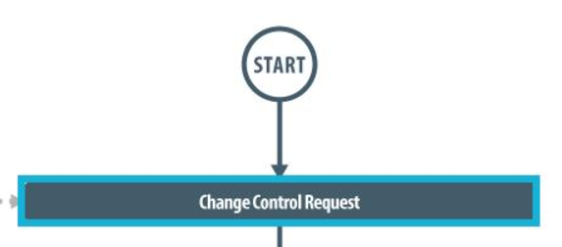
The first Primary Task box on the Process Flowchart will now be highlighted when it is opened: Change Control Request.

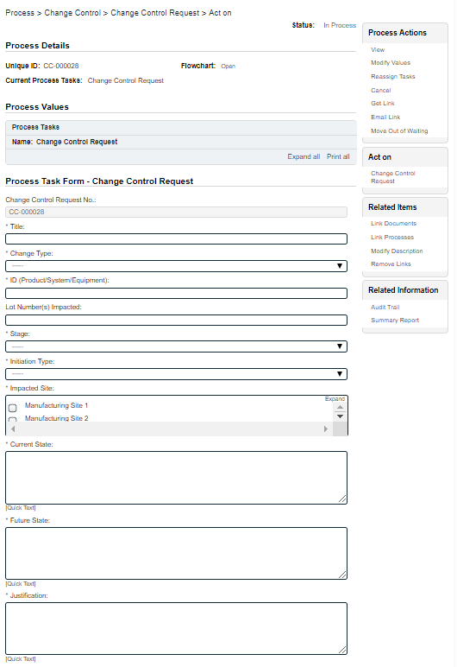
Step 1 - Change Control Request
At Step 1 the user initiating the Change Control enters all the required information and metadata into the Process Task Form.
As seen on the screen shot to the right, there are many fields to be completed by the initiator at this step. This page provides some general information on the various types of fields.
Some of the fields on the Process Task Form are editable text fields or text areas. Others are single-select drop-down lists or multi-select fields. Fields with an asterisk (*) are mandatory.
The right-hand Related Items menu allows the initiator to Link Documents or Link Processes, if applicable. There are also sections to initiate Secondary Tasks and initiate new Related Processes, including a Document Control Process.
Each of the fields on the Process Task Form will be displayed and described more clearly starting on the next page.
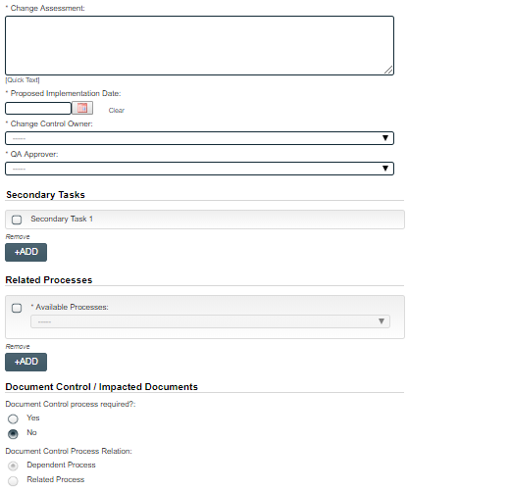
Refer to the separate document SOLABS QM10: Introduction to PROCESS Section for information on use of the right-hand menus and Related Processes, since they are common to all SOLABS QM Process APPs.
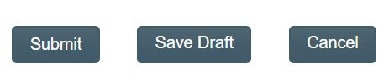
There is a Save Draft option at the bottom if you cannot complete the required fields at one time or when you need to use the right-hand menus to Link Processes or Link Documents.

CAUTION: If you navigate away from this page without clicking on either Submit or Save Draft, all entries will be lost. To complete the information after the Save Draft option, you can either choose the Act On option from the Process section of your HOME Page, or search for the In-Process Change control and then use the right-hand Act on Menu to open the Process Task Form fields.

Completing the Process Task Form:
This sub-section covers the information required for each field in the Process Task Form at Change Control Process Step 1 - Change Control Request.
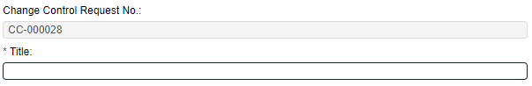
The Change Control Request No. field will be automatically populated with the next available Change Control process number. The Title field is mandatory. Choose a clear, concise and intuitive title for the Change Control that will quickly communicate the subject. Titles will appear in Change Control Process Reports.

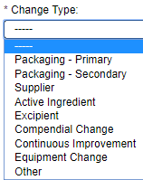
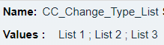

The Change Type field is a mandatory field. It is a Single-item selection drop-down list populated by values from an editable Custom List maintained by your SOLABS System Administrator, with terminology unique to your organization. Example:
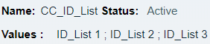

The ID (Product/System/Equipment) field is a mandatory field. It is also a Single-item selection drop-down list populated by values from an editable Custom List maintained by your SOLABS System Administrator, with terminology unique to your organization.

The Lot Number(s) Impacted field is an optional text field allowing for up to 1024 characters.
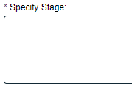
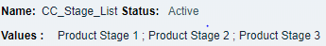

The Stage field is a mandatory single-item selection field populated by values from an editable Custom List maintained by your SOLABS System Administrator, with terminology unique to your organization. It also includes the option of Other. When “Other” is selected, another field will appear to Specify Stage.

The Initiation Type field is a mandatory single-item selection field with two choices: Internal or External. If External is selected, additional mandatory fields will be displayed.

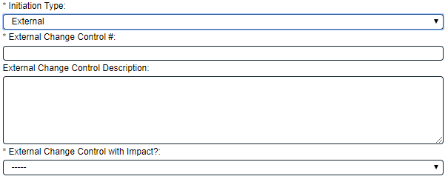
External Change Control # is a mandatory free-text field allowing for up to 1024 characters.
External Change Control Description is an optional free-text area allowing for up to 4000 characters.
External Change Control with Impact? is a single-item selection field with Yes or No as options.
The choice of Yes or No in the External Change Control with Impact? field will determine what path the Process workflow will take upon submission of a QA Approval to Proceed decision at Step 2. (See Page 19)
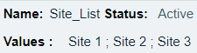
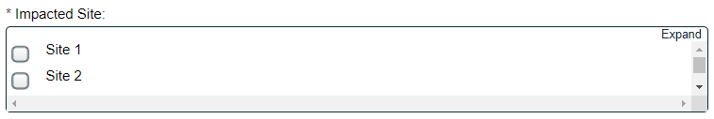

Impacted Site is a mandatory multi-item selection field populated by values from an editable Shared Custom List maintained by your SOLABS System Administrator, with terminology unique to your organization.

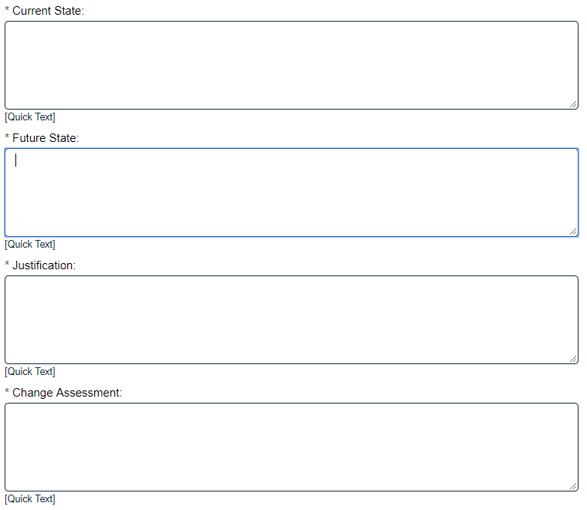
General Information Fields
For any Change Type selected, the next fields on the Process Task Form are mandatory free-text fields to enter the Current State, the Future State, the Justification and the Change Assessment.
These fields allow up to 4000 characters each, or can be populated by Quick Text.
Quick Text is an editable Custom List of standardized phrases/terms that can be created as values for these fields.

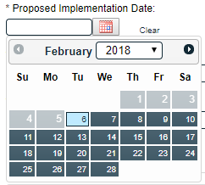
The mandatory Proposed Implementation Date field can be populated from a Calendar.

The mandatory Change Control Owner field is a Single-select drop-down populated by the list of Users to whom the Process Role PR_CC_Owner is assigned. It will default to the Initiator, if that person is included in the list. The person chosen in this field will be assigned the following Steps in the Change Control Process and will receive various email Notifications regarding status of Secondary Tasks and the impact on the Proposed Implementation Date:
- Step 6 - Pre Implementation Task Completion
- Step 7 – Owner Implementation Approval
- Step 10 – Post Implementation Task Completion

The mandatory QA Approver field is a Single-select drop-down populated by the list of Users to whom the Process Role PR_CC_Approver is assigned. The person chosen in this field will be assigned the following steps in the Change Control Process:
- Step 2: Quality Assessment and Selection of Reviewers
- Step 5: QA Approval to Proceed
- Step 9: QA Implementation Final Approval
- Step 11: Closeout

Creating Secondary Tasks
The initiator of the Change Control Process can create Secondary Tasks that will be associated with the Change Control. These Secondary Tasks can be assigned to appropriate Users for activities required to support completion of the Change Control but that are not part of the Primary Tasks.
The Secondary Task section is under the Process Task Form, but still on the Change Control Request screen. This section is available at various Primary Task Steps of the Change Control Process, allowing others involved in the review, implementation and approval of the Change Control to assign additional Secondary Tasks.
After selecting Secondary Task 1, additional fields will be displayed to define and assign that task.
Replace the text “Secondary Task 1” with an appropriate Title for the task.
The task Type can then be chosen from a drop-down list of Task Types. These Task Types are available in Steps 1-5. Pre-Implementation Task Type is not available in Steps 7-9. If a task Type is chosen that is not applicable at this Step, the message This type of task is not allowed at current step will be displayed.
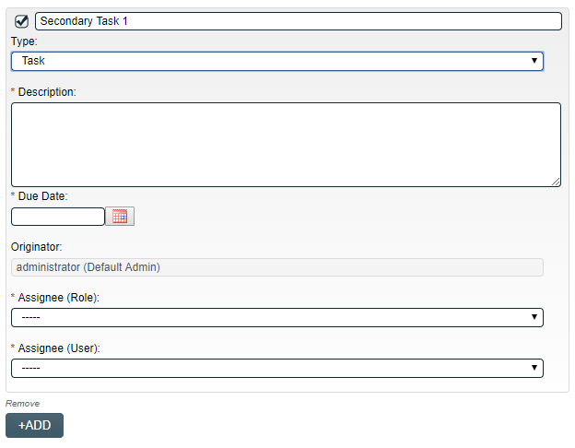
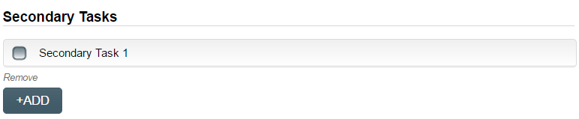
Enter a Description and a Due Date for the Task. Choose due dates appropriate to ensure tasks are completed in a time frame that supports on time Change Control completion.
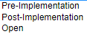
The Originator field will default to the User initiating the Change Control Process and completing Step 1.
The +ADD button can be used to create additional Secondary Tasks.
Both the Assignee (Role) and the Assignee (User) fields must be completed for the chosen User. The drop-down lists will bring up the Active Roles list and the Active Users list.
To assign by Role, choose the appropriate Function Role from the list.
All Users with that Role will then appear in the Assignee (User) drop-down list so that the appropriate person can be selected. To assign by User, choose the appropriate User from the list. Their Function Roles will then appear in the Assignee (Role) drop-down list and an appropriate option must be selected.
The Assignees of Secondary Tasks of Task Type = Open or Task Type = Pre-Implementation will receive email Notifications and see the View/Act On options for their Secondary Tasks only after QA Approval to Proceed is completed at Step 5. Until then the Task status is Not Started. Secondary Tasks of Task Type = Post Implementation are not released to assignees until after Step 9. The Secondary Tasks are listed under Related Items at the bottom of the screen for any Change Control Step.
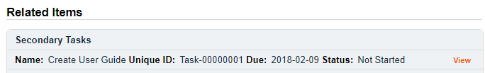

Secondary Tasks (Post-Implementation and Open) can also be initiated in Steps 7-9. In that case they are released after QA Implementation Final Approval is completed at Step 9, along with all Post Implementation Secondary Tasks initiated during Steps 1-5.

Initiating a Related Process
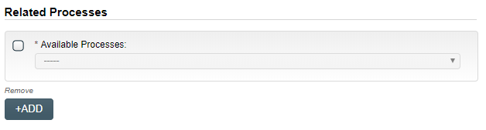
To initiate a new SOLABS QM10 Process from within this Process, check the Available Processes box.
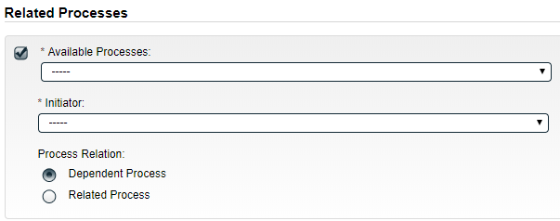
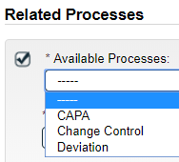
The Available Processes field is a single-item selection field that lists Process Apps deployed for your organization.
Choose the Process Relation as either a Dependent Process (must be completed before the Change Control is closed), or a Related Process.
If the Process Relation is selected as Dependent Process, the process it was initiated from is considered the Parent Process. Dependent Processes will be in a status of “Waiting for Parent Process” until after QA Approval to Proceed is completed at Step 5. Dependent Processes initiated after Step 5 will be “Waiting for Parent Process” until QA Implementation Final Approval is completed at Step 9.
The mandatory Initiator to field is a Single-item selection field that displays the Active User list for your organization. The person chosen in this field will be the person who will be assigned Step 1 of the process you are choosing to initiate. There is also an option to choose myself, if you would like to initiate both processes concurrently as the initiator. This process will be the Parent Process of the new process being initiated.
If a Related Process was already initiated in SOLABS QM10, separately from this Change Control, it can be linked as a Related Item using the right-hand menu option under Related Items. In this case, do not select the Available Processes box and instead use the Link Processes option.
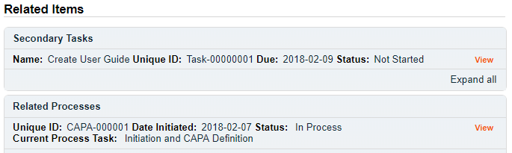
Whether linking an existing process or initiating a new one, the Related Process will be listed in the Related Items section when CCR Step 1 is Submitted and Confirmed.
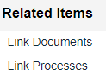

The Related Processes will be released to the assignees only after QA Approval to Proceed is completed at Step 5. Related Processes initiated after Step 5 will be released after QA Implementation Final Approval is completed at Step 9.

Initiating a Document Control Process
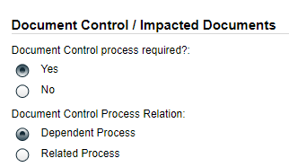
To initiate a new SOLABS QM10 Document Control Process to manage any document updates required for this Change Control, select Yes. One or more documents can be included in a Document Control Process.
When the Yes option is selected, also choose whether it will be a Dependent Process (must be completed before the Change Control is closed), or a Related Process.

If the Process Relation is selected as Dependent Process, the process it was initiated from is considered the Parent Process.

If a Document Control Process was already initiated in SOLABS QM10, separately from this Change Control, it can be linked as a Related Item using the right-hand menu option under Related Items. In this case, leave the above setting at the default of No.
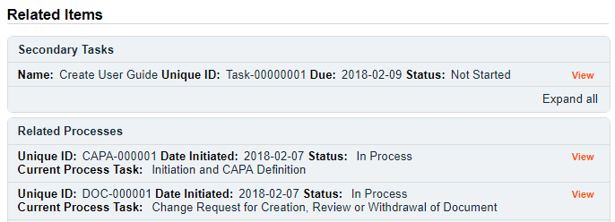
When the Yes option is selected, Step 1 of the Document Control Process will be launched immediately upon submission of Step 1 – Change Control Request, so that the person initiating the Change Control Process can also concurrently initiate the Document Control Process. The Change Control Process will be considered the Parent Process.
Whether linking an existing Doc Control Process or initiating a new one, it will be listed in the Related Items section when CCR Step 1 is Submitted and Confirmed.

Dependent Document Control Processes will be in a status of “Waiting for Parent Process” until after QA Approval to Proceed is completed at Step 5. Dependent Document Control Processes initiated after Step 5 will be “Waiting for Parent Process” until QA Implementation Final Approval is completed at Step 9.

Submit and Confirm
When all information has been entered in the Process Task Form, and any Secondary Tasks, Linked Documents, Linked Processes, Related Processes or Document Control Processes have been added, click Submit and then Confirm. This will change the Status to In Process and to progress the process to Step 2 – Quality Assessment and Selection of Reviewers.
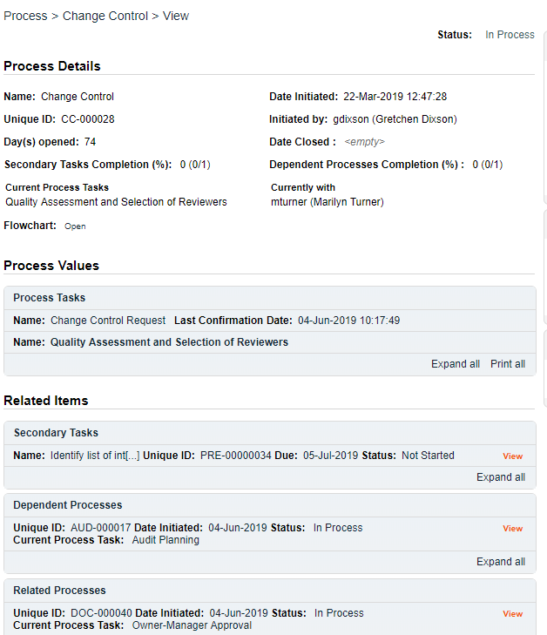
The Process Flowchart will highlight the next step of the process and the person chosen in Step 1 in the QA Approver field will be listed. This person will also receive an email Notification and will see the Step 2 – Quality Assessment and Selection of Reviewers task listed on their SOLABS QM10 HOME Page.
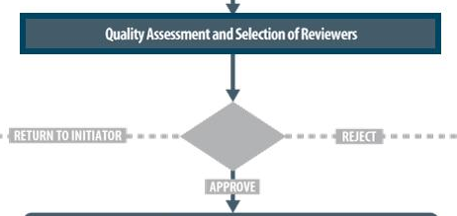

Step 2 – Quality Assessment and Selection of Reviewers
At this step in the Change Control Process, the person chosen at Step 1 will receive an email Notification and will see the Step 2 – Quality Assessment and Selection of Reviewers task listed in the Process section of their SOLABS QM10 HOME Page.
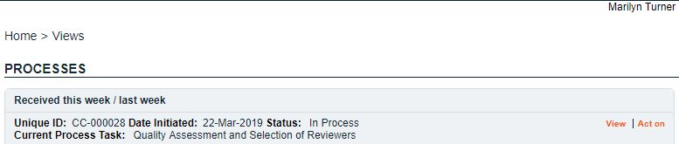

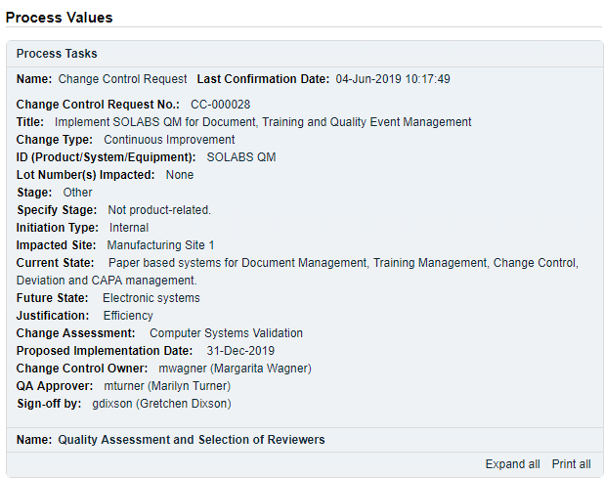
Viewing a Quality Assessment and Selection of Reviewers Task
If the User clicks on the View option to the right of the Process Task on their HOME Page, they will get the same screen shown on the previous page.
From that View screen, there are Expand all options under the Process Values table and the Related Items table, that can be used to see more detail on the information entered by the initiator at Step 1.
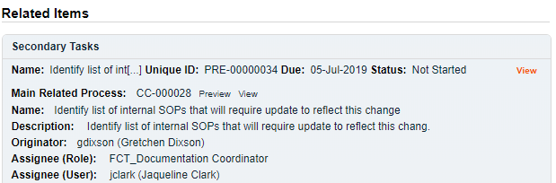
They can also click on the View option to the right of any individual Related Items (Secondary Tasks, Linked Documents, Linked Processes) to go to the Task Details, Document Details or Process Details screens associated with those Related Items.
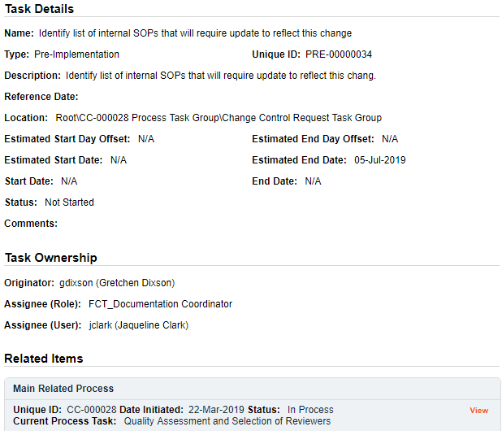
From any of those screens they can quickly return to the Process since it will be listed as a Related Item on all of those screens. See example below.
In this example, clicking on View for the Secondary Task listed in CC-000028 brings up the Task Details screen for that assigned Task.
Secondary Task PRE-00000034 is listed as a Related Item for that Task. To get back to CC-000028, the User can click on the View option.
This makes it easy to toggle between the Process and any Related Items.

Acting on the Quality Assessment and Selection of Reviewers Task
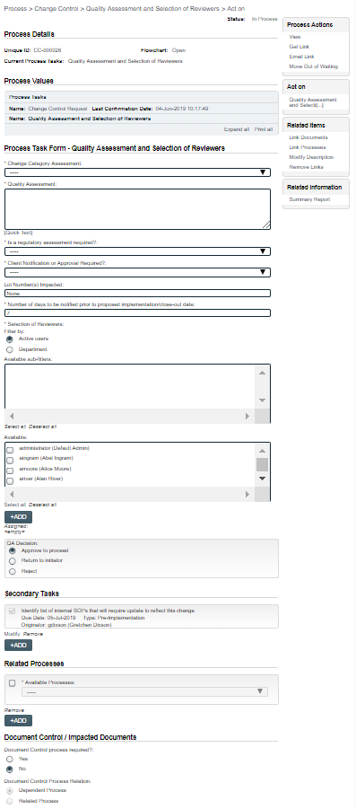
When the assigned User clicks on the Act on option to the right of the Process Task, they will go immediately to the Act on screen for their Quality Assessment and Selection of Reviewers task.
As described on the last page, they can then use the Expand all option under the Process Values table to see all information entered at Step 1.
As seen on the screen shot to the right, there are a number of fields to be completed by the assigned User at this step.
As with Step 1, there are different field types on the Process Task Form, including date fields, Single-select drop-down lists and free text fields/areas. Fields with an asterisk (*) are mandatory.
Each of the fields on this Process Task Form will be displayed more clearly and described starting on the next page.
The right-hand Related Items menu allows the initiator to Link Documents or Link Processes, if applicable. There are also sections to initiate Secondary Tasks and initiate new Related Processes, including a Document Control Process.
Refer to the separate document SOLABS QM10: Introduction to PROCESS Section for information on use of the right-hand menus and Related Processes, since they are common to all SOLABS QM Process APPs.
Use the Save Draft option at the bottom if you cannot complete all the required fields at one time or when you use the right-hand menus to Link Documents or Link Processes.

CAUTION: If you navigate away from this page without clicking on either Submit or Save Draft, all entries will be lost. To complete the information after the Save Draft option, choose either the Act On option from the Process section of your HOME Page, or search for the Change Control and use the right-hand Act on Menu to open the Process Task Form fields.

Completing the Process Task Form
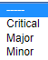
This sub-section covers the information required for each field in the Process Task Form at Change Control Process Step 2: Quality Assessment and Selection of Reviewers.
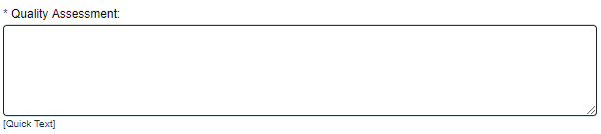
Change Category Assessment field is a mandatory single-item selection field with three choices: Critical, Major and Minor.

Quality Assessment is a mandatory free-text area that allows up to 4000 characters to describe the Quality Assessment. It can also be populated by Quick Text. Quick Text is an editable Custom List of standardized phrases/terms that can be created as values for these fields.

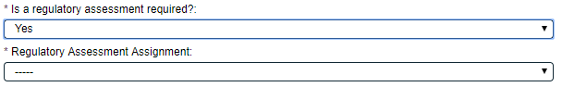
Is a regulatory assessment required? is a single-item selection with just Yes or No options.
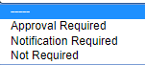
If Yes is selected, an additional mandatory single-item selection field will appear to identify the Regulatory Assessment Assignment. It is populated with names of the Users who are assigned the Process Role PR_CC_RA.

Client Notification or Approval Required? is a mandatory single-item selection field with three possible choices.
If either Approval Required or Notification Required is selected, an additional mandatory free-text field is displayed. It allows up to 1024 characters to provide the related details.

Lot Number(s) Impacted is an optional free-text field allowing up to 1024 characters. It will be pre-populated with any Lot Numbers entered at Step 1 and is editable as needed.

Number of days to be notified prior to proposed implementation/close-out date is a mandatory numeric field that defaults to “7” but is editable as needed.
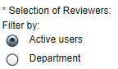
Selection of Reviewers is mandatory to select people in the organization who should provide additional review of the proposed Change Control. There are choices to filter by either Active Users or by Department to find and select the appropriate people.
A filter choice of Active users will display a multi-select Available field populated with the SOLABS QM10 Active Users list. Selection of one or more Usernames followed by the +ADD button will place those names in the Assigned field.
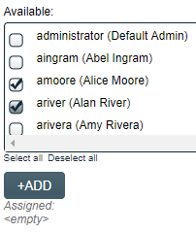
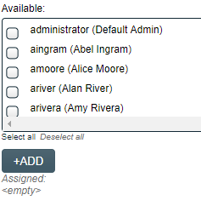

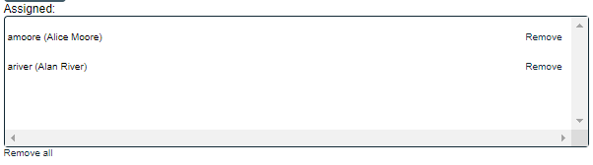

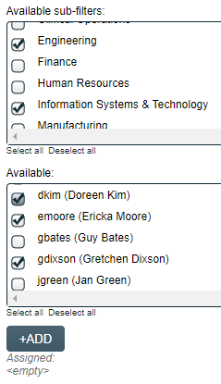
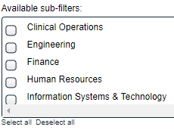
A filter choice of Department will display a multi-select Available sub-filters field populated with the list of SOLABS QM10 Departmental Security Roles. Selection of one or more departments will then display a multi-select Available field populated with the list of Users associated with those Departments. Selection of one or more Usernames followed by the +ADD button will place those names in the Assigned field.

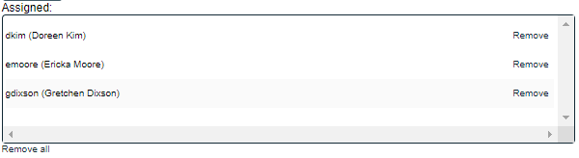

Reviewing Secondary Tasks and Related Processes
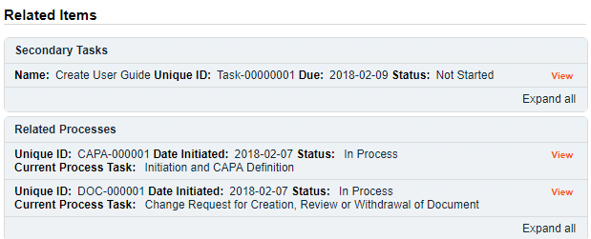
Before making the final QA Decision, the assigned User should also review the Related Items, by using the available Expand all and View options.

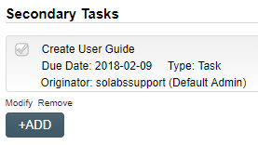
There are Modify or Remove options for the existing Secondary Tasks. Additional Secondary Tasks can be created using the +ADD option.
The User acting on Step 2 can also Link Documents or Link Processes using the right-hand Related Items menu. The options to initiate a new Related Process or initiate a new Document Control Process are also enabled at Step 2.

Submit and Confirm the Agreement of Change Decision
After reviewing all information from Step 1, completing all required fields in the Process Task Form, reviewing any Secondary Tasks and reviewing any Related Processes or Doc Control Process, the assigned User for Step 2 will make the QA Decision. The QA Decision section allows for three options.
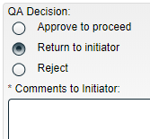
A QA Decision of Return to initiator brings up a mandatory free-text area Comment field allowing up to 4000 characters.
Submission of this QA Decision will return the Change Control Process back to Step 1.

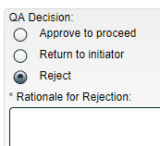
A QA Decision of Reject brings up a mandatory free-text area Rationale for Rejection field allowing up to 4000 characters.
Submission of this QA Decision will Close the Change Control Process.

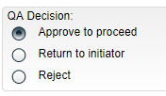
A QA Decision of Approve to proceed will progress the Change Control Process as follows:
- If the Initiation Type chosen at Step 1 was Internal, the process will progress to Step 3: Change Control Review.
- If the Initiation Type chosen at Step 1 was External with a choice for External Change Control with impact = Yes, the process will also progress to Step 3: Change Control Review.
- If the Initiation Type chosen at Step 1 was External with a choice for External Change control with impact = No, the Change Control Process will Close.

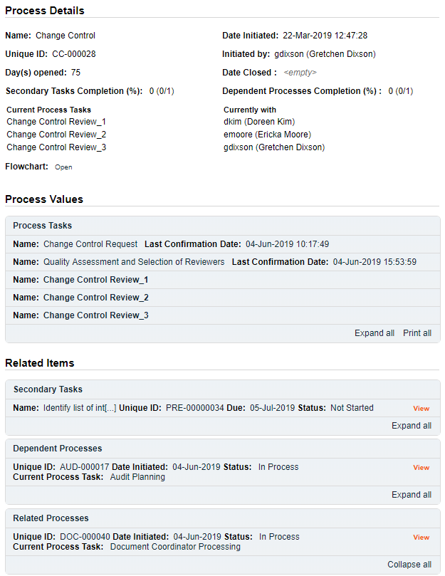
The Process Flowchart will highlight the next step of the process. The Process Details screen will display the Current Process Task and who it is Currently with. In this case three people were selected for the Change Control Review Step so all three are listed. The tasks are identified with “_1”, “_2” and “_3”.

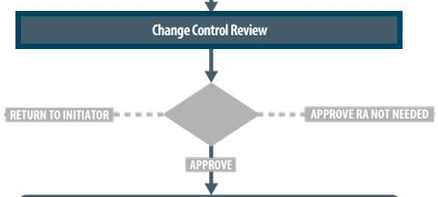

Step 3 - Change Control Review
At this step in the Change Control Process, the person(s) selected as Reviewers in Step 2 will receive an email Notification and will see the Step 3 – Change Control Review task listed in the Process section of their SOLABS QM10 HOME Page. Each person selected will need to Act on that task. In this example there were three people assigned the task, so the numbers _1, _2 and _3 will appear after the task name to differentiate those tasks.
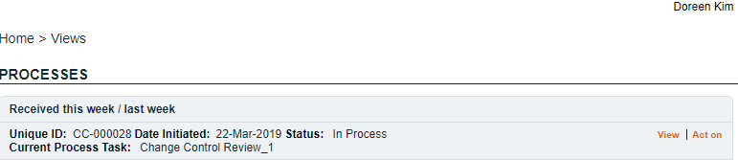

As the Change Control Process progresses from Step to Step, the information from each step is added to the Process Values table so that it is available for those acting on later steps to review. If the process goes back to a previous step at any point, and then progresses again, all that detail will be captured as well. If Secondary Tasks, Related Documents or Related Processes are added along the way, they will be added to the Related Items section.
As mentioned previously, with each Primary Task assignment, Users can use the View option from their HOME Page to see the Process Details screen, to Expand the Process Values table for additional details and to toggle back and forth between the Process and any Related Items.

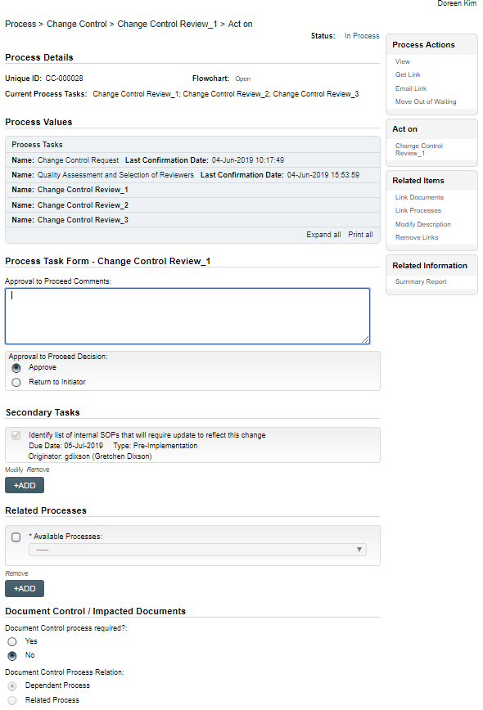
Acting on the Change Control Review Task
When a Change Control Review assignee clicks on the Act on option to the right of the Process Task, they will go immediately to the Act on screen for Step 3 – Change Control Review.
As described previously, the person can use the Expand all option under the Process Values table to see all information entered at Steps 1 and 2 of the process. They can also review all Related Items by clicking on View in the right-hand Process Actions menu.
The options to Link Documents, Link Processes, Review/Modify/Remove/Add Secondary Tasks and initiate additional Related Processes or Document Control Processes are enabled at Step 3 as well.
The Process Task Form fields will be displayed more clearly and described on the next page.
The Reviewers will use the Approval to Proceed Comments section to provide any information they would like to add regarding the Change Control being proposed.
They then have two choices for the Approval to Proceed Decision.
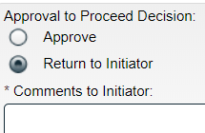
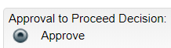
- A choice of Approve will progress the process to Step 4 – Regulatory Assessment (IF Regulatory Assessment was chosen at Step 2) or to Step 5 – QA Approval to Proceed. It will be assigned to the Users selected at Step 2.
- A choice of Return to initiator will require Comments to the Initiator. When that decision is made by at least one Reviewer, the Change Control process will go back to Step 1 – Change Control Request, after all Reviewer’s decisions are submitted, so that the Initiator can address the comments.
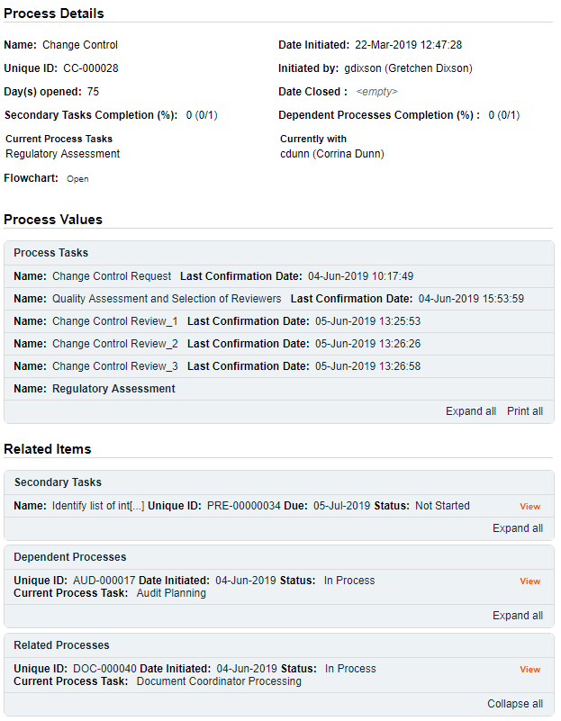
The Process Flowchart will highlight the next step of the process. The Process Details screen will display the Current Process Task and who it is Currently with. In this case, since the Regulatory Assessment was selected as Yes at Step 2, the Change Control Process progresses to Step 4 – Regulatory Assessment. If the selection for Regulatory Assessment had been No at Step 2, the Change control Process would skip Step 4 and go to Step 5 – QA Approval to Proceed. (See Page 26)

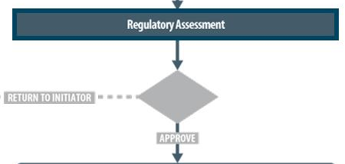

Step 4 – Regulatory Assessment
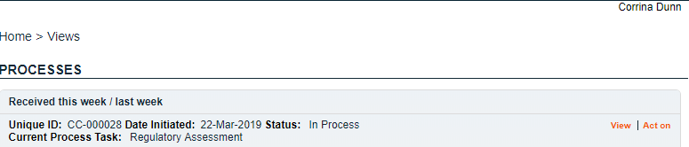
At this step in the Change Control Process, the person selected at Step 2 for Regulatory Assessment, will receive an email Notification and will see the Step 4 – Regulatory Assessment task listed in the Process section of their SOLABS QM10 HOME Page.

Again, as the Change Control Process progresses from Step to Step, each step is added to the Process Values table so that it is available for those acting on later steps to review. If Secondary Tasks, Related Documents or Related Processes are added along the way, they will be added to the Related Items section.
As mentioned previously, with each Primary Task assignment, Users can use the View option from their HOME Page to see the Process Details screen, to Expand the Process Values table for additional details and to toggle back and forth between the Process and any Related Items.

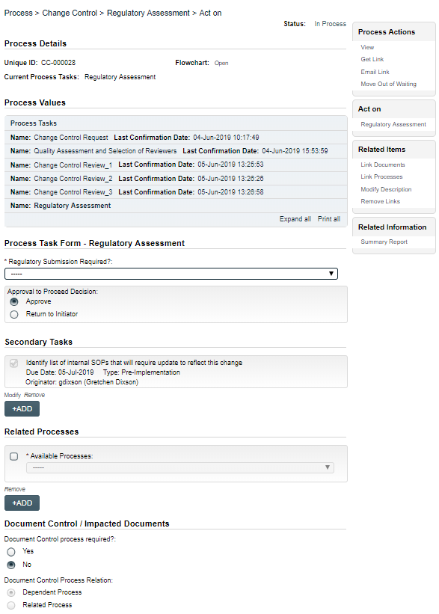
Acting on the Regulatory Assessment Task
When a Regulatory Assessment assignee clicks on the Act on option to the right of the Process Task, they will go immediately to the Act on screen for Step 4 – Regulatory Assessment.
As described previously, the person can use the Expand all option under the Process Values table to see all information entered at Steps 1 - 3 of the process. They can also use Process Actions/View to review all Related Items.
The options to Link Documents, Link Processes, Review/Modify/Remove/Add Secondary Tasks and initiate additional Related Processes or Document Control Processes are enabled at Step 4 as well.
The Process Task Form fields will be displayed more clearly and described starting below.
Regulatory Submission Required? is a single-item selection with two choices: Yes or No. Depending on the choice selected, additional mandatory fields will be displayed.
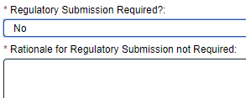

A selection of No will bring up a mandatory free-text area field for Rationale for Regulatory Submission not Required. It allows up to 4000 characters.
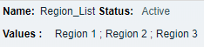
A selection of Yes will bring up a mandatory multi-item selection field for Regions. The values are populated from an editable Shared Custom List maintained by your SOLABS System Administrator, with terminology unique to your organization.
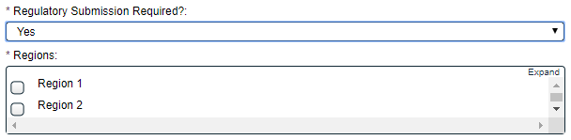
For every Region selected, a set of mandatory data entry fields will be displayed.

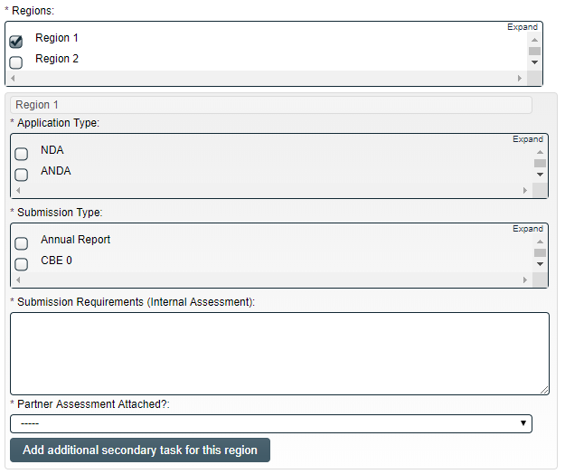
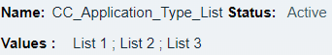
Application Type and Submission Type are multi-select fields populated by values from editable Custom Lists maintained by your SOLABS System Administrator, with terminology unique to your organization.
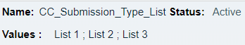
Submission Requirements (Internal Assessment) is a free-text area that allows up to 4000 characters.
Partner Assessment Attached? is a single-item selection field with values of either Yes or No. Assessments can be attached using the right-hand Link Documents menu option.

Secondary Tasks Created for Submissions and Related Approval Letters
For every Region selected, the Secondary Tasks section is automatically updated with a set of two Secondary Tasks for Submission and for Obtain Regulatory Approval Letter. The Add additional secondary tasks for this region button can be used for additional Region-specific Secondary Tasks, as needed. These Secondary Tasks are used by the Regulatory Assessment assignee to assign those related activities.
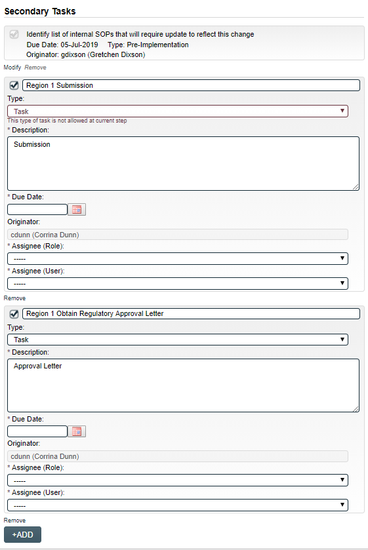
The first of the two added Secondary Tasks will be titled Region 1 Submission but can be edited. The task Type must be changed to an allowable task type (Pre Implementation, Post Implementation, Other).
The Description field will be pre-populated with Submission but is editable up to 4000 characters.
A Due Date can be selected for the Submission using the calendar.
The Originator field defaults to the person assigned the Regulatory Assessment Step and is not editable.
The mandatory Assignee (Role) and Assignee (User) fields are single-item selection fields populated with Active FCT Roles and Active Users. Either can be populated first, and then the other will be populated with only those values applicable to that selection.
The second of the two added Secondary Tasks will be titled Region 1 Obtain Regulatory Approval Letter but can be edited. The task Type must be changed to an allowable task type (Pre Implementation, Post Implementation, Other).
The Description field will be pre-populated with Approval Letter but is editable up to 4000 characters.
A Due Date can be selected for the Submission using the calendar.
The Originator field defaults to the person assigned the Regulatory Assessment Step and is not editable.
The mandatory Assignee (Role) and Assignee (User) fields are single-item selection fields populated with Active FCT Roles and Active Users. Either can be populated first, and then the other will be populated with only those values applicable to that selection.
If more than one Region was selected, there will be another set of Secondary Tasks to populate for the related Submission and Approval Letter.
As mentioned on the previous page, the Add additional secondary task for this region button is available in the Regions section for additional Secondary Tasks associated with a particular Region. An +ADD button is available at the end of the entire Secondary Tasks section for any general Secondary Tasks for the Regulatory area.
At this point the Regulatory Assessment assignee will review all the information that has been entered so far, add any additional Secondary Tasks, Related Documents, Related Processes or Document Control Processes, and then make their Approval to Proceed Decision.
There are just two choices for that decision:
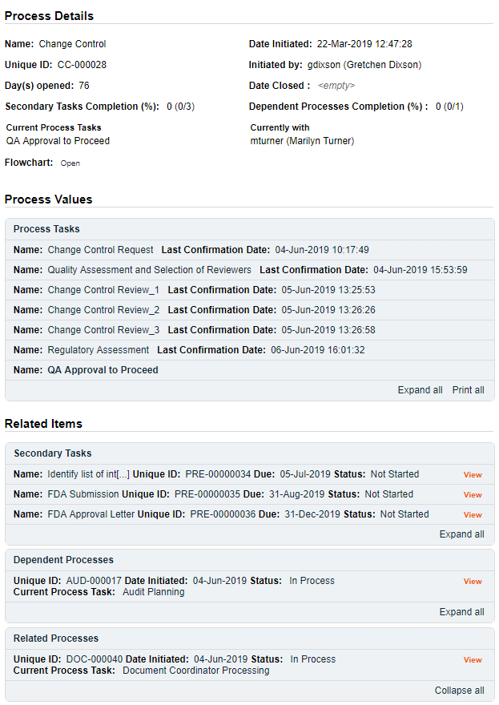
- A choice of Return to Initiator will require mandatory Comments to Initiator. After submission of this step, the process will then go back to Step 1 – Change Control Request so that the Change Control Initiator can address the comments.
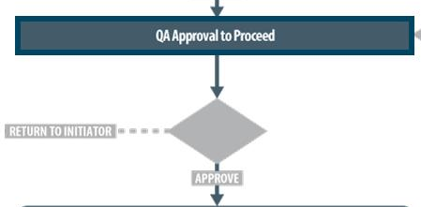
- A choice of Approve will progress the process to Step 5 – QA Approval to Proceed. It will be assigned to any Users who have the Process Role PR_CC_QA_Approver assigned. (Note: if PR_CC_QA_Approver is not assigned to any users, the Step will be assigned to anyone who has the SOLABS Documentation Administrator role assignment).
The Process Flowchart will highlight the next step of the process. The Process Details screen will display the Current Process Task and who it is Currently with.

Step 5 - QA Approval to Proceed
At this step in the Change Control Process, the person assigned as QA Approver in Step 1 will receive an email Notification and will see the Step 5 – QA Approval to Proceed task listed in the Process section of their SOLABS QM10 HOME Page. As mentioned previously, with each Primary Task assignment, Users can use the View option from their HOME Page to see the Process Details screen, to Expand the Process Values table for additional details and to toggle back and forth between the Process and any Related Items.
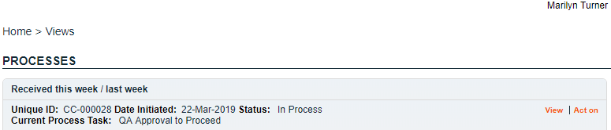

Acting on the QA Approval to Proceed Task
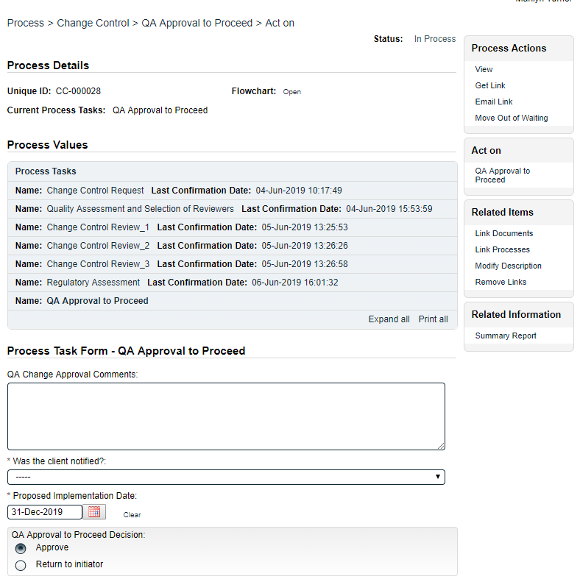
When the QA Approver clicks on the Act on option to the right of the Process Task, they will go immediately to the Act on screen for their Step 5 - QA Approval to Proceed task.
As described previously, the person can use the Expand all option under the Process Values table to see all information entered at Steps 1 - 4 of the process. They can also choose the View option in the Process Actions menu to review all Related Items.
The options to Link Documents, Link Processes, add Secondary Tasks and initiate additional Related Processes or Document Control Processes are enabled at Step 5 as well.
The Process Task Form fields are displayed more clearly and described starting on the next page.
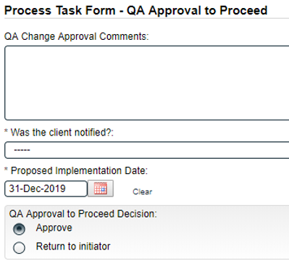
An optional 4000- character text area is available for QA Change Approval Comments.
Was the client notified? is a mandatory Yes or No single-item selection field that ONLY appears IF the field Client Notification or Approval Required at Step 2 was set at Notification Required.
Was approval from client obtained? is a mandatory Yes or No single-item selection field that ONLY appears IF the field Client Notification or Approval Required at Step 2 was set at Approval Required.
The Proposed Implementation Date defaults to what was selected at Step 1 but is editable.

At this step in the Change Control process, the QA Approver will review all the information that has been entered so far, add any additional Secondary Tasks, Related Documents, Related Processes or Document Control Processes, and then make their QA Approval to Proceed Decision. There are two choices for that decision:
- A choice of Return to initiator will require mandatory Comments to initiator. After this decision is submitted, the process will then go back to Step 1 – Change Control Request so that the Change Control Initiator can address the comments.
- A choice of Approve will progress the process to Step 6 – Pre Implementation Task Completion. When this Step is Submitted, all Secondary Tasks with Task Type = Pre-Implementation and/or Task Type = Open will be released for assignees to Act on. Any Post Implementation Secondary Tasks will not be released until after Step 9. Any Document Control Processes will progress out of the “Waiting for Parent Process” phase.

Assignees of Secondary Tasks will receive email Notifications and see those activities listed in the TASKS section of their SOLABS QM10 HOME Page.
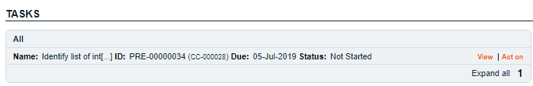

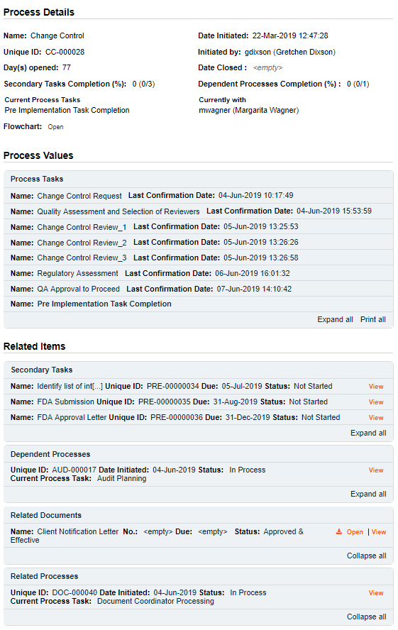
The Process Flowchart will highlight the next step of the process. The Process Details screen will display the Current Process Task and who it is Currently with – the Change Control Owner identified at Step 1.
The Change Control Process will stay at Step 6 until all Dependent Processes and Secondary Tasks with Task Types of Pre Implementation or Open are completed.
When the Change Control Owner chooses the Act on option for this step, the following message will be displayed: You are assigned this task because some Pre-Implementation Secondary Tasks are not completed. Please wait until all Pre-Implementation Secondary Tasks are completed to submit this step.
The Change Control owner can use an optional Next Follow-Up Date field if desired.
No new Secondary Tasks or Document Control Processes can be initiated at Step 6.
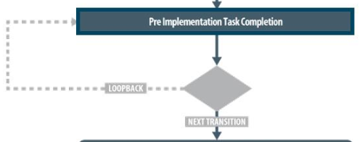

Step 6 – Pre Implementation Task Completion
Any Secondary Tasks are now released to Act on since the Change Control Process has been approved by QA. Step 1 of any Related Processes initiated from within the Change Control were assigned to the selected User at the time of assignment and can be progressed concurrently. Any that were set with Process Relation of Dependent, will need to be completed during this Waiting Phase.

Viewing a Secondary Task
When the Assignee for a Secondary Task chooses the View option from their HOME Page, they are brought to the Task > View screen for that Task. They can now review what has been assigned to them and can also toggle to the Change Control Process that triggered the Task, since it is listed at the bottom of the screen as a Related Item.

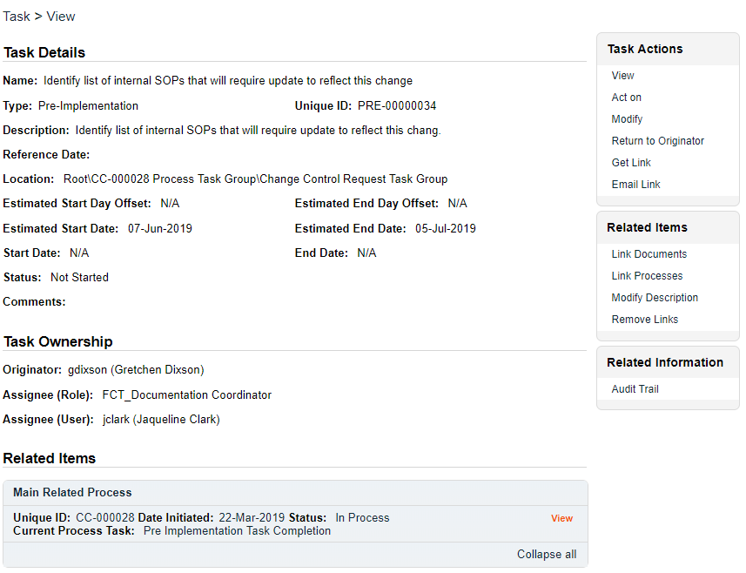

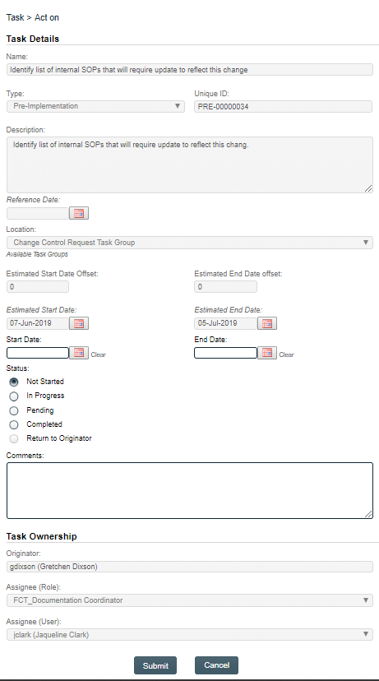
Acting on a Secondary Task

When the Assignee for a Secondary Task chooses the Act on option from their HOME Page, they are brought to the Task > Act on screen for that Task.
From this screen, the Assignee can also review the Task Details.
The fields they have available to them are to select a Start Date, enter an End Date when they are finished with the task and to change the Status as they progress it.
They can also enter free-text Comments at any point.
The task will default to a status of Not Started. If a status of In Progress is selected, the Start Date field will be populated with the current date. If a Start Date is entered, the Status will automatically move to In Progress. For longer term tasks, it is best practice to periodically log in and provide status updates in the Comments field.
If a status of Pending is selected, the Start Date field will be grayed out.
If a status of Completed is selected, the End Date field will be populated with the current date. If an End Date is entered, the Status will automatically move to Completed.
The Return to Originator option is grayed out since it is currently not available.
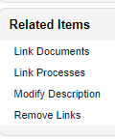
If the Assignee would like to add evidence / documentation to support completion of the task, the Link Documents option is available on the right-hand menu.

Acting on the Pre Implementation Task Completion Task
When all Secondary Tasks of Task Type Pre Implementation and Open are completed, and any Dependent Processes are at a status of Completed (or Cancelled), the Change Control Owner will be able to Act on Step 6 by simply entering the current Date into the Next Follow-Up Date field.
The Change Control Process will then move to Step 7 – Owner Implementation Approval. It will stay assigned to the Change Control owner but will be tracked as a separate step in the Change Control Process.
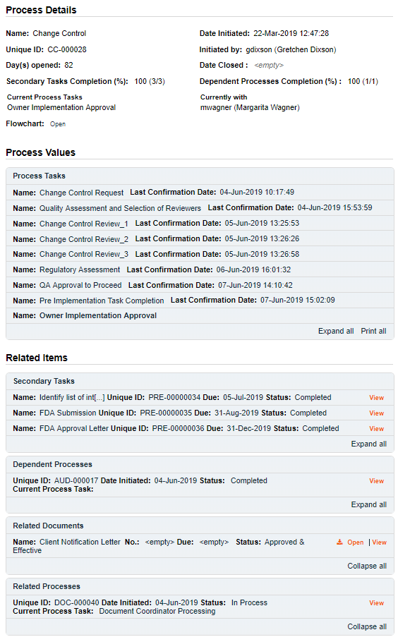
The Process Flowchart will highlight the next step of the process. The Process Details screen will display the Current Process Task and who it is Currently with.
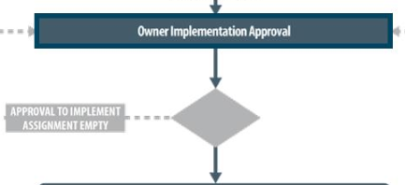

Step 7 – Owner Implementation Approval
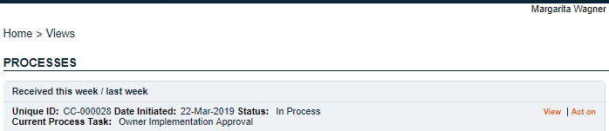
At this step in the Change Control Process, the Change Control Owner will receive an email Notification and will see the Step 7 – Owner Implementation Approval task listed in the Process section of their SOLABS QM10 HOME Page.

As mentioned previously, with each Primary Task assignment, Users can use the View option from their HOME Page to see the Process Details screen, to Expand the Process Values table for additional details and to toggle back and forth between the Process and any Related Items.

Acting on the Change Control Final Approval Task
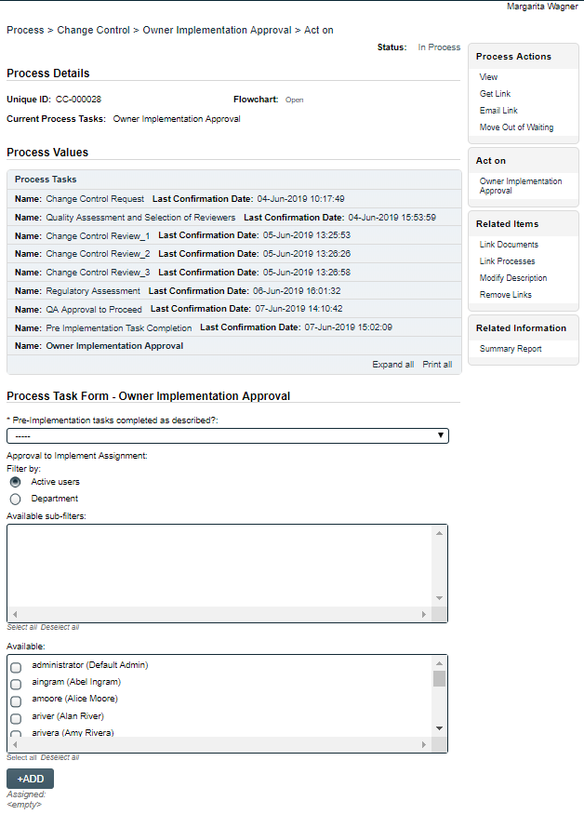
When an approver clicks on the Act on option to the right of the Process Task, they will go immediately to the Act on screen for their Step 7 – Owner Implementation Approval task.
They need to complete the Pre-Implementation tasks completed as described? and also have the option to choose other people for Approval to Implement Assignment to obtain concurrence that the Change Control is ready to implement. These fields are described on the next page.
At this point they have the option to initiate more Secondary Tasks (Post Implementation or Open) or Document Control Processes if needed. A new Related Process can still be initiated, and the Link Documents and Link Processes options on the Related Items menu are still possible.
The Process Task Form fields will be displayed more clearly and described starting below.
The Save Draft option can be used if the required fields cannot all be completed at the same time or if the Link Documents and Link Processes options on the Related Items menu are used.

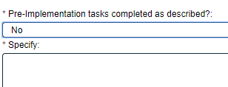
The Pre-Implementation tasks completed as described? field is a mandatory single-item selection field with choices of Yes, No or N/A. If No is selected another mandatory Text Area field will be displayed to Specify the status, allowing up to 4000 characters.
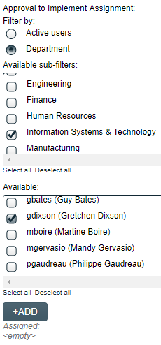
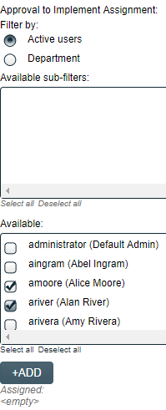
The optional Approval to Implement Assignment section allows the Change Control Owner to seek formal input from others regarding whether the Change Control is ready to implement. Users can be selected using the following Filter by options:
- The Active users filter displays all active users in the Available box. One or more users can be selected.
- The Department filter displays all active Departmental Security Roles in the Available sub-filters box. One or more Departments can be selected. The associated users will then be displayed in the Available box. One or more users from those Departments can then be selected. Selection of one or more Usernames followed by the +ADD button will place those names in the Assigned field.
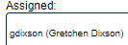
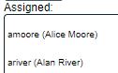

When Step 7 is Submitted and Confirmed, the Change Control Process will progress as follows:
- If one or more users were selected in the Approval to Implement Assignment field, the process will move to Step 8 – Implementation Approval.
- If no users were selected in the Approval to Implement Assignment field, the process will move to Step 9 – QA Implementation Final Approval. (See Page 37)

The Process Flowchart will highlight the next step of the process. The Process Details screen will display the Current Process Task and who it is Currently with – in this case any users who were selected at Step 7 in the Approval to Implement Assignment field. If more than one user was selected, the Process Tasks will be differentiated as Implementation Approval_1, Implementation Approval_2, etc. Each selected user will need to complete the Implementation Approval task.
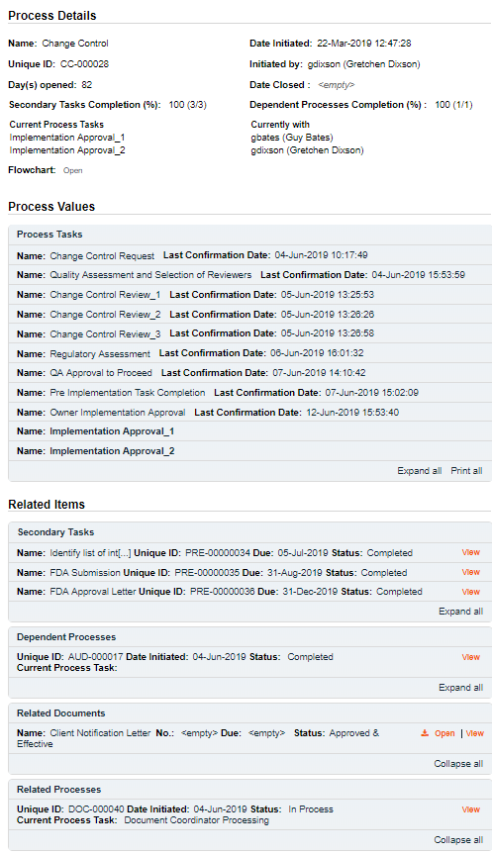

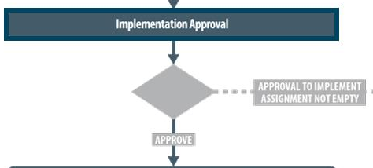

Step 8 – Implementation Approval
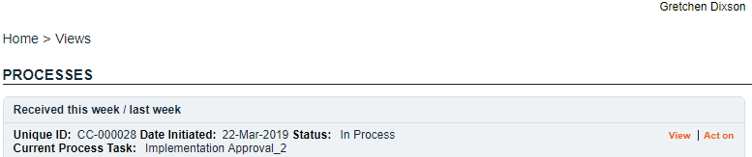
At this step in the Change Control Process, each person selected at Step 7 in the Approval to Implement Assignment field will receive an email Notification and will see the Step 8 – Implementation Approval step listed in the Process section of their SOLABS QM10 HOME Page. They must all act on the task.

As mentioned previously, with each Primary Task assignment, Users can use the View option from their HOME Page to see the Process Details screen, to Expand the Process Values table for additional details and to toggle back and forth between the Process and any Related Items.

Acting on the Implementation Approval Task
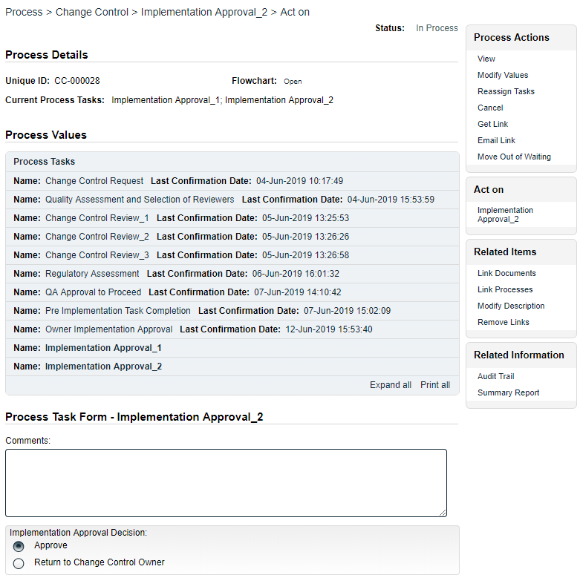
When a User clicks on the Act on option to the right of the Process Task, they will go immediately to the Act on screen for their Step 8 – Implementation Approval task.
At this step more Secondary Tasks (Post Implementation or Open), Document Control Processes or Related Process can still be initiated, and the Link Documents and Link Processes options on the Related Items menu are still available.
The only fields at this stage are an optional field for Comments and the Implementation Approval Decision or either Approve or Return to Change Control Owner.

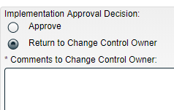
A decision of Return to Change Control Owner brings up a mandatory text area for Comments to Change Control Owner. Upon confirmation of that decision, the process moves back to Step 7 – Owner Implementation Approval.
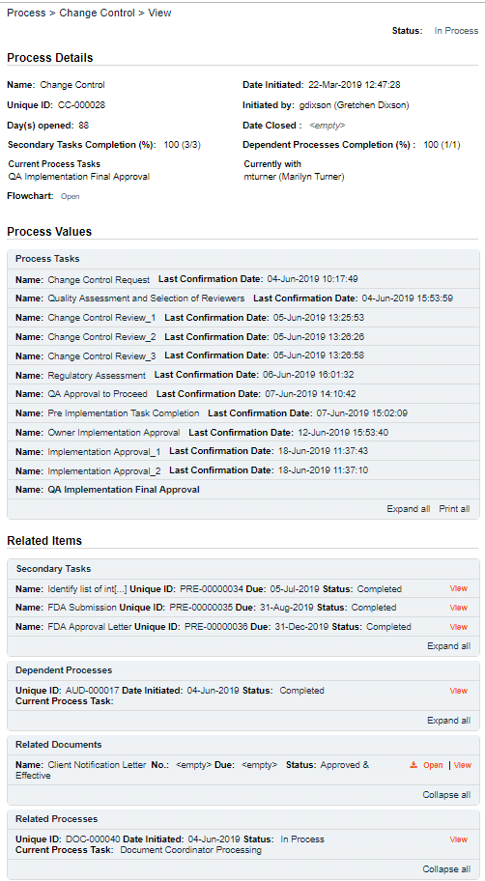
A decision of Approve by all assignees of Step 8 will progress the Change Control process to Step 9 - QA Implementation Final Approval.

The Process Flowchart will highlight the next step of the process. The Process Details screen will display the Current Process Task and who it is Currently with.

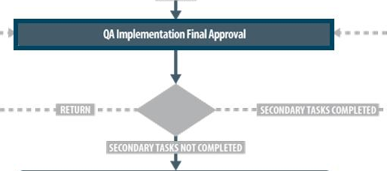

Step 9 – QA Implementation Final Approval
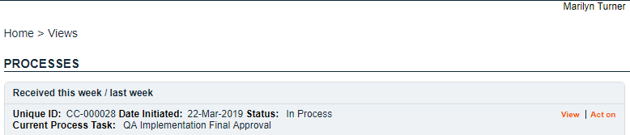
At this step in the Change Control Process, the person assigned as QA Approver at Step 1 will receive an email Notification and will see the Step 9 – QA Implementation Final Approval task listed in the Process section of their SOLABS QM10 HOME Page.

As mentioned previously, with each Primary Task assignment, Users can use the View option from their HOME Page to see the Process Details screen, to Expand the Process Values table for additional details and to toggle back and forth between the Process and any Related Items.

Acting on the QA Implementation Final Approval Task
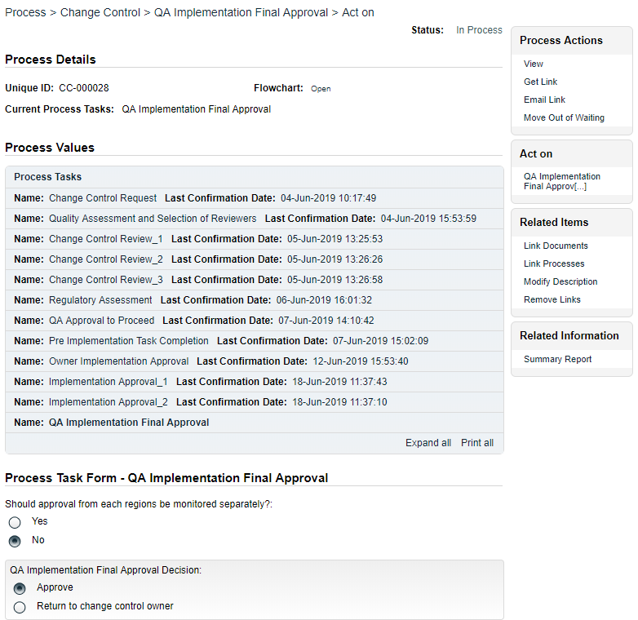
When the QA Approver clicks on the Act on option to the right of the Process Task, they will go immediately to the Act on screen for their Step 9 – QA Implementation Final Approval task.
If there were regulatory submissions associated with the Change Control, the QA Approver needs to select Yes or No for Should approval from each regions be monitored separately? This will allow the Change Control to progress for one region if an approval is received ahead of another. This choice is set to No, and is not editable, if the Step 4 decision was No for Regulatory Submission Required or if the Step 2 decision was No for Is a regulatory assessment required?
At this point the options to initiate more Secondary Tasks (Post Implementation or Open), Document Control Processes or Related Process are available.
The Link Documents and Link Processes options on the Related Items menu are still possible. The Save Draft option can be used if the required fields cannot all be completed at the same time or when the Link Documents or Link Processes options are utilized.
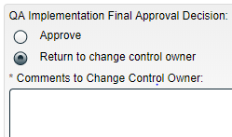
The QA Approver then needs to make the QA Implementation Final Approval Decision.
- A decision of Return to change control owner will require mandatory Comments and will return the process to Step 7 – Owner Implementation Approval upon confirmation.

- A decision of Approve will progress the Change Control process to Step 10 – Post Implementation Task Completion if any of the following situations apply:
  - Secondary Tasks of Task Type = Post Implementation were initiated at Steps 1 - 9
  - Secondary Tasks of Task Type = Open or Task Type = Pre Implementation were initiated at Steps 7 - 9
  - Dependent Processes were initiated at Steps 7 - 9
  - Any Dependent Processes, Secondary Tasks of Task Type = Open or Secondary Tasks of Task Type = Pre Implementation initiated in Steps 1-5 are not yet complete.
At this point all Post Implementation Secondary Tasks, other Secondary Tasks initiated at Steps 7-9 and Dependent Processes initiated at Steps 7-9 will be released to the Assignees.

- A decision of Approve will progress the Change Control process to Step 11 – Close-Out if all of the following conditions are met (see Page 41).
  - All Secondary Tasks have a status of Completed
  - All Dependent Processes have a status of Completed

Assignees of Secondary Tasks of Task Type = Post Implementation and of any Secondary Tasks initiated at Steps 7-9 will receive email Notifications and see those activities listed in the TASKS section of their SOLABS QM10 HOME Page. Any dependent processes initiated at Steps 7-9 will move out of the “Waiting for Parent Process” phase.
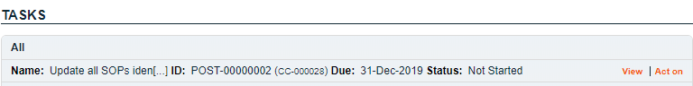

The Process Flowchart will highlight the next step of the process. The Process Details screen will display the Current Process Task and who it is Currently with – the Change Control Owner identified at Step 1.
The Change Control Process will stay at Step 10 until all Dependent Processes and Secondary Tasks are completed.
When the Change Control Owner chooses the Act on option for this step, the following message will be displayed: You are assigned this task because some Secondary Tasks and Dependent Processes are not completed. Please wait until all Secondary Tasks and Dependent Processes are completed to submit this step.
The Change Control owner can use the optional Next Follow-Up Date field if desired.
No new Secondary Tasks or Document Control Processes can be initiated at Step 10.

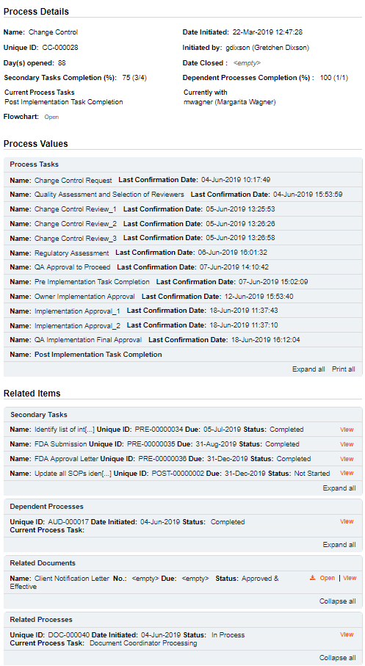

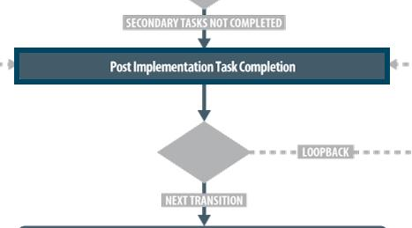

Step 10 – Post Implementation Task Completion
Any new or Post Implementation Secondary Tasks are now released to Act on. Step 10 is a Waiting Phase for the Change Control Owner to monitor the activities and follow up with assignees as needed.

Acting on the Post Implementation Task Completion Task
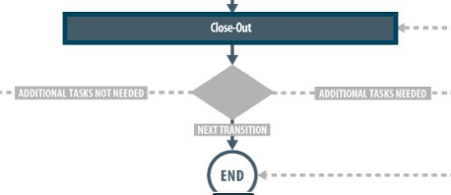
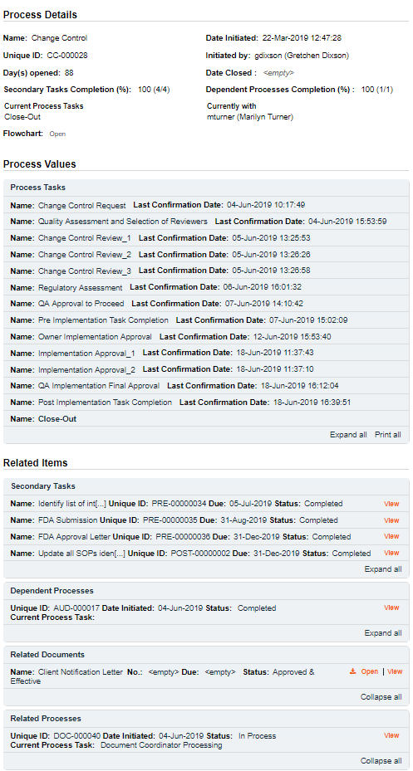
When all Secondary Tasks and Dependent Processes are at a status of Completed (or Cancelled) for at least one Region (or if no Regulatory Submissions Required), the Change Control Owner will be able to Act on Step 10 by simply entering the current Date into the Next Follow-Up Date field.
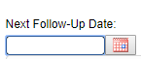

If at Step 9 Should approval from each regions be monitored separately = Yes, the Change Control Process will then move to Step 11 – Close-Out and will be assigned to the QA Approver.
If at Step 9 Should approval from each regions be monitored separately = No, the Change Control Process will move back to Step 10 until all Secondary Tasks and Dependent Processes are at a status of completed.
The Process Flowchart will highlight the next step of the process. The Process Details screen will display the Current Process Task and who it is Currently with.

Step 11 – Close-Out
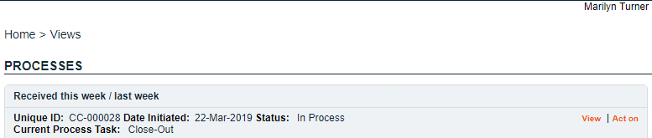
At this step in the Change Control Process, the person assigned as QA Approver at Step 1 will receive an email Notification and will see the Step 11 – Close-Out task listed in the Process section of their SOLABS QM10 HOME Page.

As mentioned previously, with each Primary Task assignment, Users can use the View option from their HOME Page to see the Process Details screen, to Expand the Process Values table for additional details and to toggle back and forth between the Process and any Related Items.

Acting on the Close-Out Task
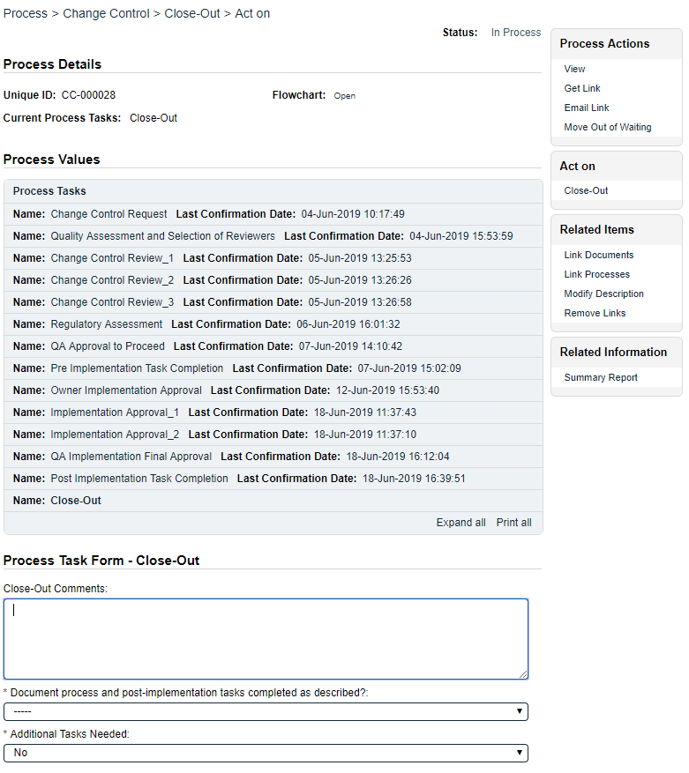
When the QA Approver clicks on the Act on option to the right of the Process Task, they will go immediately to the Act on screen for their Step 11 – Close-Out task.
There is an optional text area (4000 characters) field for any Close-Out- Comments.
The QA Approver will need to enter information regarding whether the Document process and post-implementation tasks completed as described? and whether there are Additional Tasks Needed. Information entered in these fields will impact where the process goes next.
Depending on choices made at previous steps, there are also additional fields displayed to enter information regarding regulatory Region Title and Region Status.
The Process Task Form fields will be displayed more clearly and described starting below.
At this point no more Secondary Tasks or Document Control Processes can be initiated.
The Link Documents and Link Processes options on the Related Items menu are still possible, as is the ability to initiate a new Related Process. The Save Draft option can be used if the required fields cannot all be completed at the same time or when the Link Documents or Link Processes options are utilized.

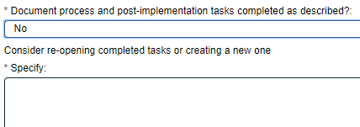
The mandatory Document process and post-implementation tasks completed as described? field is a single-item selection field with choices of Yes, No or N/A.
If No is selected, the phrase Consider re-opening completed tasks or creating a new one is displayed and a mandatory text area (4000 characters) field Specify is opened.

If the decision at Step 9 for Should approval from each regions be monitored separately? was Yes, Step 11 will also include non-editable fields named Region Title and Region Status for each applicable regulatory region. When all related Secondary Tasks are completed, the corresponding Region Status field will be auto-populated with the value “Completed”. For each regulatory region, a check box named Assessed is also displayed. It defaults to being unchecked but can be checked when applicable.
The mandatory Additional Tasks Needed field is a single-item selection field with either Yes or No as options. It defaults to No. A selection of Yes will result in the process going back to Step 9 – QA Implementation Final Approval, so the QA Approver can initiate the additional tasks.

Confirmation of Step 11 – Close-Out
When Step 11 is Submitted and Confirmed, the Change Control Process will progress as follows, depending on the options selected:
- If Additional Tasks Needed = Yes, the process moves to Step 9 – QA Implementation Final Approval so the additional tasks can be added.
- If Additional Tasks Needed = No, but any of the following situations exist, the process moves to Step 10 – Post Implementation Task Completion to wait for completion of those activities to be complete.
  - There is at least one Secondary Task not complete
  - There is at least one Dependent Process not complete
  - There is at least one regulatory region at a status of “Completed” but its Assessed box is unchecked
- The Change Control Process moves to Close (END) if all the following conditions are met:
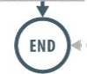
  - All Secondary Tasks are complete
  - All Dependent Processes are complete
  - Additional Tasks Needed = No
and one of the following conditions are met:
- The Assessed box is checked for each regulatory region
- At Step 5, Should approval from each regions be monitored separately? = No

Viewing Details for a Completed Change Control Process
Users are able to search for and view processes at any stage, using the Navigation tab in the PROCESS Section of SOLABS QM10. If the Process was recently worked on, it will also be available in the Recent Items section.
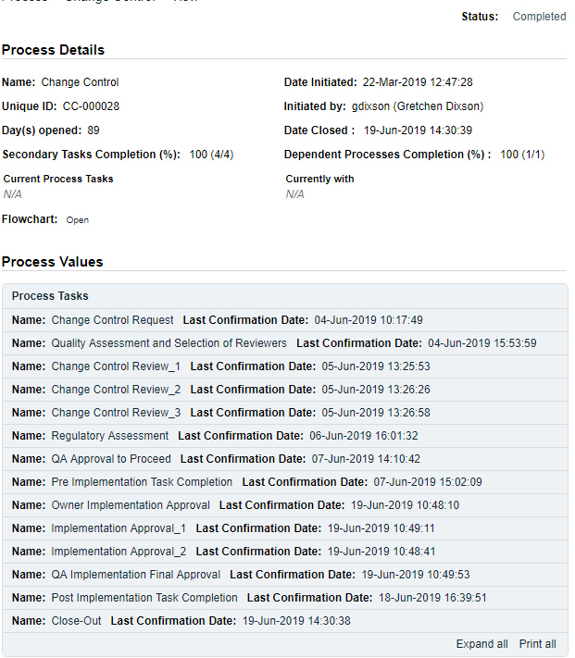
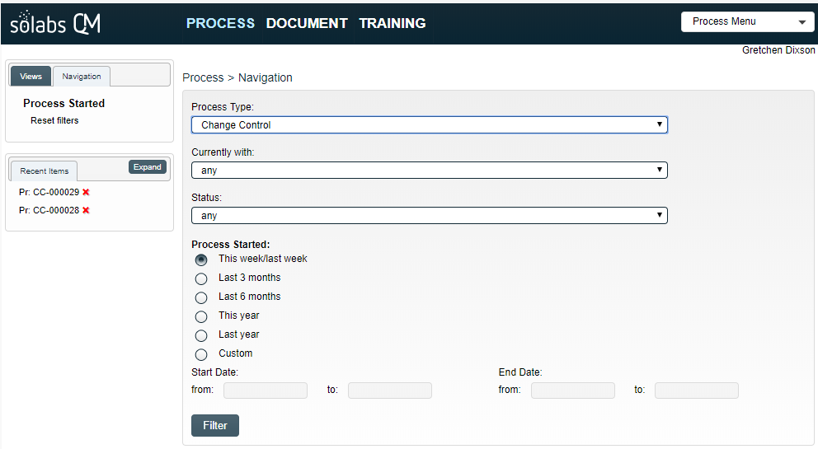

Using the Process Values Table
Process Tasks can be viewed by using the Expand all or Print all options at the bottom of the Process Values table. An individual Process Task can be expanded by clicking on it within the Process Values table.

Using the Related Items Table
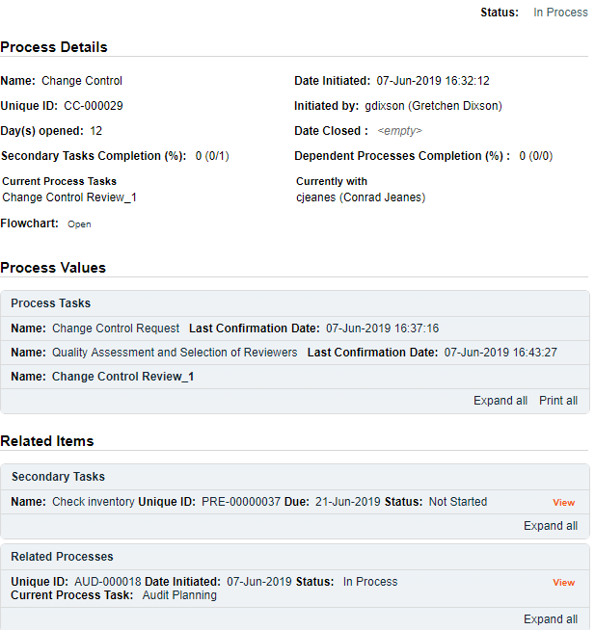
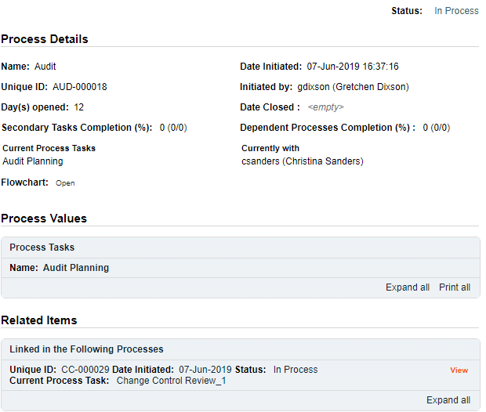
Information on any Secondary Tasks, Related Processes or Related Documents can be accessed by clicking on the View option beside the listing in the Related Items section of the screen. From any of those Details screens, the Process will be listed under Related Items – you can quickly toggle back to the Main Process by clicking View next to it.

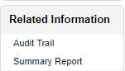
Creating a Summary Report
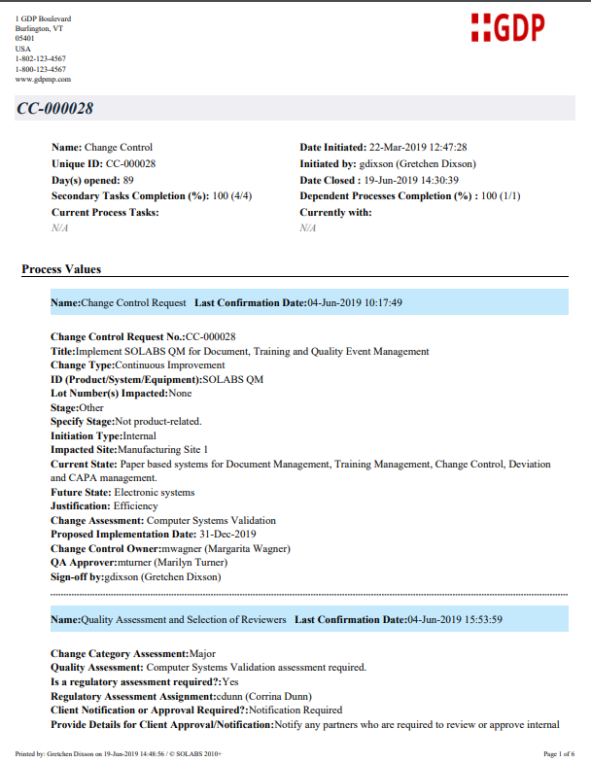
Under the right-hand Related Information menu, click on the Summary Report option.
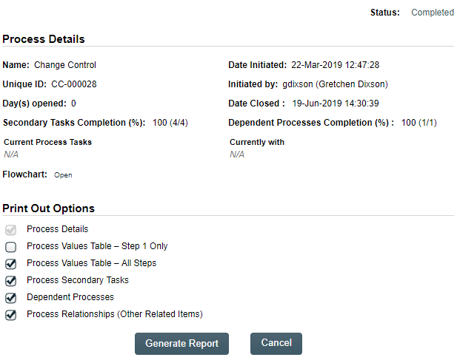
Select the desired Print Out Options and then click on Generate Report. A multi-page PDF Report will be generated, with any company header information set in System Configurations, and will include details on each step requested for the report.

Using the Audit Trail
Users with the SOLABS System Administrator role assignment, will also see the Audit Trail option on the right-hand Related Information menu.

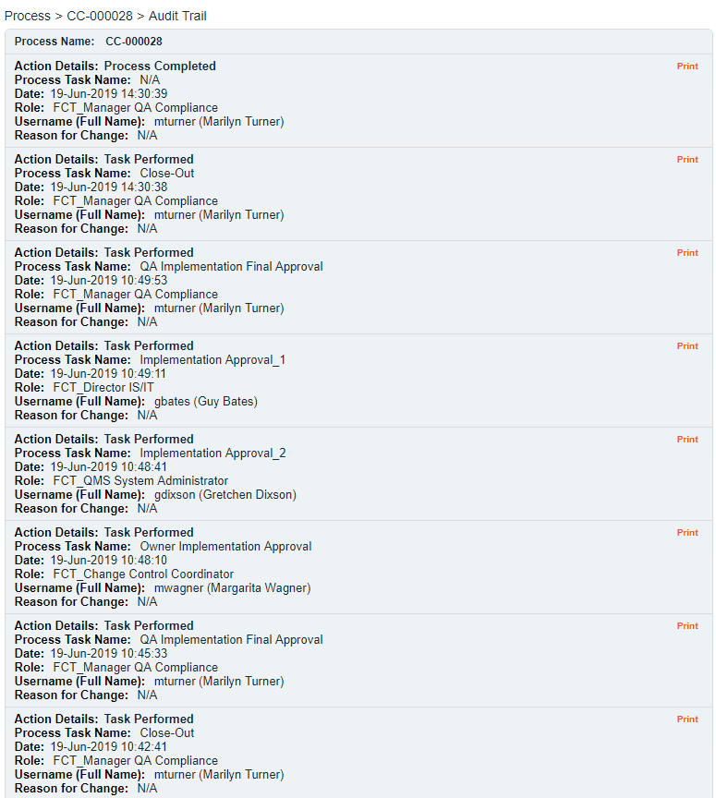
There you will find all the details for every step of the Change Control Process, from Process Completed all the way down to Process Started, with options to expand or print the entire process or any individual steps.

Change Control Process Notifications
The Notifications available with the Off-the-Shelf Change Control Process APP P0036 are identified in the Process Roles section of this User Guide and at the related Process Steps. The content of these email Notifications is described below.
General information on SOLABS QM10 Notifications are available on the SOLABS Knowledge Base in a document titled SOLABS QM10: Notifications Guide.
- When Step 1 is confirmed, the following email notification is sent.
TO: Change Control Owner selected at Step 1
SUBJECT: Assignment of Change Control owner: Change Control Process CC-XXXXXX
BODY: You received this notification because you have been assigned as the Change Control Owner for the following process:
Process ID: [CC-XXXXXX]
Title: [Step 1 Title]
Implementation Date: [Step 1 Proposed Implementation Date]
- When one of the following conditions is met, the following email notification is sent.
  - Today >= Step 5 Proposed Implementation Date – X (where X = Step 2 Number of days to be notified prior to proposed implementation/close-out date) and some Pre-Implementation Secondary Tasks are not completed.
  - Today = Step 6 Next Follow-Up Date and some Pre-Implementation Secondary Tasks are not completed.
TO: Change Control Owner selected at Step 1
SUBJECT: SOLABS QM CC Process: some Pre-Implementation secondary tasks are not completed and the proposed implementation date is approaching (or is already reached)
BODY: Please note that some Pre-Implementation secondary tasks are not completed and the proposed implementation date is approaching (or is already reached)
CC#: [process number hyperlinked to process]
Type of Change: [Step 1 Change Type]
Title: [Step 1 Title]
Proposed Implementation Date: [Step 5 Proposed Implementation Date]
Next Follow-Up Date: [Step 6 Next Follow-Up Date]
- When all Pre-Implementation Secondary Tasks are completed, the following email notification is sent.
TO: Change Control Owner selected at Step 1
SUBJECT: SOLABS QM CC Process: all Pre-Implementation Secondary tasks are completed
BODY: Please note that all Pre-Implementation secondary tasks are completed
CC#: [process number hyperlinked to process]
Type of Change: [Step 1 Change Type]
Title: [Step 1 Title]

- When Today = Step 10 Next Follow-Up Date and some Secondary Tasks or Dependent Document Control Processes are not completed, the following email notification is sent.
TO: Change Control Owner selected at Step 1
SUBJECT: SOLABS QM CC Process: some secondary tasks or Dependent Document Control Processes are not completed
BODY: Please note that some Secondary tasks OR Document Control Processes are not completed and the proposed implement date is approaching (or is already reached).
CC#: [process number hyperlinked to process]
Type of Change: [Step 1 Change Type]
Title: [Step 1 Title]
Next Follow-Up Date: [Step 10 Next Follow-Up Date]
- When all the following conditions are met, the following email notification is sent.
  - All Open Secondary Tasks are completed
  - All Post-Implementation Secondary Tasks are completed
  - All Dependent Document Control Processes are completed
TO: Change Control Owner selected at Step 1
SUBJECT: SOLABS QM CC Process: all Post-Implementation and Open secondary tasks and all Dependent Document Control Process are completed
BODY: Please note that all Post-Implementation and Open secondary tasks and all Dependent Document Control Process are completed
CC#: [process number hyperlinked to process]
Type of Change: [Step 1 Change Type]
Title: [Step 1 Title]

- When all the secondary tasks related to one region are completed and if Yes is selected at Step 9 for Should approval from each regions be monitored separately?, the following email notification is sent.
TO: Change Control Owner selected at Step 1
SUBJECT: SOLABS QM CC Process: all the secondary tasks for [Region] are completed.
BODY: Please note that all the tasks required for [Region] are completed.
CC#: [process number hyperlinked to process]
Type of Change: [Step 1 Change Type]
Title: [Step 1 Title]

