SOLABS QM10 Document Control Process: General Overview and Guide to Process Flow
Document Control Process Flowchart: 2
Advantages to using the Document Control Process 2
Process Roles Associated with the Document Control Process 3
Step 1: Change Request for Creation, Revision or Retire of Document 3
Step 2: Owner-Manager Approval 5
Step 3: Document Coordinator Processing 6
Waiting Document Approval 7
Step 4: Training Assignment Confirmation 7
Waiting Document Approval or Training Completion 8
Step 5: Document Processing Completion 8

This document provides an overview of the SOLABS QM10 Document Control Process (P0007) – by guiding you through each step in the process and providing high level information on the activities, settings and options associated with each step. Other documents on the SOLABS Knowledge Base provide detailed screen views and transactional instructions for each step in the process.

Document Control Process Flowchart:
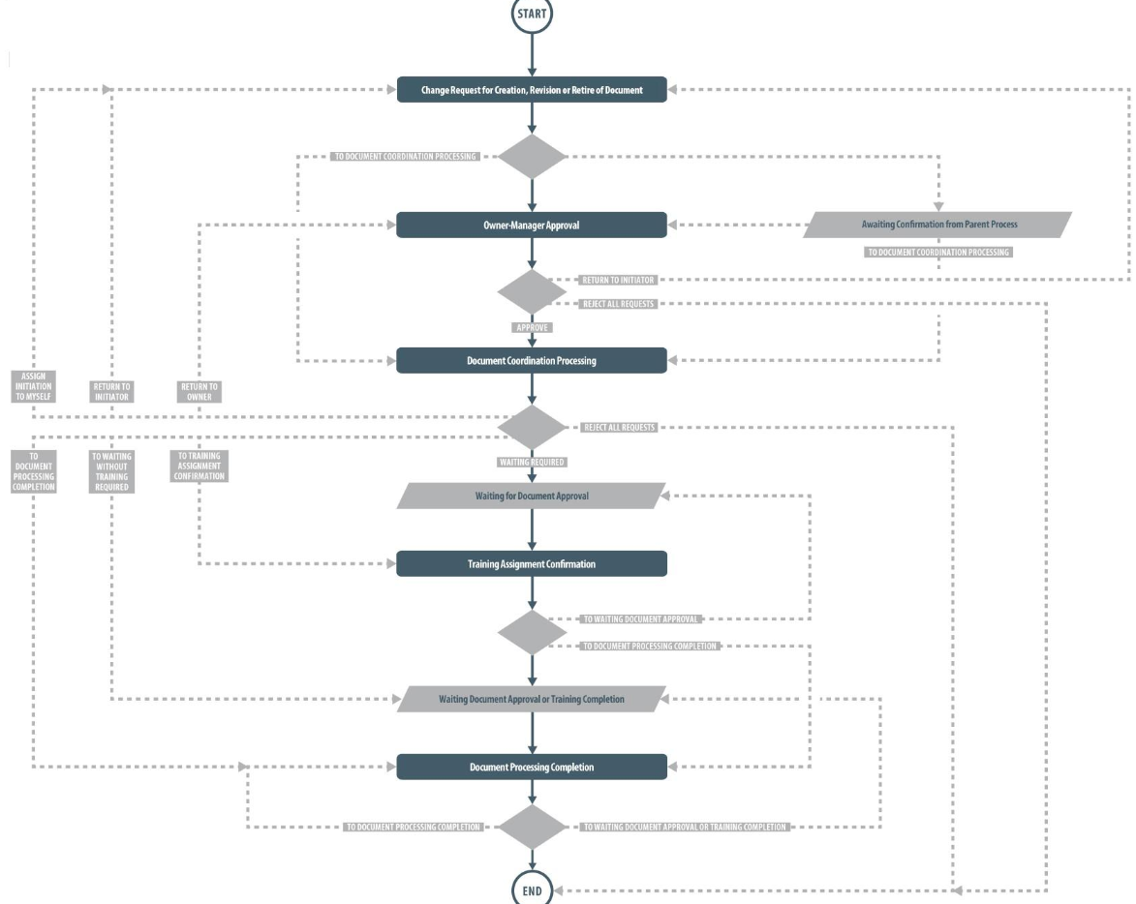
As seen above, decisions made by those involved in the process act to progress the process or return it to a prior step.

Advantages to using the Document Control Process
The DOCUMENT Section of SOLABS QM10 allows users to create documents, modify existing documents, route them for review/approval, link them to training if desired and make them effective.
Using the SOLABS QM10 Document Control Process to manage the document creation/revision process is optional, but provides the following benefits and opportunities:
- Ability to centralize document processing among a few trained individuals while allowing anyone to request new documents, revisions to existing documents or retirement of documents
- Ability to obtain pre-authorization of the change(s) from the Document Owner-Manager before the document updates are processed
- Ability to coordinate the update of multiple documents at the same time
- Ability to trigger the Training Administrator to create Training Activities for new documents set to typically require them and to coordinate training completion with documents going to Effective status
- Ability to link other related SOLABS QM 10 Processes – CAPA, Change Control, etc. – as Related Items
- Ability to link other documents as Related Items
- Can be used by the Document Administrators to initiate Periodic Reviews as they come due

Process Roles Associated with the Document Control Process
The following Process Roles need to be assigned to the appropriate users in SOLABS QM10 in order to manage the process workflow as designed.
PR_DOC_Business_Owner: For Document Types that are configured to typically require Owner-Manager Approval, this Process Role must be assigned to those Owner-Managers. Their names are then available to be selected by the Initiator at Step 1 and the process will notify them to perform that task at Step 2 of the Document Control Process. If this role is inadvertently not assigned to anyone, or if the only assignee happens to also be the Initiator, the Owner-Manager field will default to a list of all active users who are identified as either a Manager or a Department Head in any user accounts.
PR_DOC_DOC_COORD: This Process Role must be assigned to the users who will act as Documentation Coordinator in this process. It is a different role than the System Role SOLABS Document Administrator but can be assigned to the same person. These users will receive email Notifications to act on Steps 3 and 5 of the Document Control Process to actually process the documents. There are will have links within the process steps to access the related documents from the Document Section. If this role is inadvertently not assigned to anyone, the Notification will go to anyone with the SOLABS Document Administrator role.
PR_DOC_TRAIN_COORD: For Document Types that are configured to typically require Training, this Process Role must be assigned to the users who will act as Training Coordinator in this process. It is a different role than the System Role SOLABS Training Administrator but can be assigned to the same person. These users will receive an email Notification to act on Step 4 of the Document Control Process in order to coordinate creation/update of related Training Activities. If this role is inadvertently not assigned to anyone, the Notification will go to anyone with the SOLABS Training Administrator role.

Step 1: Change Request for Creation, Revision or Retire of Document
Refer also to the guide on the Knowledge Base titled SOLABS QM10: Initiating a Document Control Request.
At Step 1 the user requesting creation, revision or retirement of one or more documents enters all the related information into the Process Task Form. They can upload new document(s) and link existing document(s) for revision, which will automatically put the requested document(s) to an Authoring status.
Some of the fields on the Process Task Form are single-item selection fields, others are editable text fields and others are radio buttons - those with an asterisk (*) are mandatory. Some of the information entered at Step 1 will determine how the process flows through the remaining steps.
- Concerned Company Structure – drop-down list of any Organizational Security (SEC) Roles created for your workplace during Setup, along with an option for “All”
If there are different Documentation Coordinators and/or Training Coordinators for different parts of the organization, the selection here is important to ensure that the process goes to the correct person at the steps requiring Documentation Coordinator input (Steps 3 and 5) or Training Coordinator input (Step 4). If this is the case, be sure that those Organizational Security (SEC) Roles are assigned to those users.
- Type of Change – these options are related to whether the document is NEW from outside SOLABS QM10, NEW (from Document already created in SOLABS QM10), an existing document requiring REVISION or an existing document to RETIRE
- Document Type – drop-down list of all Document Types created for your workplace during Setup
- Document Name – this field will be displayed for Type of Change = NEW and allows up to 256 characters
OR
- Document Name or Control Number – this field will be displayed for Type of Change = NEW (from Document already created in SOLABS QM10), REVISION or RETIRE
When the initiator starts to type the Document Name or Control Number in this field, matching documents will be displayed and the appropriate one can be selected.
- Cosmetic Change – this is a Radio Button selection of Yes or No
When Yes is selected for revisions to existing documents that require training, training will not be triggered even if the related Training Activity is set for Recurrence based on document revision.
- Suggested Document Workflow – drop-down list of all Document Workflows created for your workplace during Setup
This field is not mandatory. The initiator can leave it blank, preview and select one of the available Document Workflows or select Other and then provide names of users they would like to be involved in the Review/Approval Cycles in the mandatory Workflow Comments field that will then be displayed.
When left blank the workflow will default to the Default Document Workflow set for that Document Type in the case of new documents OR, for existing documents, the workflow used during the prior version. The Documentation Coordinator will be able to revise and adjust this as necessary at Step 3.
- Draft Location – options are available to Upload Document, provide an External Link to a document or to select N/A if it will be provided to the Documentation Coordinator separately or has already been linked through the above Document Name or Control Number selection.
- Description of Change – a 4000-character free-text field to describe the request and that also allows the option for Quick Text if set up by the System Administrator (a Custom List of set terminology)
- Purpose of Change – a 4000-character free-text field to describe the purpose of the request and that also allows the option for Quick Text if set up by the System Administrator (a Custom List of set terminology)
-  - a button that will bring up another set of the above fields, in order to include multiple document change requests in one Document Control Process. The Description of Change and Purpose of Change fields will be pre-populated with the same information as entered for the initial document request but can be edited as necessary.
- Priority and Target Completion Date. This information is key to helping you communicate when you need the changes to the others who will be involved in progressing this process.
- Owner-Manager Assignment – drop-down list of all users assigned the Process Role PR_DOC_Business_Owner
A selection is mandatory for Document Types configured to require Owner-Manager Approval. For Document Types that do not require Owner-Manager Approval, this field will be grayed out.
- Related Processes – a section that allows the initiator to link one or more quality process from the list of Available Processes deployed in the company’s instance of SOLABS QM10
The linked process can be set as a Dependent Process or a Related Process.
- Click Submit, verify your entries, enter your Password (for digital e-Signature) and then click Confirm.
This will automatically move the process to Step 2 – Owner-Manager Approval or to Step 3 – Document Coordinator Processing, depending on the Document Type and whether or not Owner-Manager Approval is required.

Step 2: Owner-Manager Approval
In Step 2 (when applicable) the Owner-Manager reviews the information submitted by the initiator and then provides their feedback. The Owner-Manager will receive a Notification and will also see the task in the PROCESSES section of their HOME Page. When they click the option to “Act on” the task (from the HOME Page listing or using the right-hand menu after clicking “View” from the HOME Page), they can do the following:
- Expand the Process Values table to review all the information entered by the initiator
- Provide any Owner-Manager Comments they may have
- View or Open the attached document(s) if necessary
- Link Documents or Link Processes as Related Items using the right-hand menus
- Choose Reassign Tasks if they feel they are not the appropriate person to approve the request(s)
- Provide their Owner-Managed Decision and then Submit and Confirm to progress the process as follows:
  - Approve – this sends the Process to Step 3 – Document Coordinator Processing
  - Return to Initiator with Comments – this will require mandatory Comments to Initiator and will send it back to the Initiator for additional actions
  - Reject Request for All Documents with Reason – this will allow selection of the document(s) the Owner-Manager wants to Reject, will require a mandatory Reason for Rejection for the selected document(s), will remove the selected document(s) from the process if there are still others to progress or will end the process if all document requests are to be rejected.
- Related Processes – a section that allows the Owner-Manager to link one or more quality process from the list of Available Processes deployed in the company’s instance of SOLABS QM10
The linked process can be set as a Dependent Process or a Related Process.

Step 3: Document Coordinator Processing
In Step 3 the Document Coordinator reviews the information submitted by the Initiator and the feedback provided by the Owner-Manager (if Step 2 was required), gets the document(s) ready for review/approval, initiates the Review Cycle and/or Approval Cycle for the document(s) and then Acts on the Document Control Process step to provide their Document Coordinator Comments and Document Coordinator Decision.
The Document Coordinator will receive a Notification and will also see the task in the PROCESSES section of their HOME Page. When they click the option to “Act on” the task (from the HOME Page listing or using the right-hand menu after clicking “View” from the HOME Page), they can do the following:
- Expand the Process Values table to review all the information entered by the Initiator and the Owner-Manager
- Provide any Document Coordinator Comments they may have
- Link Documents or Link Processes as Related Items using the right-hand menus
- Choose Reassign Tasks if they feel they are not the appropriate Document Coordinator for processing of the requested documents
- View metadata and Open the Authoring versions of the attached document(s) to get them ready to route for Review and Approval
NOTE: For more specific details on processing of documents in the Document Section, refer to the following articles on the Knowledge Base: SOLABS QM10 Guide for Document Administrators, SOLABS QM10 Creating a Document, SOLABS QM10 Revising a Document, SOLABS QM10 Document Review Cycle, SOLABS QM10 Retire a Document
  - From within the Document View screen, the Document Coordinator can also check the Document Workflow and make any changes that may be needed.
  - If everything is set as needed, the Document Coordinator can Start Review Cycle or Start Approval Cycle at this point.
  - Under Related Items at the bottom of the Document View screen the Document Control Process will be listed with options to View or Act on. This will bring the Document Coordinator back to the Process Details screen.
- Provide their final Document Coordinator Decision and then Submit/Confirm to progress the process as follows:
- Confirmed, documents now in process – this sends the Process to a waiting phase: Waiting Document Approval
- Return to initiator with comments for modification – this will require Comments and will send the Process back to the Initiator for additional actions
- Assign to myself at initiation step for modification – this will hold the Process with the Documentation Coordinator for any modifications they may need to make before being ready to Act on it.
  - Return to Owner-Manager for modification – this will require a Comments to Owner-Manager and will send the Process back to the Owner-Manager for additional actions
  - Reject request for ALL documents with rationale - this will allow selection of the document(s) the Document Coordinator wants to Reject, will require a mandatory Rationale for the selected document(s), will remove the selected document(s) from the process if there are still others to progress or will end the process if all document requests are to be rejected.

Waiting Document Approval
At this point the Document Control Process is in a waiting phase waiting for the actual document Review Cycles, Approval Cycles or Retire Cycles to be completed.

Step 4: Training Assignment Confirmation
Upon approval of documents of Document Types that are configured to require Training, the Training Coordinator will receive an email Notification, and will also see the Training Assignment Confirmation task in the PROCESSES section of their HOME Page. This allows them to start their work to Create Curriculum, Create Training Activities and Assign Training Activities for any new documents that will require coordinated training or to close any curricula and training activities associated with retired documents. When they click the option to “Act on” the task, they can do the following:
- Expand the Process Values table to review all the information entered for the Document Control Process so far.
- See which documents training is required for (if there are multiple documents associated with the request). If training is required for a document, they can see the Training Status as either Created or To Be Created. They can then create and assign the Training Activities if needed.
- Training Required defaults to Yes for Document Types configured to require training. The Training Coordinator can change this to No, but must provide a Rationale.
- Choose a value for Follow-up on Training Completion (%). The values on this drop-down list are from a Custom List that can be edited by a System Administrator. If it is not necessary to tie a percentage of training completion to the documents becoming effective, a value of “0” can easily be added to the list and will then be available for selection. Use of “0” percent is simply a way of stating that no dependency on a percentage of training completion is necessary, or that it will be managed separately.
When the Training Coordinator Submits and Confirms Step 4, the Document Control Process will progress as follows:
- If a value was entered for Follow-up on Training Completion (%), the Document Control Process will enter a Waiting Period for that value to be achieved.
- If Training Required = No, or if Follow-up on Training Completion (%) = 0, the Document Control Process will progress to Step 5 - Document Processing Completion.

Waiting Document Approval or Training Completion
At this point the Document Control Process is in a Waiting phase, if needed, to allow for document Approvals that may still be pending for documents that did not require training and for the required Training Activities to be completed for documents that do require training. When that point is reached, the Process will automatically proceed to Step 5 – Document Processing Completion.

Step 5: Document Processing Completion
The Document Coordinator will receive an email Notification and will also see the task in the PROCESSES section of their HOME Page. When they click the option to “Act on” the task (from the HOME Page listing or using the right-hand menu after clicking “View” from the HOME Page), they can do the following:
- Expand the Process Values table to review all the information entered for the Process so far
- Provide any Document Processing Completion Comments they may have
- The Document Coordinator will populate the Effective Date field with either the Target Completion Date, today’s date or another future date. When they Submit and Confirm Step 5, the Document Control Process will move to a status of Completed and the linked document(s) will become Approved and Effective automatically on the chosen dates. Until those dates are reached, the document(s) will be at a status of Approved, Not Effective.
- The Document Coordinator can also choose Manage Document Status Manually if they would like to put the Document Control Process to a status of Completed or allow some documents in the process to become Effective ahead of others. This may be an option if all activities have been completed ahead of the original Target Completion Date.
  - When they Submit and then Confirm using this option, the Document Control Process will be in a status of Completed and the document(s) will no longer have a link to the process for an Effective Date.
- The Document Coordinator can also choose to leave the Document Control Process at a status of In Process until they are closer to the Target Completion Date. Step 5 will remain assigned to them until they Act on the final Step in one of the above ways.

