SOLABS QM10: Audit Process P0044 User Guide
Introduction 2
Audit Process Flowcharts 3
Audit Process – Process Steps 4
Starting the Audit Process 4
Step 1: Audit Planning 5
Completing the Process Task Form: 6
Creating Secondary Tasks 7
Initiating a Related Process 9
Submit and Confirm 10
Step 2: Audit Preparation 10
Viewing the Audit Preparation Task 10
Acting on the Audit Preparation Task 11
Step 3: Audit Activities 13
Viewing the Audit Activities Task 13
Acting on the Audit Activities Task 13
Step 4: Preparation and Issuance of Audit Report 15
Viewing the Preparation and Issuance of Audit Report Task 15
Acting on the Preparation and Issuance of Audit Report Task 16
Step 5: Audit Report Response 19
Viewing the Audit Report Response Task 19
Acting on the Audit Report Response Task 20
Step 6: Completion of Commitments 22
Viewing the Completion of Commitments Task 22
Acting on the Completion of Commitments Task 22
Step 7: Audit Closure 23
Viewing the Audit Closure Task 23
Acting on the Audit Closure Task 24
Viewing Details for a Completed Audit Process 25
Using the Process Values Table 26
Using the Related Items Table 26
Creating a Summary Report 27
Using the Audit Trail 28
Audit Process Notifications 29
Audit Process Reports 29

Introduction
Starting with Core Software Release 10.9, the Audit Process is now part of the QM Essentials package and will be available to all clients.
This document provides instructions on the use of the SOLABS QM10 Audit Process APP P0044 – by guiding you through each step in the process and providing information on the activities, settings and options associated with each step. Detailed information on this process is available in the Process User Functional Design Specification (PUFDS) document that can be found in the Public folder of the SOLABS eRoom.
Refer to the following documents available in the SOLABS Knowledge Base for general information, navigation and functionality common to any SOLABS QM Process APP in the SOLABS QM10 PROCESS Section.
- SOLABS QM10: Introduction to PROCESS Section
- SOLABS QM10: Notifications Guide
- SOLABS QM10 PROCESS Section: Parent/Child Process Relationships
Different steps in a process can be assigned to different roles and/or users in the system, as appropriate. You take action on the step assigned to you. In the Audit Process, many of the steps are assigned to the same user but still maintained as separate steps to formally capture the different activities. A manager can monitor the status of process tasks assigned to their employees by using the Process Section search capabilities or the Process Reports to query process status by user.

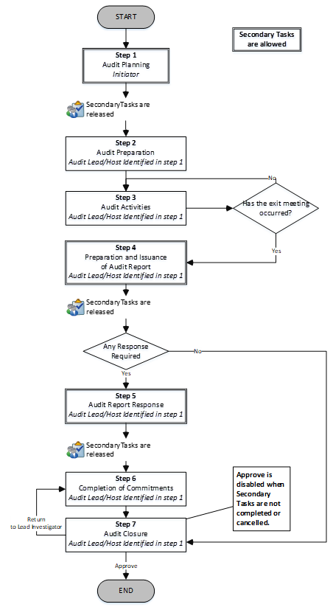
Audit Process Flowcharts
The Audit Process Flowcharts are displayed on this page for informational purposes only – to show that it is a multi-step process with related decision paths.
The flowchart shown at the right is available as part of the Process User Functional Design Specification (PUFDS) document.
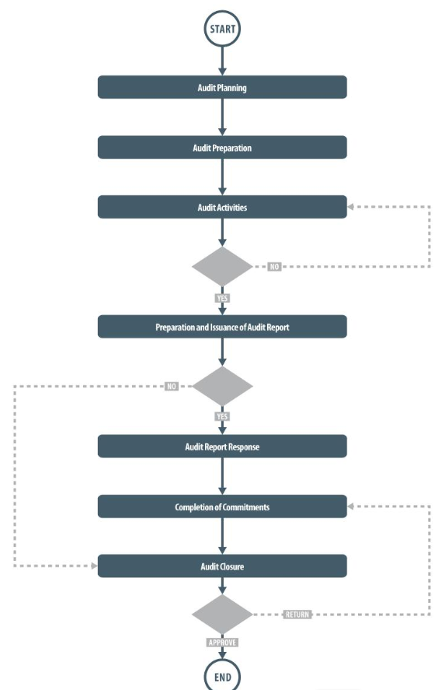
The Flowchart shown below is available within the Process APP. As the process moves along, the active step in that Flowchart is highlighted.

This User Guide is organized into sections for each of the Steps in the Audit Process. The flowchart section for each of those steps will be displayed in larger, more readable format within those sections.

Audit Process – Process Steps
The major steps in the process are displayed in the Process Flowchart by dark-shaded boxes. These major steps are considered Primary Tasks in the process. Decisions made by those involved in the process act to progress it to the next step or return it to a prior step.
Unlike other SOLABS QM Process APPs, there are no Process Roles to assign with the Audit Process P0044. An Audit Lead/Host is identified by the Initiator at Step 1 and will then be responsible for the remaining steps in the process. If the person initiating Step 1 will be the Audit Lead/Host, they can choose themselves.

Starting the Audit Process
From the PROCESS Section in SOLABS QM10, choose Start Process from the Quick Access Process Menu.
At the next screen, locate the listing for the Audit Process and click the blue START button.
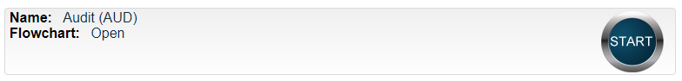

You will then be asked to Confirm this action, to move Status from Not Started to In Process. At this point a Unique ID will be assigned to the Audit Process.
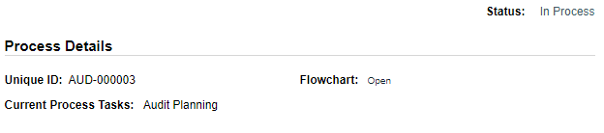
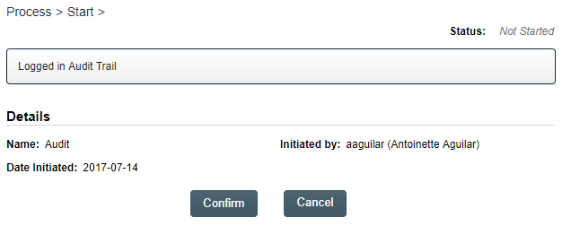

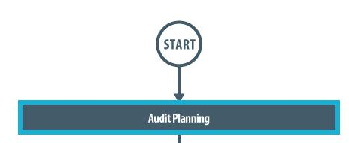
The first step on the Process Flowchart will now be highlighted when the flowchart is opened.

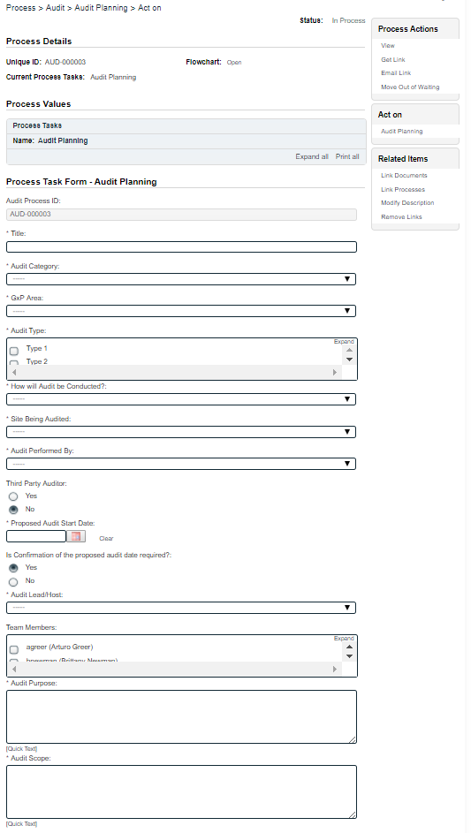
Step 1: Audit Planning
At Step 1 the user initiating the Audit enters all the required information into the Process Task Form.
The fields on the Process Task Form are editable text fields, text areas, single-item selection fields or multi-item selection fields. Those with an asterisk (*) are mandatory.
The right-hand Related Items menu allows the initiator to Link Documents or Link Processes, if applicable.
Refer to the separate document SOLABS QM10: Introduction to PROCESS Section for information on use of the right-hand menus since they are common to all SOLABS QM Process APP screens.
Each of the fields in the Process Task Form will be described starting on the next page.
Some of the information entered at Step 1 will determine how the process flows through the remaining steps.
At the bottom of the screen there is a Save Draft option if you cannot complete all the required fields at one time or when you need to use the right-hand menus to Link Documents or to Link Processes.
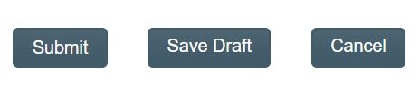

CAUTION: If you navigate away from this page without clicking on either Submit or Save Draft, all entries will be lost. To complete the information after the Save Draft option, you can either choose the Act On option from the Process section of your HOME Page, or search for the In-Process Audit and then use the right-hand Act on Menu to open the Process Task Form fields.

Completing the Process Task Form:
This sub-section covers the information required for each of the fields in the Process Task Form at Audit Process Step 1.
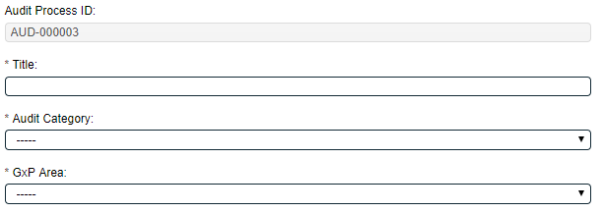
The Audit Process ID field will be automatically populated with the next available Audit number.
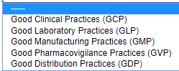
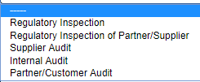
The Title field is mandatory. Choose a clear, concise and intuitive title for the Audit that will quickly communicate the subject. Titles will appear in Audit Reports.
The Audit Category and GxP Area fields are mandatory. They are Single-item Selection fields with a pre-set list of values.
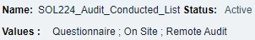
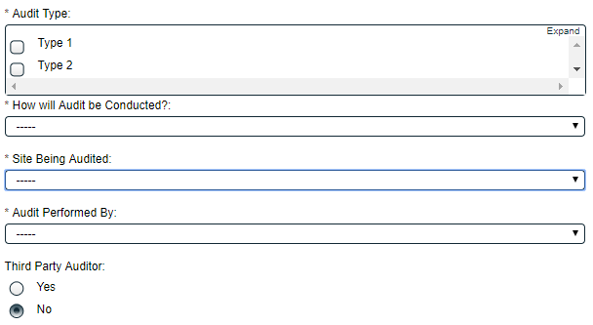
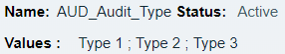
The Audit Type field is mandatory. It is a Multi-item Selection field populated from an editable Custom List of Audit Types that your SOLABS System Administrator can customize for your organization.
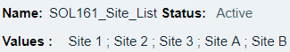
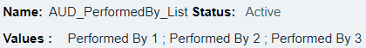
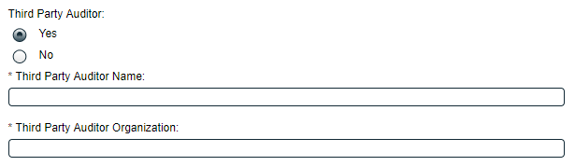
How will Audit be Conducted?, Site Being Audited and Audit Performed By are mandatory Single-item Selection fields populated from editable Custom Lists that your SOLABS System Administrator can customize for your organization.
Prior to Release 10.9 How will Audit be Conducted? allowed for just two set options – either Questionnaire or On Site. With Releases 10.9 those values and Remote Audit will be defaults but the values are editable.
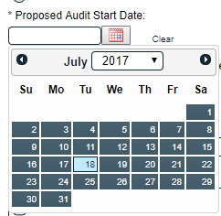
Third Party Auditor is a Yes/No selection. If Yes is selected, additional mandatory free-text fields (up to 1024 characters) are displayed for the Third Party Auditor Name and the Third Party Auditor Organization.
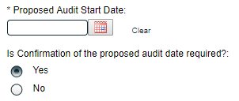
The Proposed Audit start Date is a mandatory date field that can be populated directly or from a calendar. A Yes/No selection is then made for Is Confirmation of the proposed audit date required? If Yes is selected, a Secondary Task will automatically be created for that confirmation. See Page 7 below for information on Secondary Tasks.
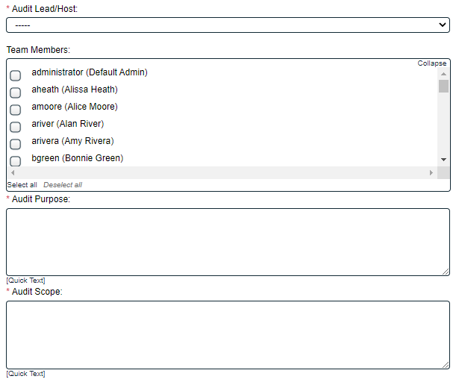
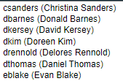
The Audit Lead/Host field is mandatory. It is a Single-item Selection field that includes the list of SOLABS QM10 Active Users who have an Account Type of “Standard”. The person chosen will be responsible for the remaining steps in the Audit Process. The initiator can choose themselves too.
The Team Members field is not mandatory. It is a Multi-item Selection field that includes the list of SOLABS QM10 Active Users who have an Account Type of “Standard”. It also includes a selection of “Other”. If “Other” is selected, then the field Specify Team Member Name is displayed.

The Audit Purpose and Audit Scope fields are mandatory text area fields (up to 4000 characters allowed) that can also be populated by Quick Text.
Quick Text lists are editable Custom Lists maintained by your SOLABS QM10 Administrator to be unique for your organization and provide consistency of related terminology.

Creating Secondary Tasks
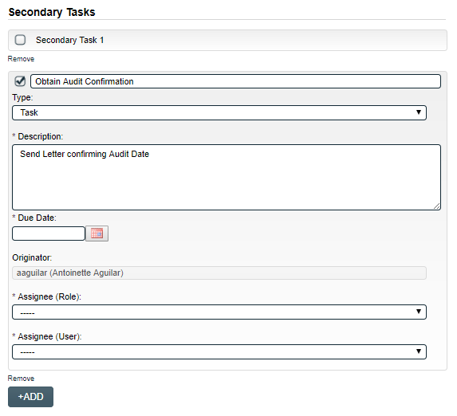
The initiator of the Audit Process can create Secondary Tasks that will be associated with the Audit. These Secondary Tasks can be assigned to appropriate Users for activities required to support completion of the Audit.
The Secondary Task section is underneath the Process Task Form, but still on the Audit Planning screen.
As mentioned above, if Yes was selected for the Is Confirmation of the proposed audit date required? field, a Secondary Task will automatically be created for that confirmation, with the Originator field defaulting to the person initiating Step 1 of the Audit Process. The mandatory fields for Due Date, Assignee (Role) and Assignee (User) will need to be populated with an appropriate date and assignee.
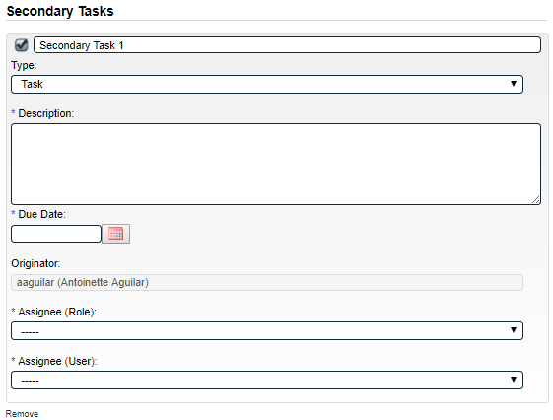
Another Secondary Tasks can be created be selecting Secondary Task 1.
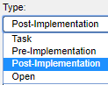
After selecting Secondary Task 1, additional fields will be displayed to define and assign that task.
Replace the text “Secondary Task 1” with an appropriate Title for the task.
The task Type can then be chosen from a drop-down list. Pre-Implementation tasks will need to be completed prior to Audit Closure.
The Description and Due Date fields are mandatory for each Task. Choose due dates appropriate to ensure tasks are completed in a time frame that supports on time Audit closure.
The Originator field will default to the User initiating the Audit Process and completing Step 1.
Both the Assignee (Role) and the Assignee (User) fields must be completed for the chosen User. The drop-down lists will bring up the Active Roles list and the Active Users list. It is a good practice to consult with the planned Assignee ahead of time to ensure they are able to complete the task in a timeframe that supports on time Audit closure.
To assign by Role, choose the appropriate Function Role from the list. All Users with that Role will then appear in the Assignee (User) drop-down list so that the appropriate person can be selected. To assign by User, choose the appropriate User from the list. Their Function Role will then appear in the Assignee (Role) drop-down list and must be selected.
The +ADD button can be used to create additional Secondary Tasks.
The Assignees will receive email Notifications and see the View/Act On options for their Secondary Tasks on their SOLABS QM10 HOME Page. The Secondary Tasks, and the status, are listed under Related Items at the bottom of the screen at any Audit Step.
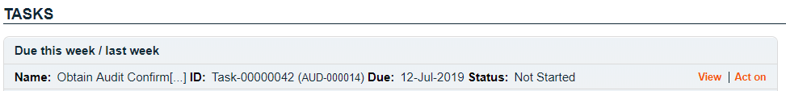

Initiating a Related Process
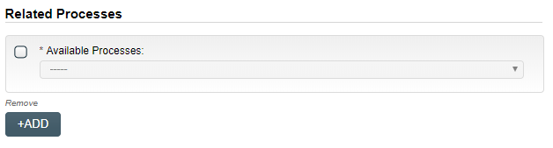
To initiate a new SOLABS QM10 Process from within this Process, check the Available Processes box.
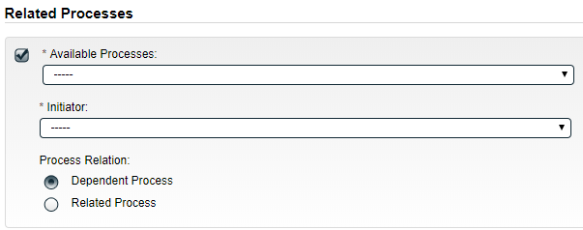
The Available Processes field is a Single-item selection field populated with a list of the Process APPs deployed at your organization.
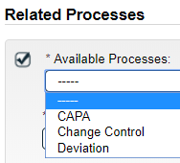
Choose the Process Relation as either a Dependent Process (must be completed before the Audit is closed), or a Related Process.

The mandatory Initiator to field is a Single-item selection field populated by the list of all Active Users. The person chosen in this field will be the person who will be assigned Step 1 of the process being initiated. There is also an option to choose myself, if you would like to initiate both processes concurrently as the initiator. The Audit process will then be the Parent Process of the new process being initiated.
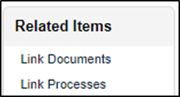
If a Related Process was already initiated, separately from this Audit, it can be linked as a Related Item using the right-hand menu option under Related Items. In this case, do not select the Available Processes box and instead use the Link Processes option.
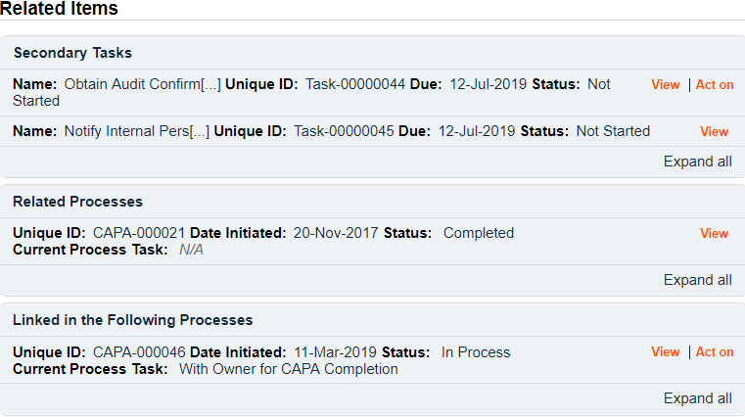
Whether linking an existing process or initiating a new one, the Related Processes will be listed in the Related Items section, along with any Secondary Tasks and Related Documents, when Audit Step 1 is Submitted and Confirmed.

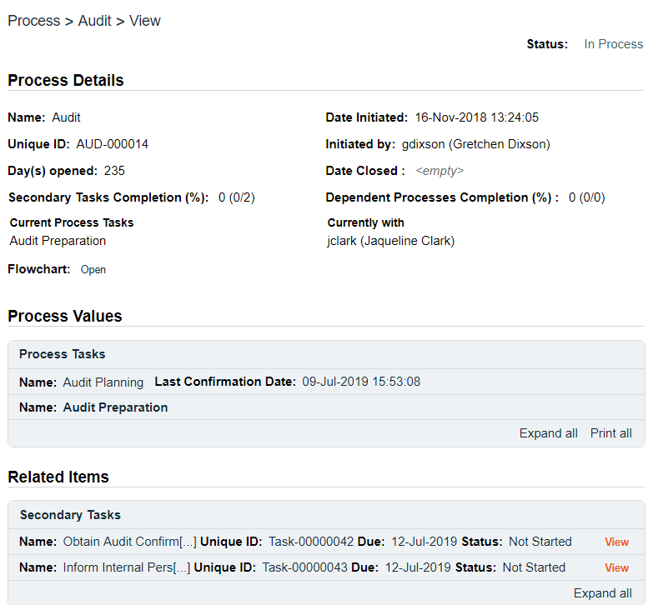
Submit and Confirm
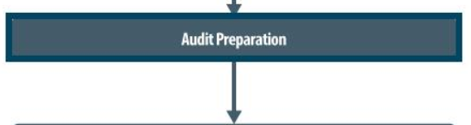
When all information has been entered into the Process Task Form, any Linked Documents or Linked Processes have been added, any Secondary Tasks have been created and any new Related Processes have been initiated, click Submit and then Confirm to progress the Audit process to Step 2 – Audit Preparation.
The Process Flowchart will highlight the next step of the process and the person chosen in Step 1 as the Audit Lead/Host will be listed. The Audit Lead/Host will also receive an email Notification and will see the Audit Preparation task listed on their SOLABS QM10 HOME Page.

Step 2: Audit Preparation
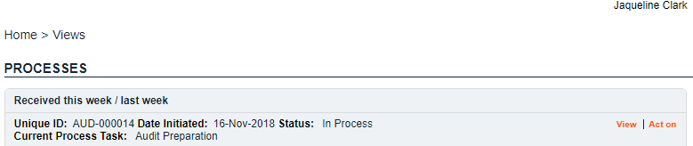
At this step in the Audit Process, the Audit Lead/Host chosen at Step 1 will receive an email Notification and will see their Audit Preparation task listed in the Process section of their SOLABS QM10 HOME Page. Even if the Lead Auditor was the one who initiated the process, they will receive a new email Notification so that activities for Audit Preparation are captured as a separate step.

Viewing the Audit Preparation Task
If the Audit Lead/Host clicks on the View option to the right of the Process Task, they will get the same screen shown above.
From the View screen, there are Expand all options under the Process Values table and the Related Items table, that can be used to see more detail on the information entered by the initiator at Step 1. They can also click on the View option to the right of any individual Related Items (Secondary Tasks, Linked Documents, Linked Processes) to go to the Task Details, Document Details or Process Details screens associated with those Related Items. From any of those screens they can quickly return to the Process since it will be listed as a Related Item on all of those screens. See example below.
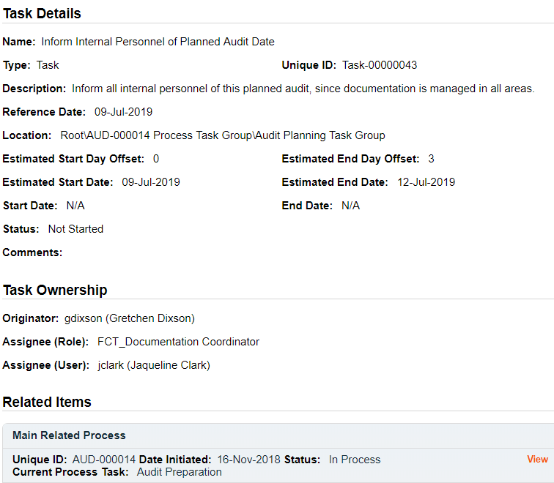
In this example, clicking on View for a Secondary Task listed in AUD-000014 brings up the Task Details screen for that assigned Task.
AUD-000014 is listed as a Related Item for that Task. To get back to AUD-000014, the Reviewer can click on the View option.

Acting on the Audit Preparation Task
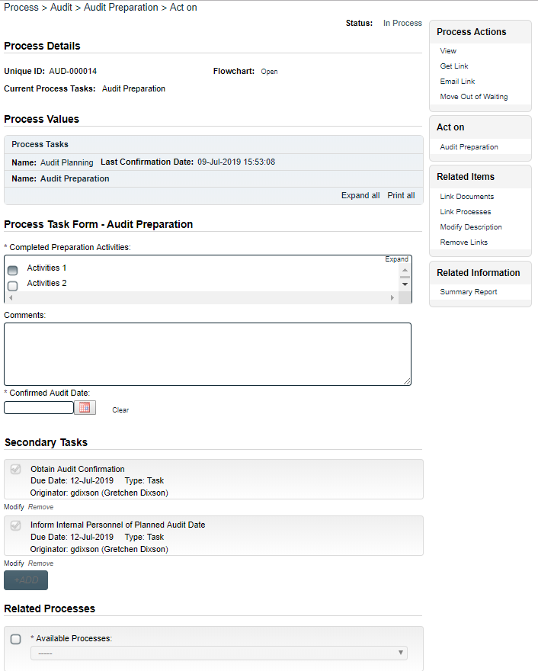
When the Audit Lead/Host clicks on the Act on option to the right of the Process Task, they will go immediately to the Act on screen for their Audit Preparation task.
As described above, the Audit Lead/Host can use the Expand all option under the Process Values table to see all information entered by the Initiator at Step 1.
The Process Task Form includes a multi-item selection field for Completed Preparation Activities, an editable text area for Comments, and a date field for the Confirmed Audit Date. Fields with an asterisk (*) are mandatory. More information on the use of these fields is provided starting on the next page.
The right-hand Related Items menu allows the Audit Lead/Host to Link Documents or Link Processes, if applicable. There is a section under the Process Task to initiate new Related Processes.
Refer to the separate document SOLABS QM10: Introduction to PROCESS Section for information on use of the right-hand menus since they are common to all SOLABS QM Process APPs.
Initiation of Secondary Tasks or a Document Control Process is not allowed at Step 2.
There is a Save Draft option at the bottom if all the required fields cannot be completed at one time or when using the right-hand menu to Link Documents or Link Processes.
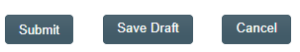

CAUTION: Navigating away from this page without clicking on either Submit or Save Draft, will result in all entries being lost. To complete the information after the Save Draft option, choose either the Act On option from the Process section of your HOME Page, or search for the Audit Process and then use the right-hand Act on Menu to open the Process Task Form fields.
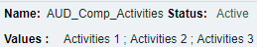
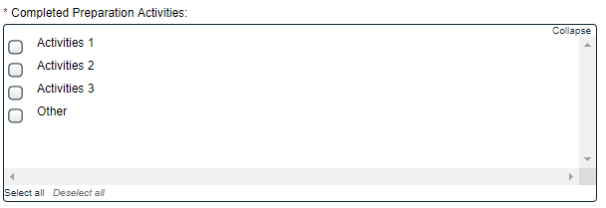
Completed Preparation Activities is a Multi-item Selection field of values from an editable Custom List. The option “Other” is also included. If “Other” is selected, the mandatory Specify Other Activity text field (up to 1024 characters) is displayed.
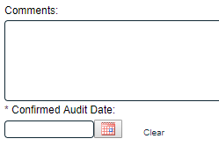
There is an optional text area field for Comments, that allows up to 4000 characters.
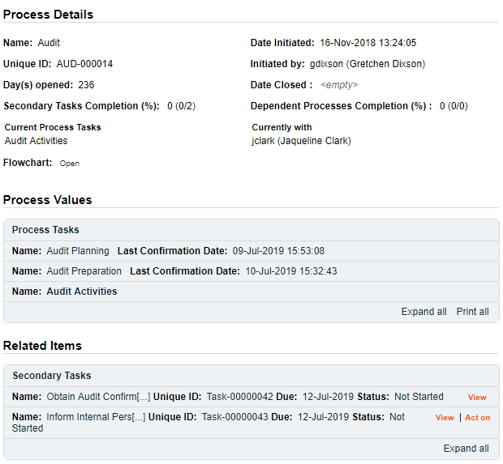
The Confirmed Audit Date field is mandatory and is populated from a calendar.

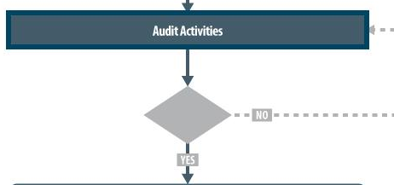
When Step 2 is Submitted and Confirmed, the Audit Process moves to Step 3: Audit Activities. It stays assigned to the Audit Lead/Host.
The Process Flowchart will highlight the next step of the process. The Audit Lead/Host will also receive an email Notification and will see the Audit Activities task listed on their SOLABS QM10 HOME Page.

Step 3: Audit Activities
At this step in the Audit Process, the Audit Lead/Host chosen at Step 1 will receive an email Notification and will see their Audit Activities task listed in the Process section of their SOLABS QM10 HOME Page. Even if the Lead Auditor was the one who initiated the process, they will receive a new email Notification so that activities for Audit Activities are captured as a separate step.
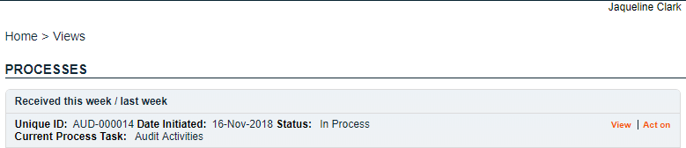

Viewing the Audit Activities Task
If the Audit Lead/Host clicks on the View option to the right of the Process Task, they will get the same screen shown above.
From the View screen, they can use the Expand all options under the Process Values table and the Related Items table to see more detail on the information entered at prior steps. They can also click on the View option to the right of any individual Related Items (Secondary Tasks, Linked Documents, Linked Processes) to go to the Task Details, Document Details or Process Details screens associated with those Related Items. From any of those screens they can quickly return to the Process since it will be listed as a Related Item on all of those screens.

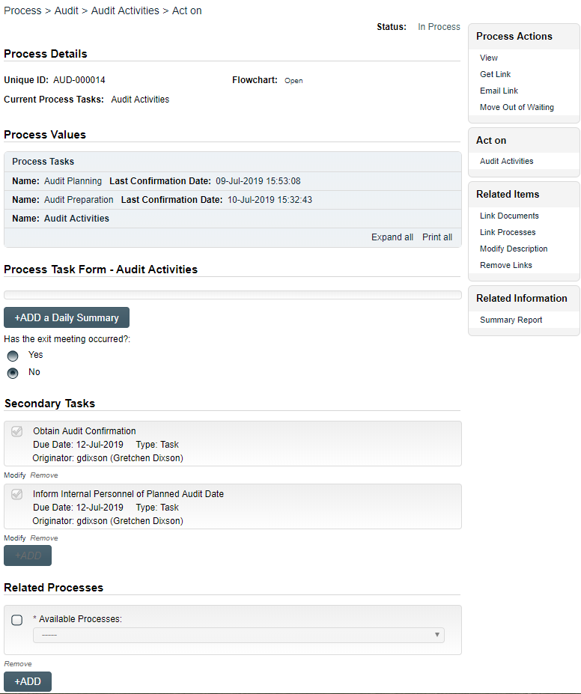
Acting on the Audit Activities Task
When the Audit Lead/Host clicks on the Act on option to the right of the Process Task, they will go immediately to the Act on screen for their Audit Activities task.
As described above, the Audit Lead/Host can use the Expand all option under the Process Values table to see all information entered in prior steps.
The Process Task Form includes the ability to add daily summaries and to indicate when the final exit meeting has occurred. These are described in more detail on the next page.
The right-hand Related Items menu allows the Audit Lead/Host to Link Documents or Link Processes, if applicable. There is a section under the Process Task to initiate new Related Processes.
Refer to the separate document SOLABS QM10: Introduction to PROCESS Section for information on use of the right-hand menus since they are common to all SOLABS QM Process APPs.
Initiation of Secondary Tasks or a Document Control Process is not allowed at Step 3.
There is a Save Draft option at the bottom if all the required fields cannot be completed at one time or when using the right-hand menu to Link Documents or Link Processes.

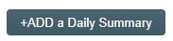
CAUTION: Navigating away from this page without clicking on either Submit or Save Draft, will result in all entries being lost. To complete the information after the Save Draft option, choose either the Act On option from the Process section of your HOME Page, or search for the Audit Process and then use the right-hand Act on Menu to open the Process Task Form fields.
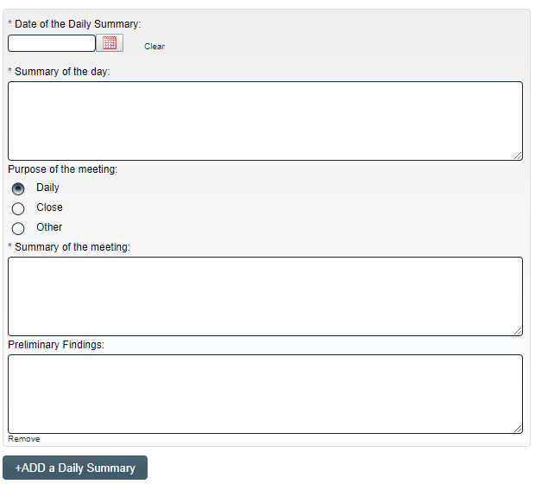
The Process Task Form for the Audit Activities step includes a +ADD a Daily Summary button. Each time the button is clicked, the following group of fields is displayed above it.
Date of the Daily Summary is a mandatory date field that is populated from a calendar.
Summary of the day is a mandatory text area allowing for 4000 characters.
Purpose of the meeting is a set of radio buttons allowing for choice of Daily, Close or Other. It defaults to Daily.
Summary of the meeting is a mandatory text area allowing for 4000 characters.
Preliminary Findings is an optional text area allowing for 4000 characters.

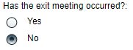
Has the exit meeting occurred? Is a set of radio buttons allowing for a Yes or No selection. It defaults to No. If No is selected, the Audit Process will stay at Step 3 – Audit Activities to allow continuted addition of Daily information.
If Yes is selected, the Audit Process will progress to Step 4 – Preparation and Issuance of Audit Report upon submission and confirmation of Step 3.
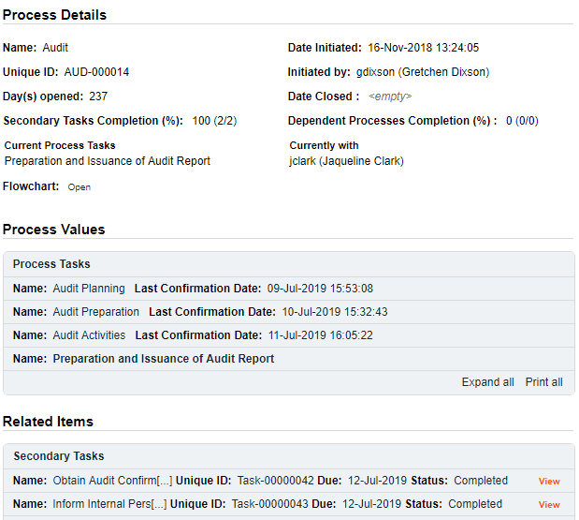
The process stays assigned to the Audit Lead/Host for Step 4.
The Process Flowchart will highlight the next step of the process. The Audit Lead/Host will also receive an email Notification and will see the Preparation and Issuance of Audit Report task listed on their SOLABS QM10 HOME Page.
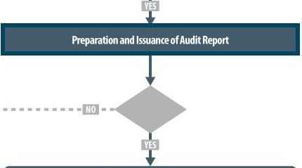

Step 4: Preparation and Issuance of Audit Report
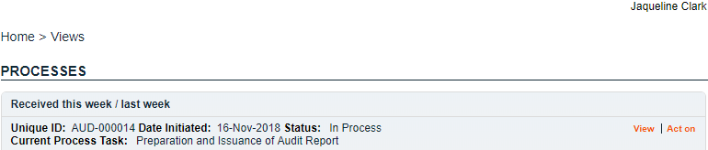
At this step in the Audit Process, the Audit Lead/Host chosen at Step 1 will receive an email Notification and will see their Preparation and Issuance of Audit Report task listed in the Process section of their SOLABS QM10 HOME Page. Even if the Lead Auditor was the one who initiated the process, they will receive a new email Notification so that activities for Preparation and issuance of Audit Report are captured as a separate step.

Viewing the Preparation and Issuance of Audit Report Task
If the Audit Lead/Host clicks on the View option to the right of the Process Task, they will get the same screen shown above.
From the View screen, they can use the Expand all options under the Process Values table and the Related Items table to see more detail on the information entered at prior steps. They can also click on the View option to the right of any individual Related Items (Secondary Tasks, Linked Documents, Linked Processes) to go to the Task Details, Document Details or Process Details screens associated with those Related Items. From any of those screens they can quickly return to the Process since it will be listed as a Related Item on all of those screens.

Acting on the Preparation and Issuance of Audit Report Task
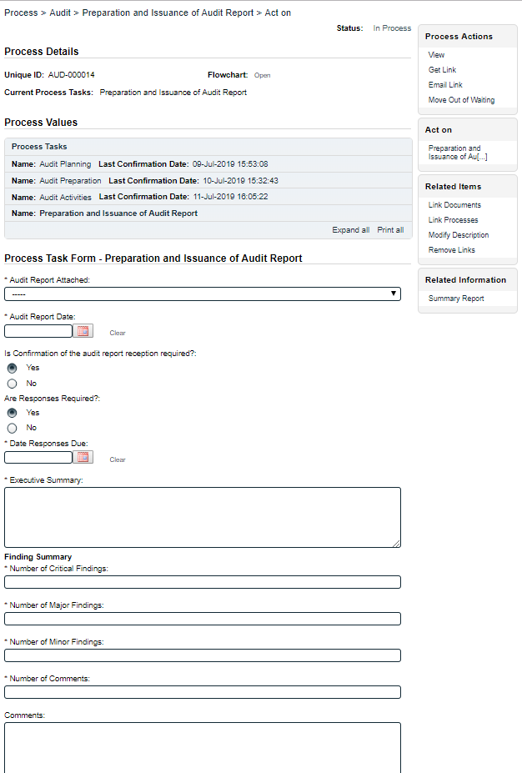
When the Audit Lead/Host clicks on the Act on option to the right of the Process Task, they will go immediately to the Act on screen for their Preparation and Issuance of Audit Report task.
As described above, the Audit Lead/Host can use the Expand all option under the Process Values table to see all information entered in prior steps.
The Process Task Form includes the fields necessary to summarize the outcome of the audit. These are described in more detail on the next page.
The right-hand Related Items menu allows the Audit Lead/Host to Link Documents or Link Processes, if applicable.
Refer to the separate document SOLABS QM10: Introduction to PROCESS Section for information on use of the right-hand menus since they are common to all SOLABS QM Process APPs.
New Secondary Tasks and Related Processes can be initiated at Step 4 but initiation of a Document Control Process is not allowed.
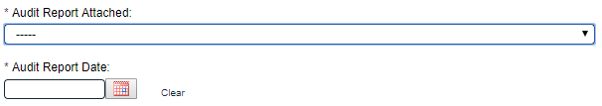

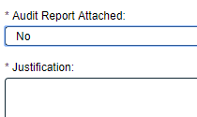
The Audit Report Attached field is a mandatory single-item selection field with values or Yes or No. If No is selected, a mandatory text area is displayed, allowing for up to 4000 characters. The Audit Report can be attached a a Related Items using the right-hand Link Documents menu option.
The mandatory Audit Report Date field can be populated by a calendar.
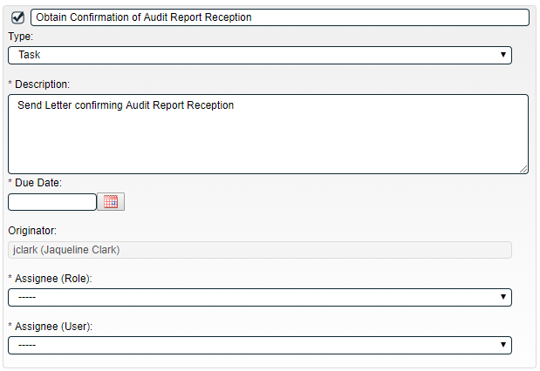
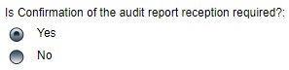
Is Confirmation of the audit report reception required? is a radio button allowing for choices or Yes or No, and defaulting to Yes. When the choice is Yes, a Secondary Task is automatically created for this activity.

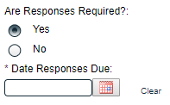
Are Responses Required? is a radio button allowing for choices or Yes or No, and defaulting to Yes. When the choice is Yes, a mandatory Date Responses Due field can be populated using a calendar.
When a Yes choice is selected, the Audit process will move to Step 5 – Audit Report Responses upon confirmation of Step 4. When No is selected, the process will move to Step 7 – Audit Closure upon confirmation of Step 4.
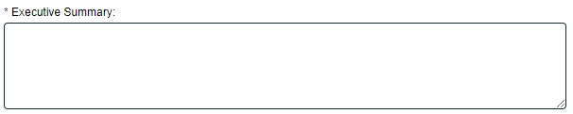
The following fields provide entry of information to summarize the Audit. The Executive Summary is a text area allowing for up to 4000 characters. The Finding Summary section includes mandatory fields for Number of Critical Findings, Number of Major Findings, Number of Minor Findings and Number of Comments. There is also an optional Comments field.

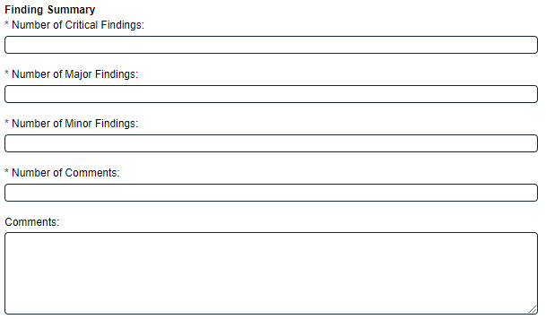

The Save Draft option is available at the bottom if all the required fields cannot be completed at one time or when using the right-hand menu to Link Documents or Link Processes.

CAUTION: Navigating away from this page without clicking on either Submit or Save Draft, will result in all entries being lost. To complete the information after the Save Draft option, choose either the Act On option from the Process section of your HOME Page, or search for the Audit Process and then use the right-hand Act on Menu to open the Process Task Form fields.

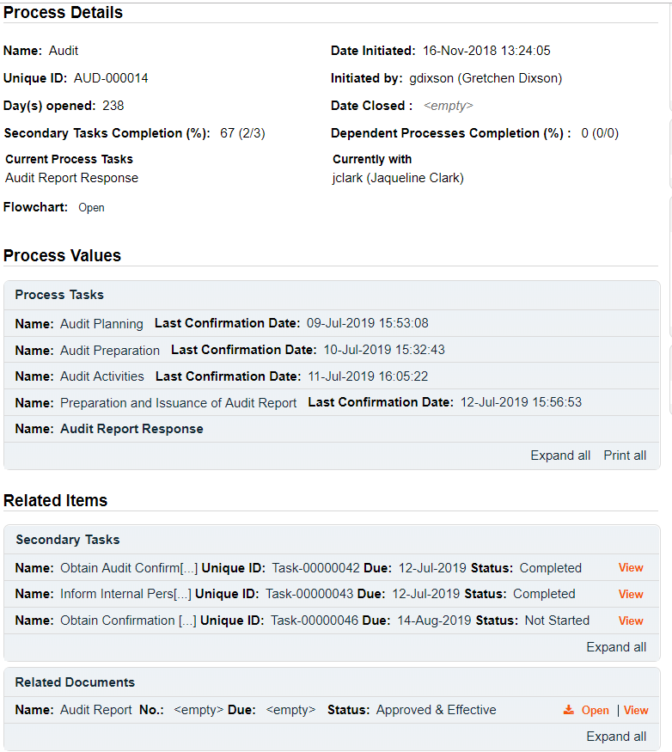
Since Yes was selected at Step 4 for Audit Responses Required, the Audit Process moves to Step 5 – Audit Report Response.
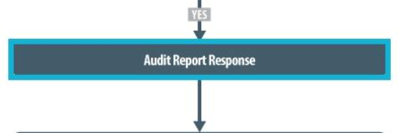
The Process Flowchart will highlight the next step of the process. The Audit Lead/Host will also receive an email Notification and will see the Audit Report Response task listed on their SOLABS QM10 HOME Page.

Step 5: Audit Report Response
At this step in the Audit Process, the Audit Lead/Host chosen at Step 1 will receive an email Notification and will see their Audit Report Response task listed in the Process section of their SOLABS QM10 HOME Page. Even though they have been assigned most steps in the process, they will receive a new email Notification so that activities for the Audit Report Response are captured as a separate step.
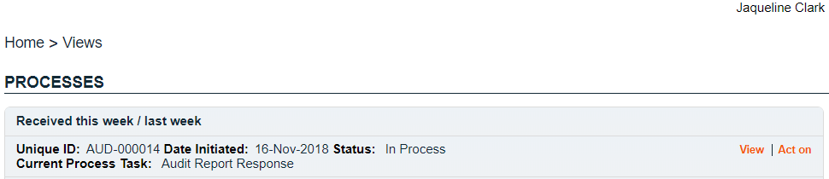

Viewing the Audit Report Response Task
If the Audit Lead/Host clicks on the View option to the right of the Process Task, they will get the same screen shown above.
As with other steps, from the View screen, they can use the Expand all options under the Process Values table and the Related Items table to review detail from prior steps. They can also click on the View option to the right of any individual Related Items (Secondary Tasks, Linked Documents, Linked Processes) to go to the Task Details, Document Details or Process Details screens associated with those Related Items. From any of those screens they can quickly return to the Process since it will be listed as a Related Item on all of those screens.

Acting on the Audit Report Response Task
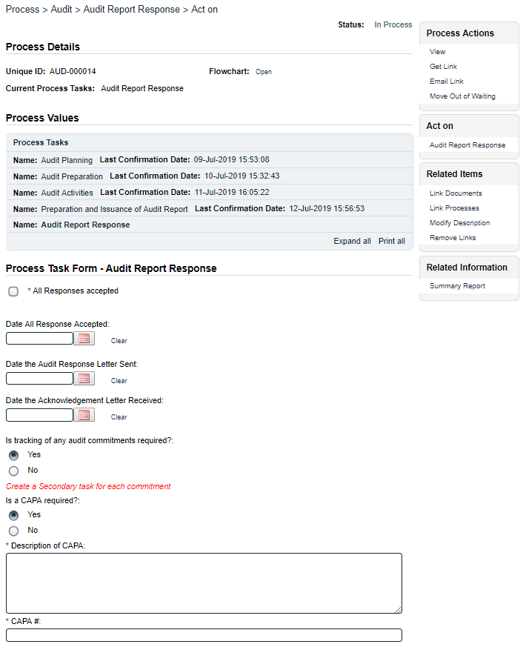
When the Audit Lead/Host clicks on the Act on option to the right of the Process Task, they will go immediately to the Act on screen for their Audit Report Response task. As described above, the Audit Lead/Host can use the Expand all option under the Process Values table to see all information entered in prior steps.
The Process Task Form includes the fields necessary to enter the details regarding the Audit Report Response. These are described in more detail on the next page.
These two fields are displayed only if the Audit Category at Step 1 was selected as one of the following:
- Regulatory Inspection
- Internal Audit
- Partner/Customer Audit
The field Date Acceptability of Audit Response Letter Sent is displayed instead if the Audit Category at Step 1 was one of the following:
- Regulatory Inspection of Partner/Supplier
- Supplier Audit

When dates are entered, messages will appear in red as a reminder to attach the applicable letters.
The right-hand Related Items menu allows the Audit Lead/Host to Link Documents or Link Processes, if applicable.
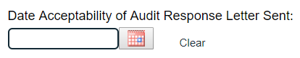
Refer to the separate document SOLABS QM10: Introduction to PROCESS Section for information on use of the right-hand menus since they are common to all SOLABS QM Process APPs.
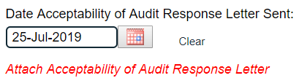
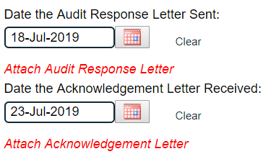
New Secondary Tasks and Related Processes can be initiated at Step 5 but initiation of a Document Control Process is not allowed.

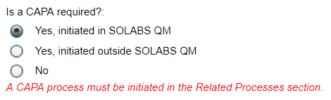
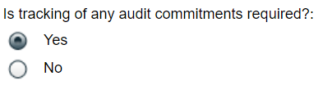
Is tracking of any audit commitments required? is a Yes or No radio button selection. The choice defaults to Yes. When Yes is selected, a message will appear in red below the radio buttons as a reminder to create Secondary Tasks for each commitment.
Is CAPA required? is a radio button selection with three possible selections. The choice defaults to Yes, initiated in SOLABS QM10 if a CAPA Process is deployed in the instance of SOLABS QM.
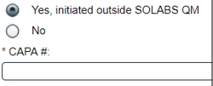
If there is not a CAPA Process deployed in the instance of SOLABS QM, that option is grayed and the default is Yes, initiated outside SOLABS QM.
If No is selected, there are no other fields displayed.
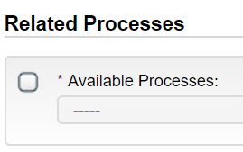
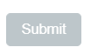
When the selection is Yes, initiated in SOLABS QM, Step 5 will not be able to be Submitted until a CAPA is initiated from within the Audit Process using the Related Processes section. The Submit button will be grayed out:
The new CAPA can be chosen as Dependent or Related. The Audit Process will be the Parent Process to the new CAPA.
As with previous steps, there is a Save Draft option at the bottom if all the required fields cannot be completed at one time or when using the right-hand menu to Link Documents or Link Processes.

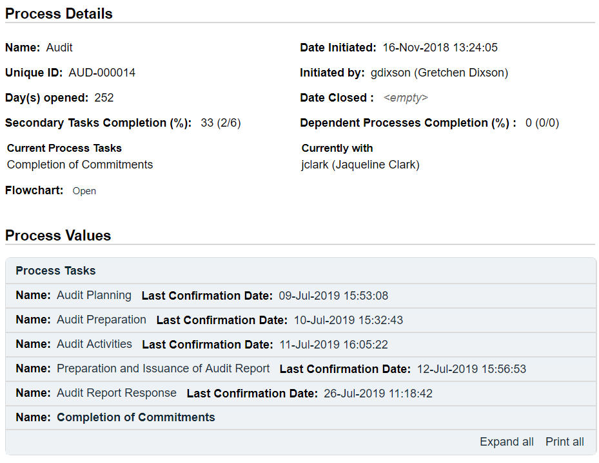
CAUTION: Navigating away from this page without clicking on either Submit or Save Draft, will result in all entries being lost. To complete the information after the Save Draft option, choose either the Act On option from the Process section of your HOME Page, or search for the Audit Process and then use the right-hand Act on Menu to open the Process Task Form fields.
When Step 5 is Submitted and Confirmed, the Audit Process will progress to Step 6 – Completion of Commitments.
The Process Flowchart will highlight the next step of the process. The Audit Lead/Host will also receive an email Notification and will see the Completion of Commitments task listed on their SOLABS QM10 HOME Page.
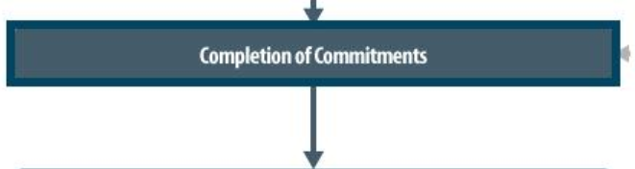

Step 6: Completion of Commitments
At this step in the Audit Process, the Audit Lead/Host chosen at Step 1 will receive an email Notification and will see their Completion of Commitments task listed in the Process section of their SOLABS QM10 HOME Page. Even though they have been assigned most steps in the process, they will receive a new email Notification so that activities for the Completion of Commitments are captured as a separate step.
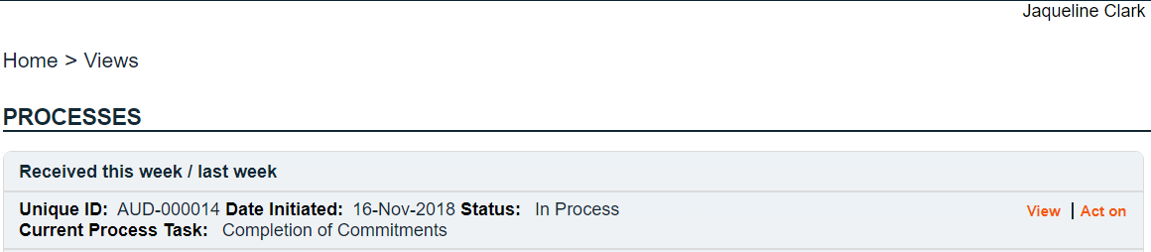

Viewing the Completion of Commitments Task
If the Audit Lead/Host clicks on the View option to the right of the Process Task, they will get the same screen shown above.
From the View screen, they can use the Expand all options under the Process Values table and the Related Items table to see more detail on the information entered at prior steps. They can also click on the View option to the right of any individual Related Items (Secondary Tasks, Linked Documents, Linked Processes) to go to the Task Details, Document Details or Process Details screens associated with those Related Items. From any of those screens they can quickly return to the Process since it will be listed as a Related Item on all of those screens.

Acting on the Completion of Commitments Task
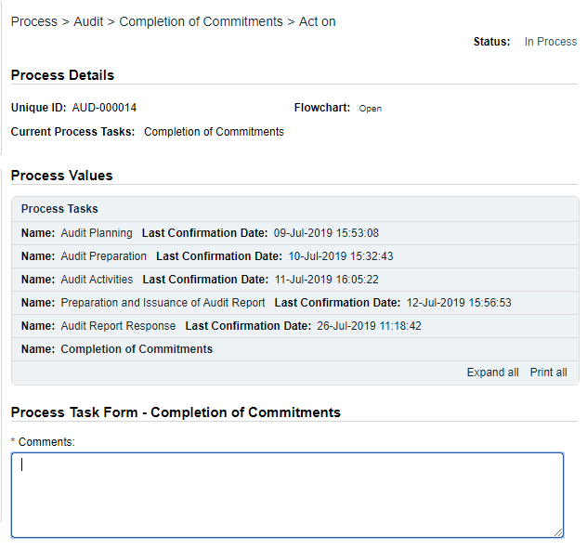
When the Audit Lead/Host clicks on the Act on option to the right of the Process Task, they will go immediately to the Act on screen for their Completion of Commitments task. As described above, the Audit Lead/Host can use the Expand all option under the Process Values table to see all information entered in prior steps.
There is a mandatory Comments field to provide any information on the progress of the commitments.
No Secondary Tasks or Document Control Process can be initiated at Step 6.
Upon Submission/Confirmation of step 6, the Audit Process moves to Step 7 – Audit Closure.

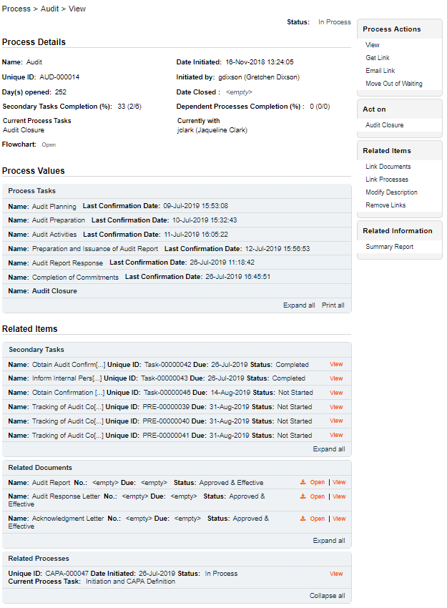
The Process Flowchart will highlight the next step of the process. The Audit Lead/Host will also receive an email Notification and will see the Audit Closure task listed on their SOLABS QM10 HOME Page.
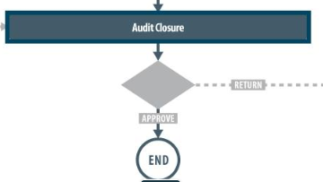

Step 7: Audit Closure
At this step in the Audit Process, the Audit Lead/Host chosen at Step 1 will receive an email Notification and will see the Audit Closure task listed in the Process section of their SOLABS QM10 HOME Page. Even though they have been assigned most steps in the process, they will receive a new email Notification so that activities for the Audit Closure are captured as a separate step.
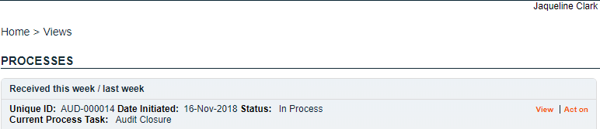

Viewing the Audit Closure Task
If the Audit Lead/Host clicks on the View option to the right of the Process Task, they will get the same screen shown above.
From the View screen, they can use the Expand all options under the Process Values table and the Related Items table to see more detail on the information entered at prior steps. They can also click on the View option to the right of any individual Related Items (Secondary Tasks, Linked Documents, Linked Processes) to go to the Task Details, Document Details or Process Details screens associated with those Related Items. From any of those screens they can quickly return to the Process since it will be listed as a Related Item on all of those screens.

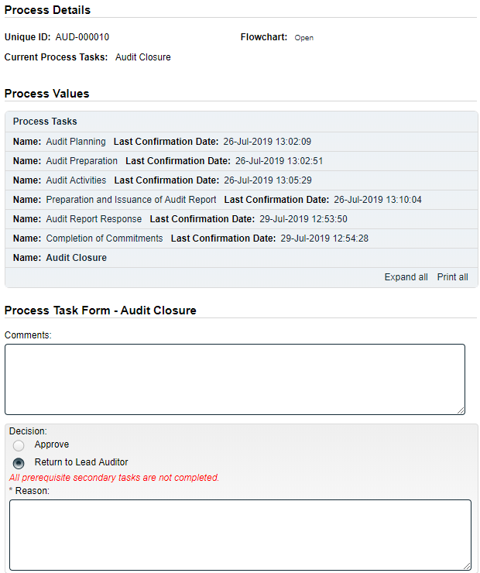
Acting on the Audit Closure Task
When the Audit Lead/Host clicks on the Act on option to the right of the Process Task, they will go immediately to the Act on screen for their Audit Closure task. As described above, the Audit Lead/Host can use the Expand all option under the Process Values table to see all information entered in prior steps.
There is an optional Comments field to provide any information on the progress of the commitments.
No Secondary Tasks or Document Control Process can be initiated at Step 7.
If there are any Secondary Tasks that are not yet completed or cancelled, the Approve option will be grayed out and the statement All prerequisite secondary tasks are not completed will be displayed in red. In that case the only Decision option is Return to Lead Auditor and a mandatory Reason field is displayed.
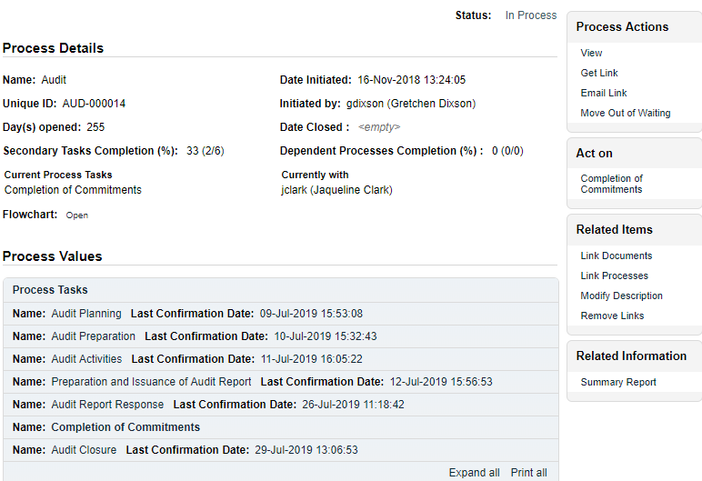
When the Return to Lead Auditor decision is submitted/confirmed, the Audit Process will move back to Step 6 – Completion of Commitments (see Page 22).

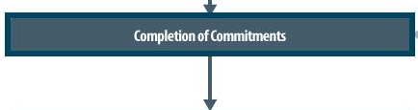

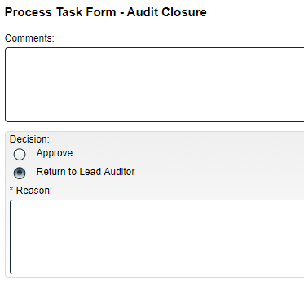
If all Secondary Tasks are completed when the Process moves from Step 6 to Step 7, the Approve option will be available in the Decision section. The Decision of Return to Lead Auditor is also available.
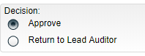
When the Decision of Approve is selected, no additional fields are required.

The Audit Process will then move to a status of Completed.
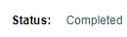

Viewing Details for a Completed Audit Process
Users are able to search for and view processes at any stage, using the Navigation tab in the PROCESS Section of SOLABS QM. If the Process was recently worked on, it will also be available in the Recent Items section.
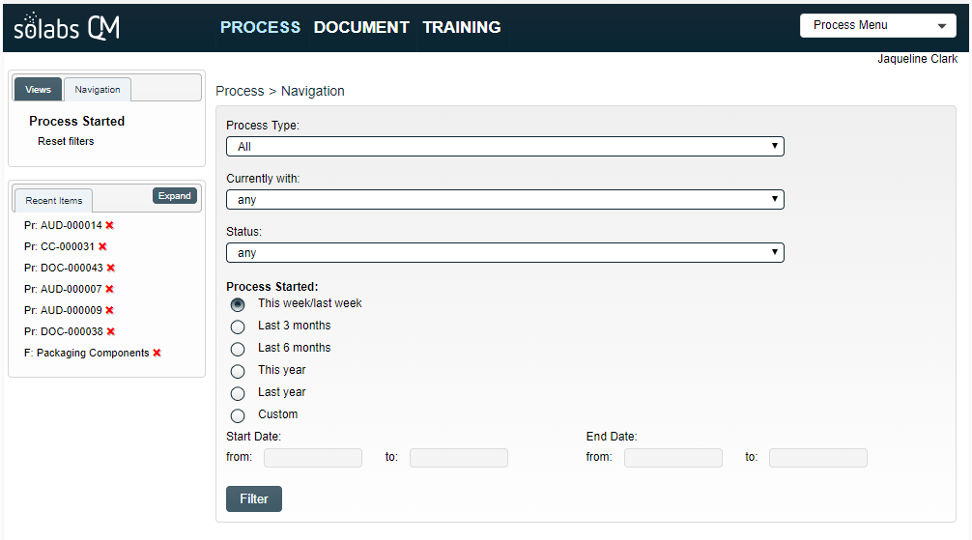

Using the Process Values Table
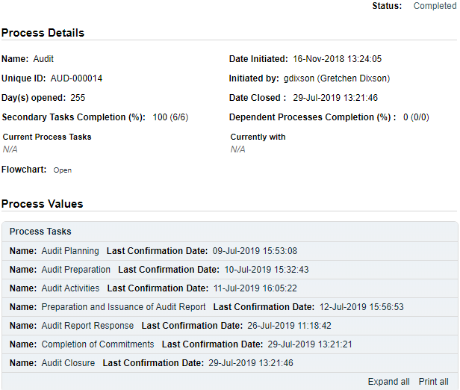
Process Tasks can be viewed by using the Expand all or Print all options at the bottom of the Process Values table. An individual Process Task can be expanded by clicking on it within the Process Values table.

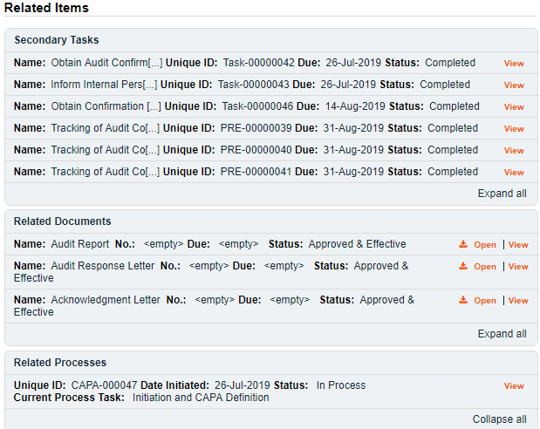

Using the Related Items Table
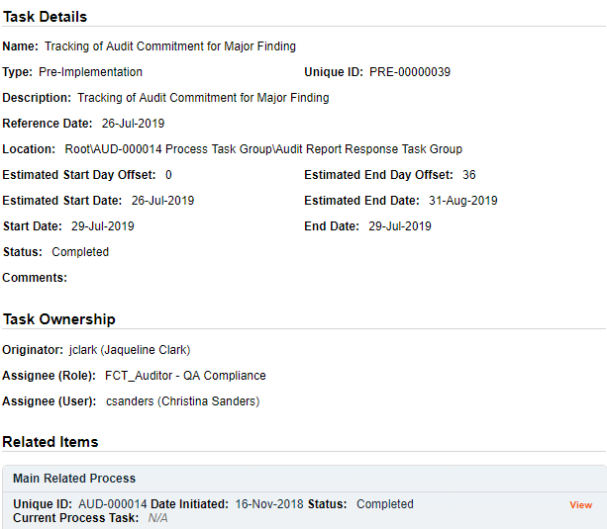
Information on any Secondary Tasks, Related Processes or Related Documents can be accessed by clicking on the View option beside the listing in the Related Items section of the screen. From any of those Details screens, the Process will be listed under Related Items – you can quickly toggle back to the Main Process by clicking View next to it.

Creating a Summary Report
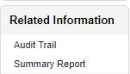
Under the right-hand Related Information menu, click on the Summary Report option.
Select the desired Print Out Options and then click on Generate Report. A multi-page PDF Report will be generated, with any company header information set in System Configurations, and will include details on each step requested for the report.
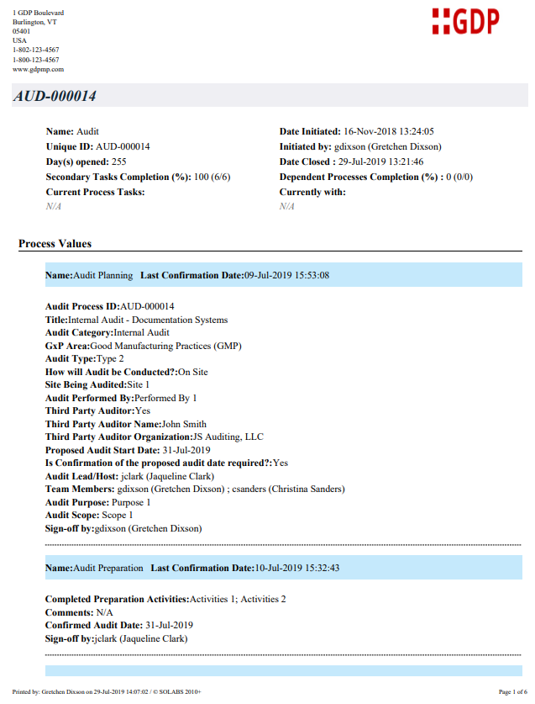
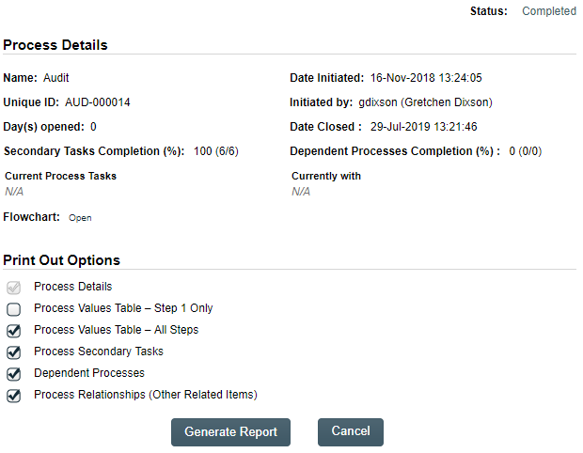

Using the Audit Trail
Users with the SOLABS System Administrator role assignment, will also see the Audit Trail option on the right-hand Related Information menu.
There you will find all the details for every step of the Audit Process, from Process Completed all the way down to Process Started, with options to expand or print the entire process or any individual steps.
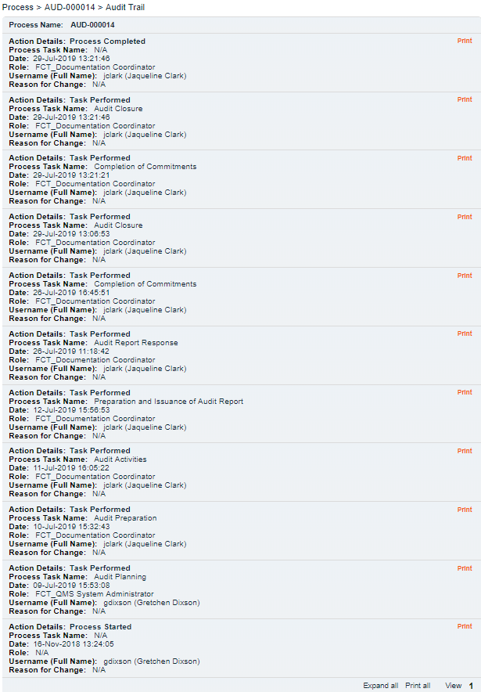

Audit Process Notifications
As mentioned throughout this document, Users will see process tasks listed on their SOLABS QM10 HOME Page and can View or Act on them from there. They will also receive Email Notifications, that include a link to SOLABS QM10.
General information on SOLABS QM10 Notifications available with the Core Software can be found on the Solabs Documentation Portal in a document titled SOLABS QM10: Notifications Guide.
There are no additional Custom Notifications or related Options available with Audit Process P0044.

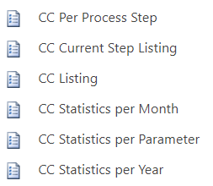
Audit Process Reports
As described in the separate User Guide titled QM APP Reports Breakdown this list of SSRS Reports is available with all SOLABS Process APPs, along with various Excel datasets.
A new macro-enabled Excel report will soon be available for the Audit Process to facilitate more advanced analytics and reporting:
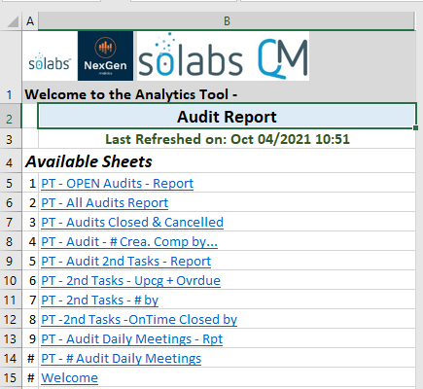
On the next page is an example of just one of the Available Sheets that will help you access, view, analyze and share information on the Audit process workflows.
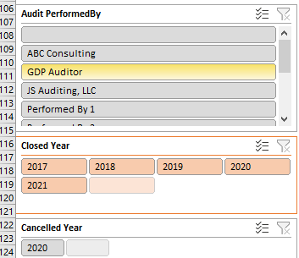
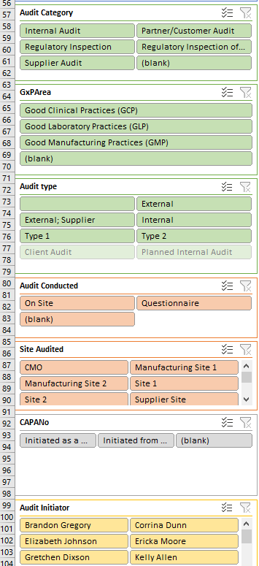
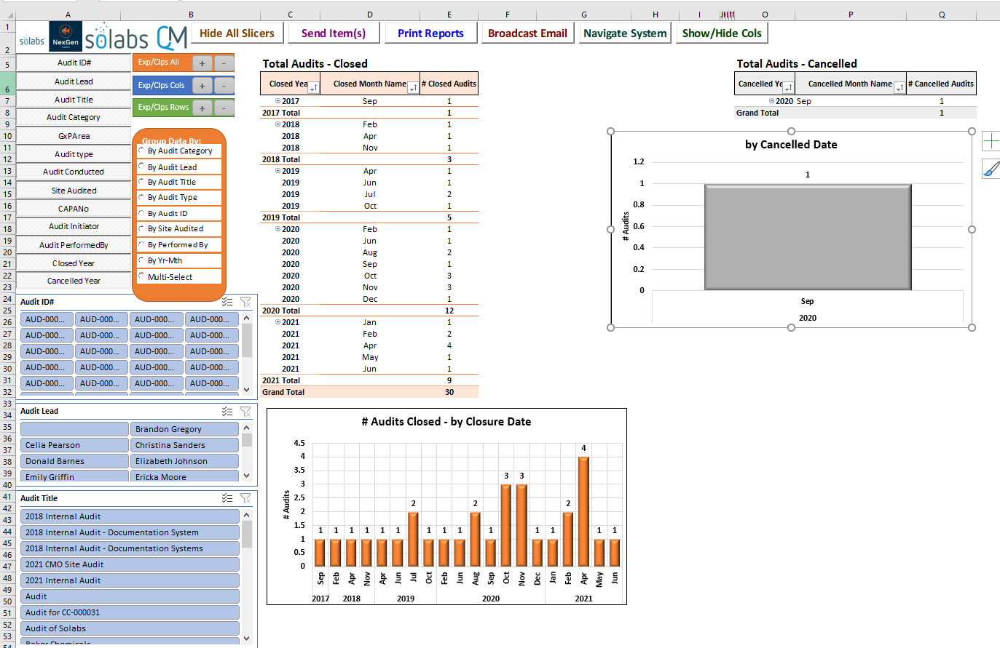
This view of all the data available on the PT - Audits Closed and Cancelled Sheet give you an idea of how powerful this report can be in helping analze your audit process data.

